LAXHYA
LET'S THINK NEW
IT Professional Portfolio
Complete customization, EmailJS and GitHub Pages deployment guide

What this portfolio is designed for
A generic modern portfolio for software engineers, IT support engineers, cloud/system specialists, designers and other technology professionals. It is intentionally zero-build: no npm install, framework build or server is required for GitHub Pages.

Version 1.0 | September 2026

1. What you downloaded
The portfolio is a complete static website. After downloading it from Laxhya, the customer can edit one primary file, preview the result locally and publish the same folder directly to GitHub Pages.

Technology used
- HTML5 for the page structure.
- Modern CSS for responsive layouts, dark/light themes, glass surfaces, gradients, animated backgrounds and reduced-motion support.
- Modern browser JavaScript for dynamic content, filters, project modal, active navigation, theme switching and animations.
- EmailJS Browser SDK for the optional contact form. No backend server is required.
- GitHub Pages for free static hosting.

Folder structure
portfolio-folder/
├── index.html
├── styles.css
├── config.js ← MAIN FILE TO EDIT
├── app.js
├── .nojekyll
├── README.md
├── Laxhya_IT_Professional_Portfolio_Setup_Guide.docx
└── assets/
├── favicon.svg
├── resume.pdf ← replace with your own resume
└── README.txt

Keep the filenames
For the easiest setup, keep index.html, styles.css, config.js and app.js in the top-level folder. GitHub Pages looks for index.html as the home page.

What is dynamic?
The template reads almost all profile content from config.js. You can add or remove experience entries, skills and projects without editing the layout code. Skills and projects automatically rebuild their filter buttons from the categories you enter.

2. Step 1 - Download and extract the portfolio
1 | Download the ZIP from Laxhya  Save the portfolio ZIP to a location you can easily find, such as Downloads.

2 | Extract the ZIP  In Windows, right-click the ZIP and choose Extract All. On macOS, double-click the ZIP. Do not work directly inside the compressed ZIP file.

3 | Open the extracted folder  You should see index.html, config.js, app.js, styles.css and the assets folder.

4 | Create a safe working copy  Optional but recommended: duplicate the extracted folder before you begin editing, so you always have an untouched backup.

Recommended editor
Visual Studio Code is recommended because it is free and makes JavaScript editing easier. However, any plain-text code editor can be used.
Do not use Microsoft Word to edit code files
Files such as config.js must stay plain text. Word processors can insert formatting characters that break JavaScript.

3. Step 2 - Preview it locally before editing
The website can technically open by double-clicking index.html, but a small local web server gives a more accurate preview and is recommended before testing EmailJS.

Windows PowerShell
cd "C:\path\to\your\portfolio-folder"
py -m http.server 5500

Then open this address in your browser:
http://localhost:5500

If Python is not installed
You can use the Visual Studio Code Live Server extension, or double-click index.html for basic design/content testing. EmailJS testing should be done from a local server or the final GitHub Pages URL.

4. Step 3 - Personalize your content
Open config.js. The object named window.PORTFOLIO_DATA contains the editable portfolio information. Text inside quotation marks can be replaced with your own information.

Personal profile and hero
personal: {
name: "Your Name",
initials: "YN",
headline: "Your professional headline.",
intro: "Short introduction about your work and strengths.",
location: "City, Country",
email: "you@example.com",
availability: "Open to opportunities",
profileImage: "assets/profile.jpg",
resumeFile: "assets/resume.pdf",
roles: ["Software Engineering", "IT Support", "Cloud"]
}

- name and initials appear in the navigation, hero and footer.
- headline is the large hero statement. Keep it concise and outcome-focused.
- roles rotate automatically in the hero section.
- profileImage can be left blank. The template will use the animated initials card instead.
- resumeFile already points to assets/resume.pdf.

Metrics
The three hero metrics are deliberately generic. Replace them with truthful numbers that strengthen your profile. Examples: years of experience, supported users, projects delivered, automation hours saved, SLA achievement, certifications or customer satisfaction.

About me
Replace the two sample paragraphs with a concise professional story. The three principle cards work well for values such as reliability, customer focus, security, automation, maintainability, collaboration or design quality.

5. Step 4 - Update experience, skills and projects

Experience entries
{
company: "Company Name",
role: "Your Role",
period: "2024 - Present",
location: "Hybrid",
summary: "One-sentence role summary.",
achievements: [
"Achievement or improvement 1.",
"Achievement or improvement 2."
],
technologies: ["Azure", "PowerShell", "ServiceNow"]
}

Add another experience by copying a complete {...} entry inside the experience array. Remember to separate entries with commas.

Skills
Skills are grouped automatically. You can use the existing categories Engineering, Support & Cloud, Design & UX and Tools, or create additional categories. The filter buttons are generated from the categories in your skill data.
{
name: "Incident Troubleshooting",
category: "Support & Cloud",
level: "Core",
description: "Short explanation of where you use this skill."
}

Use honest skill levels
The labels Core, Strong and Working are intentionally less artificial than percentage bars. They describe how central a skill is to your work without claiming a precise percentage.

Projects
{
title: "Project title",
category: "Software",
description: "What you built or improved.",
impact: "What changed because of the work.",
stack: ["JavaScript", "API", "GitHub"],
image: "assets/project-example.webp",
liveUrl: "https://example.com",
sourceUrl: "https://github.com/username/repository",
featured: true
}

If image is blank, the page creates a styled generated visual automatically. If liveUrl or sourceUrl is blank, the project modal simply hides that button.
Dynamic skills section preview
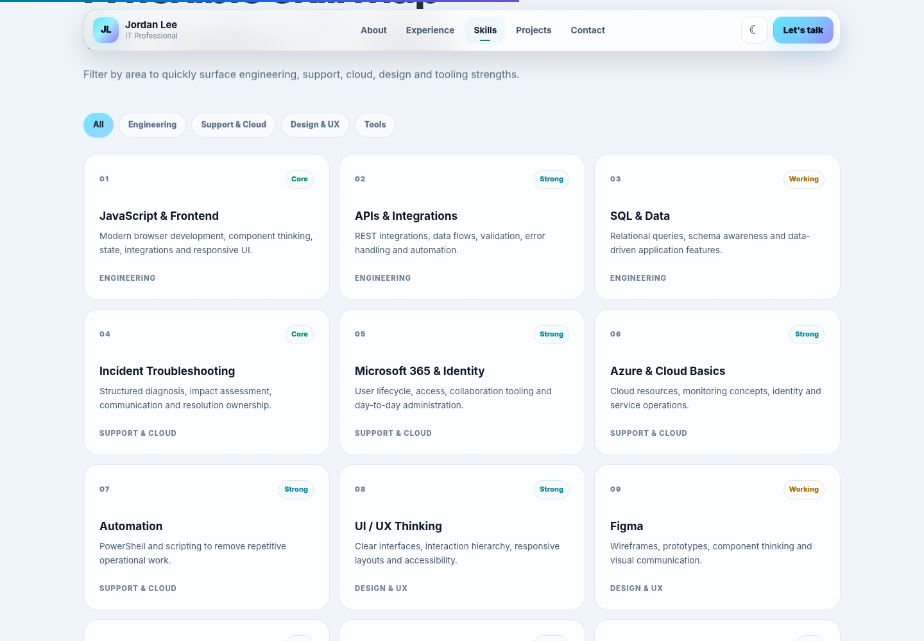

6. Step 5 - Add your photo, resume and project images

Profile photo
1 | Copy your photo into assets  Example filename: profile.jpg. A portrait image around 900 × 1100 px works well.

2 | Update config.js  Set profileImage: "assets/profile.jpg". If you leave it blank, the initials design remains.

Resume download
1 | Prepare your resume as PDF  Use a clear filename and remove sensitive information you do not want publicly available.

2 | Replace assets/resume.pdf  Delete the sample placeholder and copy your own PDF into assets using the same filename.

3 | Test the footer download button  Click the download icon after refreshing the local preview.

Project images
WebP is recommended for screenshots because it is usually smaller than PNG. Keep screenshots consistent in aspect ratio and compress large files before upload.
Everything in a GitHub Pages repository is public
Do not upload confidential screenshots, customer data, API keys, passwords, internal URLs or documents you do not have permission to publish.

7. Step 6 - Configure EmailJS for the contact form
The contact form is already coded for EmailJS. Without EmailJS configuration, the rest of the portfolio still works and the form displays a setup reminder instead of failing.

Create the EmailJS connection
1 | Create or sign in to an EmailJS account  Use the EmailJS dashboard in your browser.

2 | Add an Email Service  Connect the email mailbox that should receive portfolio enquiries.

3 | Create an Email Template  Create a template for messages sent from this portfolio.

8. EmailJS template and configuration

Recommended template variables
Configure your EmailJS template to use these variables. The portfolio sends all of them automatically:
{{from_name}}
{{from_email}}
{{reply_to}}
{{subject}}
{{message}}
{{to_name}}

A simple template body can be:
New portfolio enquiry
Name: {{from_name}}
Email: {{from_email}}
Subject: {{subject}}
Message:
{{message}}

Set Reply-To in EmailJS to {{reply_to}} so replying to the received message goes to the visitor.

Copy your EmailJS IDs into config.js
emailjs: {
serviceId: "service_xxxxx",
templateId: "template_xxxxx",
publicKey: "xxxxxxxxxxxxxxxx"
}

These EmailJS identifiers are used in the browser
A static portfolio has no private server environment. EmailJS is specifically designed for browser use, but you should still configure EmailJS security controls such as allowed origins/domains and rate limits where available.

Test EmailJS locally
1 | Run the local server  Use py -m http.server 5500 and open http://localhost:5500.

2 | Submit a real test message  Use an email address you can check.

3 | Confirm receipt and Reply-To  Open the received message and verify that replying targets the address entered in the portfolio form.

4 | Test the failure state  Temporarily disconnect the network or use an incorrect ID to confirm that a readable error is shown.

9. Step 7 - Final local checks before GitHub
- Hero text, location and rotating roles are correct.
- About section contains your own wording.
- Experience dates and achievements are accurate.
- Skill filters show the expected categories.
- Project filters and project detail pop-up work.
- Live/source project links open the correct destinations.
- Dark/light theme switch works.
- Mobile menu opens and closes.
- Resume download opens your own PDF.
- LinkedIn and GitHub icons point to your profiles.
- Contact form sends through EmailJS, or you have intentionally left it unconfigured.
- No private or confidential information is present.
Mobile navigation preview
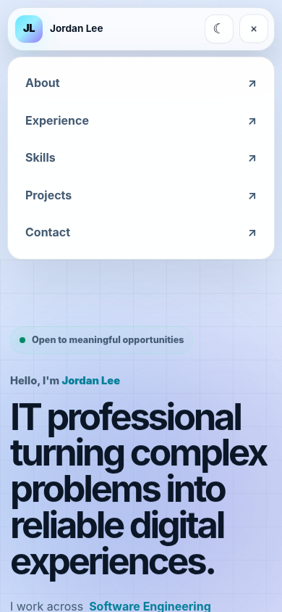

10. Step 8 - Create the GitHub repository
1 | Sign in to GitHub  Open github.com and sign in to the account that will own the portfolio.

2 | Create a new repository  Click New repository. Choose a simple name such as my-portfolio or yourname-portfolio.

3 | Choose Public  GitHub Pages on standard personal accounts is commonly used with a public repository. Remember that all files will be visible.

4 | Do not initialize with unrelated starter files  The downloaded portfolio already contains the required files. Creating an empty repository keeps the upload simple.

5 | Create repository  GitHub will display the new empty repository page.

Option A - Upload using the GitHub website
1 | Choose Add file → Upload files  Drag the contents of the extracted portfolio folder into the upload area. Upload the files themselves, not an extra outer folder.

2 | Check the root structure  index.html must appear at the repository root alongside styles.css, config.js and app.js.

3 | Commit the upload  Use a message such as Initial portfolio setup and commit to the main branch.

Option B - Upload using Git
git init
git add .
git commit -m "Initial portfolio setup"
git branch -M main
git remote add origin https://github.com/YOUR-USERNAME/YOUR-REPOSITORY.git
git push -u origin main

11. Step 9 - Enable GitHub Pages
1 | Open repository Settings  Use the Settings tab inside the portfolio repository.

2 | Open Pages  In the left settings menu, choose Pages.

3 | Choose Deploy from a branch  Under Build and deployment, set Source to Deploy from a branch.

4 | Choose main and /(root)  Select branch main, folder /(root), then click Save.

5 | Wait for deployment  GitHub may take a few minutes to publish the first version. Refresh the Pages settings screen until the site URL appears.

6 | Open the published URL  A project repository normally uses a URL similar to https://USERNAME.github.io/REPOSITORY-NAME/.

No repository-name setting is required
This template uses ordinary relative files and no framework build step, so the same source works from GitHub Pages repository subpaths without changing a Vite/React base path.

After the site is live
If you use EmailJS, add the final GitHub Pages URL to the allowed origins/domains in your EmailJS security settings if that control is available in your account. Then send another test message from the live site.

12. Updating the portfolio later
Edit config.js, replace assets or update other files, then commit the change to the main branch. GitHub Pages republishes the updated static files automatically after the commit reaches the repository.

13. Troubleshooting
Problem | What to check
The page is blank | Check that config.js and app.js are in the same folder as index.html. Open the browser console and look for JavaScript errors.
Styles are missing | Confirm styles.css is in the repository root and has not been renamed.
Profile photo does not appear | Check the exact filename, extension and letter casing in assets and config.js. GitHub is case-sensitive.
Resume returns 404 | Confirm assets/resume.pdf exists and resumeFile in config.js matches it exactly.
Contact form says EmailJS is not configured | Replace YOUR_SERVICE_ID, YOUR_TEMPLATE_ID and YOUR_PUBLIC_KEY in config.js.
EmailJS works locally but not on GitHub Pages | Check EmailJS allowed origins/domains and add your final GitHub Pages address.
GitHub Pages shows a 404 | Confirm Pages is set to main + /(root), and index.html is at the repository root.
Changes do not appear immediately | Wait a minute, hard-refresh the browser, and confirm the latest commit reached main.
Mobile menu looks wrong after heavy CSS edits | Restore styles.css from the original download and reapply your changes carefully.

14. Quick customization reference
- Main content: config.js
- Profile photo: assets/profile.jpg (or your chosen filename)
- Resume: assets/resume.pdf
- Project screenshots: assets/... and each project image field
- Colours/layout: styles.css
- EmailJS IDs: config.js → emailjs
- Deployment: GitHub repository → Settings → Pages → main → /(root)
Before sharing the final portfolio
Open it on both desktop and mobile, click every link, download the resume, test the contact form and review the repository for anything private. A portfolio is part of your professional identity, so publish only content you are comfortable making public.

Laxhya • Let's Think New

