Retail Schema Design Use Case
Normalized database design, SQL DDL versioning, AI validation, and early DataOps discipline

1. Use Case Overview
This use case demonstrates how a retail business should represent orders, customers, products, stores, and categories in a reliable normalized relational structure before data is moved into analytics layers such as a data warehouse, lakehouse, or reporting layer.
Item | Description
Real-world illustration | Design how retail orders, customers, products, and stores should be represented in a reliable relational structure before analytics layers.
Hands-on | Design a normalized retail schema, store SQL/DDL in versioned folders, and use Claude to validate relationships and suggest improvements.
Outcome | Understand database design principles and use AI to improve schema quality with early DataOps discipline.

2. Business Scenario
A retail company sells products through physical stores and online channels. Customers place orders for multiple products, and each order must be tracked accurately. Before the data flows into analytics, the company wants a clean relational design that avoids duplicate data, enforces relationships, and supports reliable reporting.
Problem | Example
Duplicate customer data | Same customer repeated across multiple order rows.
Product inconsistency | Same product name written differently in different files.
Poor order tracking | Order header and product line details mixed in one table.
No relationship clarity | Difficult to identify which customer bought which product from which store.
Analytics errors | Reports may show incorrect sales, revenue, customer count, or store performance.

3. Normalized Retail Schema Diagram
The recommended design separates master data and transaction data. Orders store order-level information, while order_items stores product-level details within each order.
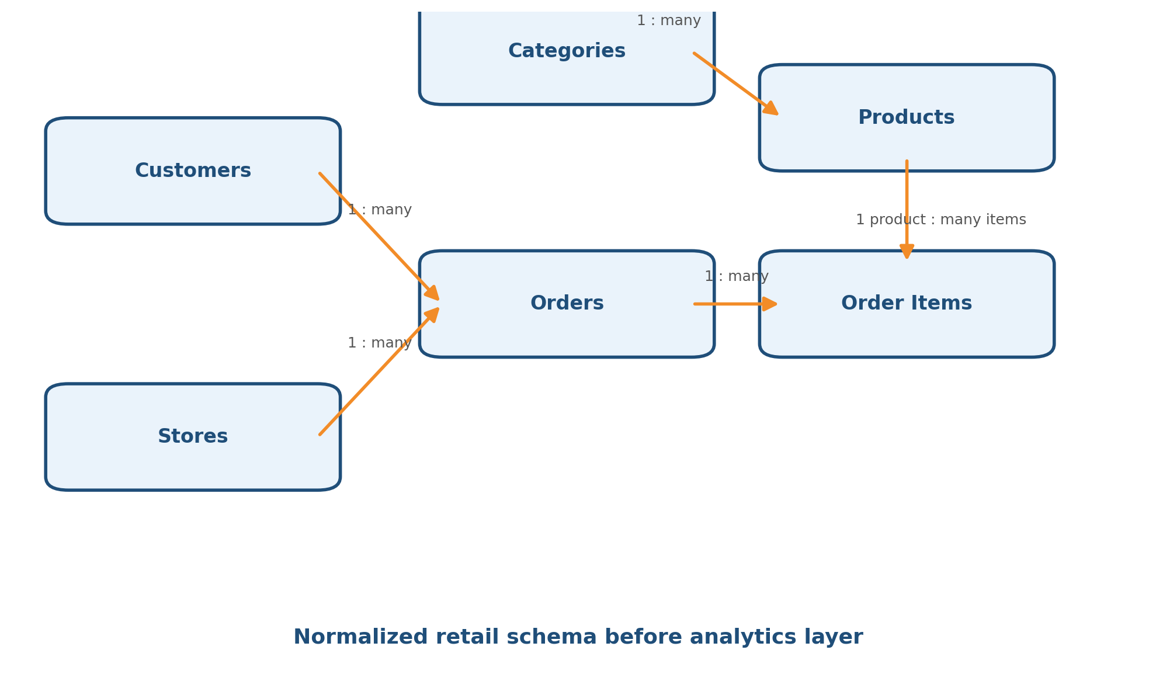

4. Tables and Relationships
Entity | Purpose | Key Relationship
customers | Stores unique customer details. | One customer can place many orders.
stores | Stores store or channel information. | One store can receive many orders.
categories | Stores product category master data. | One category can have many products.
products | Stores product master data. | One product can appear in many order items.
orders | Stores order header details. | Each order belongs to one customer and one store.
order_items | Stores product-level order details. | Each order can have many order items.

5. Normalization Principles
Normal Form | Meaning | Retail Example
1NF | Columns should contain atomic values. | Do not store multiple products in one order column. Use order_items.
2NF | Non-key columns should depend on the full key. | Product name should be in products, not repeated in order_items.
3NF | Non-key columns should not depend on other non-key columns. | Category name should be in categories, not repeated in products.

6. SQL DDL Scripts

6.1 customers
CREATE TABLE customers (
customer_id INT PRIMARY KEY,
first_name VARCHAR(100) NOT NULL,
last_name VARCHAR(100),
email VARCHAR(150) UNIQUE,
phone VARCHAR(20),
created_at TIMESTAMP DEFAULT CURRENT_TIMESTAMP
);

6.2 stores
CREATE TABLE stores (
store_id INT PRIMARY KEY,
store_name VARCHAR(150) NOT NULL,
city VARCHAR(100) NOT NULL,
state VARCHAR(100),
country VARCHAR(100),
store_type VARCHAR(50),
opened_date DATE
);

6.3 categories
CREATE TABLE categories (
category_id INT PRIMARY KEY,
category_name VARCHAR(100) NOT NULL UNIQUE,
description VARCHAR(255)
);

6.4 products
CREATE TABLE products (
product_id INT PRIMARY KEY,
product_name VARCHAR(150) NOT NULL,
category_id INT NOT NULL,
sku VARCHAR(100) UNIQUE NOT NULL,
unit_price DECIMAL(10,2) NOT NULL,
is_active BOOLEAN DEFAULT TRUE,
CONSTRAINT fk_products_category
FOREIGN KEY (category_id) REFERENCES categories(category_id)
);

6.5 orders
CREATE TABLE orders (
order_id INT PRIMARY KEY,
customer_id INT NOT NULL,
store_id INT NOT NULL,
order_date TIMESTAMP NOT NULL,
order_status VARCHAR(50) NOT NULL,
payment_method VARCHAR(50),
total_amount DECIMAL(12,2),
CONSTRAINT fk_orders_customer
FOREIGN KEY (customer_id) REFERENCES customers(customer_id),
CONSTRAINT fk_orders_store
FOREIGN KEY (store_id) REFERENCES stores(store_id)
);

6.6 order_items
CREATE TABLE order_items (
order_item_id INT PRIMARY KEY,
order_id INT NOT NULL,
product_id INT NOT NULL,
quantity INT NOT NULL,
unit_price DECIMAL(10,2) NOT NULL,
discount_amount DECIMAL(10,2) DEFAULT 0,
line_total DECIMAL(12,2) NOT NULL,
CONSTRAINT fk_order_items_order
FOREIGN KEY (order_id) REFERENCES orders(order_id),
CONSTRAINT fk_order_items_product
FOREIGN KEY (product_id) REFERENCES products(product_id),
CONSTRAINT chk_order_items_quantity CHECK (quantity > 0)
);

7. Versioned Folder Structure for DataOps
Store SQL scripts in versioned folders so schema changes can be tracked, reviewed, and promoted safely across environments.
retail-schema-project/
|
|-- README.md
|
|-- database/
| |-- ddl/
| | |-- v001_create_customers.sql
| | |-- v002_create_stores.sql
| | |-- v003_create_categories.sql
| | |-- v004_create_products.sql
| | |-- v005_create_orders.sql
| | |-- v006_create_order_items.sql
| |
| |-- seed/
| | |-- v001_insert_sample_customers.sql
| | |-- v002_insert_sample_stores.sql
| | |-- v003_insert_sample_products.sql
| | |-- v004_insert_sample_orders.sql
| |
| |-- validation/
| |-- check_duplicate_customers.sql
| |-- check_orphan_orders.sql
| |-- check_invalid_order_items.sql
| |-- check_total_amount_mismatch.sql
|
|-- docs/
| |-- er_diagram.png
| |-- schema_design_notes.md
| |-- claude_review_notes.md
|
|-- changelog/
|-- schema_change_log.md

8. Sample Seed Data
INSERT INTO customers (customer_id, first_name, last_name, email, phone)
VALUES
(1, 'Ravi', 'Kumar', 'ravi.kumar@example.com', '9876543210'),
(2, 'Priya', 'Sharma', 'priya.sharma@example.com', '9876500001');
INSERT INTO stores (store_id, store_name, city, state, country, store_type, opened_date)
VALUES
(101, 'Bangalore Indiranagar Store', 'Bangalore', 'Karnataka', 'India', 'Physical', '2020-01-15'),
(102, 'Online Store', 'Bangalore', 'Karnataka', 'India', 'Online', '2021-05-10');
INSERT INTO categories (category_id, category_name, description)
VALUES
(10, 'Accessories', 'Computer and mobile accessories'),
(20, 'Electronics', 'Electronic devices');
INSERT INTO products (product_id, product_name, category_id, sku, unit_price)
VALUES
(501, 'Laptop Bag', 10, 'SKU-LB-001', 1500.00),
(502, 'Wireless Mouse', 10, 'SKU-WM-002', 700.00);
INSERT INTO orders (order_id, customer_id, store_id, order_date, order_status, payment_method, total_amount)
VALUES
(1001, 1, 101, '2026-06-10 10:30:00', 'PAID', 'UPI', 2900.00);
INSERT INTO order_items (order_item_id, order_id, product_id, quantity, unit_price, discount_amount, line_total)
VALUES
(1, 1001, 501, 1, 1500.00, 0.00, 1500.00),
(2, 1001, 502, 2, 700.00, 0.00, 1400.00);

9. Validation Queries

Check orders without valid customers
SELECT o.order_id
FROM orders o
LEFT JOIN customers c ON o.customer_id = c.customer_id
WHERE c.customer_id IS NULL;
Expected result: No rows.

Check order items without valid products
SELECT oi.order_item_id, oi.product_id
FROM order_items oi
LEFT JOIN products p ON oi.product_id = p.product_id
WHERE p.product_id IS NULL;
Expected result: No rows.

Validate order total
SELECT o.order_id,
o.total_amount AS order_total,
SUM(oi.line_total) AS calculated_total
FROM orders o
JOIN order_items oi ON o.order_id = oi.order_id
GROUP BY o.order_id, o.total_amount
HAVING o.total_amount <> SUM(oi.line_total);
Expected result: No rows.

Check duplicate customer emails
SELECT email, COUNT(*) AS duplicate_count
FROM customers
WHERE email IS NOT NULL
GROUP BY email
HAVING COUNT(*) > 1;
Expected result: No rows.

10. Claude Prompt for Schema Validation
Act as a senior data architect and database design reviewer.
I am designing a normalized relational schema for a retail business.
Entities:
- customers
- stores
- categories
- products
- orders
- order_items
Please review the following DDL for:
1. Normalization issues
2. Missing primary keys
3. Missing foreign keys
4. Incorrect relationships
5. Data type improvements
6. Naming convention improvements
7. Missing constraints
8. Analytics-readiness
9. Data quality risks
10. Suggestions for future data warehouse migration
DDL:
[paste SQL DDL here]
Give your review in this format:
- Overall assessment
- Table-wise feedback
- Relationship issues
- Constraint improvements
- Recommended changes
- Final improved DDL

11. Expected AI Review Suggestions
Area | Possible Suggestion
Surrogate keys | Use generated identity columns where appropriate.
Audit columns | Add created_at, updated_at, and created_by.
Soft delete | Add is_active flag for master data.
Data validation | Add check constraints for amount and quantity.
Naming | Use consistent snake_case naming.
Lookup tables | Create order_status and payment_methods lookup tables.
Analytics readiness | Add indexes on foreign keys and date columns.
Data quality | Validate totals and orphan records using SQL checks.

12. Analytics Layer Mapping
Relational Table | Analytics Layer Usage
customers | Customer dimension
stores | Store dimension
products | Product dimension
categories | Product category dimension
orders | Sales fact header
order_items | Sales fact detail

13. Hands-On Exercise Plan
Step | Task | Expected Output
1 | Create project folder structure. | Versioned retail-schema-project repository.
2 | Create DDL files for each table. | SQL files under database/ddl.
3 | Add primary keys and foreign keys. | Validated relational structure.
4 | Insert sample data. | Seed scripts under database/seed.
5 | Run validation SQL. | No orphan records, duplicate emails, or total mismatches.
6 | Paste DDL into Claude for review. | Claude review notes with improvement suggestions.
7 | Improve schema and document changes. | Updated DDL and changelog.

14. Learning Outcomes
Outcome | Description
Understand normalization | Apply 1NF, 2NF, and 3NF to retail transactional data.
Create reliable relationships | Use primary keys and foreign keys correctly.
Avoid duplicate data | Separate master data from transaction data.
Prepare analytics-ready data | Understand how OLTP tables feed analytics layers.
Practice DataOps discipline | Store SQL scripts in versioned folders with changelog.
Use AI effectively | Use Claude to review schema quality and suggest improvements.

15. Final Interview-Style Explanation
In this use case, we design a normalized retail database structure before moving data into analytics layers. Customers, stores, products, categories, orders, and order items are separated into relational tables. Primary keys and foreign keys ensure data integrity. Orders store transaction-level information, while order_items stores product-level order details. This avoids duplication and improves data quality. SQL DDL scripts are stored in versioned folders to introduce DataOps discipline. Claude is used as an AI reviewer to validate relationships, suggest constraints, improve naming, and make the schema more analytics-ready.

