Webapp before fixing alignment UI issues
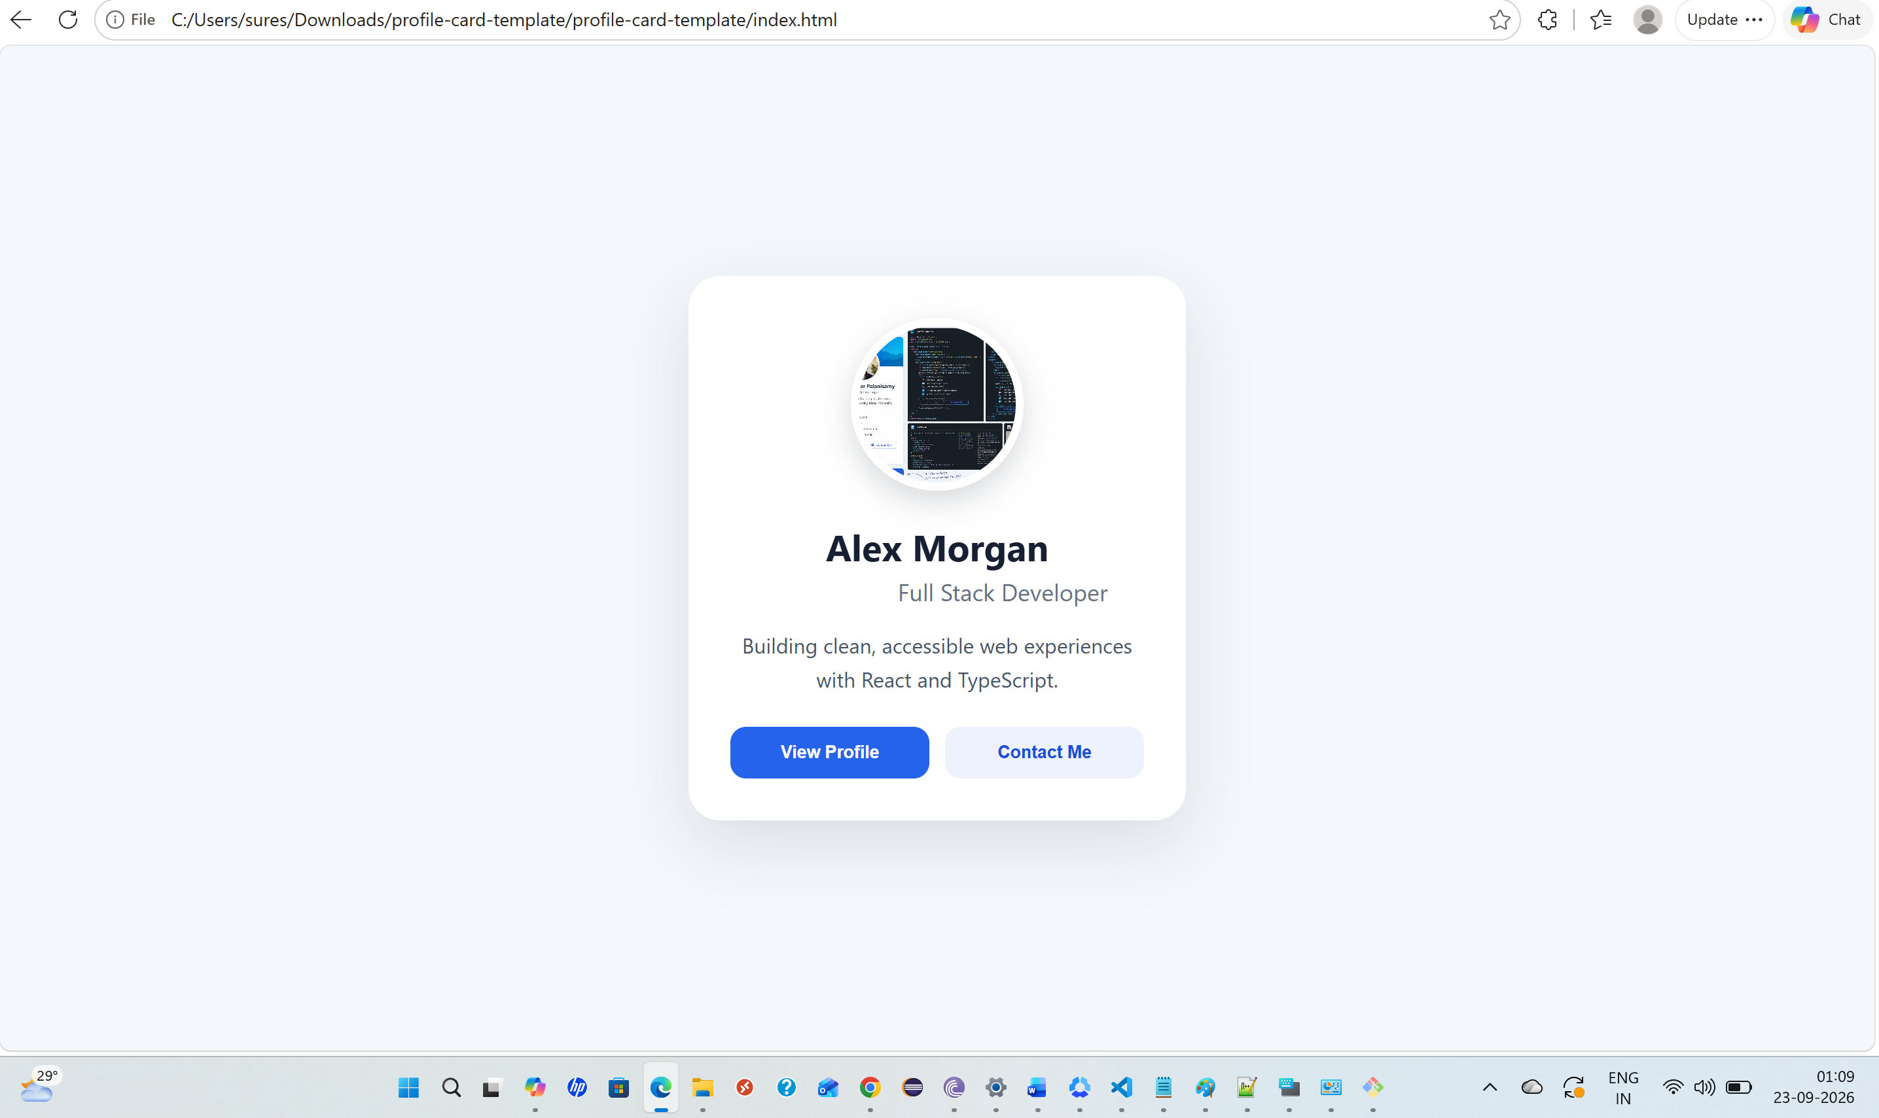

Webapp after fixing alignment UI issues using Astra

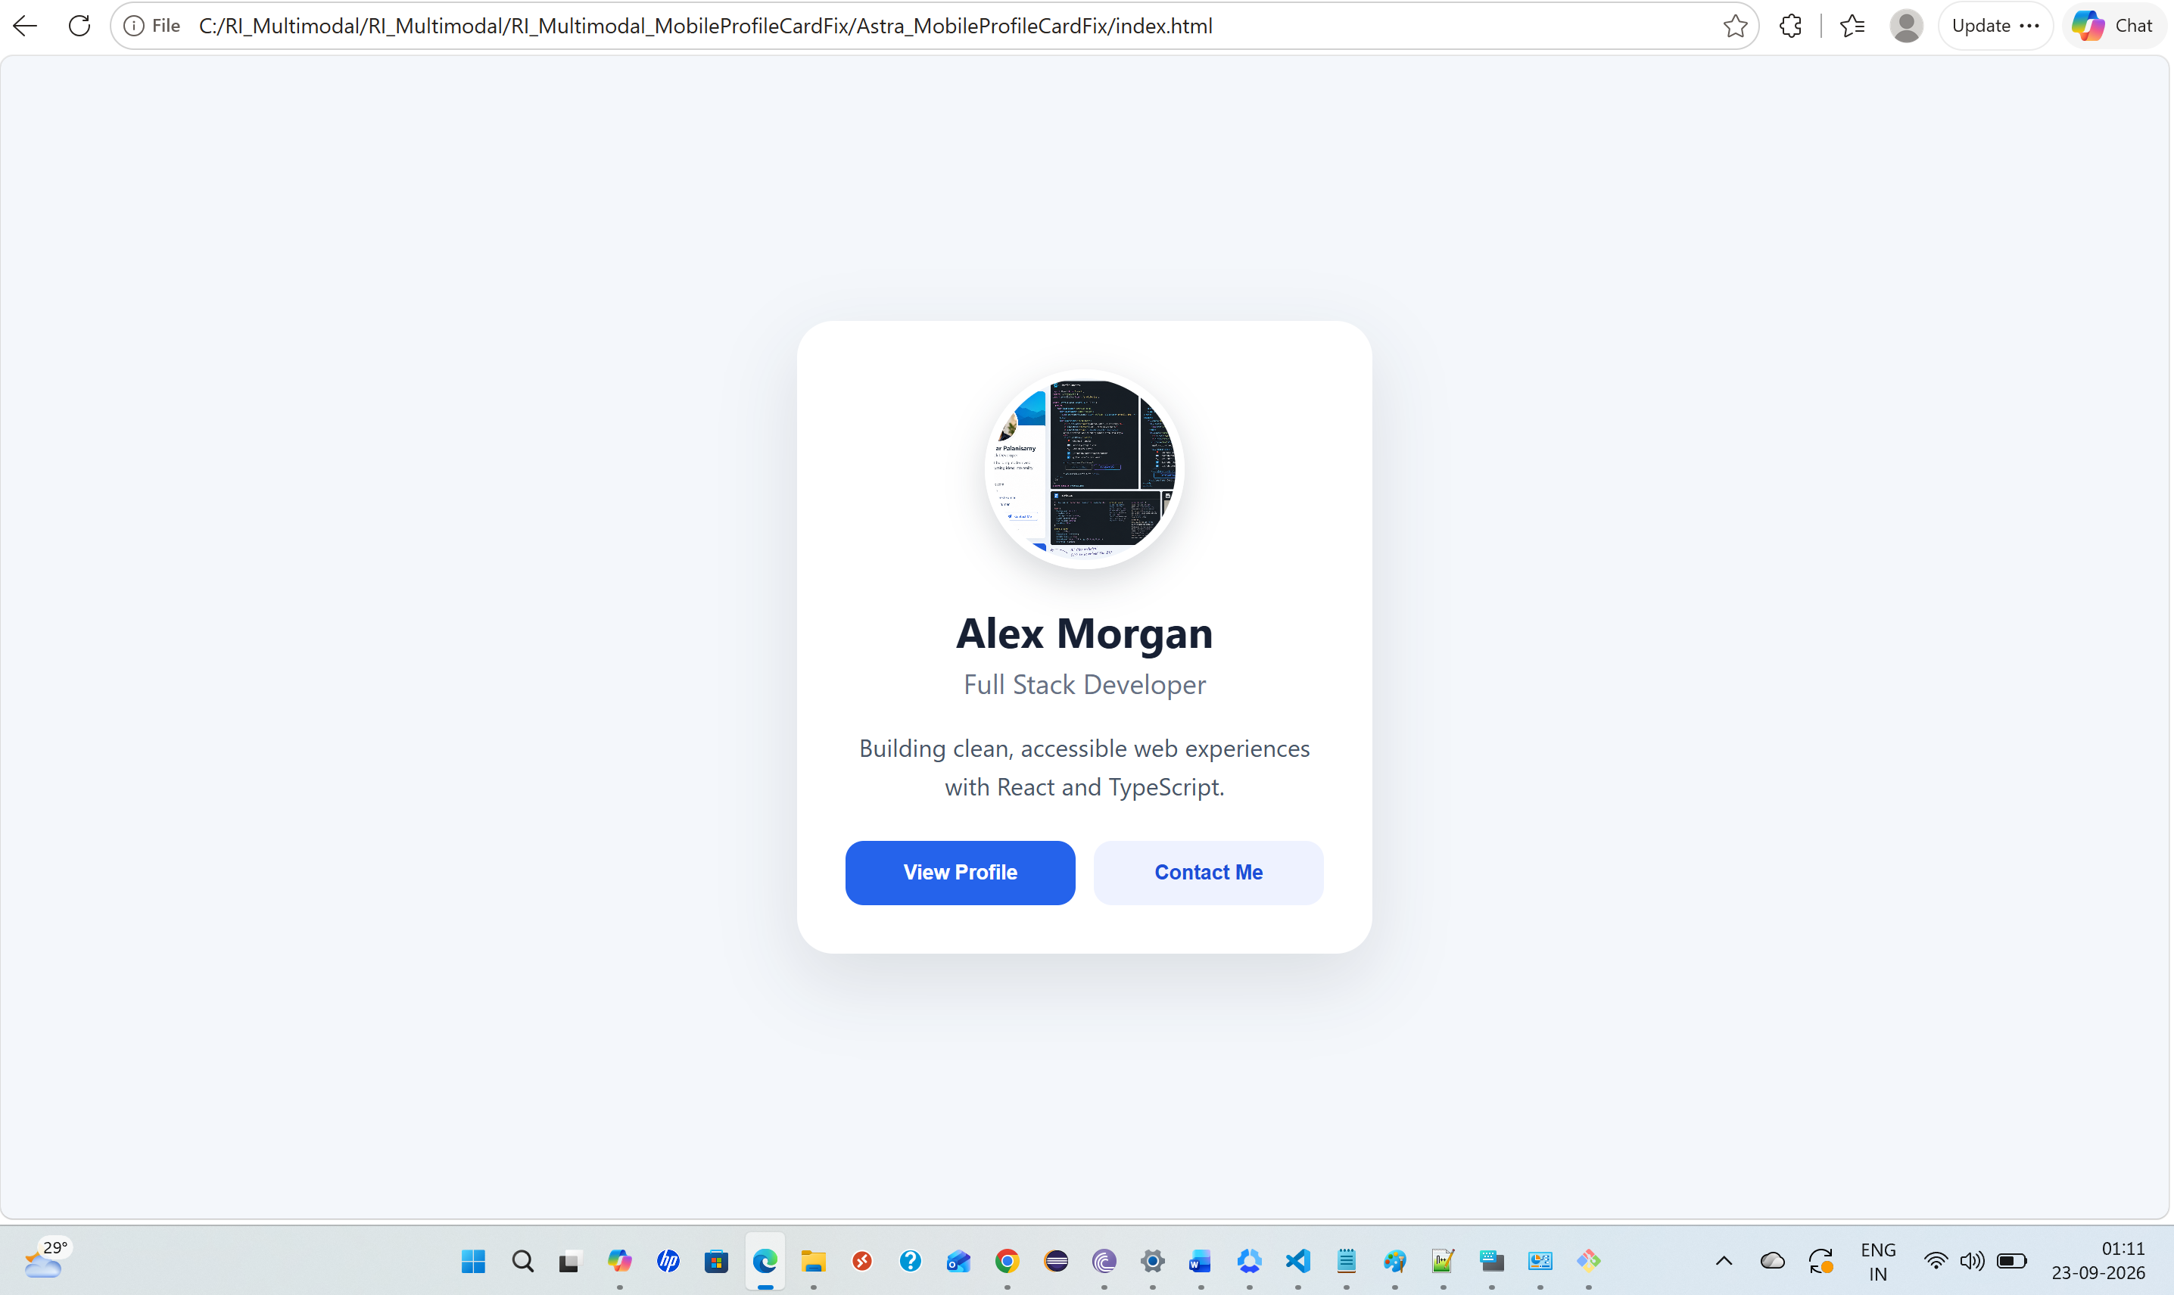

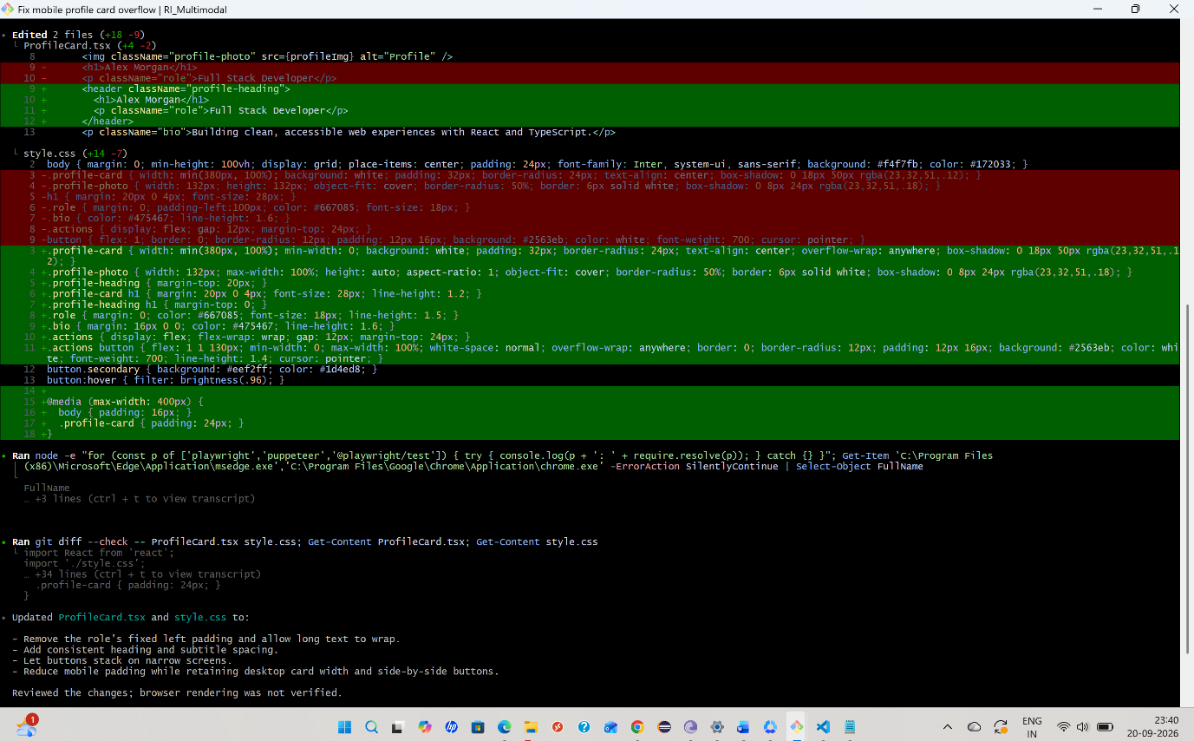

Astra session JSON file

Webapp after fixing alignment UI issues using Gemini flash

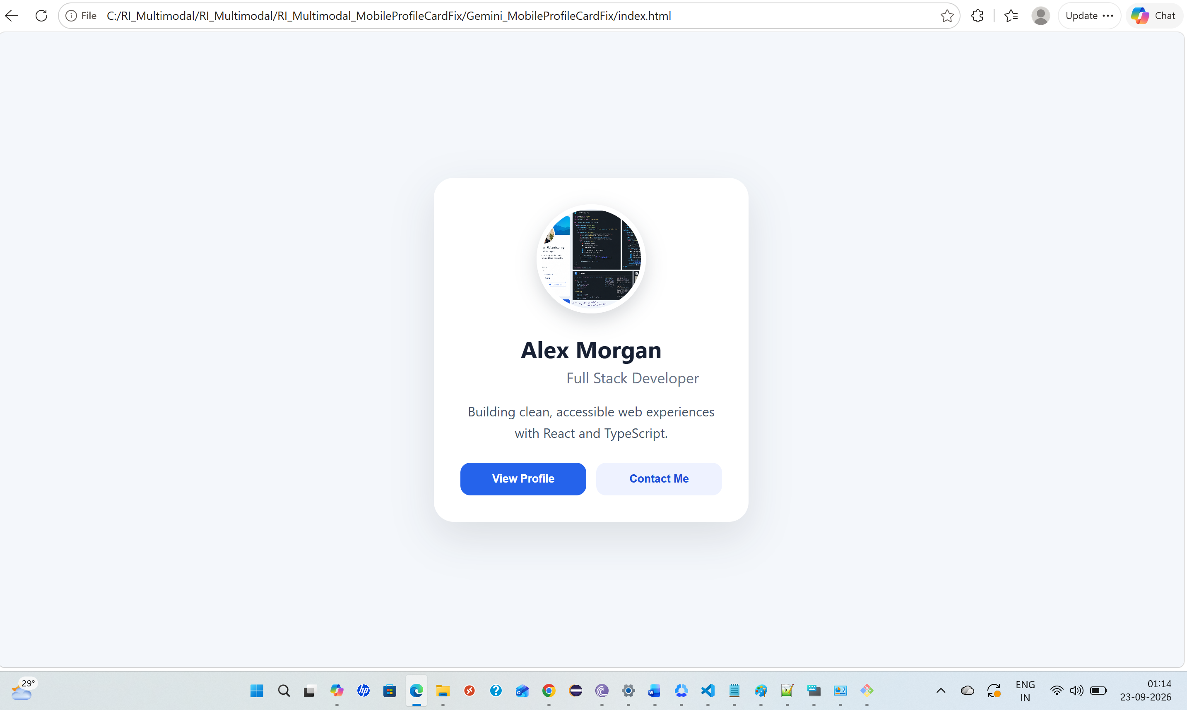

Gemini flash session transcript json file

