Webapp before fixing alignment UI issues
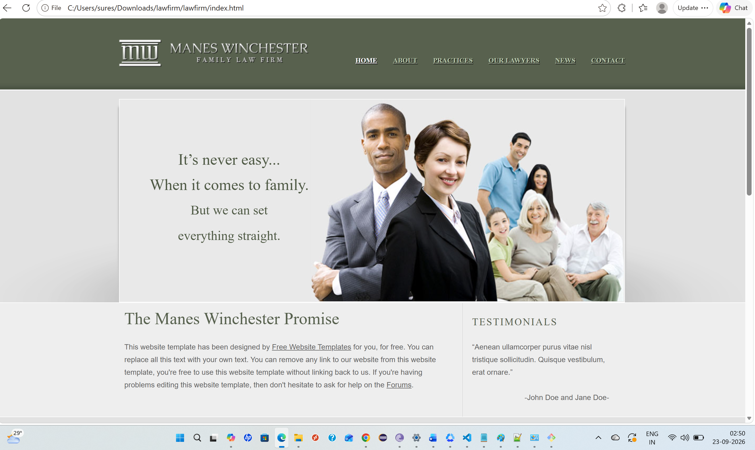

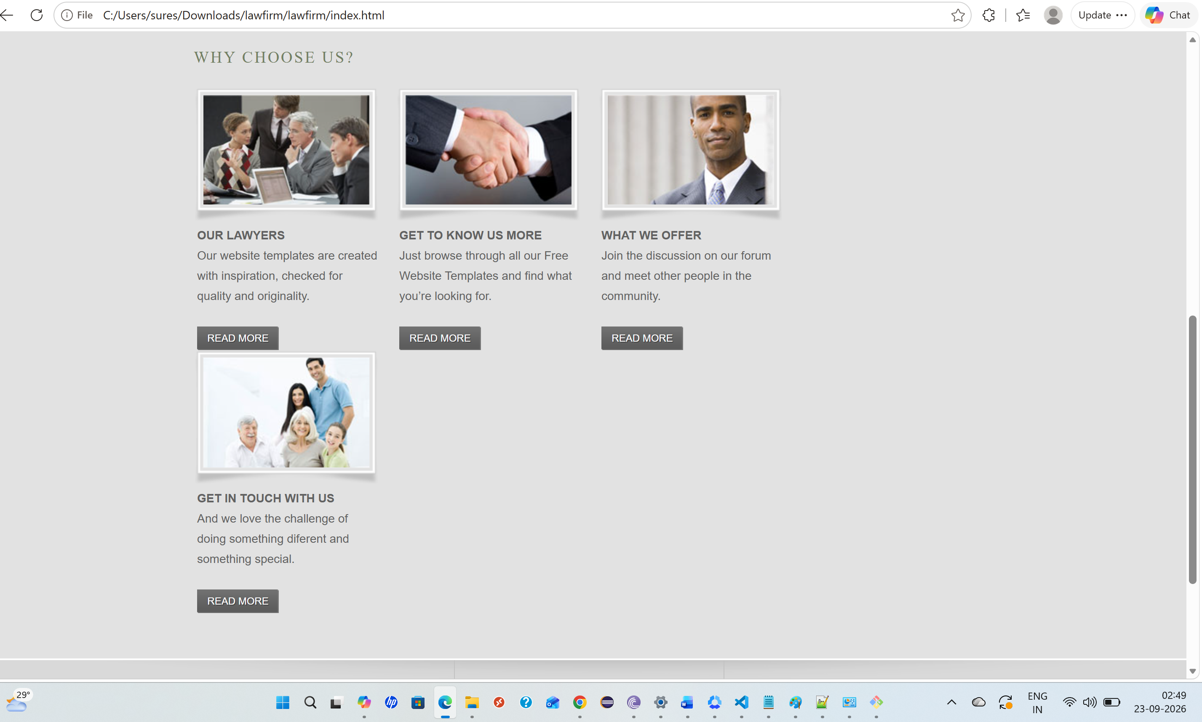

Prompt - Fix the responsive/mobile layout of this law-firm website.

Webapp after fixing alignment UI issues using Astra

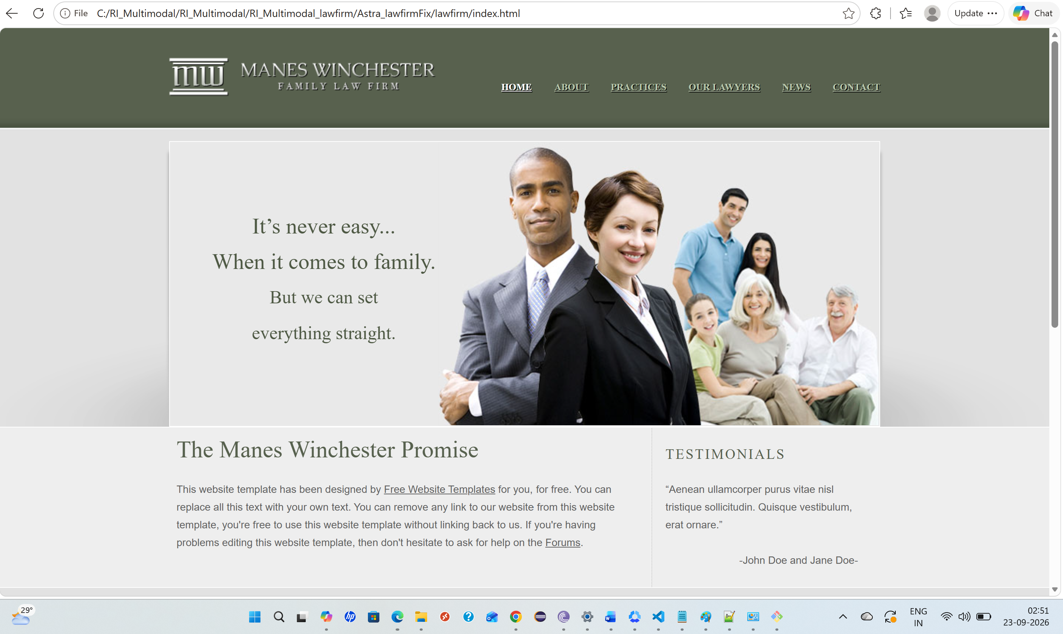

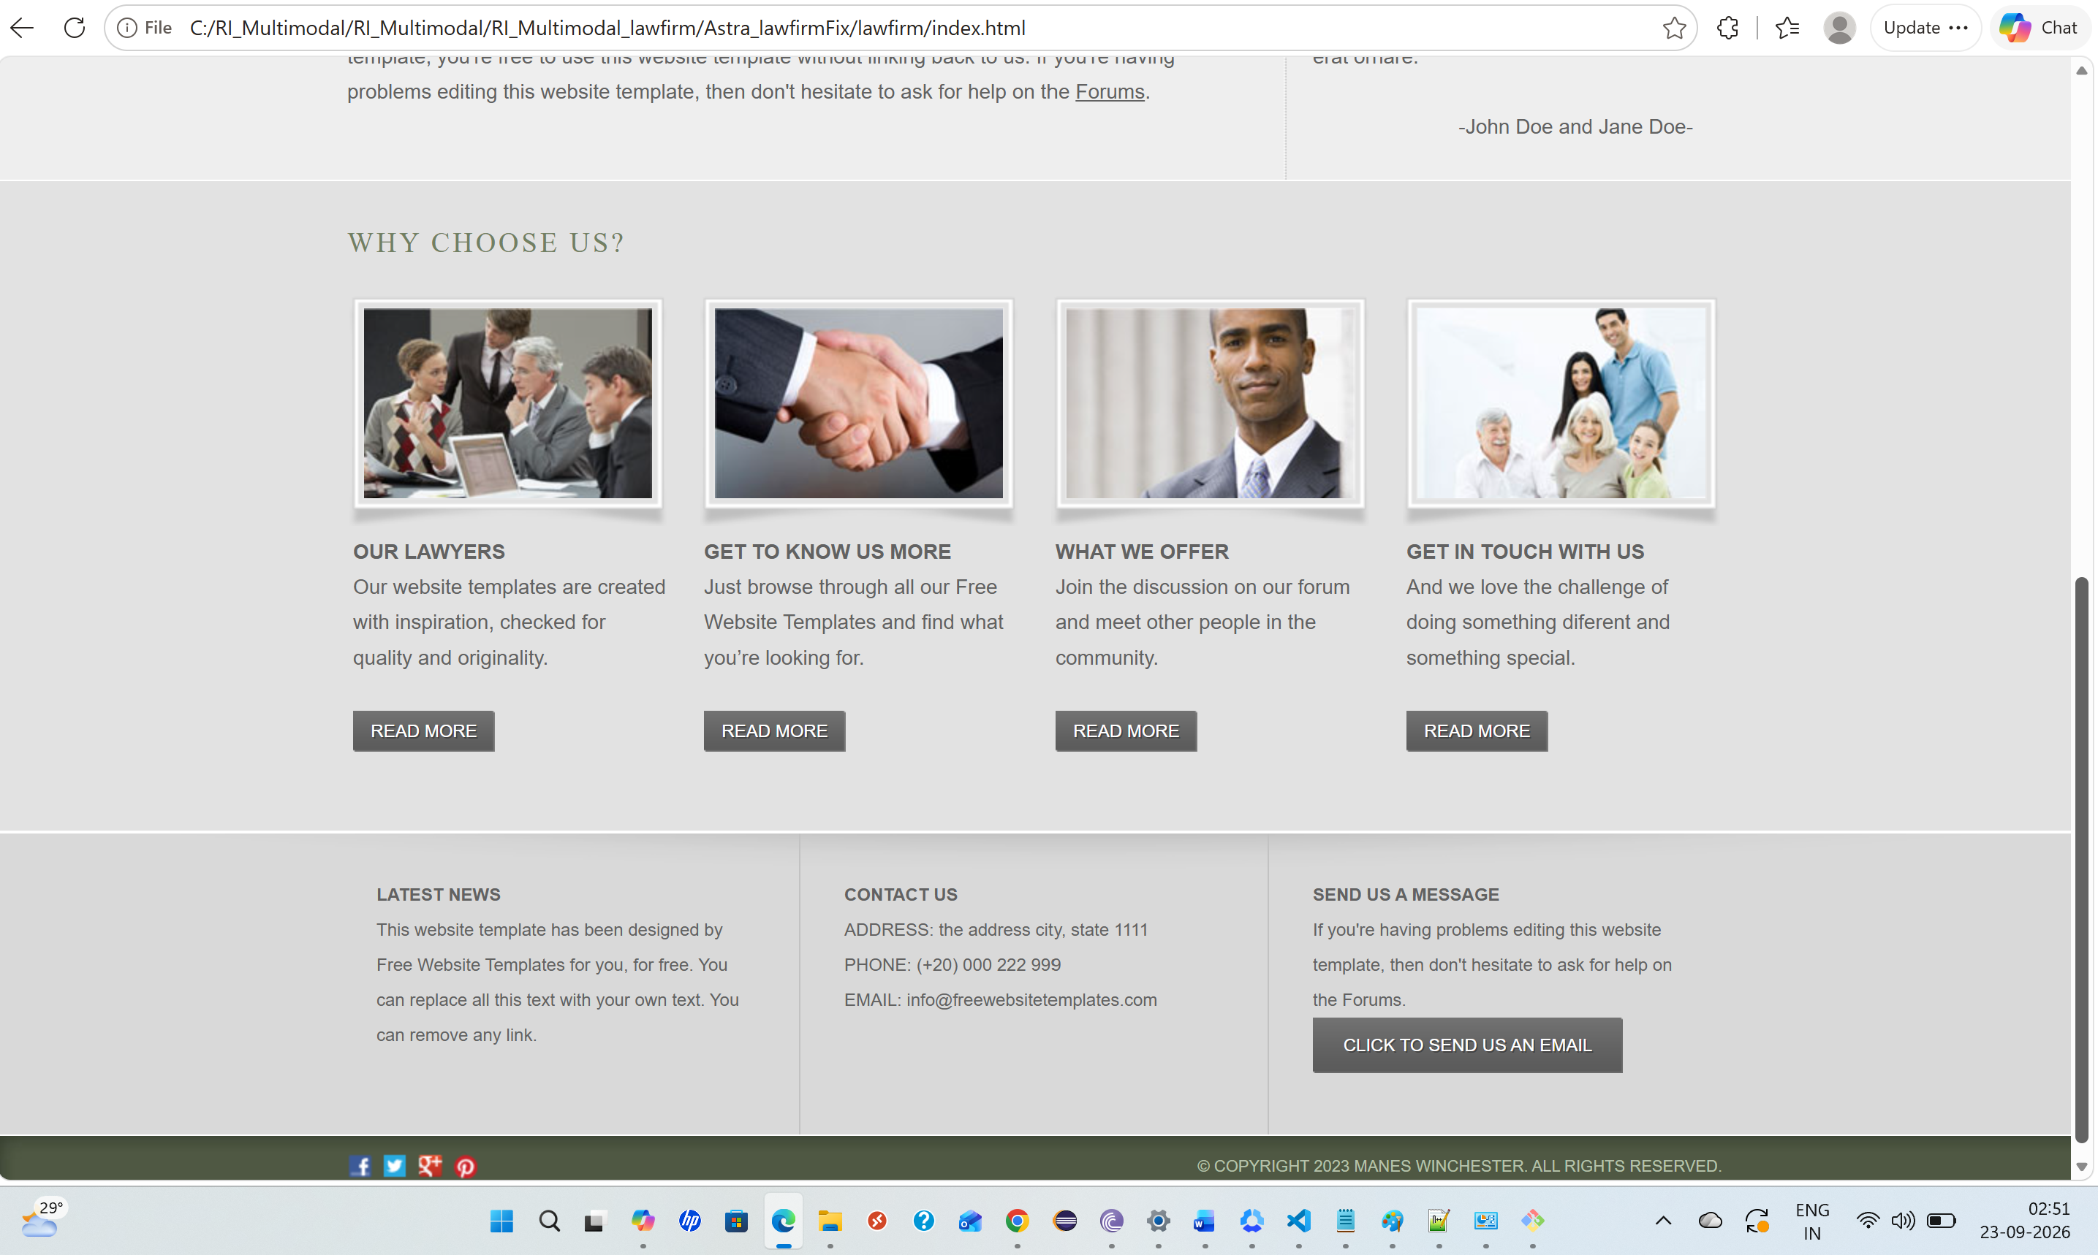

Astra session JSON file

Webapp after fixing alignment UI issues using Gemini flash

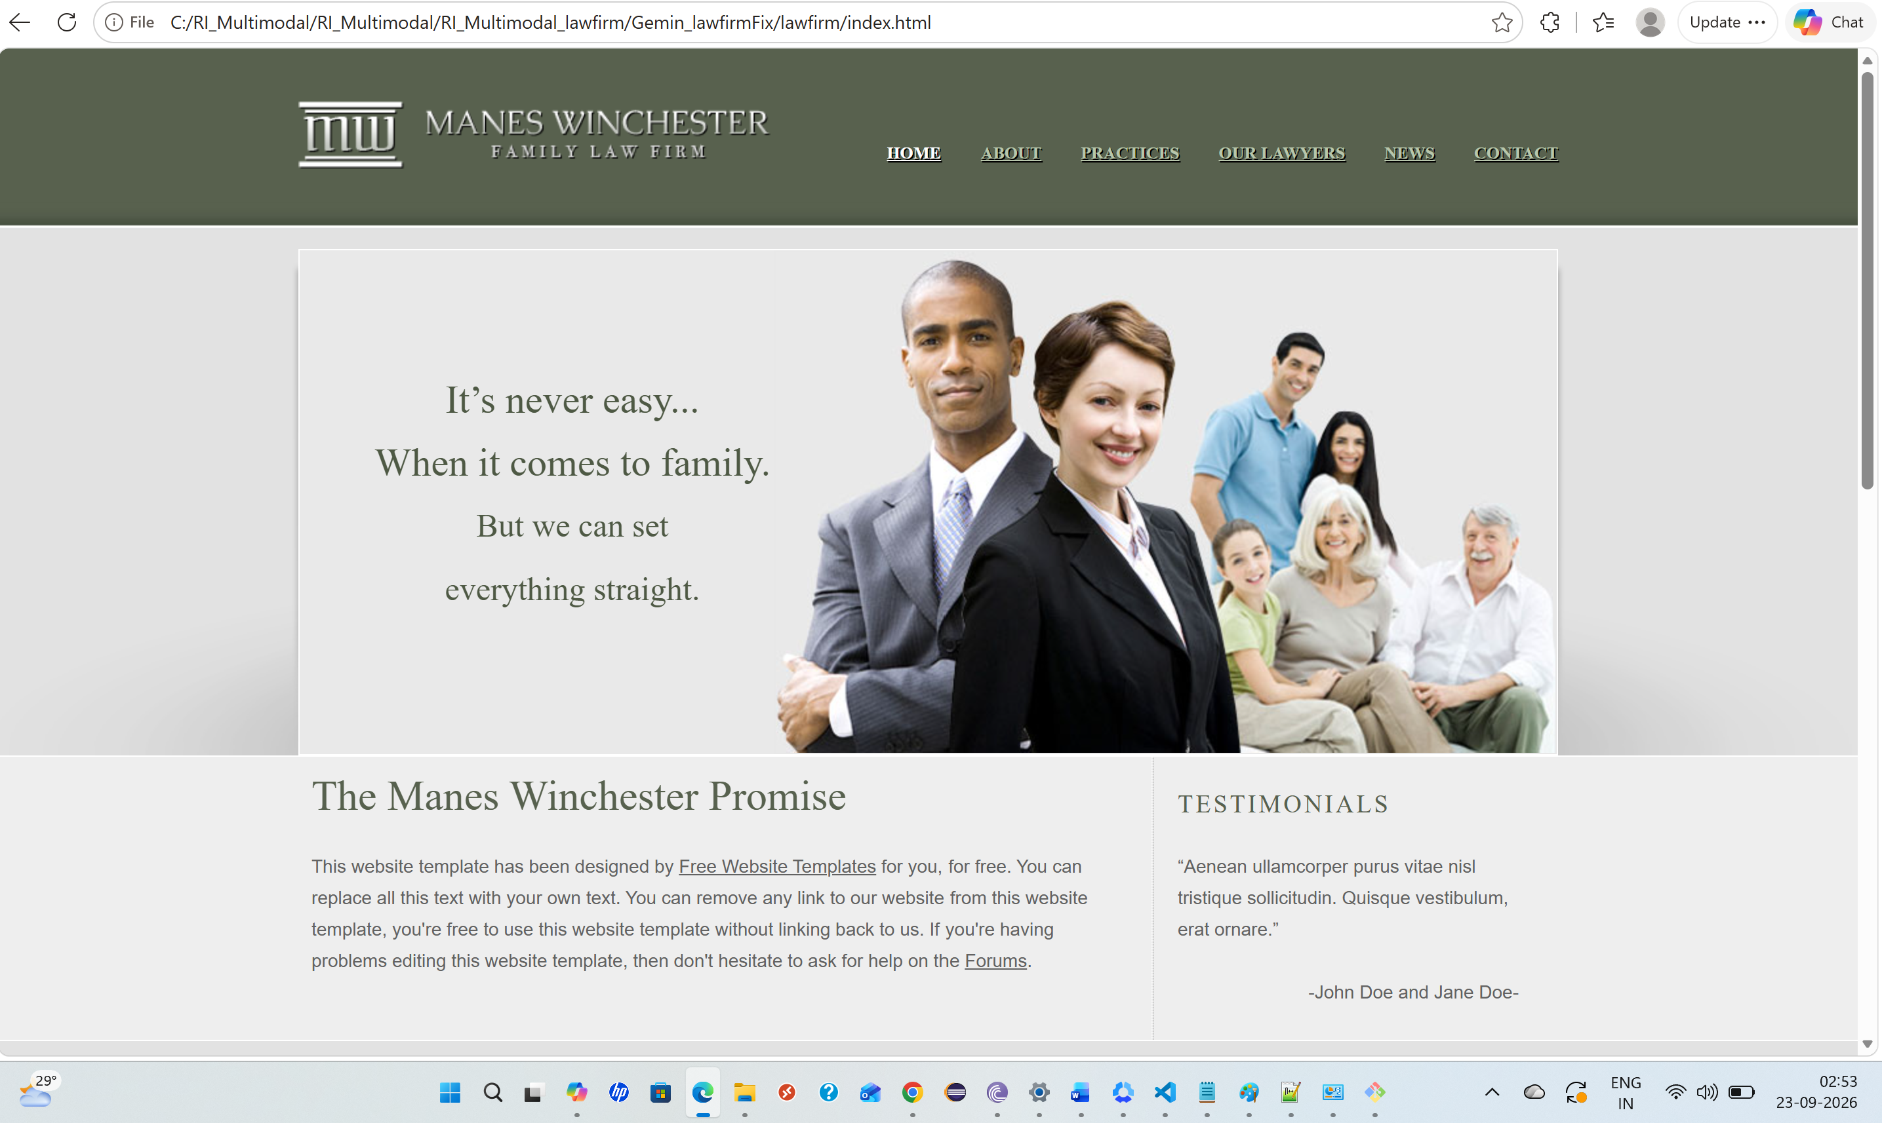

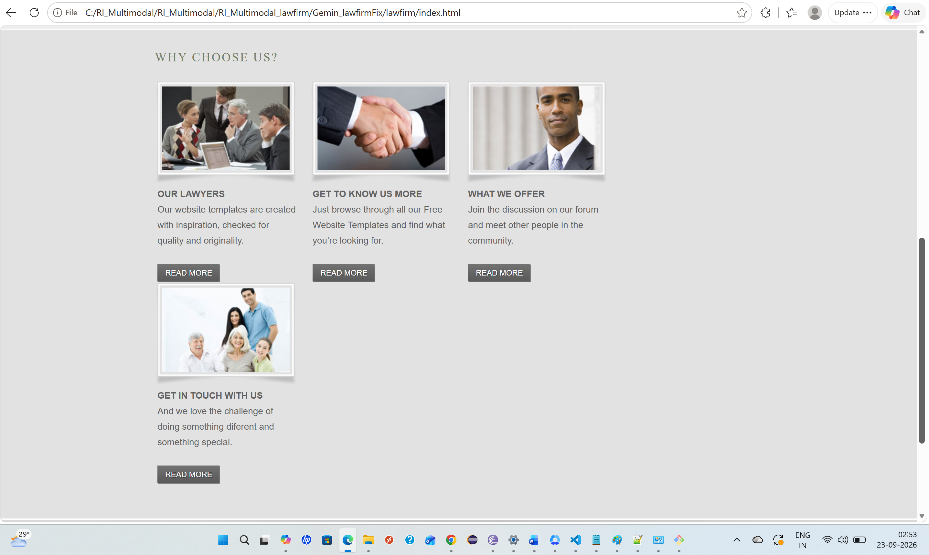

Gemini flash session transcript json file

