1. Client and server on same network:

When the client and server are on the same network, the response time is very short because the client and server clocks are almost in sync. This is likely because they both rely on the same NTP server to synchronize their time and experience similar delays in receiving packets.

1. Server running on cloud

When the client is operating on the local machine and the server is hosted in the Google Cloud, we observe a higher level of delay and offset compared to the previous scenario. This can be attributed the network latency in retrieving the outcome is more significant, which reduces our precision in calculating the offset.

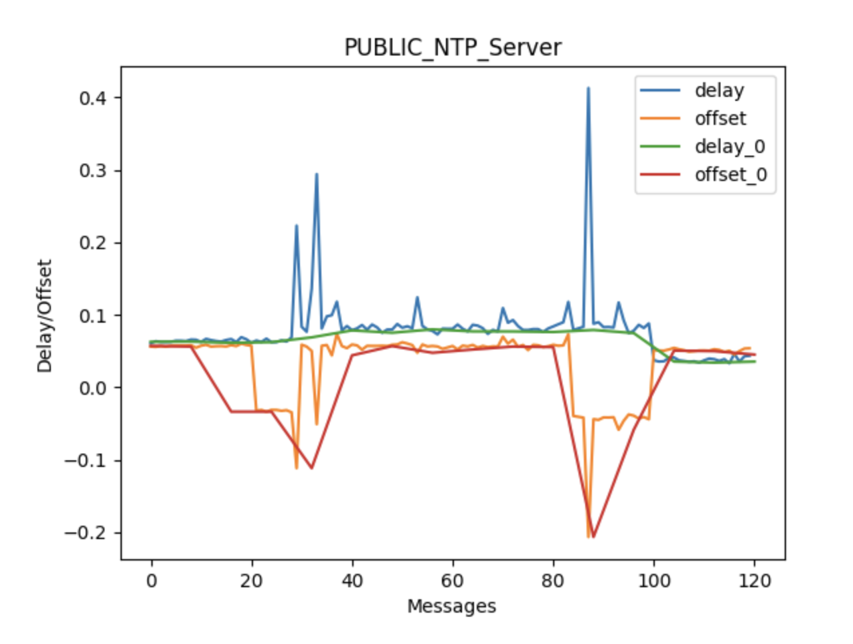

Upon querying the NTP server for the time, we notice that the delay and offset are minimal, which can be attributed to the fact that the client machine is already synchronized with the NTP server. Although we expected a more significant delay due to the server not being on the same LAN, the anomaly can be explained by the presence of an NTP server in a nearby geographical area, such as Boulder.

***The shorter and more symmetric the round-trip time is, the more accurate the estimate of the current time will be.***

When the server system is located closer, the round-trip time and delay in time are reduced.

This reduction in transmission delay allows for more precise time difference estimation. In cases where transmission delay is greater, it becomes difficult to determine whether the latency or processing time caused a longer duration. Additionally, network packet loss or delays in transmission to the client can further complicate the estimation. On the other hand, if the round-trip time is shorter and consistent across multiple requests, it becomes easier to identify the round-trip duration and estimate server time more accurately.