Solis Dealer Digital Ecosystem Research
Business evidence and investment decisions for the Netherlands
Prepared for Raja and company leadership
3 November 2026
Global and European evidence with a detailed audit of solistractor nl
The Netherlands already has meaningful digital tractor discovery and commerce. The next investment should establish who owns the dealer relationship and data, inspect the existing private systems, and test a connected dealer and parts workflow. Public evidence supports this discovery and pilot decision; it does not establish a Solis return on investment.
The working name Solis Structures NL is unresolved. It must not be used as a verified legal entity or contracting party.

1 Executive summary
Recommendation. Authorise discovery and a measured Dutch pilot across the Dealer Portal, Parts Intelligence, Agentic Commerce and Dealer Onboarding. Inspect existing systems and dealer tasks before committing to development.
Existing capabilities. The fresh Dutch audit verifies selection, an actual comparison table, configuration, dealer/demo enquiries and a public warranty-registration form. AgriXpert also offers tractor purchase entry. Reuse these capabilities and test their operational handoff. [I07, I08, I09, I31, B26]
Private systems. German login, Romanian DMS/IBIZ links and a US portal description provide reuse leads. Dutch access and functions remain unknown. [I10, I11, M10]
Legal identity. Solis Structures NL remains unresolved. ITL's reported wholly owned Solis B.V. must be distinguished from importer AgriXpert/DIGO. Current registry extracts and contracts must establish project authority. [I04, I05, F01]
Financial evidence. No reliable Solis machine/parts split was established. AGCO parts represented 18.58% of 2025 sales. Titan's parts plus service represented 24.98% of FY2026 revenue and 63.25% of gross profit. These distinct peers cannot supply Solis margins or ROI. [F02, F03]
Immediate Dutch priorities. Resolve the published demo follow-up placeholder, investigate zero-width selector results and align registration guidance. Then test enquiry ownership, machine identity and correct-part fulfilment with dealers. These specific findings support a bounded pilot; no dealer interviews or private-system tests were conducted. [B25, B28, I31, I32]
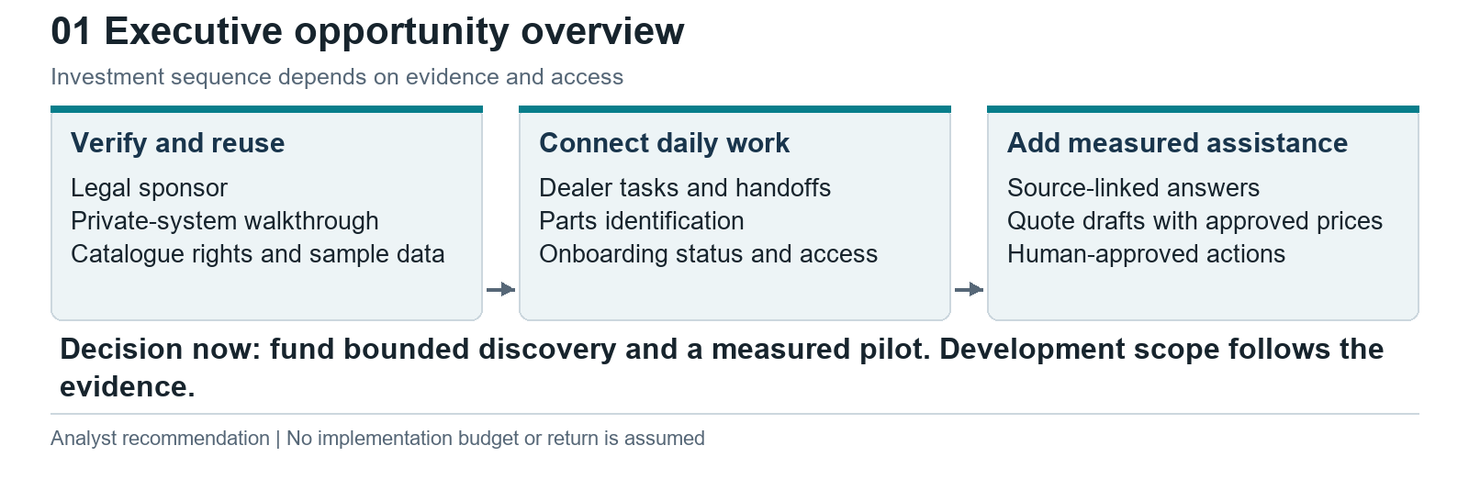
Executive opportunity overview | Evidence map or proposed design as labelled

2 Decisions and strategic implications
Leadership can approve discovery now while retaining control over the larger investment. The following decisions separate what the evidence supports from what requires operational access.
Decision | Recommendation and rationale | Evidence needed for next commitment
Legal and commercial sponsor | Name the benefiting legal entity and accountable executive before contracting | Current KvK extracts, group chart and dealer agreement signatory
Reuse or rebuild | Inspect ITL DMS/IBIZ, regional portals and importer commerce before procurement | Authorised walkthrough, coverage, costs, integration rights and operating owner
First dealer workflow | Pilot a task queue and preserved enquiry context with a small dealer cohort | Actual handoff records, observed re-entry, agreed response responsibility
First parts workflow | Start with licensed identification and expert escalation before order execution | Serial/build coverage, catalogue rights, parts cases and stock semantics
AI scope | Trial source-linked product answers and structured handoff; defer consequential writes | Reviewed answer set, data access, approval policy and error monitoring
Onboarding scope | Track approvals and readiness; use existing signing/training tools if suitable | Qualification policy, accountable approvers and access provisioning map
Geography | Prove the Dutch operating model; assess reuse with one other importer later | Different contracts, language, prices, parts rights and support responsibilities
Dutch website corrections before a pilot. The demonstration page leaves the follow-up owner and timing unresolved in visible editorial copy. The selector can include records with 0 cm widths in a narrow-opening result. Warranty intake already exists and should be reused; its registration and extension rules need reconciliation. Fix or validate these issues with the responsible owners before adding conversational recommendations. [B25, B28, I31, I32]
Investment alternatives. Extending existing ITL/importer tools should be tested first. A thin integration workspace is attractive if core transactions already exist but context is fragmented. Buying a dealer-management or B2B commerce module can reduce custom maintenance where it fits the current systems. A custom platform becomes defensible only where a measured workflow gap survives those comparisons. These are proposed options; the report does not assert which systems are installed.
The project should have a stop condition. If existing portals already address the dealer problem at acceptable cost, concentrate on adoption, data quality and integration. If catalogue or transaction rights cannot be obtained, limit the pilot to controlled requests and deep links. If dealer task observation finds little avoidable work, revise the investment case.

Contents
1 Executive summary 2
2 Decisions and strategic implications 3
3 Scope and research methodology 5
4 Solis and ITL business overview 5
5 Corporate structure and Netherlands ecosystem 6
6 Existing website and digital capability audit 6
7 Dealer ecosystem and customer journeys 10
8 Evidence backed dealer needs and pain points 11
9 Dealer Portal research and proposed capabilities 12
10 Parts Intelligence research and proposed capabilities 13
11 Agentic Commerce research and proposed capabilities 15
12 Dealer Onboarding research and proposed capabilities 17
13 Competitor benchmarking 18
14 Financial analysis of machines parts and after sales 20
15 Integrated future state ecosystem and architecture 22
16 Proposed UX information architecture and wireframes 23
17 Business value and transparent scenario framework 25
18 Implementation options and phased roadmap 26
19 Risks data requirements ownership and dependencies 27
20 KPIs and measurement framework 28
21 Unanswered questions and stakeholder requests 29
22 Conclusions and recommendations 30
23 Research limitations and material corrections 30
24 Detailed source register and appendices 31

3 Scope and research methodology
The research covers the global Solis brand, its actual European country routes, the Netherlands importer and dealer journey, and selected manufacturer/dealer benchmarks. Public evidence was accessed on 3 November 2026. Source publication periods are retained separately. The similar domain solis.eu was tested and excluded because it redirects to an appliance business. European tractor research uses Solis World's EU range, its official country selector and the relevant country/importer sites. [I01, I06]
The work combined source discovery with opening original pages, following public links and inspecting forms, catalogue descriptions, model options and financial disclosures. The Netherlands selector was followed through successive requirement choices, including a narrow-opening branch. An actual two-model comparison, the demonstration route, warranty form, model options, price list, importer listing, service and dealer pages were inspected. The Dutch site was rechecked specifically for this edition; access date does not establish when a feature was launched. No enquiry, application, order, warranty claim or payment was submitted. No private credentials were used. A public login proves an entry point, while public product documentation proves a described capability within its stated market.
Evidence labels. Verified means a reviewed reliable source directly supports the statement. Company claims remain identified as company descriptions. Reported means a third party or limited-access source states the claim. Inference is an analytical conclusion from cited evidence. Hypothesis is an untested operational proposition. Open question identifies information requiring ITL, importer, dealer or registry confirmation.
Capability labels. Verified present identifies a directly observed public capability or documented entry point. Partially verified means part of the journey was inspected but execution or coverage was not. Not publicly discoverable records that research did not locate the capability, without concluding it is absent. Unclear / requires direct confirmation is used where scope, permissions or system behaviour cannot be established.
Evidence quality prioritises audited filings, official corporate and product documentation, registry information and credible industry research. Forums are qualitative signals with unverified identities. Search snippets were used for discovery; inaccessible originals are recorded as limitations rather than silently accepted. No paid survey results were obtained.
An initial workspace inventory found no earlier Solis research document among the available document files. The research therefore proceeded independently. Material corrections to common assumptions are explicit: EU namesake excluded; existing selector/configurator/commerce recognised; private portal clues retained; Dutch and global parts routes separated; peer economics never presented as Solis economics.
The complete register provides source titles, publishers, direct URLs, access dates, supported claims and limitations. Cross-references such as [I08] point to that register and are linked in the editable report. Source duplicates are retained where separate research areas used the same original, and can be matched by URL.

How to use this report
Sections 1 and 2 support the immediate decision. Sections 4 to 14 provide the business, workflow, benchmark and financial evidence. Sections 15 to 20 describe a proposed connected experience and investment sequence. Sections 21 to 24 set measurement, outstanding requests, recommendations and source details. All proposed screens use illustrative task text and deliberately omit invented part numbers, stock quantities and commercial prices.

4 Solis and ITL business overview
Solis is the tractor brand presented by International Tractors Limited. The global website distinguishes EU and global ranges and links visitors to local distributors. ITL's own history and generic heritage wording differ across pages; the report does not turn marketing heritage dates or global scale claims into audited brand figures. Local model, engine, emissions and warranty variants matter for digital product data. [I02, I06, I13]
The likely commercial chain is manufacturer to regional/importer organisation to authorised dealer to owner. This is a useful analytical map, but the legal seller, invoice issuer, stock owner, warranty obligor and data controller can differ by transaction. An importer that also has retail listings may act in more than one role. Each proposed workflow must retain these distinctions.
Public Netherlands journeys combine brand discovery, dealer advice and an importer ecommerce route. A prospective owner can identify candidates and request a quote; a local dealer remains important for configuration, installation, demonstration, handover and service. Parts support depends on the exact machine and component identity, not simply its public model name. [I08, I09, I20]
Financial scale is available at ITL level only. ICRA reproduces FY2025 consolidated operating income of INR10,021.8 crore and profit after tax of INR1,780.9 crore, compared with INR9,485.4 crore and INR1,740.3 crore in FY2024. These are reported ITL indicators, not Solis-brand or Netherlands turnover. The report did not obtain ITL's full audited statements or a Solis revenue split. [F01]
Implication. A local product needs a bounded business case. Neither ITL scale nor the global dealer network establishes the Dutch volume available to a digital service. The necessary denominators are active Dutch dealers, sold and supported machines, eligible leads, parts requests and invoice lines over a defined period.

5 Corporate structure and Netherlands ecosystem
The phrase Solis Structures NL remains an open question. No reviewed evidence establishes it as a legal tractor company. Use it as Raja's working reference until the sponsor supplies the exact entity and current registration.
Organisation | Evidence and confidence boundary | Responsibilities requiring confirmation
International Tractors Limited | Official manufacturer and Solis brand description [I02, I06] | Catalogue, trademark, software and data licensing authority
Solis Tractors & Agricultural Machinery B.V. | ICRA reports 100% ITL ownership from FY2025 accounts [F01, I27] | Current directors, operating mandate, dealer contracts and data role
AgriXpert B.V. | Official Dutch importer/support and webshop descriptions [I04, I05, I09] | Wholesale seller, parts ownership, pricing, ERP and dealer approval rights
DIGO Groep | AgriXpert self-describes group membership [I05] | Certified legal shareholding chain and relevant contracting entities
Dutch dealers and subdealer | Official locator names locations and distinguishes a subdealer [I15] | Active contract roster, territory, sales/service authority and sharing permissions
ILAFA eG Germany | Legal notice identifies operator of German site and login [I10, I12] | Contract and system relationship to other markets
An exhibition listing places the Solis B.V. at an address associated with AgriXpert, while a registry aggregator gives another address. Shared or inconsistent addresses do not establish identity, ownership or agency. Registry-aggregator details are a lead for a current certified extract, not a substitute. [I14, I16]
Proposed ownership rule. ITL should confirm authoritative engineering and build data. The importer should confirm local price, stock and dealer terms. Dealers should confirm customer, workshop and transaction records. The actual controller/processor arrangements, contractual rights and system owners must be documented before records are combined. These are proposed responsibilities, not findings about existing contracts.

6 Existing website and digital capability audit
The material conclusion is that Solis has a distributed digital estate with significant public capability. Gaps in public visibility should become demonstration requests, not statements that systems do not exist.

Dutch website findings and their business implications
The Netherlands website is an operating customer touchpoint, not simply a brochure. The public journey combines model discovery, requirements filtering, comparison, indicative configuration prices, regional dealers, demonstration requests and warranty intake. The refresh corrects the earlier audit's incomplete comparison and Dutch registration coverage. It verifies public presence, while leaving transaction delivery and private workflows separate. [I31, I38, B26, B27]
Network scope. The site lists 19 dealers and one subdealer, consistent with the homepage's 20 sales/service points. Romox is identified under van Vijfeijken, without its own tractor stock. This is a published roster, not proof of 20 independent dealer contracts. Proposed lead routing and account permissions must support that main-dealer/subdealer relationship. Confirm the active contractual roster and service authority before provisioning accounts. [I38, I39]
Tractor discovery and comparison. The selector was followed through loading, repeated forward/reverse and width choices. A narrower-than-one-metre branch returned models whose parsed widths were 0 cm; a second branch showed a heading/card-count discrepancy. These are reproducible page-data flags, not measured tractor widths. Unknown dimensions should require confirmation before a model is represented as meeting a physical constraint. The actual S26/H26 comparison table now loads and includes technical categories and explicit missing-value labels. Previous comparison timeouts must not be described as an absent capability. [B24, B25, B26]
Configuration and enquiries. The S26 page exposes options and dependency guidance with indicative prices and dealer-selected enquiry. The fresh check also inspects demonstration intake. Form presence, fields and source model context can be verified; acknowledgement, received configuration, assignment, response times and CRM integration require a controlled test. Public contact routes do not demonstrate manual back-office work. [I08, B28, B27]
Demonstration content defect. The public demonstration page displays unfinished instructions asking for a follow-up owner, response timing and commercial conditions. This leaves the next step unclear to a customer. The importer should replace that text with an agreed service promise and test a received request through its responsible dealer. The finding concerns published content; no failed delivery is alleged. [B28]
Prices and commercial authority. The S50 promotion page publishes EUR 21,725 for the tractor, EUR 4,995 for the loader and EUR 650 for mounting, totalling EUR 27,370 excluding VAT. It explicitly leaves the promotion's active period for dealer confirmation. These are indicative retail amounts, not turnover, dealer margin or a binding current quote. A future assistant or quote draft must retain price-list version, included options, installation, tax, validity and commercial approval. [M12, I18]
After-sales and existing registration. Dutch service directs owners to dealers with machine identity and hours. Warranty and service pages lead to a Dutch registration form with owner, dealer, serial, purchase and invoice evidence. Registration intake is verified; processing, activation and a complete machine history remain unknown. Reuse this route before building another form, and ask the warranty owner to demonstrate acknowledgement and exception handling. The displayed lookup and photo-deletion descriptions do not establish extraction accuracy or actual deletion. [I31, I32, I33]
Importer commerce and shared data. AgriXpert offers a separate tractor purchase route. The refresh identifies differing S16 lifting/width descriptions across Dutch discovery and importer content; configuration or revision differences may explain them and must be checked. Do not choose an authoritative value by guesswork. Identify a market/model/variant master and feed consistent facts into selector, comparison, configuration, shop and future assistant. [I09, B22, B35]
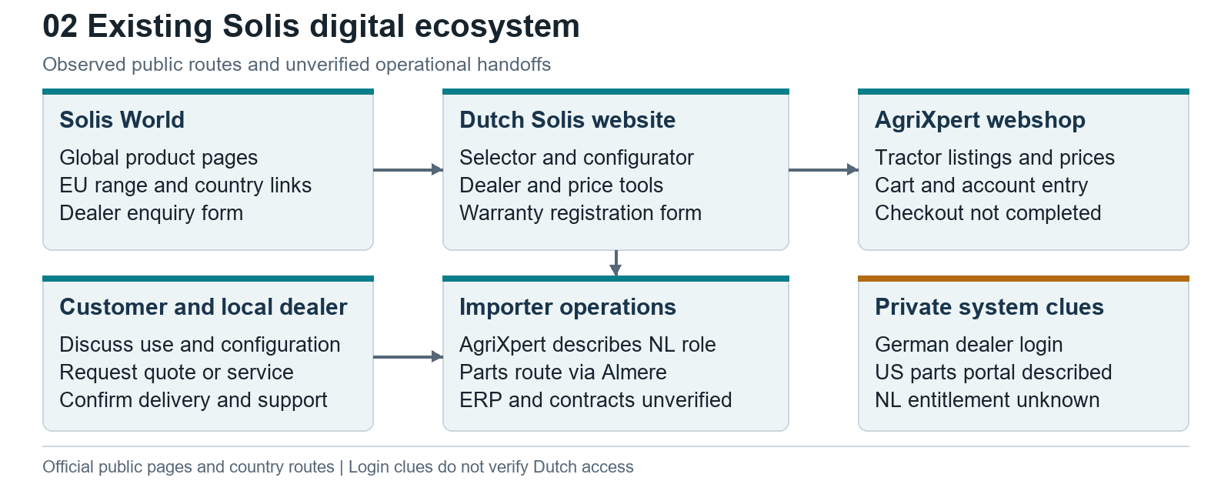
Existing Solis ecosystem | Evidence map or proposed design as labelled

Capability audit across public surfaces
Capability | Status | Scope and evidence
Global and EU catalogues | Verified present | Solis World ranges and country links [I06]
Model specifications | Verified present | Global and Dutch S26 pages [I08, I26]
Model selector | Verified present | Dutch guided flow followed [I07, I17]
Configurator | Verified present | S26 options and dependency guidance [I08]; recalculation not independently tested
Indicative prices and price list | Verified present | Dated PDF and importer listings [I09, I18]
Tractor comparison | Verified present | Actual S26/H26 comparison table inspected; earlier timeout limitation superseded [B26]
Dealer locator and dealer information | Verified present | 19 dealers and one subdealer; published roster and relationship [I38, I39]
Stock labels | Verified present | Importer product and generic locator labels [I09, I15]
Real-time dealer inventory | Unclear / requires direct confirmation | Quantity, refresh and reservation semantics not established
Enquiries quote and demo requests | Verified present | Dealer-selected forms; response and delivery untested [I08, B28, B27]
Automated lead routing | Unclear / requires direct confirmation | Delivery, CRM and service levels not tested
Saved or shared configurations | Unclear / requires direct confirmation | Comparison selection persistence is described; full configuration sharing and dealer transfer remain unverified [B26, B27]
Dealer interest application | Verified present | Global form and Dutch contact route [I02, I23]
Automated onboarding | Not publicly discoverable | Approvals, contracts, certification and provisioning not exposed
Tractor cart and purchase entry | Verified present | AgriXpert configurable listings [I09, I19]
Completed checkout and fulfilment | Partially verified | Entry found; no transaction performed
Implements and attachments | Verified present | Product options and public listings [I06, I08, I19]
Serial-linked electronic parts catalogue | Not publicly discoverable | No public NL/global catalogue journey verified
Exploded parts diagrams | Not publicly discoverable | Private or licensed catalogue cannot be excluded
Parts order and fulfilment | Partially verified | Dealer/distribution descriptions; US portal claim [I20, I21, M10]
Service booking | Partially verified | Dealer contact route; no calendar booking established [I20]
Warranty policy | Verified present | Netherlands policy page [I25]
Warranty registration intake | Verified present | Dutch owner dealer machine and invoice form; processing not tested [I31, I32]
Warranty claims processing | Unclear / requires direct confirmation | No private claim workflow inspected
Machine registration intake | Verified present | Public Dutch warranty form collects machine identity [I31]
Machine ledger and service history | Unclear / requires direct confirmation | Public intake does not establish an accessible machine record or history
Dealer-only login entry | Verified present | Germany; Romania DMS/IBIZ links [I10, I11]
Dutch dealer portal functions | Unclear / requires direct confirmation | Authorised walkthrough needed
Customer support | Verified present | Public dealer, phone and email routes [I20]
Brochures and price documents | Verified present | Public model/document links [I18, I21, I26]
Workshop and operator manual coverage | Unclear / requires direct confirmation | Download centre content required sign-in
Supported public API | Not publicly discoverable | No documented catalogue, stock or order API established

Priority actions from the Dutch audit
These priorities are analyst recommendations based on the public evidence. Priority describes the order of validation and correction, not a quantified return or an agreed delivery schedule.
Priority and finding | Recommended action and proposed owner | Evidence required to close
First Demo follow-up copy remains unfinished [B28] | Importer sales and website owner agree recipient, acknowledgement and response responsibility | Approved copy plus an authorised test received by the correct person
First Selector accepts zero-width records [B25] | Product data owner tests width filters and prevents unknown dimensions from implying fit | A reviewed test set with known widths and unknown-value cases
First Warranty guidance has unresolved conditions [I31, I32] | Warranty owner separates intake, provisional registration, extension approval and claims | Confirmed policy and tests for no plate, missing evidence and correction
Next Specifications differ across channels [B35] | Product and commerce owners reconcile variant and source revisions | Signed-off data record used consistently by discovery and shop
Next Current pricing and supply need authority [M12, I38] | Commercial and parts owners define validity, stock timestamps and dealer entitlements | One approved quote and one acknowledged parts request traced to source
The warranty form says an owner may leave the licence plate blank while the extension page describes a valid Dutch plate condition. These may concern different stages; the distinction needs clarification rather than an assumed rejection rule. The form also describes HEIC uploads while its public file-input acceptance list differs. Confirm supported formats through an authorised acceptance test. Neither observation proves that submitted registrations fail. [I31, I32]

Consequences for the four workstreams
Workstream | Dutch evidence changes the proposed scope | First demonstration to request
Dealer Portal | Reuse public enquiry demo and registration routes; show their next action in one workspace | Follow a consented enquiry from model selection to dealer receipt and response
Parts Intelligence | Dealer-assisted identification and Almere route are published; catalogue access is still a dependency | Trace a real serial to an approved part and supply acknowledgement
Agentic Commerce | Selector comparison options and prices already provide discovery; data quality must be resolved before AI advice | Answer reviewed tasks with model variant sources unknown values and dealer escalation
Dealer Onboarding | Public dealer-interest intake exists; main/subdealer roles need distinct entitlements | Show one applicant through agreement training first-order access and suspension
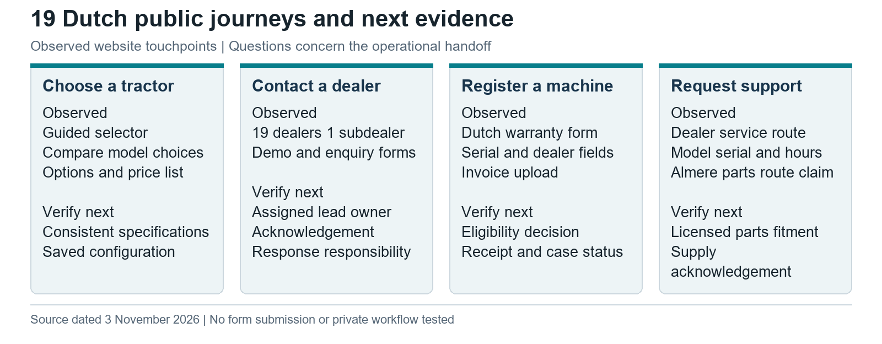
Dutch public journeys and operational evidence | Evidence map or proposed design as labelled
Interpretation. A configured form and an ecommerce cart solve only parts of the lifecycle. The strongest next question is whether the chosen dealer receives structured requirements, a reproducible configuration and an accountable next action. That question must be answered by a controlled test and private-system walkthrough.

7 Dealer ecosystem and customer journeys
The customer journey begins with a task: mowing, material movement, maintenance or another defined use. Public discovery should retain that context through model selection, configuration and dealer discussion. The dealer then validates fit, conditions, delivery and support. After delivery, the machine identity should connect the owner to correct documentation, maintenance and parts.
Proposed connected journey. Capture requirements with a versioned configuration; create a consented enquiry; assign an eligible dealer; acknowledge ownership; prepare a human-approved quote; preserve order and delivery references; register machine identity where authorised; link future parts/service requests to that machine. Each state needs a responsible organisation and a visible exception route.
For a parts request, the commercial journey is different. A customer may know only a symptom, photograph or model. The dealer must establish machine and component identity, validate a candidate against build/serial applicability, confirm supply and decide how to handle ambiguity. The architecture should support a request with missing information rather than invent a definitive part.
For a new dealer, the customer is the applicant business. Submission begins qualification; it does not confer territory, credit, warranty authority or wholesale prices. Readiness requires completed approvals, agreements, training and tested access. An applicant status page can reduce chasing even if approvals remain human decisions.
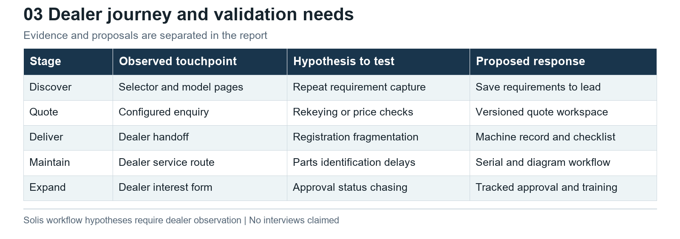
Dealer journey | Evidence map or proposed design as labelled

Proposed service responsibilities
ITL provides product authority and confirms which brand systems can be reused. The importer owns the local coordination decision after its legal mandate is verified. Dealers own customer follow-up and service execution within their contracts. A central support team handles unassigned leads, identification ambiguity, unavailable stock feeds and failed system handoffs. Responsibility must remain explicit when a workflow spans organisations.

8 Evidence backed dealer needs and pain points
Public evidence supports investigating parts, technical support, returns and warranty administration. It does not establish how often Dutch Solis dealers experience difficulties or that current tasks are manual. The following evidence and hypotheses must remain separate.
Concern | Evidence and scope | Consequence to test with Solis dealers
Parts and support reliability | NAEDA survey overview includes availability, returns, technical support and warranty [B17]; North America | Identification time, delayed work, lost orders and escalation frequency
Dealer readiness | Industry checklist covers territory, stock, tools, training and reimbursement [B18] | Missing readiness evidence, approval delays or first-order access failures
Repeated inspection administration | AGCO describes digital/offline PDI workflow [B07]; benchmark | Whether Dutch delivery records are re-entered and whether this causes errors
Catalogue-to-commerce mismatch | DMS documentation handles catalogue parts absent in local records [B11] | How unmatched parts are resolved and whether selections are lost
Mixed local Solis experience | One self-described US dealer critical and one owner positive [B19, B20]; identities unverified | Market, model and dealer differences; no general shortage conclusion
Unverified manual-work hypotheses. Dealers may retype configured enquiries into quotes, seek parts confirmation through email/phone, chase order status, submit warranty evidence in more than one place, and request onboarding updates. Each is a hypothesis. Public forms and contact routes do not prove the back-office method.

Direct research plan
Recruit a purposive pilot of six to eight Dutch dealers covering volume, tenure, workshop size and geography; importer sales, parts, warranty, finance and IT; two recent applicants and two owners if available. These are proposed research counts, not a representative statistical sample. Observe a recent enquiry/quote, unidentified-part request, backorder, return, delivery inspection, warranty case and first-order onboarding.
Collect redacted records and timestamps. Distinguish active work from elapsed waiting. For each handoff, record actor, system, information supplied, missing fields, repeated entry, exception reason, outcome and avoidable cost. Ask which existing tools work well and whether a proposed capability duplicates them. Confirm findings with participants before prioritising development. No interviews are claimed in this report.

9 Dealer Portal research and proposed capabilities
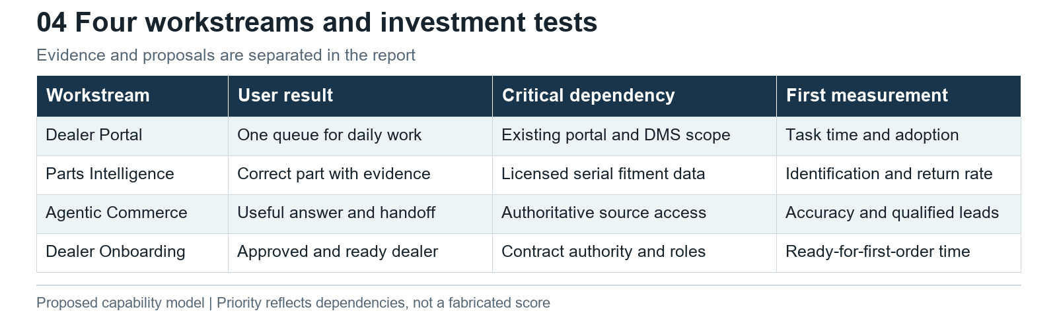
Four workstream comparison | Evidence map or proposed design as labelled
Kubota Europe's public directory is a useful operating pattern: a permissioned portal links sales, training, technical, maintenance, warranty and parts tools. AGCO Tech Connect demonstrates machine-linked inspection, technical cases and mobile evidence. DMS documentation for Deere interfaces shows that quotes, parts transactions and warranty information may cross existing systems. These are documented benchmarks, not proof of Solis's systems or universal competitor deployment. [B01, B07, B10]
Proposed concept. Make the Dealer Portal a workspace that preserves identity, context and the next action across existing applications. Start with a task queue, authorised links, structured requests and relevant source documents. Avoid replacing the importer ERP, warehouse system or dealer accounting application without a specific business reason.
Capability | Dealer problem it addresses | Phase and acceptance evidence
Lead and saved configuration context | Repeated requirements capture or lost option choices | Pilot if observed; dealer can reproduce source configuration
Customer and machine references | Difficulty linking service to installed equipment | Pilot with permissioned sample and duplicate handling
Quote draft and approval | Version confusion or unauthorised prices | Later; approved price source and commercial authority
Order and delivery status | Repeated status calls | Later; authoritative acknowledgement and timestamps
Registration and PDI | Missing handover records | Reuse Dutch intake first; record ownership and processing demonstrated [I31]
Parts identification and requests | Ambiguous fitment and manual handoff | Pilot within licensed model scope
Service and warranty cases | Missing evidence and unclear responsibility | Reuse/integrate; current process demonstrated
Documents and training | Difficulty finding current authorised guidance | Early; revision and role visibility tested
Notifications and dashboards | Missed tasks or uncertain workload | Early task alerts; dashboards follow trusted events

Roles and permissions
An applicant sees its own evidence and status. A dealer principal manages its staff and commercial approvals within assigned scope. Sales staff see permitted leads, configurations and quotes. Parts staff see licensed catalogue and authorised availability/prices. Technicians see machine/support data relevant to their work. Importer operations manage exceptions and distribution; network development manages qualification; finance/commercial owners approve credit and price entitlements; ITL product/support owners govern technical authority. Administrators manage identity without automatic rights to every commercial record.
Permissions should combine organisation, market, territory, role, contract status and record relationship. A suspended dealer must lose transaction rights promptly. A technician should not inherit dealership-wide margin visibility. Delegated access, staff departure and dealership transfer need explicit workflows.

Major workflow
A configured enquiry enters the authorised queue with consent and source revision. The dealer accepts ownership or returns it with a reason. A quote draft references the approved configuration and price version. An authorised person reviews terms and sends it. Any resulting order retains the quote reference; delivery adds a verified machine serial where available. Failed integration leaves a visible retry/exception state rather than an apparent successful order. This is a proposed workflow requiring system demonstrations.
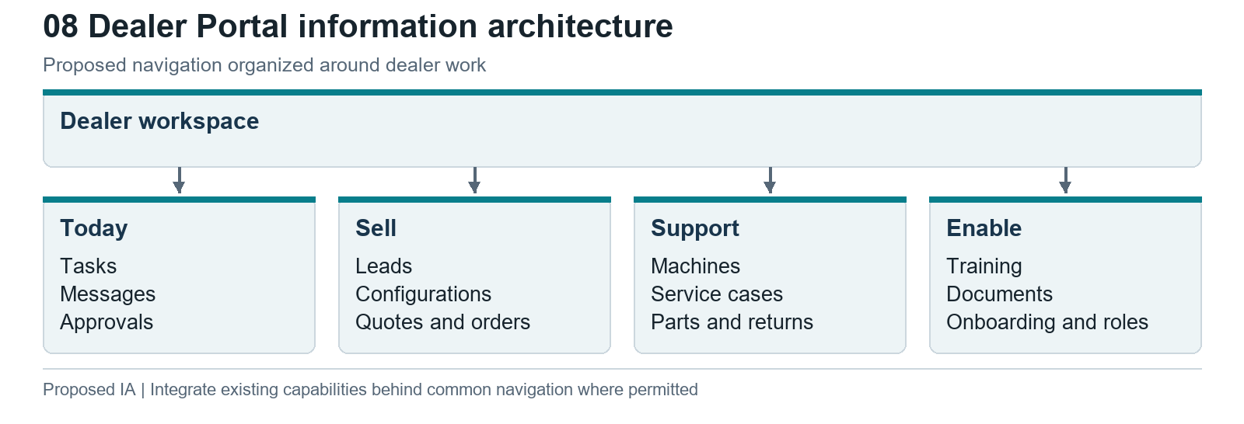
Dealer Portal information architecture | Evidence map or proposed design as labelled

10 Parts Intelligence research and proposed capabilities
The public Dutch support route is dealer assisted. Solis's global parts page describes a German/Yanmar distribution arrangement, while Dutch information describes an operational route via Almere. These may reflect different network layers, markets or dates. Do not assume a single fulfilment centre or treat a marketing delivery promise as an available-to-promise guarantee. Confirm who holds each stock item and which system acknowledges the order. [I20, I21, I22]
MyCNHStore documents serial/model discovery, assembly diagrams and fitment. Fendt's parts resources describe exploded views and a catalogue-to-request basket. Kubota Europe separates machine parts from industrial engine parts. These patterns support a machine-first identification experience and show why a catalogue and a commerce system should have a controlled handoff. [B02, B08, B01]

Proposed identification journey
- Establish full tractor serial, model, market and build date; collect a nameplate photograph when useful.
- Resolve configuration and fitted assembly; collect engine/component model and serial if relevant.
- Search licensed text and diagram data, preserving source revision and assembly context.
- Verify serial applicability, quantity, supersession and approved substitute rules. Escalate uncertain cases.
- Retrieve authorised price, stock timestamp, reservation status and lead time. Distinguish a stock snapshot from confirmed supply.
- Obtain dealer approval, send the request/order and wait for authoritative acknowledgement.
- Record shipment and installation/work-order references where permitted; capture returns and incorrect-part reasons for improvement.
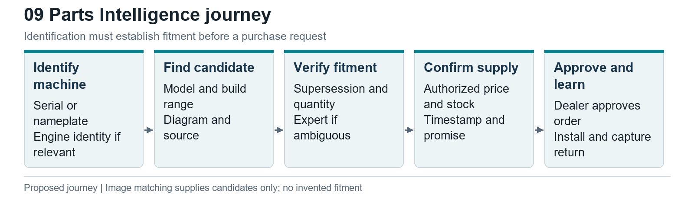
Parts identification journey | Evidence map or proposed design as labelled

Third party engines and catalogue rights
The global S26 page identifies a Mitsubishi engine, and Netherlands material distinguishes component/engine sources across the range. This is model-specific evidence. A Yanmar commercial relationship does not prove that every Solis tractor has a Yanmar engine. DET's Mitsubishi-distributor FAQ requests engine model, serial and application, and describes purchased manuals and restricted ordering accounts. It does not establish DET as the supplier for every Solis machine. [B14, B15, I21]
Permission to view a catalogue is separate from rights to redistribute diagrams, build a search index, use images for matching, embed data in an assistant or train a model. Obtain written coverage and permitted-use terms from ITL and any component/catalogue rights holder. Catalogue access should not be bypassed by scraping.

Proposed data and integration model
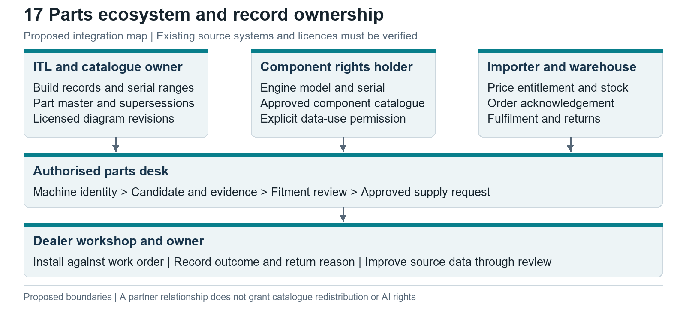
Parts ecosystem map | Evidence map or proposed design as labelled
Record | Minimum fields or relationships | Proposed authority to confirm
Machine and build | Serial, model code, market, build date, configuration, component identities | ITL engineering/build records
Catalogue and diagram | Assembly, revision, hotspot, document/source key, licence scope | ITL or licensed catalogue owner
Part and fitment | Exact identifier, descriptions, applicability ranges, quantity, supersession | Approved part master and engineering rules
Implement compatibility | Mounting, PTO, hydraulic, load and market conditions | Approved manufacturer/importer rules
Supply and entitlement | Warehouse, timestamp, available-to-promise definition, authorised price/tax | Importer ERP and warehouse systems, unverified
Order and outcome | Acknowledgement, shipment, work order, return reason, claim reference | Seller, fulfilment and dealer records, unverified
Every imported record needs its source key, owner, version, last update and permitted use. Compatibility is a structured rule requiring evidence; it must not be inferred from similar names or photographs. Genuine/aftermarket origin should be explicit, and any approved substitution or warranty implication must come from the applicable commercial policy.
Proposed first release. An authorised parts desk with machine identity, source-linked candidates, fitment status, stock freshness and expert review. Text/OCR and image search can suggest candidates; they cannot establish fitment alone. Add customer self-service and ordering only when catalogue coverage, prices, returns, availability and support responsibilities are proven.

11 Agentic Commerce research and proposed capabilities
The term agentic commerce should describe permissioned action in business systems, rather than any conversational interface. The relevant categories have different evidence and risk requirements.
Category | What it does | Evidence or Solis application
Conventional ecommerce | Catalogue, basket and checkout | AgriXpert public purchase entry [I09]
Rules-based recommendations | Deterministic rules on requirements or history | Dutch selector; Sana documents ERP-driven suggestions [I07, M07]
Conversational discovery | Asks questions and explains candidate differences | Proposed Solis requirements capture; no live Solis assistant verified
Retrieval-assisted answers | Answers from approved sources with references | AGCO describes AgBot parts/service assistance [M02]
AI quote drafting | Prepares a draft from authorised configuration and pricing | Proposed, with deterministic validation and dealer approval
AI parts assistance | Extracts identifiers and retrieves candidates | Proposed within licensed catalogue; fitment remains rule/expert validated
System-connected agent | Reads or stages changes through authorised tools | Cat product support; Ajusa implementer case, differing evidence [M03, M06]
Transaction agent | Initiates or executes an order/change | Ajusa implementer reports order creation/modification; no Solis deployment verified [M06]

Deployment evidence and its limits
AGCO describes AgBot integrated with AGCONet for dealer parts/service questions. This is a manufacturer-described capability, not independently measured performance. Caterpillar's March 2026 release describes the off-board assistant as available and the in-cab version as a prototype. Its support page distinguishes guest information and personalised account context. These sources do not prove unrestricted autonomous purchasing. [M02, M03, M04]
Deere's September 2026 JD announcement was discoverable but the original opened as a JavaScript shell. It is retained as limited-access evidence of announced early access, not proof of a general rollout. A named Ajusa implementation case reports SAP-connected order creation/modification with confirmations and audit logs; this is implementer-reported production, without customer-side confirmation or verified outcome metrics. Neither example supplies a Solis ROI assumption. [M05, M06]

Proposed Solis concept
Start by collecting work requirements, dimensions, terrain, desired implements and the market. Retrieve current authorised model and option facts. Explain a shortlist with page/specification references and unresolved requirements. Preserve the conversation and requirements in a structured dealer handoff, subject to the user's consent and the dealer's permissions.
With a verified catalogue, assist parts-counter staff in finding candidates and missing identifiers. With authorised price feeds, prepare quote drafts that retain source price revision, tax treatment, configuration, validity and approver. Dealer/stock-aware routing requires territory, capacity and availability data; a public dealer list alone cannot support a stock promise.
Now, subject to content rights. A controlled prototype can answer from a small curated public/document set, collect requirements and prepare a staff-reviewed handoff. After integration. Read authenticated machine/order data, check prices and availability, stage quote/order drafts. After separate validation. Permit narrowly bounded writes with approval, acknowledgement, retries and rollback/compensation rules. Autonomous discounts, credit changes, warranty awards, unverified substitutions and binding orders should not be in the initial scope.

Guardrails and release evidence
Use an authoritative source allowlist with document revisions. Filter retrieval by organisation, market and role before model access. Treat retrieved text, uploads and customer messages as data, never as instructions to override permissions. Tools must independently enforce identity, entitlements and allowed actions. Separate read, draft and execute permissions.
Require authoritative fitment evidence before presenting a part as compatible. If machine identity or serial range is unresolved, ask for information or escalate. An internal model confidence score is insufficient. For a draft quote, recheck pricing and availability at approval time and record the exact content approved. Use idempotent transaction keys, authoritative acknowledgements, complete audit trails and visible failure states.
Test grounded answer accuracy, wrong-model contamination, unsupported pricing, prompt injection, cross-dealer access, stale data, failed acknowledgements and approval bypass. Retain only necessary conversation data under agreed access and retention rules. Staff must be able to correct sources, stop the assistant and take over the case. Targets should be agreed from a reviewed test set, with all consequential errors investigated before wider release.
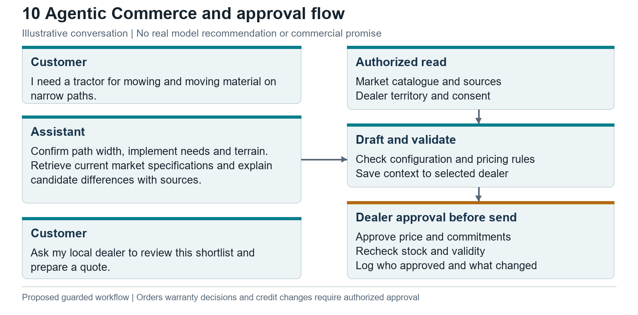
Agent conversation and approval | Evidence map or proposed design as labelled

12 Dealer Onboarding research and proposed capabilities
Solis World's form captures contact and business-interest fields and says the team will follow up. The Dutch dealer-interest route is a contact form, separate from the warranty-registration form. The directory also distinguishes one subdealer under a main dealer, so applicant status should not automatically confer wholesale or warranty rights. [I31, I38] These are verified intake capabilities, without public proof of end-to-end qualification or provisioning. [M01, I23]
Historical CNH documentation provides an explicit precedent for network, sales, service, parts, finance and legal approvals, followed by contract and portal credentials. It is a 2016 description and cannot establish today's CNH process. Kubota Engine America's programme distinguishes service authorisation levels, reinforcing that accounts and commercial privileges should reflect verified capability. An industry dealer checklist covers territory, stock, tools, training and warranty terms. [M08, M09, B18]

Proposed end to end journey
Stage | Dealer action and evidence | Internal owner and output
Apply | Legal business details, contacts, territory interest, product experience and service profile | Network lead checks completeness and duplication; acknowledgement/status
Qualify | Facilities, workshop equipment, trained staff, references and proposed business plan | Network/sales assess territory and capability; request missing evidence
Review commercial terms | Authorised business/financial information and proposed stock/service commitments | Finance, service, parts and commercial owners record approval or conditions
Agree | Review market-specific contract, territory, returns, reimbursement and obligations | Authorised legal/commercial signatory approves and executes agreement
Train and provision | Named staff, roles and required learning | Training owner certifies readiness; admin grants approved scope and verifies access
Activate | Test parts request, quote/order access and support contacts | Account owner signs first-order readiness; unresolved conditions remain visible
Enable and review | Keep staff, capability and required training current | Account owner monitors outcomes; changes/suspensions update access
Notifications should name the pending action, owner and due/review date without exposing financial documents to unrelated roles. Missing evidence returns to the applicant with a reason. Rejection, withdrawal, duplicate application and conditional approval need explicit states. A signed agreement should not automatically grant warranty authority if service certification is incomplete.
Required data. Applicant legal entity, registration evidence, authorised signatory, facilities, staff skills, territory, expected activity, credit/stock decisions, approvals, contract version, training records and role scope. Exact financial and compliance checks must come from the importer/ITL policy and applicable law; this report does not invent a universal checklist.
Integration. Reuse business verification, signing, identity and learning services where available. The workflow coordinates evidence and readiness, while authoritative decisions remain with their owners. Provisioning should be repeatable, least-privileged and reversible; failed account creation leaves the dealer pending, not active.
Geography decision. Design identifiers and policy configuration so reuse remains possible. Do not fund a multi-country rollout until a second importer demonstrates compatible needs and grants local data/process rights. Contracting entities, language, territories, warranty, prices and catalogue licences may differ.
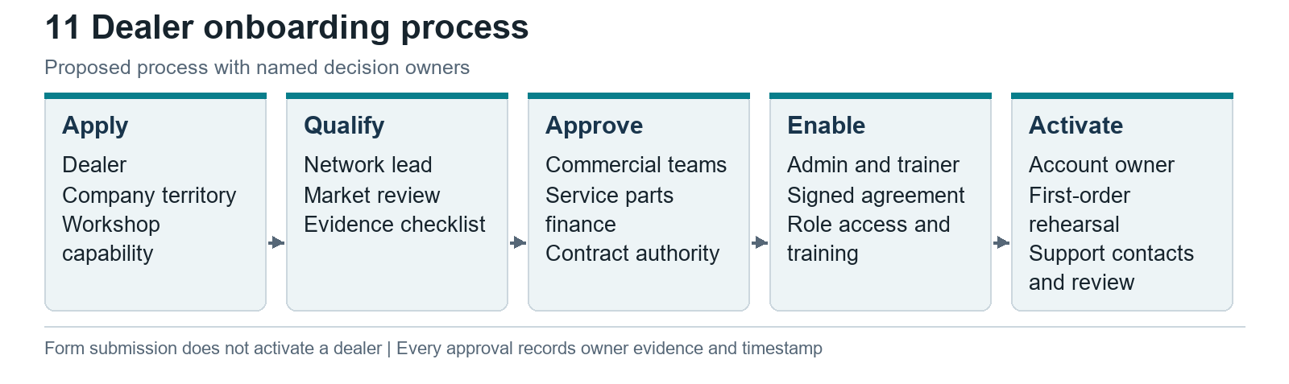
Dealer onboarding process | Evidence map or proposed design as labelled

13 Competitor benchmarking
The strongest public benchmarks demonstrate connected specialist tools, machine identity and controlled transaction handoffs. They do not support copying a global manufacturer's entire platform into a smaller importer network.
Benchmark and market | Verified description | User problem and relevance to Solis | Limitation
Kubota Europe | Permissioned SSO directory links commercial, training, technical, warranty and catalogue tools [B01] | One identity and context across existing applications | Underlying applications not entered
CNH Case IH catalogue | Serial/model/part discovery, assembly diagrams and fitment guidance [B02] | Correct identification before price/order | Dealer participation and model coverage vary
MyCNHStore North America | Equipment-based parts discovery and dealer-specific purchase journey [B03] | Connect catalogue to selling dealer | No EU availability inference
Case IH PRO and CNH support | Sales-network tools/training description and dealer-ID logins [B04, B05, B06] | Authorised sales and technical resources | Login does not prove hidden workflow details
AGCO Tech Connect | PDI, machine lookup, incidents, knowledge and mobile evidence [B07] | Link delivery/service to machine; reduce evidence loss | Solis workflow impact unmeasured
Fendt parts resources | Parts Books, diagrams and basket/request handoff [B08] | Workshop identification and preserved selections | Emailed basket is not executed order
AGCO customer service | Registered machine information and permissioned support resources [B09] | Owner documentation linked to machine | Coverage and diagnostic rights constrained
Deere via DMS documentation | Licensed interfaces for quote, parts, warranty and equipment processes [B10, B11] | Integrate existing dealer transaction systems | Vendor documentation; deployment not universal
IntelliDealer MyDealer | Customer invoice/equipment/service/parts/quote functions [B12] | Reuse DMS customer access where installed | Vendor product, not Deere-exclusive
Solis regional evidence | German login, Romanian DMS links and US portal description [I10, I11, M10] | Investigate in-brand reuse before external build | Netherlands scope unknown
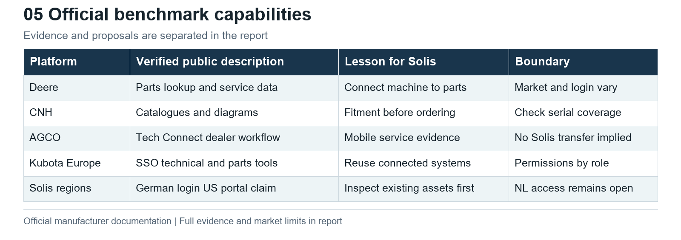
Competitor capability comparison | Evidence map or proposed design as labelled
Lead management, saved configurations, order tracking, registration, warranty, service, inventory, notifications, dashboards, roles and DMS integration should all be reviewed in the Solis walkthrough. Public evidence does not justify marking every competitor as having every feature. For unsupported features, request a current demonstration rather than fill a comparison grid with assumptions.
Transferable lessons. Give every service case and parts request a machine reference. Keep catalogue identity through the cart/request handoff. Make authentication and market entitlements explicit. Handle unmatched part records and offline evidence as operational exceptions. Measure whether a connected workflow removes dealer effort before broadening the scope.

14 Financial analysis of machines parts and after sales
How to read these numbers. Revenue is money from sales, not the number of tractors sold. In a table labelled USD million, 8,711.0 means USD8,711 million, or USD8.711 billion. That particular figure is AGCO's 2023 tractor sales revenue, not Solis revenue. Gross profit is revenue less direct costs; it is not net profit. INR crore means ten million Indian rupees per crore. The workbook now explains these units and separates company figures from the hypothetical business-case example. [F02]

ITL and Solis evidence
ICRA reproduces audited financial indicators for ITL, but the full accounts were not obtained. ICRA uses operating income as a revenue measure here, not operating profit; PAT means profit after tax. Its consolidated operating income increased 5.66% from FY2024 to FY2025. The rating analysis and consolidation annexure describe finance-company scope differently; the underlying statements are needed to reconcile this. FY2026 audited figures, Solis brand/geographic turnover and machine/parts splits were not established. Non-disclosure is not zero. [F01]
Reporting entity and period | Metric | Amount and units | Interpretation
ITL consolidated FY2024 | Revenue labelled operating income / PAT | INR9,485.4 / 1,740.3 crore | Rating agency reproduction; all relevant group operations
ITL consolidated FY2025 | Revenue labelled operating income / PAT | INR10,021.8 / 1,780.9 crore | Not Solis or Netherlands turnover
ITL standalone FY2025 | Revenue labelled operating income / PAT | INR9,789.7 / 1,818.8 crore | Different entity perimeter; do not mix with consolidated
ITL FY2025 exports | Tractor volume | Approximately 30,000; about 20% of total volume | Reported by ICRA; not Solis-only or EU-only
Solis Netherlands | Machines versus parts/service | Not established | Local invoices and management accounts required

Audited OEM comparison
AGCO's 2025 annual report separately discloses tractors and replacement parts. The most defensible chart is its own multi-year consolidated product mix, retaining residual categories. Replacement parts are not a combined parts-and-service measure. [F02]
AGCO calendar year USD million | Tractors | Replacement parts | Other product revenue | Consolidated sales | Parts / sales
2023 | 8,711.0 | 1,816.0 | 3,885.4 | 14,412.4 | 12.60%
2024 | 7,059.3 | 1,827.8 | 2,774.8 | 11,661.9 | 15.67%
2025 | 6,693.0 | 1,873.3 | 1,515.7 | 10,082.0 | 18.58%
Other product revenue = total minus tractors minus replacement parts; it includes grain systems and other machinery. Parts share = replacement parts / consolidated sales. The increase in share partly reflects declining total sales and the 2024 G&P divestiture; it is not evidence of digital causation. These are group figures, not a single brand, region or Solis. [F02]
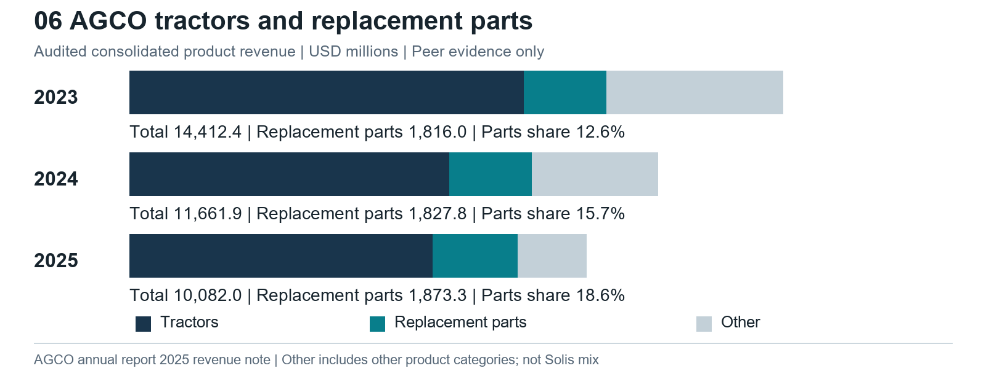
Machine and parts revenue mix | Peer evidence only

Dealer economics comparison
Titan Machinery is a useful separately labelled dealer-group benchmark. Its fiscal year ended 31 January 2026 covers agricultural and construction equipment and multiple geographies. Revenue and gross profit have different denominators and must remain separate. [F03]
Titan FY2026 USD million | Revenue | Share of revenue | Gross profit | Gross margin
Equipment | 1,774.535 | 73.11% | 129.330 | 7.3%
Parts | 428.261 | 17.64% | 132.515 | 30.9%
Service | 177.910 | 7.33% | 109.459 | 61.5%
Rental and other | 46.401 | 1.91% | 11.252 | 24.2%
Total | 2,427.107 | 100.00% | 382.556 | 15.8%
Parts plus service revenue share = (428.261 + 177.910) / 2,427.107 = 24.98%. Their gross-profit share = (132.515 + 109.459) / 382.556 = 63.25%. Gross profit precedes operating expenses, and service labour accounting affects comparability. Dealer retail margins and manufacturer net sales are not interchangeable. Rounded category shares may not sum to 100%. [F03]
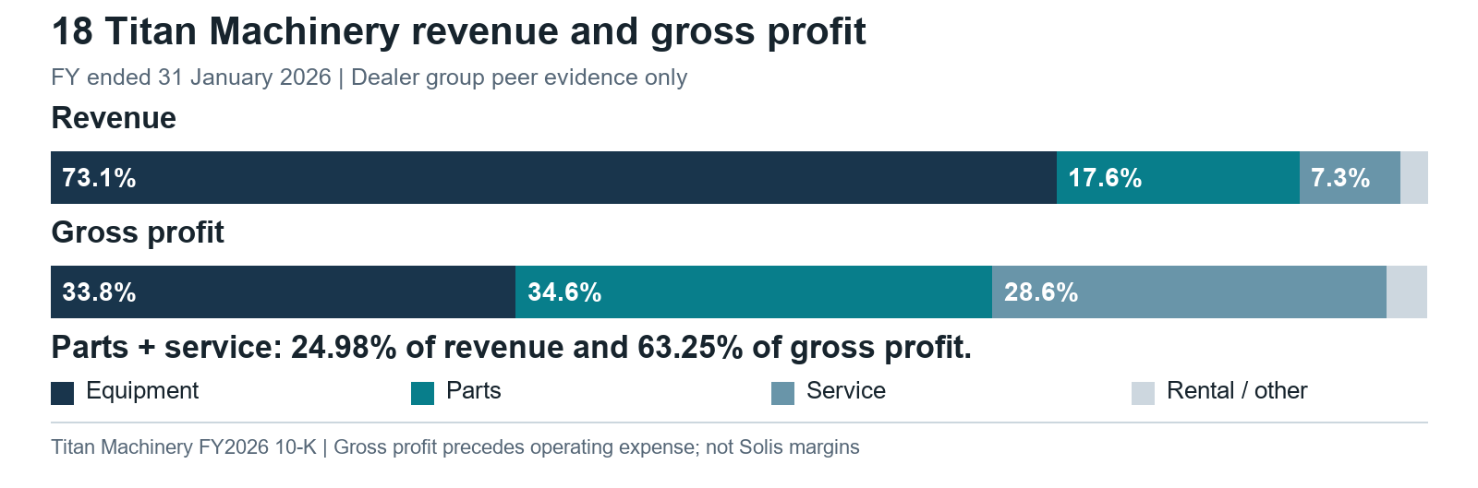
Dealer revenue and gross profit comparison | Evidence map or proposed design as labelled
Inference. After-sales deserves equal attention in discovery because recurring owner support can matter economically beyond its revenue share. This does not establish the corresponding Solis margin, installed base, retention rate or investment priority. It establishes a reason to obtain those inputs.

Other peer disclosure boundaries
Entity and financial year | Reviewed scope and disclosed amount | Parts comparison outcome
CNH 2025 | Agriculture net sales USD12,390m; Industrial net sales USD15,346m | Reviewed disclosures do not isolate parts revenue [F04]
Deere FY2025 | Equipment net sales USD38,917m including parts/technology | No isolated comparable parts denominator established [F05]
Kubota 2025 | Group JPY3,018,891m; Machinery JPY2,628,618m | Reviewed release does not disclose a parts split [F06]
These totals illustrate why a percentage cannot be inferred from segment names. Finance, service, industrial engines, construction and other products may be included differently. No currency conversion or cross-company synthetic parts average is used.

Information required for a Solis case
Obtain 24 months of invoice-line records separating machines, genuine parts, implements, service labour and warranty reimbursements. Include cost/margin definitions, dealer, customer and machine keys, market, channel and returns reasons. Reconcile to ledger totals. Add installed machines by model/age, active dealers, parts demand lost or deferred, availability/fill rate, labour handling time, quote outcomes and onboarding records. Confirm whose benefit is being measured: manufacturer, importer or dealer. Avoid adding the same channel margin more than once.

15 Integrated future state ecosystem and architecture
The four workstreams should share records and permissions while preserving authoritative systems. Onboarding establishes dealer identity and entitlement. The portal uses those rights to present tasks and records. Parts Intelligence consumes licensed machine, catalogue and supply data. Agentic Commerce reads the same authorised information and stages actions through the same approval workflows.
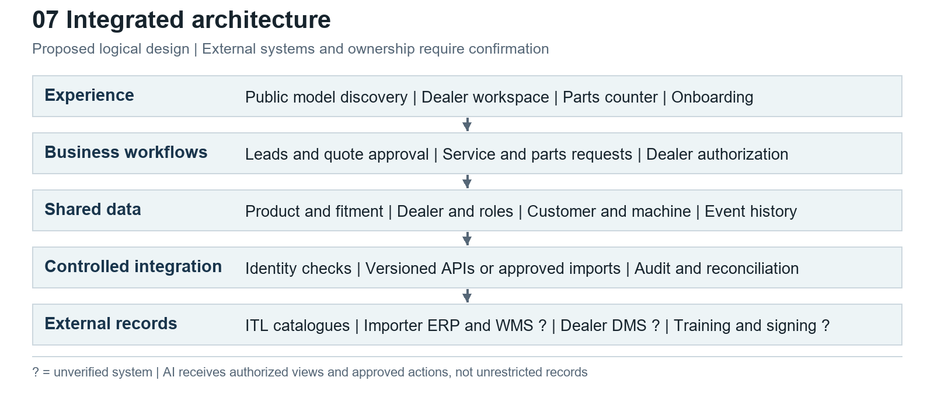
Integrated platform architecture | Evidence map or proposed design as labelled

Proposed boundaries and ownership
Data or workflow | Proposed system of record boundary | Unresolved evidence
Engineering products, build and fitment | ITL or authorised catalogue source | Actual export/API, revision and rights
Local options, price and tax | Approved importer/commercial system | Authority, version and dealer net/retail separation
Stock, orders and fulfilment | Seller ERP / warehouse system | Names, acknowledgement, reservations and refresh
Dealer identity and contract | Named network authority; identity service executes access | Legal signatory, territory and suspension policy
Customer and work order | Permitted dealer CRM/DMS or agreed shared service | Controller rights and cross-dealer visibility
Warranty | Applicable manufacturer/importer warranty system | Registration, claims, evidence and decision authority
Search and assistant | Derived authorised index, not the authoritative ledger | Retention, source revocation and evaluation
Cross-system task history | Integration/workflow service with source references | Owner, event model and reconciliation
Unknown external systems are marked with a question mark in the architecture. The diagram does not claim Solis uses a specific ERP, cloud or DMS. Support approved deep links and controlled imports as initial integration options; use supported APIs for transactional work when available. A public web endpoint is not automatically a supported business interface.

Integration requirements
Define stable source identifiers and cross-reference mappings before combining data. Use a versioned product/configuration record, durable dealer and machine IDs, timestamped stock snapshots and explicit order states. Maintain correlation IDs across portal requests and authoritative acknowledgements. Use idempotency to prevent duplicate orders and reconciliation to identify missing or contradictory updates.
Separate customer consent and privacy preferences from contract permissions. Filter records before exposing them to the assistant or user. Log access and decisions proportionately. Provide operational ownership for failed imports, stale feeds, identity conflicts, source revocations and unavailable systems. An integration layer without staffed exception handling does not complete a dealer workflow.

16 Proposed UX information architecture and wireframes
The proposed navigation is Today, Sell, Machines, Parts, Service, Training and Administration. It organises work around dealer tasks while allowing links to existing specialist systems. The first screen should answer what needs attention, who owns it and what information is missing.
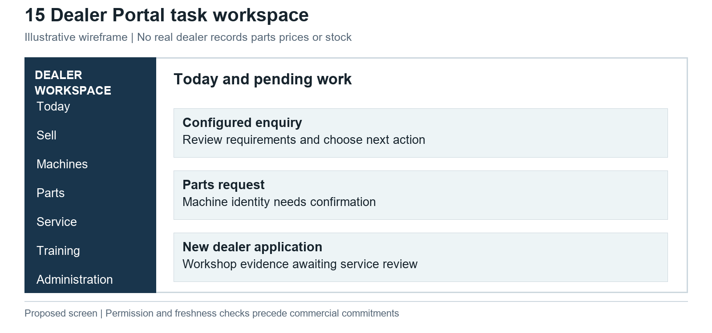
Dealer workspace wireframe | Evidence map or proposed design as labelled
Proposed Today screen. Each row has task type, customer or machine reference when permitted, responsible person, status, next action and source-system link. An unresolved machine identity or failed handoff is visible. Counts and performance tiles should appear only after event completeness is established; mock performance data would distract from validation.
Proposed Sell screen. A lead retains work requirements, market and source configuration revision. Dealers can inspect options and uncertainties, ask for missing information and prepare a draft. Price entitlements, taxes, validity and approval are explicit. The system records which quote was sent rather than overwriting the previous version.
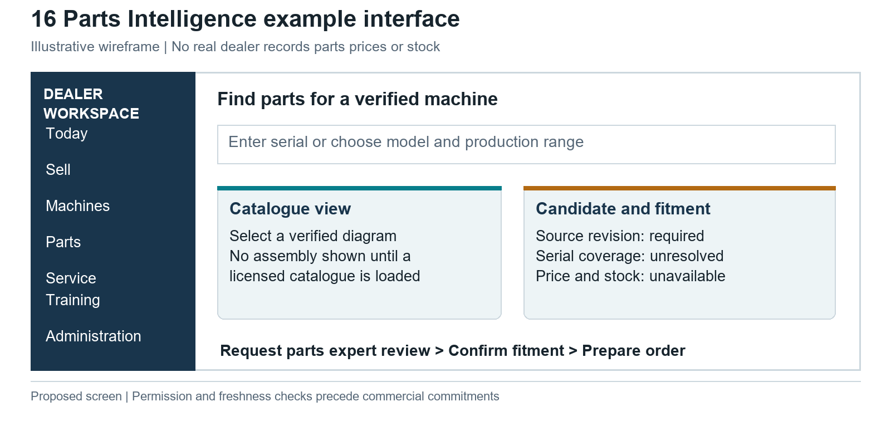
Parts desk wireframe | Evidence map or proposed design as labelled
Proposed Parts screen. Put machine identity above search. Show licensed catalogue/diagram context beside candidates and fitment status. Use clear unavailable/stale states for stock and price. A request for expert review remains available when a serial is missing. Do not substitute a model-level guess for a verified compatible part.
Proposed Onboarding screen. Present the applicant's pending evidence, review stage, named contact and next action. Internal users see only their authorised review documents. Account readiness should expose incomplete training or provisioning even after commercial approval.
These are original wireframes rather than reconstructions of private Solis systems. They use illustrative task text and contain no real dealer records, catalogue part numbers, availability, prices or ROI. Mobile design should prioritise serial capture, documents and service evidence; desktop design should support comparison, quotes and parts-counter work. Accessibility, language, field connectivity and actual device use require pilot testing.

17 Business value and transparent scenario framework
A Solis-specific quantified business case cannot yet be produced. The financial workbook separates sourced historical data from illustrative assumptions and leaves actual Solis inputs blank. Missing inputs remain unavailable, rather than becoming zero benefit or a fabricated return.
Driver | Formula | Required local evidence
Dealer capacity | Annual eligible tasks x adoption x minutes saved / 60 | Task count, observed time and task mix
Capacity equivalent | Capacity hours x loaded hourly cost | Verified cost; cash savings need staffing/overtime decision
Incorrect-part costs avoided | Eligible orders x adoption x return-rate reduction x avoidable cost | Fitment-related return causes and non-overlapping cost
Retained parts contribution | Recoverable lost demand x attributable capture change x net basket x contribution margin minus added costs | Lost demand, causal change and invoice margin
Machine contribution | Qualified leads x attributable conversion change x incremental contribution minus variable cost | Comparable lead cohorts and sold-unit contribution
Onboarding capacity | Applicants x adoption x administrative hours saved x cost | Internal work time, excluding work shifted to another role
Net cash benefit | Attributable cash cost avoided + incremental contribution minus run/change costs | Approved cost, timing and accountable benefit owner

Illustrative normalised example
The following assumptions are examples per 1,000 eligible annual requests, not Solis data or forecasts. The illustration assumes one eligible parts order per identification request; an actual case must separate these volumes if they differ. The illustrative hourly cost is EUR35. The example wrong-part return rate starts at 8%; avoided-return cost is EUR40 of non-labour cost. Productivity time excludes return handling so the two example benefits do not count the same labour twice.
Illustrative scenario | Low | Base | High
Adoption | 30% | 60% | 80%
Minutes saved per adopted request | 5 | 10 | 15
Return-rate reduction | 1 percentage point | 2 percentage points | 3 percentage points
Capacity hours | 25 | 100 | 200
Capacity equivalent EUR | 875 | 3,500 | 7,000
Avoided returns | 3 | 12 | 24
Avoided non-labour cost EUR | 120 | 480 | 960
Combined gross opportunity equivalent EUR | 995 | 3,980 | 7,960
Combined opportunity is before implementation and operating costs and includes capacity value that may not become cash savings. It is not ROI, payback or revenue uplift. At base adoption, each extra minute saved adds 10 hours, equivalent to EUR350; each extra percentage point of avoided returns adds six returns, equivalent to EUR240. These sensitivities follow the example formulas. They should guide what to measure, not set a budget.
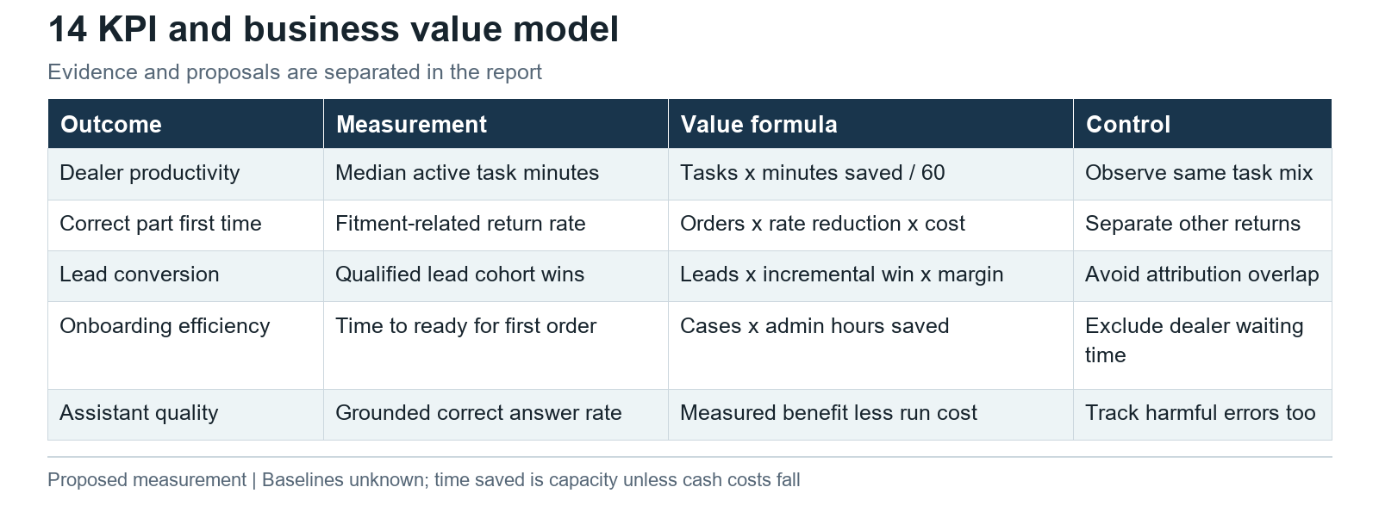
KPI and value framework | Evidence map or proposed design as labelled

18 Implementation options and phased roadmap

Option assessment
Option | Appropriate when | Main tradeoff and evidence gate
Extend ITL/importer tools | Existing services cover core tasks and allow local configuration | Dependence on product roadmap; inspect rights, support and cost
Integrate a dealer workspace | Transactions exist but identity/context are fragmented | Integration and support obligations; prove handoff reliability
Buy a DMS/B2B module | Existing estate or vendor supports required dealer workflow | Fit and licence cost; test real catalogue and entitlement data
Custom build | Distinct measured gaps persist after reuse/vendor assessment | Long-term operating burden; require data rights and benefit case
The sequence below is proposed. Calendar duration, staffing and cost depend on access, catalogue scope and integration complexity. No unsupported delivery date or cost estimate is presented.
Discovery. Confirm legal sponsor; inventory private systems; map current processes; obtain catalogue permissions and sample records; baseline dealer tasks; compare reuse options. Exit with a documented scope, owners and measurable pilot hypothesis. Stop or narrow if authority or data is unavailable.
Connected pilot. Use a bounded Dutch dealer cohort and model/catalogue sample. Preserve configured enquiry context, expose the next dealer action, trial machine-first parts identification and track onboarding evidence/status. Use source-linked assistance only where the content is approved. Exit after users complete real tasks and results reconcile to authoritative records.
Operational rollout. Add approved quote/order integrations and relevant service/warranty links after authoritative pricing, stock, acknowledgements, access control, support and recovery are tested. Resolve pilot failure causes before broadening. Establish support ownership, change control, data-quality monitoring and vendor obligations.
Optional market reuse. Validate one additional importer with different contracts or language. Separate market policy from shared software only where actual differences justify it. A successful Dutch pilot is evidence for a second test, not automatic approval for all ITL markets.
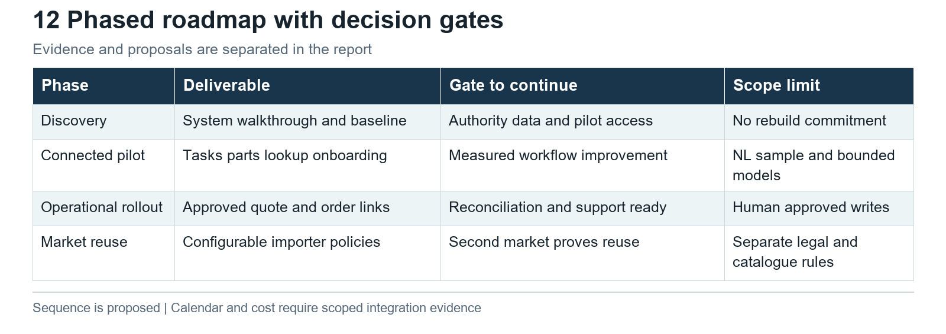
Phased roadmap | Evidence map or proposed design as labelled

19 Risks data requirements ownership and dependencies
Risk or dependency | Consequence | Mitigation and decision owner
Unresolved legal identity | Wrong sponsor, contract or data authority | Executive sponsor supplies current legal/registry evidence
Hidden existing capability | Duplicate build and conflicting workflows | ITL/importer IT demonstrates current portals and integrations
Missing catalogue/build rights | Unsafe or unlicensed parts service | Parts/product owner agrees rights and validates serial cases
Stale prices or inventory | Unfulfillable quotation or misleading promise | Commercial/operations owner defines freshness and acknowledgement
Model/version inconsistency | Wrong recommendation or incompatible option | Product owner governs market-specific master data and revisions
Cross-dealer data exposure | Loss of trust and unauthorised access | Identity/data owners enforce record-level scope and review tests
AI unsupported answers or actions | Incorrect fitment, price or commitment | Product/security owners gate sources, actions and human approvals
Poor adoption | Capacity benefit fails to materialise | Dealer pilot owners co-design tasks and measure actual use
Unowned integration failures | Requests disappear or duplicate | Operations owner monitors queues and reconciles records
Benefits double counted | Misleading business case | Finance owner separates channel/entity cash and capacity value
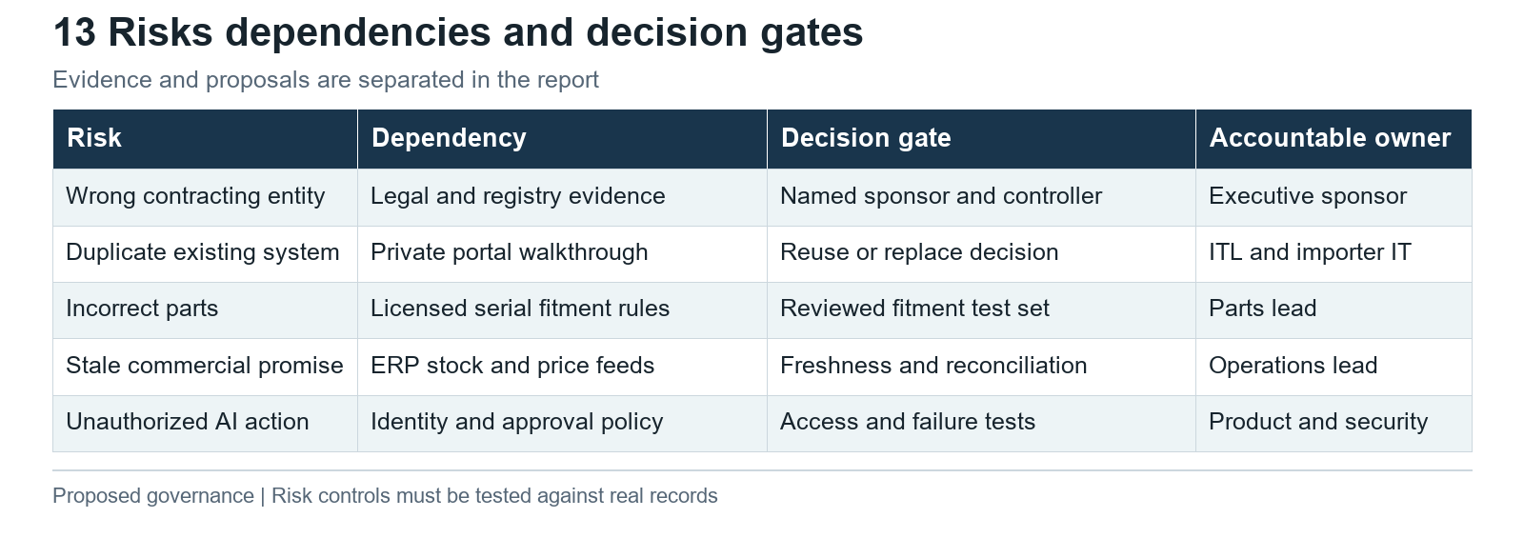
Risks and decision gates | Evidence map or proposed design as labelled

Proposed data readiness exercise
Ask ITL and the importer for an authorised sample spanning ten real serial-to-part cases, including a build change, engine variation, supersession, backorder, incorrect part and return. Request representative configured enquiries, quotes, orders, delivery inspections, warranty cases and onboarding files with personal information redacted where possible. Ten cases are a proposed starting sample, not proof of catalogue completeness.
For each record, confirm source, owner, identifier, revision, coverage, update method, entitlement and permitted use. Record errors and missing links rather than silently repairing them in a prototype. Determine whether current APIs, exports, deep links or manual controls can support the pilot. Expansion requires evidence across more models and exception types.

Privacy and contractual boundary
Data ownership, permitted processing and catalogue licensing must be documented by the relevant parties. The report proposes minimisation, access control, retention, audit and revocation controls; it is not a legal opinion. Legal reviewers must determine the applicable privacy and commercial obligations before combining customer/dealer data or deploying automated decisions. No assumption is made that public availability grants reuse rights.

20 KPIs and measurement framework
Measure workflow outcomes and failure causes alongside adoption. Establish baselines before a pilot and compare equivalent tasks, models, dealers and seasonal conditions. Use a staged rollout or matched comparison where feasible. Small purposive samples support operational learning, not a statistically proven network-wide uplift.
KPI | Definition and denominator | Proposed owner and collection
Dealer response time | Median and 90th percentile from qualified enquiry received to meaningful dealer response | Sales owner; joined source and dealer timestamps
Configuration handoff completeness | Enquiries with reproducible configuration and required context / eligible configured enquiries | Product/sales; payload checks
Quote handling time | Active work minutes per comparable quote, separated from elapsed customer waiting | Dealer sales; observation and event sample
Correct identification first time | Verified correct initial part selections / reviewed eligible requests | Parts lead; fitment review and order outcome
Fitment-related return rate | Returns caused by identification/compatibility / eligible delivered part lines | Parts/finance; reason-coded returns
Availability accuracy | Confirmed supply matches the displayed promise / reviewed promises | Operations; snapshot and acknowledgement comparison
Parts demand retained | Fulfilled eligible demand / measured requested demand, including logged lost cases | Parts/commercial; requests linked to orders
Onboarding readiness time | Elapsed complete application to approved first-order readiness; waiting reasons separately | Network lead; stage timestamps
Onboarding administration | Active internal hours per completed applicant and repeated-evidence rate | Network/finance; observation sample
Workflow adoption | Eligible tasks actually completed through workflow / eligible tasks | Product owner; event coverage reconciliation
Assistant grounded accuracy | Correct source-supported answers / reviewed test and live sample | Technical owner; expert-labelled review
Consequential assistant error | Wrong fitment, price, permission or executed commitment, by severity and denominator | Product/security; incident and approval logs
Integration reliability | Acknowledged requests and reconciled updates / requests sent; duplicates and unresolved failures | IT/operations; transaction ledger
Targets are deliberately unset until current performance and acceptable error levels are agreed. A high answer rate is not success if the assistant produces unsupported advice. Increased portal usage is not a benefit unless task outcomes improve. Time saved creates capacity; finance must separately confirm cash effects or incremental contribution.

21 Unanswered questions and stakeholder requests

Executive sponsor and legal owners
Identify the exact organisation Raja calls Solis Structures NL, the project beneficiary and the budget owner. Supply current KvK extracts, group ownership evidence and authorised signatories. Clarify the relationship among ITL's Solis B.V., AgriXpert and DIGO. Identify the dealer agreement counterparty, warranty obligor and data controller for each journey.

ITL and existing system owners
Demonstrate DMS/IBIZ and any other dealer platforms with relevant Dutch roles. Identify product, lead, quote, order, registration, warranty, parts, training and reporting coverage. Provide supported integration methods, entitlement model, change roadmap, support responsibility and reuse costs. Confirm which engineering/build and catalogue data can be licensed and for what uses.

Importer website commercial and operations owners
Show the configured enquiry payload and its dealer handoff; demonstrate whether a saved configuration, acknowledgement and response tracking already exist. Confirm who approves model/options/prices, which price list is effective and how website content is updated. Explain AgriXpert stock labels, stock ownership, warehouse routes via Almere/Germany, order acknowledgement and returns. Identify ERP/WMS/DMS systems without assuming vendor names.
Assign the demo follow-up promise, test the selector with unknown dimensions and reconcile cross-channel S16 variants. Demonstrate Dutch warranty intake through receipt, eligibility decision and correction; distinguish plate-free initial intake from any extension condition. Confirm supported uploads and document handling without assuming the lookup uses AI or an approved vehicle registry integration. [B25, B28, B22, B35, I31, I32]

Parts service and dealer owners
Walk through the proposed serial-to-part sample and recent warranty/return cases. Explain engine identification, supersessions, substitutions, workshop documents and catalogue rights. Show actual tasks and tools before declaring them manual. Supply timing, failure reasons and invoice/return records needed for a local business case.

Network development finance and training owners
Provide applicant stages, qualification standards, territory/credit decisions, agreement templates, required service capability, training and activation policy. Confirm who grants and revokes each role, how staff changes are handled and how a dealer becomes ready for its first order. Provide the ledger and cost definitions needed to separate machines, parts, service and warranty economics.

22 Conclusions and recommendations
The research supports a connected ecosystem opportunity, with reuse and evidence gathering as the immediate actions. Public Netherlands discovery and commerce are sufficiently developed that another selector or storefront needs a specific, demonstrated rationale. Regional portal evidence makes an ITL/importer walkthrough essential before procurement. [I07, I08, I09, I10, I11, M10]
First, establish authority. Resolve the legal sponsor, dealer contracts and data rights. ITL's reported ownership of Solis B.V. and AgriXpert's self-described importer role do not determine which entity can approve every workflow. [F01, I04, I05]
Second, observe and measure. Validate dealer tasks, private systems and catalogue coverage using real records. Treat rekeying, chasing and identification difficulty as hypotheses until observed. Establish entity-specific financial baselines; peer parts economics justify investigation without supplying a Solis percentage.
Third, connect a bounded pilot. Preserve enquiry context, give dealers a clear queue, improve verified parts identification and track onboarding readiness. Use existing transaction systems and catalogue tools where suitable. Keep exceptions visible and decisions with authorised owners.
Fourth, add AI where it earns its place. Source-linked answers and structured handoffs can be tested before transactional agency. Quote/order actions require approved prices, verified fitment, identity controls, explicit human approval and authoritative acknowledgement. No peer assistant announcement establishes Solis readiness.
Finally, decide with measured evidence. Broaden only when the pilot improves comparable tasks, resolves material failures and has an accountable operating model. If existing tools already meet the need, invest in configuration, data quality and adoption. If the data cannot support safe parts or commercial automation, retain human-assisted requests and narrow the scope.

23 Research limitations and material corrections
The work is public-source desk research. It did not include authenticated systems, direct interviews, catalogue licences, real machine records, transaction execution or certified Dutch registry extracts. Source access failures included timeouts, JavaScript-only pages, a sign-in-gated document centre, protected survey results and an unavailable US brochure. Those limitations restrict claims, not the usefulness of the decision framework.
No exact Solis machine-versus-parts/after-sales financial split, local installed base, verified returns cost, adoption baseline, implementation cost or ROI was established. FY2026 ITL audited statements were not obtained; ICRA's FY2025 reproduction is labelled Reported. Peer fiscal years and entity perimeters remain distinct.
The major corrections are: solis.eu is an unrelated namesake; public Dutch selection, configuration and ecommerce already exist; a dealer portal cannot be declared absent; stock labels do not prove real-time inventory; a warranty form does not prove full machine history; a partner parts hub does not identify every engine or its data rights; an appliance/solar Solis business must not enter the tractor map; and parts/service peer gross profit is not Solis machine revenue.
The targeted Dutch refresh additionally verifies the actual comparison table and public registration intake, correcting earlier access/coverage limits. It records the demo editorial placeholder, zero-width selector results, cross-channel specification differences and registration-policy questions as specific findings for accountable owners. These are newly verified research findings; no website deployment dates or successful form-processing results are inferred. [B26, I31, B28, B25, B35, I32]
The proposed screens, architecture, roles, roadmap and interview sample are original analytical recommendations. Their data owners and system-of-record boundaries are provisional. Further implementation decisions should replace those assumptions with documented operational evidence.

24 Detailed source register and appendices
The following register records the reviewed sources and limitations. The accompanying CSV is the searchable evidence record; the financial workbook contains sourced actuals and the separate illustrative scenario build. The Visual Assets directory contains the original diagrams, chart and wireframes used in the report.

I01 Solis Deutschland redirected from solis.eu
Solis household appliances | Verified | Published not stated | Accessed 2026-11-03
https://solis.eu/
Supports: solis.eu redirects to solis.de appliance site; exclude from tractor ecosystem
Evidence and limits: Opened domain; coffee kitchen beauty climate; Swiss family company description Namesake; no tractor-brand relationship established

I02, M01 Become a Solis Dealer
Solis World ITL | Verified | Published Undated | Accessed 2026-11-03
https://solisworld.com/become-a-dealer/
Supports: Public dealer interest form captures contact country company address products sold and years in business; follow-up by company team
Evidence and limits: Opened page; inspected form fields and follow-up text No application submitted; qualification, approval, agreements and provisioning not observed

I03 International Tractors Limited Ratings reaffirmed
ICRA | Reported | Published 2024-09-30 | Accessed 2026-11-03
https://www.icra.in/Rating/ShowRationalReportFilePdf/130279
Supports: Solis Tractors & Agricultural Machinery BV 100% ownership full consolidation
Evidence and limits: Annexure II page 6; source ITL consolidated annual report FY2023 Historical credit agency reproduction; superseded for currency by I27

I04, I36, B30 Solis Nederland AgriXpert BV dealer in Schipluiden
Solis Nederland AgriXpert | Verified | Published Not stated | Accessed 2026-11-03
https://www.solistractor.nl/dealers/agrixpert/
Supports: Dealer details provide phone route shop link and call-for-current-availability guidance
Evidence and limits: Original page opened; current availability and visit demonstration call instruction visible No inventory reservation or service booking execution verified

I05 Agrixpert home
AgriXpert | Verified | Published not stated | Accessed 2026-11-03
https://www.agrixpert.com/
Supports: AgriXpert describes membership of DIGO group and ecommerce account benefits
Evidence and limits: Homepage group description; account login and order/shipping history benefit list No legal shareholding chain verified

I06 Best Farm Tractor Mini Tractor for Sale
Solis World / ITL | Verified | Published not stated | Accessed 2026-11-03
https://solisworld.com/
Supports: Global catalogue contains EU/global range and country selector linking Netherlands
Evidence and limits: Country selector Netherlands to solistractor.nl; product engines/implements Public marketing counts not audited; no central pan-European site established

I07, B23 Keuzehulp welke Solis past bij uw werk
Solis Nederland AgriXpert | Verified | Published Not stated | Accessed 2026-11-03
https://www.solistractor.nl/keuzehulp/
Supports: Three-step selector provides work transmission and width criteria
Evidence and limits: Followed actual links loading then shuttle; counts 12 to8 to4 Rules beyond sampled routes not exhaustively tested

I08, B27 Solis S26 Mechanisch 26pk prijs en specificaties
Solis Nederland AgriXpert | Verified | Published Price basis2026-02-01 | Accessed 2026-11-03
https://www.solistractor.nl/modellen/s26/
Supports: Configurator options dependencies indicative price disclaimer and dealer-selected quote form present
Evidence and limits: Original page and public form markup read; model hidden field present; no form sent Browser recalculation and full option payload transfer delivery CRM acknowledgement untested

I09, B35 Solis16 4WD
AgriXpert | Verified | Published Not stated | Accessed 2026-11-03
https://www.agrixpert.com/solis-16-4wd
Supports: Importer purchase page stock options VAT prices cart; lift500kg width90cm differ from Dutch model index
Evidence and limits: Direct public HTTPS HTML text inspected; product detail500kg and descriptive90cm; links solistractor.nl Version/configuration basis unresolved; no cart action checkout or live quantity verification; do not choose correct specification without owner

I10 Haendlerlogin
Solis Germany / ILAFA | Verified | Published not stated | Accessed 2026-11-03
https://www.solis-traktor.de/haendlerlogin
Supports: Explicit Solis dealer portal login exists in Germany
Evidence and limits: Email/password form and dealer-area description No credentials used; functionality and NL access unknown

I11 Leading Agricultural Tractor Implements Manufacturer
Solis Romania / DELTATEH | Verified | Published not stated | Accessed 2026-11-03
https://tractoarelesolis.ro/
Supports: Country-linked site exposes DMS/IBIZ login to crm.sonalika.com/EMS
Evidence and limits: Global selector link provenance; opened page DMS and IBIZ anchors Endpoint timed out; no authenticated features verified

I12 Impressum
ILAFA eG | Verified | Published not stated | Accessed 2026-11-03
https://www.solis-traktor.de/impressum
Supports: German tractor website legal operator ILAFA eG Radolfzell
Evidence and limits: Legal notice company address registry 550028 Freiburg Does not prove ITL ownership or country exclusivity

I13 Global Leader in Agricultural Innovation About Solis
Solis World / ITL | Verified | Published not stated | Accessed 2026-11-03
https://solisworld.com/about-solis/
Supports: ITL corporate/production and international network self-description
Evidence and limits: Body incorporation1995 versus generic1969 footer; EU/nonEU markets and manufacturing described Marketing counts vary; not audited current volumes or installed base

I14 Solis Tractors Agricultural Machinery BV
Compadex | Reported | Published not stated | Accessed 2026-11-03
https://www.compadex.com/nl/businesses/nl/solis-tractors-agricultural-machinery-b-v-73516228-41551346
Supports: Registry aggregator reports KvK73516228 Hoofddorp Polarisavenue130
Evidence and limits: Opened listing business/address records; opened version updated8Aug2025 Not certified KvK extract; search snippet had different update; address differs from EIMA

I15, I38, B29 Dealers
Solis Nederland AgriXpert | Verified | Published Not stated | Accessed 2026-11-03
https://www.solistractor.nl/dealers/
Supports: Locator19 dealers1subdealer province selector generic stock labels; subdealer lacks own stock
Evidence and limits: Direct public HTTPS HTML retrieved after research-tool timeouts; full text inspected Generic stock label not SKU quantity or live data feed; active contractual roster not verified

I16 Solis Tractors Agricultural Machinery BV exhibitor
EIMA / FederUnacoma | Reported | Published not stated | Accessed 2026-11-03
https://www.eima.it/en/2530/solis-tractors-agricultural-machinery-bv
Supports: Exhibitor lists Solis BV at Rijksstraatweg34 Schipluiden
Evidence and limits: Opened current2026 exhibitor page company/address and ITL brand profile Exhibitor record not corporate registry; shared address not identity or ownership proof

I17, B24 Keuzehulp loading shuttle no width restriction result
Solis Nederland AgriXpert | Verified | Published Not stated | Accessed 2026-11-03
https://www.solistractor.nl/keuzehulp/?situation=laden&transmission=shuttle&width=any
Supports: Result heading four matches but returned text three cards; S50 and S60 widths zero
Evidence and limits: Linked final result opened; heading4 cards S26ShuttleXL S50 S60; width0cm latter two Returned content observation; native browser visual confirmation unavailable; do not infer actual machine width

I18 Solis Prijslijst per 01 02 2026
Solis Nederland / AgriXpert | Verified | Published 2026-02-01 | Accessed 2026-11-03
https://www.solistractor.nl/wp-content/uploads/2026/08/Solis-prijslijst.pdf
Supports: Dated public11-page price list covers machines tyres loaders installation and options
Evidence and limits: PDF internal effective date1Feb2026; S26 page4 EUR10150 excluding VAT per model page Promotional validity dealer confirmation required; upload path is not effective date

I19 Solis tractoren
AgriXpert | Verified | Published not stated | Accessed 2026-11-03
https://www.agrixpert.com/tractoren/tractoren/solis
Supports: Importer ecommerce lists Solis tractors and attachments with prices and cart entry
Evidence and limits: 20 products in opened category; account benefits and cart Product count volatile; dealer wholesale functions not established

I20, I33, B31 Service en ondersteuning
Solis Nederland AgriXpert | Verified | Published Not stated | Accessed 2026-11-03
https://www.solistractor.nl/klantenservice/
Supports: Parts request links dealer locator; asks model serial hours; warranty registration links dedicated form
Evidence and limits: Direct HTTPS text and hrefs inspected after web tool timeout; parts href/dealers and registration href/garantieformulier Public human-assisted journey does not prove manual internal workflows or absence private parts systems

I21, I37, B34 Informatie over Solis tractoren
Solis Nederland AgriXpert | Verified | Published Not stated | Accessed 2026-11-03
https://www.solistractor.nl/informatie/
Supports: Company describes NL operational parts route via Almere and names different component suppliers
Evidence and limits: Original page opened sections Partners and Garantie en onderdelen Company description not warehouse audit or licence confirmation; no full build-to-component map

I22, B16 Tractor Parts
Solis World | Verified | Published Not stated | Accessed 2026-11-03
https://solisworld.com/tractor-parts/
Supports: Global company page describes German Yanmar joint venture parts hub and sub-48-hour delivery
Evidence and limits: Germany section lines 214–223 Company claim only; not a measured service level; current operational route and contractual entitlement need confirmation

I23 Contact dealer subject
Solis Nederland / AgriXpert | Verified | Published not stated | Accessed 2026-11-03
https://www.solistractor.nl/contact/?onderwerp=dealer
Supports: NL become-dealer link is general contact form route
Evidence and limits: Name email phone subject message privacy checkbox No qualification/credit/agreement/provisioning workflow demonstrated

I24 Garantie aktivieren
Solis Germany / ILAFA | Verified | Published not stated | Accessed 2026-11-03
https://www.solis-traktor.de/garantie
Supports: German warranty registration form exists
Evidence and limits: Invoice upload PDFJPGPNG; optional serial/model/date; staff review described German coverage only; no submission; do not apply to NL

I25, I32 Garantie op Solis tractoren
Solis Nederland / AgriXpert | Verified | Published not stated | Accessed 2026-11-03
https://www.solistractor.nl/garantie/
Supports: Warranty information links to Dutch registration; terms vary by model
Evidence and limits: Page contains registration link; valid Dutch plate condition for extension; dealer confirmation Policy interpretation and exact eligibility require owner confirmation; form permits blank plate, potentially different registration stage

I26, B14 Compact Tractor for Superior Farming Efficiency
Solis World | Verified | Published Not stated | Accessed 2026-11-03
https://solisworld.com/solis-s26-compact-tractor/
Supports: S26 page describes three-cylinder Mitsubishi engine
Evidence and limits: Engine section lines 239–242; page uses S26 and S26+ labels Market and build-specific engine configuration not verified; model-name ambiguity needs serial/build validation

I27, F01 International Tractors Limited Ratings reaffirmed
ICRA | Reported | Published 2025-11-28 | Accessed 2026-11-03
https://www.icra.in/Rating/GetRationalReportFilePdf?id=139360
Supports: ITL FY2024 and FY2025 financial indicators and Solis BV ownership
Evidence and limits: Audited indicator table p4; export discussion p2; ownership annexure p6 reproduces company accounts. Rating agency reproduction, not underlying audited accounts. No Solis brand, Dutch or parts revenue split. Finance consolidation scope requires reconciliation.

I28, I34 Privacybeleid
Solis Nederland / AgriXpert | Verified | Published not stated | Accessed 2026-11-03
https://www.solistractor.nl/privacybeleid/
Supports: Public purposes/contact present; detailed legal-controller and extraction data map not established
Evidence and limits: Original page sections cover contact/warranty purposes general retention/security and rights; AgriXpert footer Do not infer absence of internal agreements or legal noncompliance; no specific extraction processor/retention verified

I29 Global Download Center folder
Solis World / Google Drive | Open question | Published not stated | Accessed 2026-11-03
https://drive.google.com/drive/folders/17tWwFbPSFUTQHPbf4EIDB1lIVkhGKnSi?usp=sharing
Supports: Global download centre target not inspectable in research tool
Evidence and limits: Official footer link followed; redirected Google sign-in Do not infer contents require private access for everyone; tool limitation only

I30 DMS endpoint
ITL / Sonalika | Open question | Published not stated | Accessed 2026-11-03
https://crm.sonalika.com/EMS/
Supports: Official-country-linked DMS destination timed out
Evidence and limits: Followed Romanian DMS anchor No endpoint function/access claim beyond publicly linked destination

B01 Intranet Multi Links
Kubota Europe SAS | Verified | Published Not stated | Accessed 2026-11-03
https://landing.kubota-eu.com/intranet-multi-links/
Supports: Permissioned SSO dealer workspace links sales training technical warranty maintenance and parts applications
Evidence and limits: Public directory lines 31–124 identifies CDC SSO, prior authorisation, Showell, e-learning, K E-Service, SCC, KITS, K-PAD and KEP Public documentation; authenticated tools not entered; no performance verification

B02 How To Shop
CNH MyCNHStore | Verified | Published Not stated | Accessed 2026-11-03
https://www.mycnhstore.com/it/it/caseih/HowToShop
Supports: Parts search by serial model and part; diagrams fitment availability saved equipment shopping lists orders and checkout described
Evidence and limits: Guide lines 218–299 describes capabilities; lines 338–340 says not all dealers available; photo upload UI lines 378–417 Italian route contains English guide and payment references; do not presume all functions/payment types apply in Netherlands; no live order or image accuracy test

B03 Genuine New Holland Parts
New Holland Agriculture CNH | Verified | Published Not stated | Accessed 2026-11-03
https://agriculture.newholland.com/en-us/nar/services-and-solutions/parts
Supports: North America MyCNHStore offers model serial keyword discovery and account shopping lists equipment single cart
Evidence and limits: Official product page lines 5–12 and dealer fulfilment lines 82–86 North American scope; manufacturer description not completed transaction

B04 CASE IH PRO
CNH Industrial America LLC | Verified | Published Not stated | Accessed 2026-11-03
https://pro.caseih.com/site/accountview/login
Supports: Dealer sales support platform with information assistance tools training and Dealer Portal login
Evidence and limits: Public login page lines 2–9 No authenticated features inspected; does not establish CRM quote management or dashboards

B05 eTIM Login
CNH | Verified | Published Not stated | Accessed 2026-11-03
https://services.cnh.com/etim/
Supports: eTIM requires Dealer Portal credentials
Evidence and limits: Original login page explicitly requests Dealer Portal ID and password Login presence only; underlying functionality not inspected

B06 Warranty Information Tool Login
CNH | Verified | Published Not stated | Accessed 2026-11-03
https://services.cnh.com/wit/
Supports: Warranty Information Tool requires Dealer Portal credentials
Evidence and limits: Original login page requests Dealer Portal ID and password No claims execution demonstrated

B07 AGCO Tech Connect
AGCO Corporation | Verified | Published Not stated | Accessed 2026-11-03
https://www.agcocorp.com/us/en/home/brands-and-solutions/service-and-information/agco-tech-connect.html
Supports: Dealer portal PDI technical incidents knowledge search partial serial lookup notifications mobile evidence and offline PDI
Evidence and limits: Official page lines 19–42 documents modules and workflow capabilities Manufacturer description; no quantified productivity outcome verified

B08 Spare parts
Fendt AGCO GmbH | Verified | Published Not stated | Accessed 2026-11-03
https://www.fendt.com/int/parts-service/spareparts
Supports: AGCO Parts Books dealer access and ordering; mobile exploded views hotpoints emailed basket and offline lists
Evidence and limits: Official page sections AGCO Parts Books and Books To Go lines 39–57 Account required via Fendt partner; emailed basket is not transactional checkout; regional coverage not tested

B09 AGCO Service and Information Resources for Customers
AGCO Corporation | Verified | Published Not stated | Accessed 2026-11-03
https://www.agcocorp.com/us/en/home/brands-and-solutions/service-and-information/agco-service-and-information-resources.html
Supports: Registered customer machine manuals warranty information and dealer-mediated diagnostics; EU dealer tool web store
Evidence and limits: Sections Service and Information Portal, Process for dealers in EU, and access process Supported models vary; no Solis diagnostic entitlement implied

B10 John Deere Credentials
VitalEdge IntelliDealer technical documentation | Verified | Published 2026-02 revision | Accessed 2026-11-03
https://help.intellidealer.com/intellidealer/Content/configuration.interfaces.deere.credentials.htm
Supports: DMS vendor documents licensed Deere quote parts availability warranty credit EPC proactive jobs and telematics interfaces
Evidence and limits: Interface table lines 114–123 and scope/credentials instructions Primary vendor documentation of integration; not Deere certification for all dealers or proof of Solis integration

B11 My Dealer John Deere Parts Catalog Integration
VitalEdge IntelliDealer technical documentation | Verified | Published 2024-10 revision | Accessed 2026-11-03
https://help.intellidealer.com/intellidealer/Content/configuration.interfaces.deere.partscatalog.credentials.htm
Supports: EPC selections transfer to dealer cart for logged-in and guest flows with licensing credentials and exceptions
Evidence and limits: Prerequisites and process walkthrough lines 108–202; unmatched local parts sent to parts manager Specific vendor interface; credentials/licences required; does not grant reusable catalogue or API rights

B12 Introduction to MyDealer
VitalEdge IntelliDealer technical documentation | Verified | Published Not stated | Accessed 2026-11-03
https://help.intellidealer.com/intellidealer/Content/Ref/MyDealer_Introduction.htm
Supports: Customer portal exposes invoices equipment service requests quotes and parts commerce
Evidence and limits: Public product help lines 54–75 Vendor platform is not Deere-exclusive; requires licensed IntelliDealer

B13, M10 Solis USA service and support
Solis Tractors USA | Verified | Published Undated | Accessed 2026-11-03
https://solistractorusa.com/content/sportsman/service.php
Supports: Official US service page states dealers order parts through a Solis dealer portal and customers order through dealers
Evidence and limits: Opened page Ordering and Fulfillment Process lines 42 to 45 Company-described US capability; portal not accessed; EU/NL scope unknown; inconsistent HQ statements elsewhere not relied on

B15 Frequently asked questions
Diesel Equipment Trading | Verified | Published Not stated | Accessed 2026-11-03
https://webshop.det-mitsubishi.com/faq.aspx
Supports: Distributor requests engine model serial application; manuals purchased; ordering login needs delivery and payment agreement
Evidence and limits: FAQ engine identification ordering and self-order sections; company describes Mitsubishi distribution role No verified supplier relationship with every Solis model; no catalogue redistribution licence or API rights established

B17 Dealer Manufacturer Relations Survey
North American Equipment Dealers Association | Verified | Published Not stated | Accessed 2026-11-03
https://www.naeda.com/dealer-manufacturer-relations-survey/
Supports: Primary dealer survey evaluates parts availability quality returns technical support warranty and communication
Evidence and limits: Annual assessment description lines 245–253; results download redirects to password-protected page North American study; proprietary latest results not reviewed; no Solis or Dutch scores inferred

B18 Questions To Ask Before Acquiring A New Manufacturer
Western Equipment Dealers Association hosted by NAEDA | Verified | Published 2020 | Accessed 2026-11-03
https://www.naeda.com/wp-content/uploads/2020/03/Questions-To-Ask-Before-Acquiring-A-New-Manufacturer.pdf
Supports: Dealer readiness checklist includes territory finance stocking payment returns tools training warranty reimbursement and contract responsibilities
Evidence and limits: PDF page 2 ten desirable provisions; subsequent detailed questions Industry association guidance from North America; not Solis agreement or Dutch legal advice

B19 Summit vs Kubota vs
Reddit r tractors user japollner | Reported | Published Relative timestamp approximately two years ago; exact date not verified | Accessed 2026-11-03
https://www.reddit.com/r/tractors/comments/1h25w0w/summit_vs_kubota_vs/
Supports: One self-described New Hampshire Solis and TYM dealer says perceived parts availability and network influence sales preference
Evidence and limits: Comment by japollner at lines 432–437 in opened thread Anonymous identity not independently verified; qualitative US anecdote; not representative of NL or entire network

B20 Solis Summit 26 and flail mower
Reddit r tractors user C-man14 | Reported | Published Relative timestamp approximately one year ago; exact date not verified | Accessed 2026-11-03
https://www.reddit.com/r/tractors/comments/1nyh8nq/solissummit_26_flail_mower/
Supports: One owner reports a nearby dealer and spare parts availability
Evidence and limits: C-man14 pros and cons comment includes dealer 30 km away and parts availability Self-reported geography and machine configuration not verified; not a Dutch dealer finding

F02 AGCO 2025 Annual Report
AGCO Corporation via SEC | Verified | Published 2026; exact issue date not established | Accessed 2026-11-03
https://www.sec.gov/Archives/edgar/data/880266/000088026626000027/agco2025annualreport_ars.htm
Supports: AGCO 2023 to 2025 revenue by product, and 2025 Europe Middle East parts sales
Evidence and limits: Audited financial statements Disaggregated Revenue pp113 to115. Group and regional OEM sales; not Solis. Parts exclude separately unidentified services. G&P divestiture in November2024 changes denominator.

F03 Titan Machinery FY2026 Form 10 K
Titan Machinery via SEC | Verified | Published 2026-03-31 | Accessed 2026-11-03
https://www.sec.gov/Archives/edgar/data/1409171/000162828026022376/titn-20260131.htm
Supports: Dealer revenue, gross profit and segment mix
Evidence and limits: Year ended31 January2026; pp31 to33 and Note3 p62; amounts USD thousands. Multi-brand dealer group including construction, Europe and Australia. Retail vs OEM economics differ. Service gross profit definition differs from parts.

F04 CNH 2025 Form 10 K
CNH via SEC | Verified | Published 2026; exact filing date not established | Accessed 2026-11-03
https://www.sec.gov/Archives/edgar/data/1567094/000156709426000006/cnhi-20251231.htm
Supports: CNH segment net sales and aftersales business relevance
Evidence and limits: Parts and Services pp10 to11; segment net sales pp49 to50. Reviewed disclosure does not isolate parts revenue; do not infer parts share from Agriculture total.

F05 Deere and Company FY2025 Form 10 K
Deere and Company via SEC | Verified | Published 2025-12-18 | Accessed 2026-11-03
https://www.sec.gov/Archives/edgar/data/315189/000110465925122321/de-20251102x10k.htm
Supports: Equipment operations net sales include service parts and technology
Evidence and limits: Item1 Equipment Operations and Note27 Segment Data. No isolated comparable parts percentage found in reviewed revenue and segment disclosures. FY ends2 November2025.

F06 Financial Results for the Year Ended December 31 2025 IFRS
Kubota Corporation | Verified | Published 2026-02-12 | Accessed 2026-11-03
https://www.kubota.com/ir/financial/release/data/136q4e.pdf
Supports: Kubota group and Machinery 2025 revenue
Evidence and limits: Earnings release p1 and segment/product tables. Parts revenue not isolated in reviewed release. Earnings release rather than audited annual statement.

M02 FarmerCore annual report strategy
AGCO | Verified | Published 2025 annual report context | Accessed 2026-11-03
https://www.agcocorp.com/us/en/home/annual_report/our-strategy/farmercore.html
Supports: AGCO describes AgBot within AGCONet answering dealer parts/service questions; FarmerCore connects online configure and parts with dealer delivery and service
Evidence and limits: Opened official page sections Creating A Seamless Digital Journey and Global Support Powered by AI Company capability description; no login, accuracy or independent adoption verification

M03 Cat AI Assistant
Caterpillar | Verified | Published Undated 2026 context | Accessed 2026-11-03
https://www.cat.com/en_US/support/technology/cat-ai-assistant.html
Supports: Guest and logged-in assistance; parts/manual/fleet/dealer support; progressive rollout across Cat applications
Evidence and limits: Opened official support page Rollout differs by surface; no account transaction test or proven autonomous ordering

M04 Caterpillar brings intelligent solutions to life at CONEXPO CON AGG 2026
Caterpillar | Verified | Published 2026-03 | Accessed 2026-11-03
https://www.cat.com/content/dam/catDotCom/documents/trade-press-releases/en_us/2026/march/40PR26.pdf
Supports: Off-board Cat AI Assistant described as now available; in-cab application described as prototype
Evidence and limits: Opened four-page official press release; text on pages 1 and 2 Later refetch timed out; manufacturer assertion not independently tested

M05 John Deere introduces JD the AI assistant that helps farmers put their data to work
John Deere | Reported | Published 2026-09-01 | Accessed 2026-11-03
https://www.deere.ca/en-ca/john-deere-news/introducing-jd-ai-assistant
Supports: JD announced with limited early access for selected US agricultural customers; broader availability planned
Evidence and limits: Official indexed article discovered; direct open returned JavaScript-only shell Full original article could not be inspected; limited evidence; not proof broad production rollout

M06 A 24 7 sales assistant on Azure that takes real orders with enterprise grade security
Unlock Management | Reported | Published 2026-02 | Accessed 2026-11-03
https://www.unlockmanagement.com/cases/ajusa-azure-sales-assistant/
Supports: Implementer describes Ajusa assistant connected to SAP/catalog APIs creating and changing orders with explicit confirmations and auditing
Evidence and limits: Opened named implementer case study Vendor case study; no customer-side confirmation, adoption or quantified outcome evidence

M07 Product Suggestions
Sana Commerce documentation | Verified | Published Undated | Accessed 2026-11-03
https://support.sana-commerce.com/Content/Sana-User-Guide/Ordering-Checkout/Product-Suggestions.htm
Supports: Product suggestions can be produced by ERP rules using customer order history
Evidence and limits: Opened product documentation Documented software feature rather than a named deployment; not evidence of AI agency

M08 Sustainability Report 2016 dealer management
CNH Industrial | Verified | Published 2017 reporting 2016 | Accessed 2026-11-03
https://www.cnh.com/-/media/CNHi/cnhicorporate/Sustainability/sustainability_reports/docs/CNH_Industrial_2016_Sustainability_Report_PRINTABLE.pdf?rev=-1
Supports: Historical eNAAF cross-functional approvals, contracted dealer provisioning, role training and dealer sales/after-sales portal documented
Evidence and limits: Opened PDF; inspected printed pages 229 to 231 including page screenshot Historical precedent only; cannot establish current CNH or Solis process

M09 Kubota Engine Dealer Program
Kubota Engine America | Verified | Published Undated | Accessed 2026-11-03
https://www.kubotaengine.com/service/dealer-program/
Supports: Dealer authorizations differ for full service specialized and trade partner; training and technical resources described
Evidence and limits: Opened dealer program and navigation to academy parts and warranty systems US engine channel; requirements not transferable to Dutch tractor dealerships

M11 Solis USA dealer recruitment brochure
Solis Tractors USA | Open question | Published 2025 path | Accessed 2026-11-03
https://solistractorusa.com/wp-content/uploads/2025/07/solis-dealerrecruitment-web.pdf
Supports: Search discovery suggested additional portal documentation; excluded as substantive evidence
Evidence and limits: Direct fetch returned 404 Unavailable original; indexed snippets not sufficient

M12 Actieprijzen
Solis Nederland / AgriXpert | Verified | Published not stated | Accessed 2026-11-03
https://www.solistractor.nl/acties/
Supports: Published S50 loader package prices and unspecified promotion validity
Evidence and limits: Opened package table: tractor EUR 21,725, loader EUR 4,995, mounting EUR 650, total EUR 27,370 excluding VAT; page asks dealer to confirm active period Public indicative prices, not dealer net prices, a binding quote or proof of current stock; publication date not stated

I31, B32 Garantieformulier
Solis Nederland AgriXpert | Verified | Published Not stated | Accessed 2026-11-03
https://www.solistractor.nl/garantieformulier/
Supports: NL machine warranty registration form owner dealer serial invoice upload and optional data extraction controls present
Evidence and limits: Original opened; required purchase proof optional plate/photo and model/chassis lookup copy; warns not automatic5year guarantee No upload/submission; extraction accuracy photo deletion processing approval and retention untested

I35 Over Solis
Solis Nederland / AgriXpert | Verified | Published not stated | Accessed 2026-11-03
https://www.solistractor.nl/over-ons/
Supports: AgriXpert represents Solis NL; ITL manufacturer; published NL parts route Almere
Evidence and limits: Direct public HTTP200 retrieval after web timeout; about-page role descriptions Self-description; no certified current registry, warehouse owner, contract or data rights

I39, B21 Solis Tractoren Compacte kracht voor elk terrein
Solis Nederland AgriXpert | Verified | Published Not stated | Accessed 2026-11-03
https://www.solistractor.nl/
Supports: Homepage exposes 12 models prices selector comparison dealer demo and service routes
Evidence and limits: Original page opened; 12 model cards 16–90 pk and discovery/navigation links Company-published product data not independently engineering-verified

B22 Solis modellen Tractoren van 16 tot 90 pk
Solis Nederland AgriXpert | Verified | Published Not stated | Accessed 2026-11-03
https://www.solistractor.nl/modellen/
Supports: Model list includes price specs comparison selection; S16 published lift650kg standard width94.5cm
Evidence and limits: Web tool timed out; direct public HTTPS HTML retrieval succeeded and text inspected No browser layout QA; specification version basis requires product owner confirmation

B25 Keuzehulp loading shuttle less than one metre result
Solis Nederland AgriXpert | Verified | Published Not stated | Accessed 2026-11-03
https://www.solistractor.nl/keuzehulp/?situation=laden&transmission=shuttle&width=100
Supports: Less than1m criterion returns S50 S60 S75 all with displayed width0cm and match assurance
Evidence and limits: Followed narrower-than1m link from step3; original final result inspected Cannot substantiate clearance from shown data; actual tractor dimensions not independently established

B26 Modellen vergelijken S26 and H26
Solis Nederland AgriXpert | Verified | Published Not stated | Accessed 2026-11-03
https://www.solistractor.nl/vergelijken/?modellen%5B%5D=s26&modellen%5B%5D=h26
Supports: Populated two-model comparison table with price engine transmission width weight pump and other fields
Evidence and limits: Comparison shell opened; observed GET form modellen[] fields used for read-only HTTPS request; populated S26H26 table retrieved Web query fetch failed but direct HTTPS succeeded; browser persistence and differences toggle execution untested

B28 Demonstratie aanvragen model S26
Solis Nederland AgriXpert | Verified | Published Not stated | Accessed 2026-11-03
https://www.solistractor.nl/demonstratie/?model=s26
Supports: Demo form is public and unfinished follow-up editorial instructions are live
Evidence and limits: Both generic and model-linked original opened; section before form says Nog in te vullen voor livegang and asks for follow-up recipient timeframe and commitment wording No submission; model preselection backend routing and follow-up cannot be inferred

B33 Contact
Solis Nederland AgriXpert | Verified | Published Not stated | Accessed 2026-11-03
https://www.solistractor.nl/contact/
Supports: General contact form subjects include dealer application warranty and parts/service
Evidence and limits: Direct public HTTPS text retrieved after web timeout; name email phone subject message consent fields No submitted lead or automated onboarding demonstrated

