Bug#1:

**Summary:**

The **yearly** plan with **50** Rentals displays $**518** for **ultimate** plan, instead of $**525**

**Test Environment:**

Lodgify application hosted on local server is accessed via Chrome browser

**Steps to reproduce:**

1. Go to Application (using url: <http://localhost:8080>)
2. Click on pricing.html page to go to pricing page (<http://localhost:8080/pricing.html>)
3. Slide the number of Rentals bar to 50
4. Make sure yearly plan is selected, if not selected, by default
5. Observe that the pricing value displayed for Ultimate plan is $518

**Expected Result:**

The “**Yearly**” plan with “**50**” rentals should display “$**525**” for the “**Ultimate**” plan

**Actual Result:**

The “**Yearly**” plan with “**50**” rentals displayed “$**518**” for the “**Ultimate**” plan

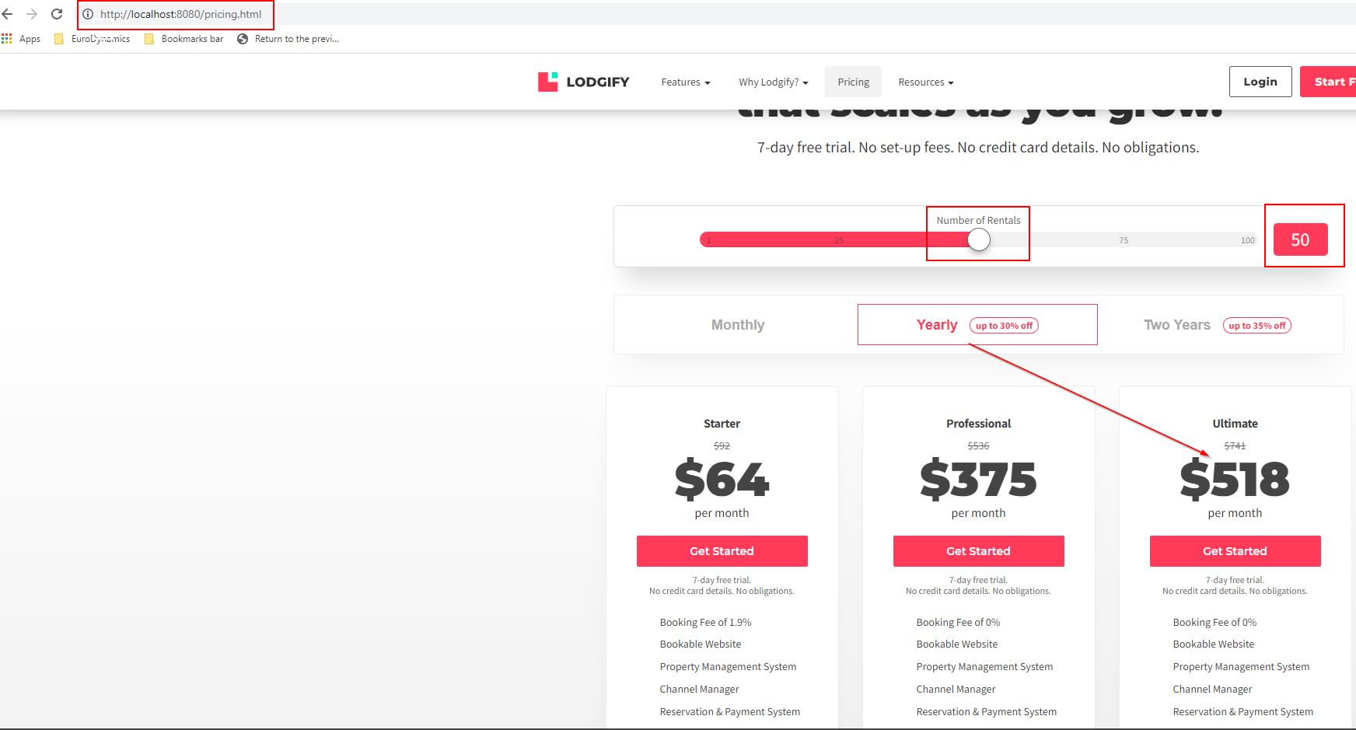

**Contact page bugs:**

**Bug#2:**

**Summary:**

User can not distinguish the mandatory fields vs optional fields on the contact page.

**Steps to reproduce:**

1. Go to Application (using url: <http://localhost:8080>)
2. Click on contact.html page to go to contact page(<http://localhost:8080/contact.html>)
3. Observe the contact form to locate mandatory fields

**Expected Result:**

The mandatory fields on the contact page should be distinguished from Optional fields using “*” in RED color.

**Actual Result:**

Users can not distinguish the mandatory fields vs Optional fields on the contact page.

**Name, Phone, Email, Comments** are the mandatory fields as per requirement document.

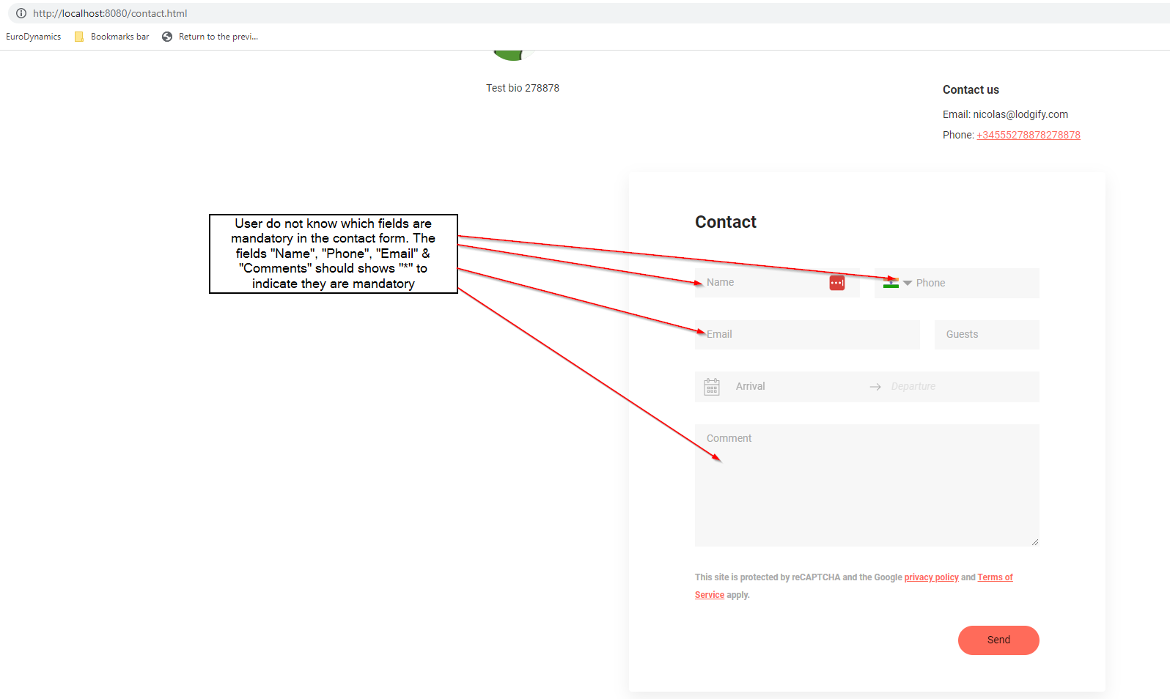

**Bug#3:**

**Summary:**

When the user clicks on send button having all the fields empty, on the contact form do not highlight the phone field with text “Phone is mandatory”

**Steps to reproduce:**

1. Go to Application (using url: <http://localhost:8080>)
2. Click on contact.html page to go to contact page(<http://localhost:8080/contact.html>)
3. Make sure all the fields in the contact page are empty
4. Click the Send button
5. Observe the text in red color indicating the mandatory field is not displayed for **Phone** field

**Expected Result:**

Since the phone field is mandatory, when not filled, the mandatory text should be displayed “Phone is mandatory”

**Actual Result:**

“**Phone is mandatory**” is not displayed when the page is submitted with empty **phone** field.

