Bug#1:
Summary:
The yearly plan with 50 Rentals displays $518 for ultimate plan, instead of $525

Test Environment:
Lodgify application hosted on local server is accessed via Chrome browser
Steps to reproduce:
- Go to Application (using url: http://localhost:8080)
- Click on pricing.html page to go to pricing page (http://localhost:8080/pricing.html)
- Slide the number of Rentals bar to 50
- Make sure yearly plan is selected, if not selected, by default
- Observe that the pricing value displayed for Ultimate plan is $518
Expected Result:
The “Yearly” plan with “50” rentals should display “$525” for the “Ultimate” plan
Actual Result:
The “Yearly” plan with “50” rentals displayed “$518” for the “Ultimate” plan
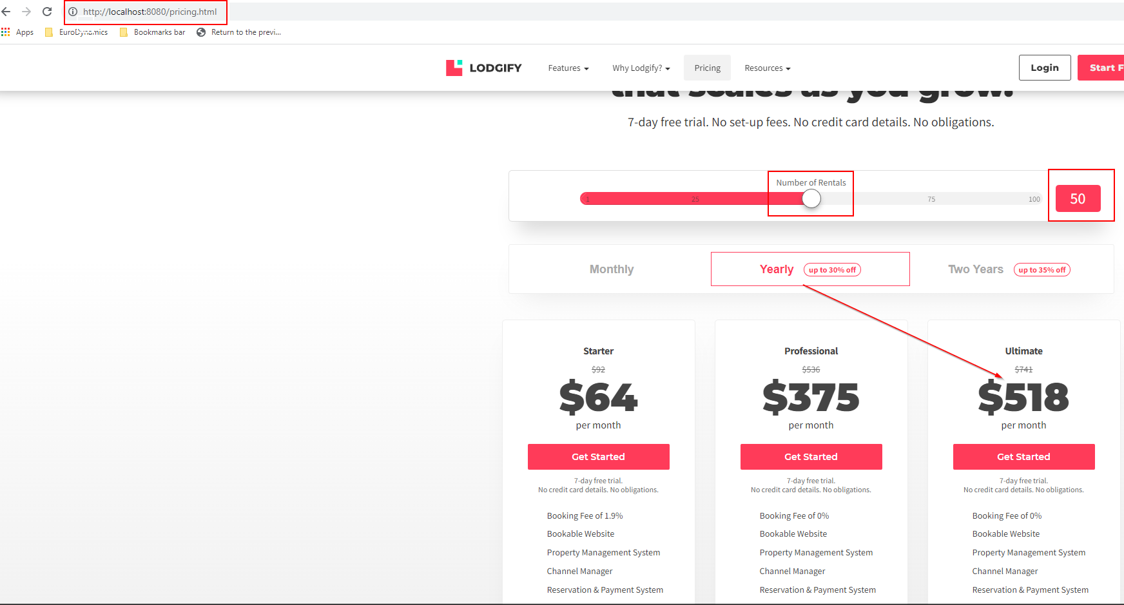

Contact page bugs:
Bug#2:
Summary:
User can not distinguish the mandatory fields vs optional fields on the contact page.
Steps to reproduce:
- Go to Application (using url: http://localhost:8080)
- Click on contact.html page to go to contact page(http://localhost:8080/contact.html)
- Observe the contact form to locate mandatory fields
Expected Result:
The mandatory fields on the contact page should be distinguished from Optional fields using “*” in RED color.
Actual Result:
Users can not distinguish the mandatory fields vs Optional fields on the contact page.
Name, Phone, Email, Comments are the mandatory fields as per requirement document.
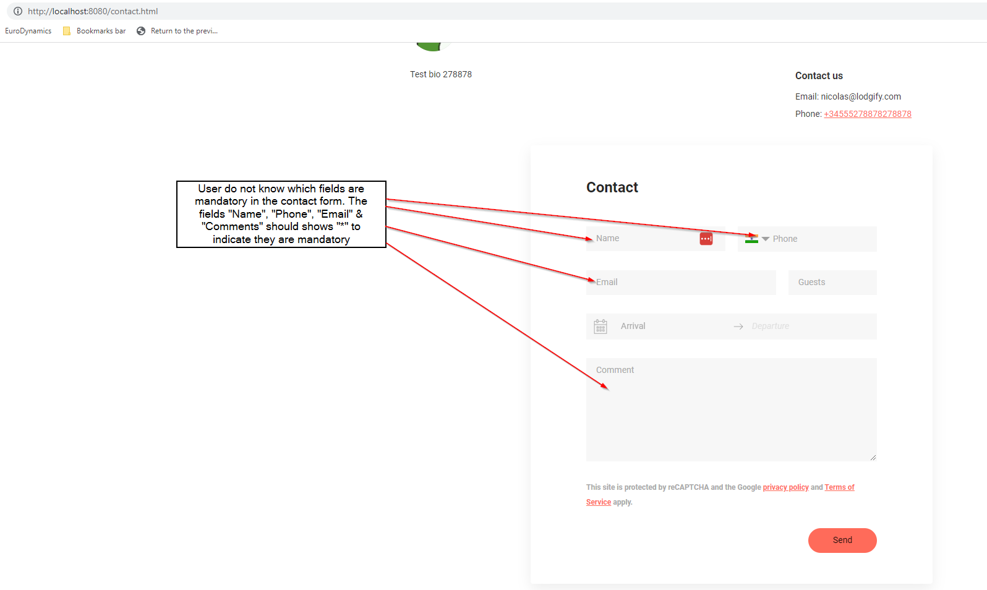

Bug#3:
Summary:
When the user clicks on send button having all the fields empty, on the contact form do not highlight the phone field with text “Phone is mandatory”

Steps to reproduce:
- Go to Application (using url: http://localhost:8080)
- Click on contact.html page to go to contact page(http://localhost:8080/contact.html)
- Make sure all the fields in the contact page are empty
- Click the Send button
- Observe the text in red color indicating the mandatory field is not displayed for Phone field
Expected Result:
Since the phone field is mandatory, when not filled, the mandatory text should be displayed “Phone is mandatory”
Actual Result:
“Phone is mandatory” is not displayed when the page is submitted with empty phone field.
