Credit Card – Eligibility Validator

CreditCard-Home Page:

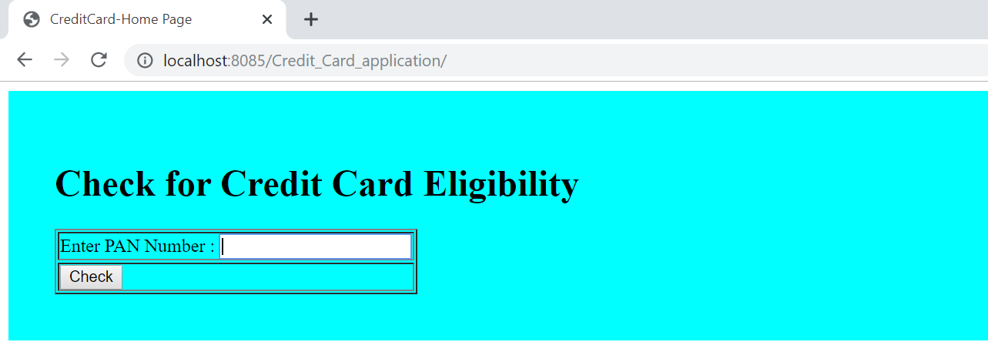

After Clicked on Check Button

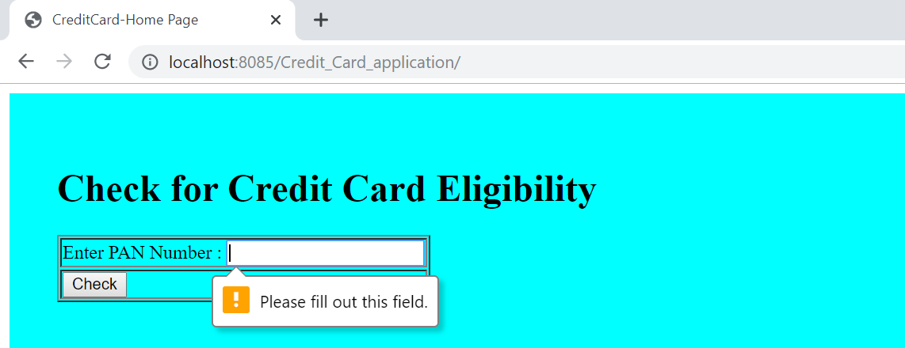

Validation message :

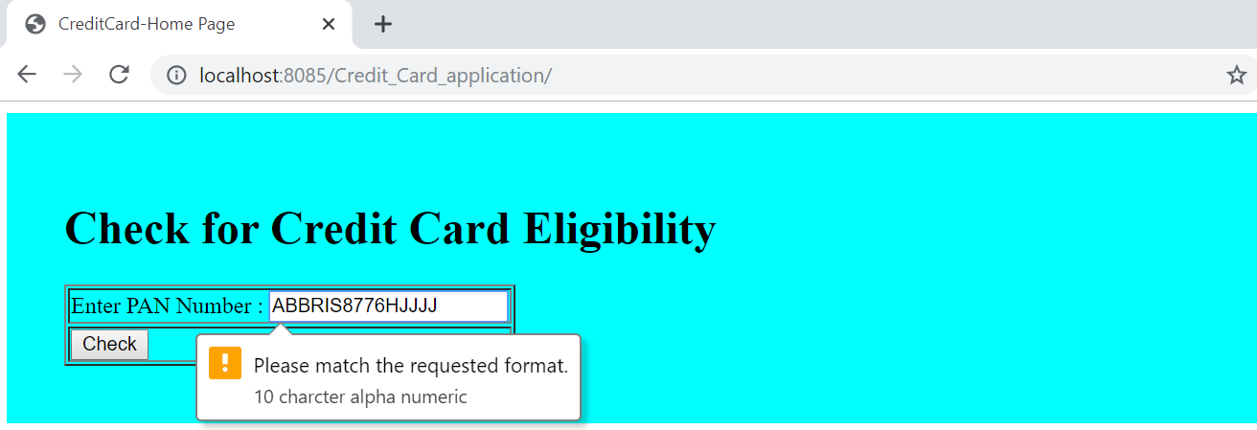

|  |  |
| --- | --- |
| PAN Number | Credit Score |
| AXSSP1122H | 3.10 |

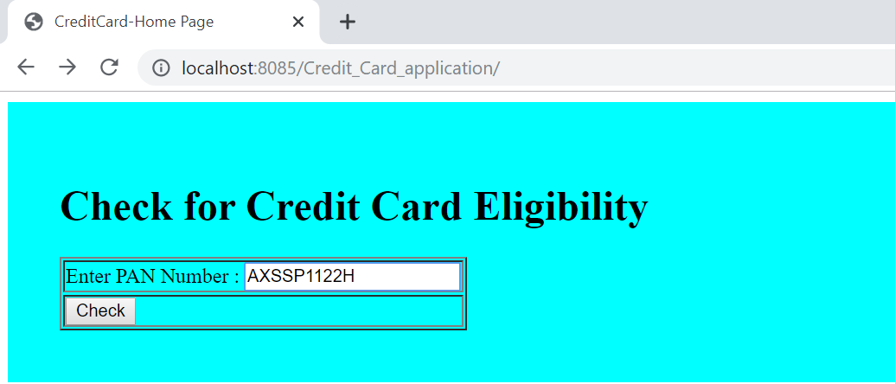

Creditscore is less than 5,not eligible for a credit card

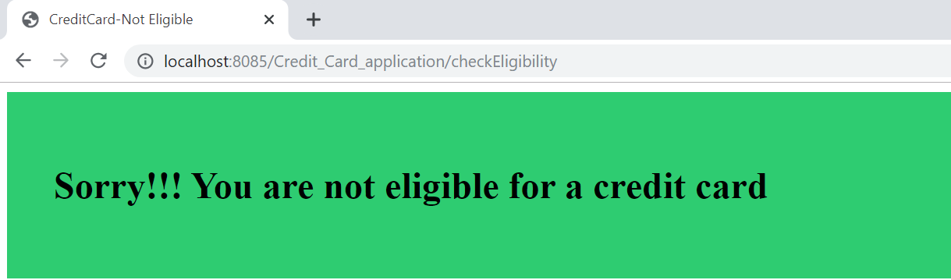

|  |  |
| --- | --- |
| PAN Number | Credit Score |
| AXSSP1122H | 3.10 |
| APPSA3355P | 8.50 |

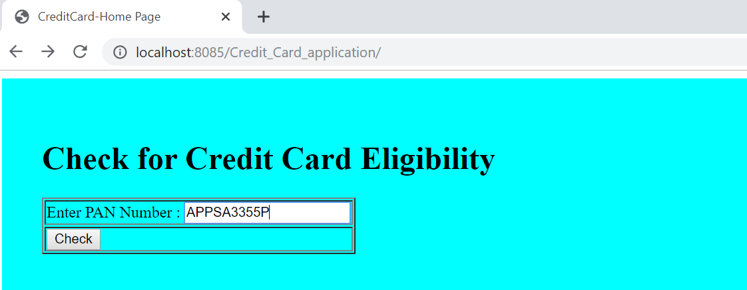

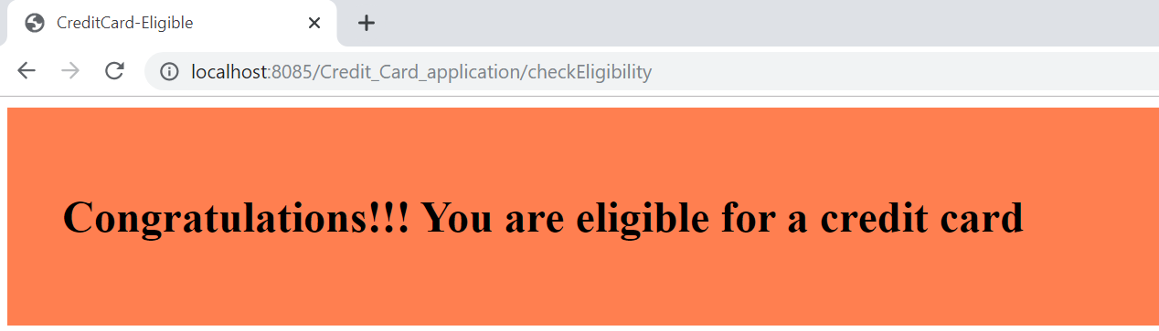

Pan number in lower case:

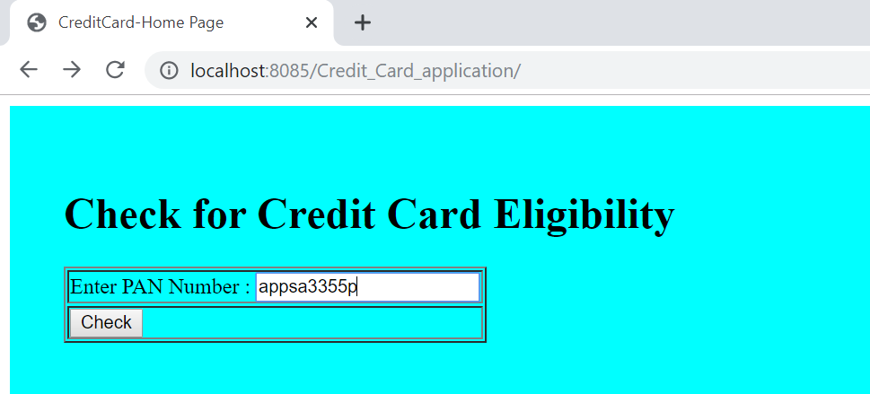

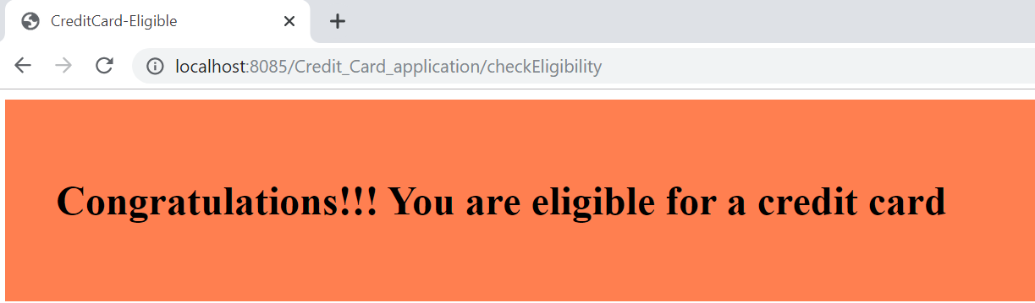

Invalid page :

