**Screenshot :**

**Assignment 1:**

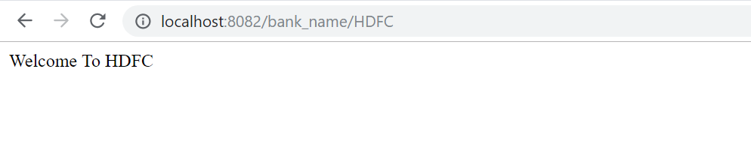

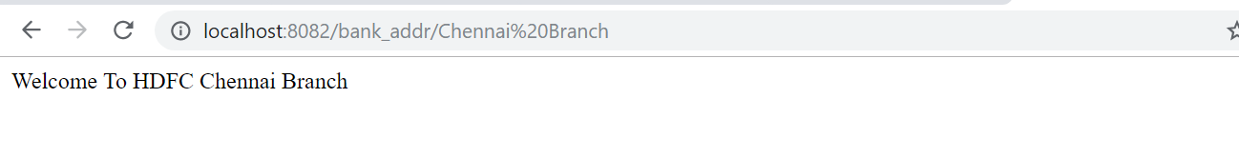

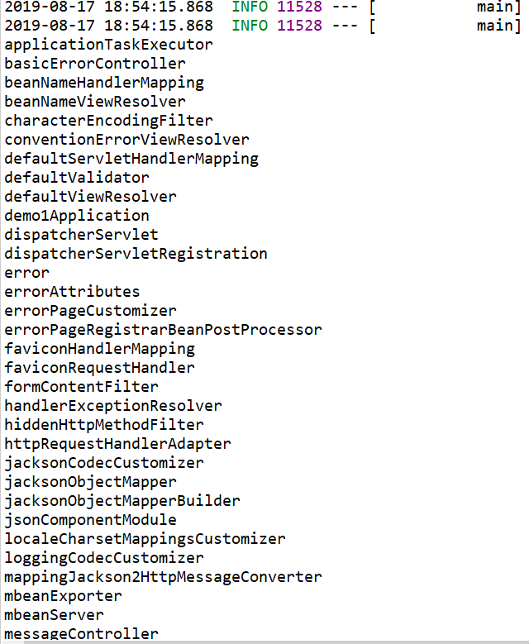

**Assignment – 2:**

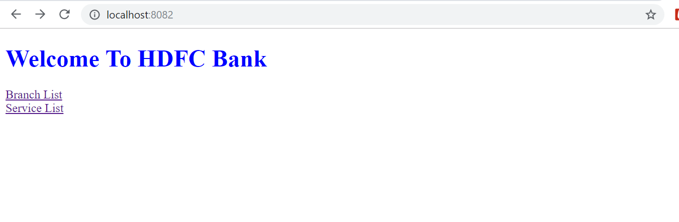

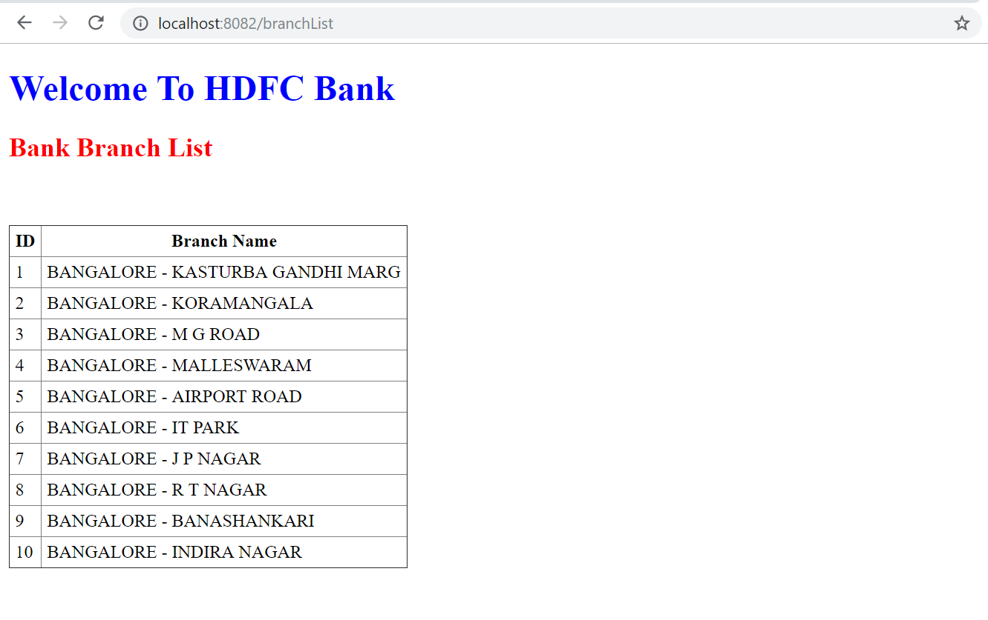

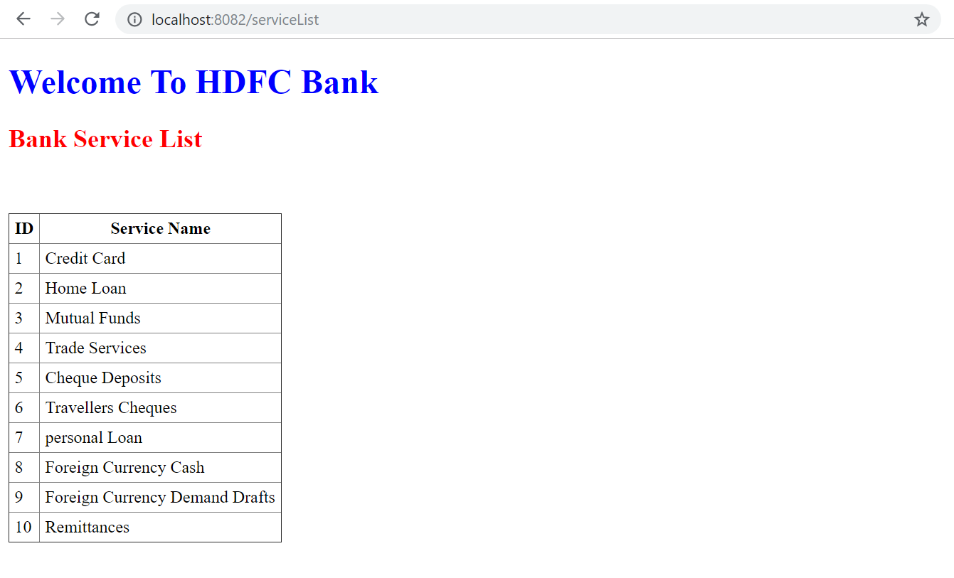

Assignment-3:

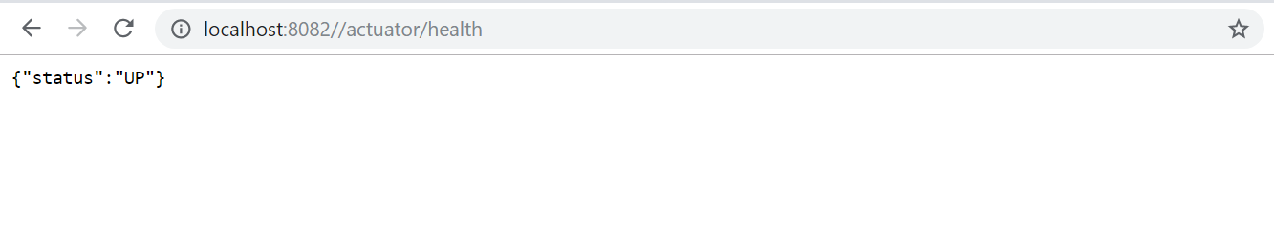

**Assignment-4:**

Index page :

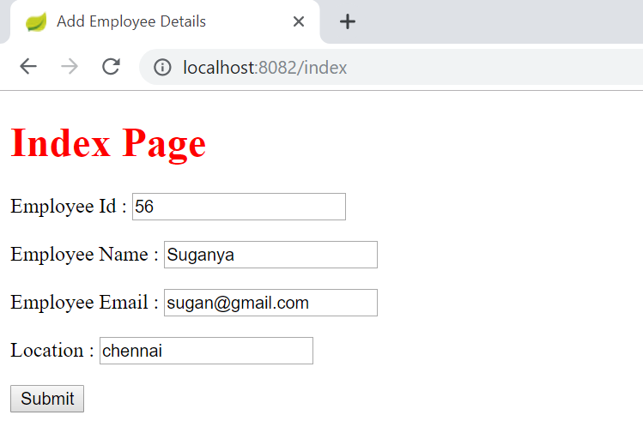

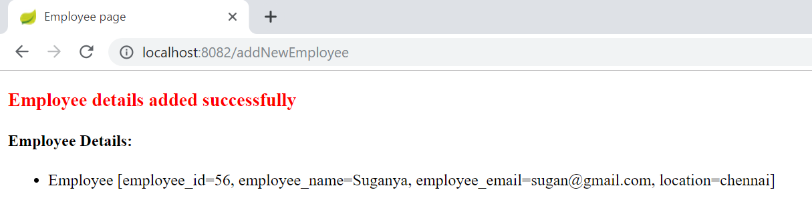

/displayAll

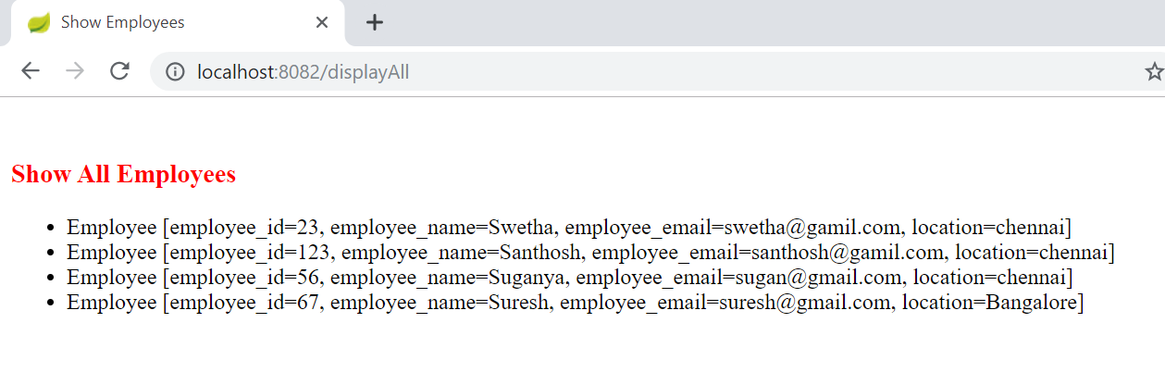

/display/67 -- search by id

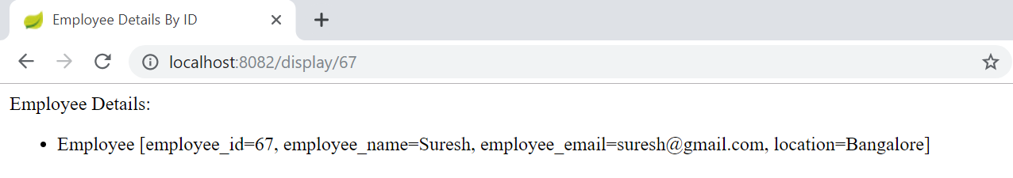

Assignment – 5 :

