**Sales of different TV Task 6 : Modify Sales of different TV Task 3 (refer session 5, assignment 2) to take advantage of Combiner.**

**//driver**

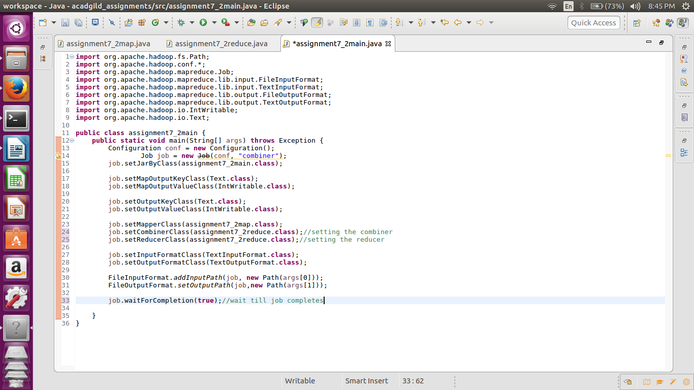

**//mapper**

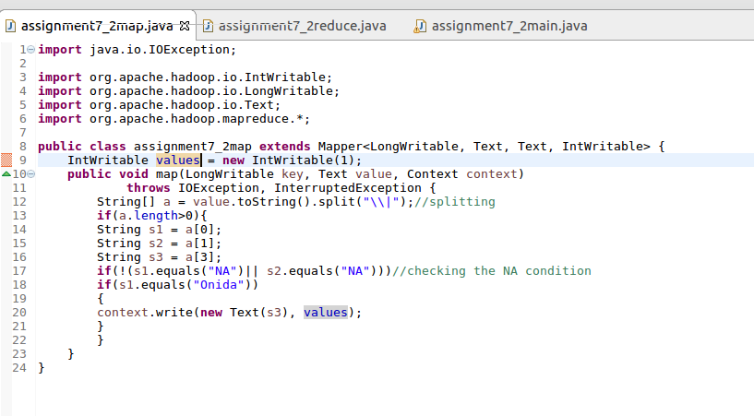

**//reducer**

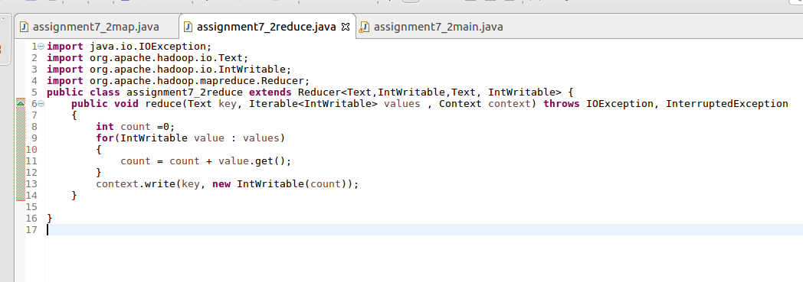

**//running the jar file**

**D:\assignment7\7.2run.png**

**//output**

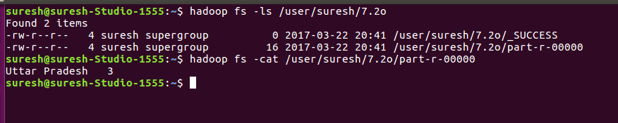

**Sales of different TV Task 7 : Write a Mapreduce program to view the total sales for each product for every Company corresponding to each size. Make sure that all records for a single company goes to a single reducer and inside every reducer, keys must be sorted in descending order of the size. You may write a custom WritableComparable for this purpose. "**

**//driver**

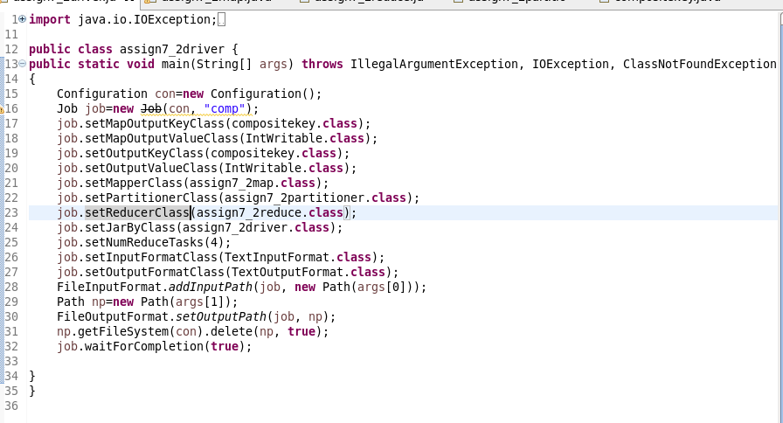

**//mapper**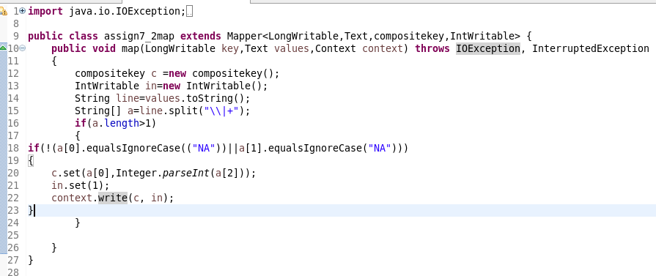

**//reducer**

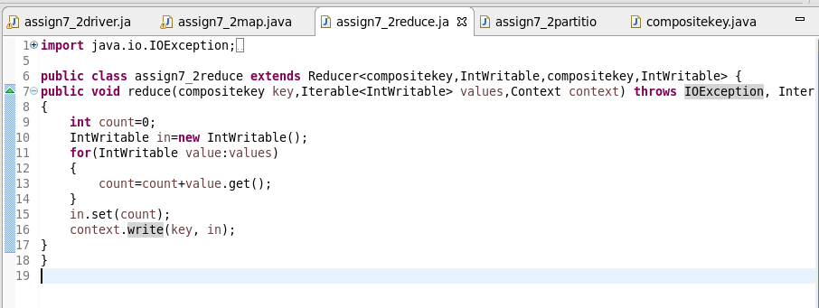

**//partitioner**

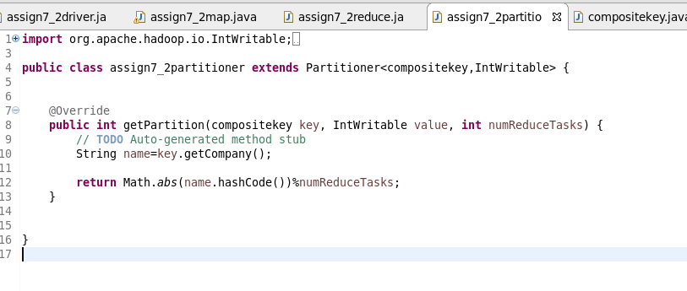

**//comparable writable class**

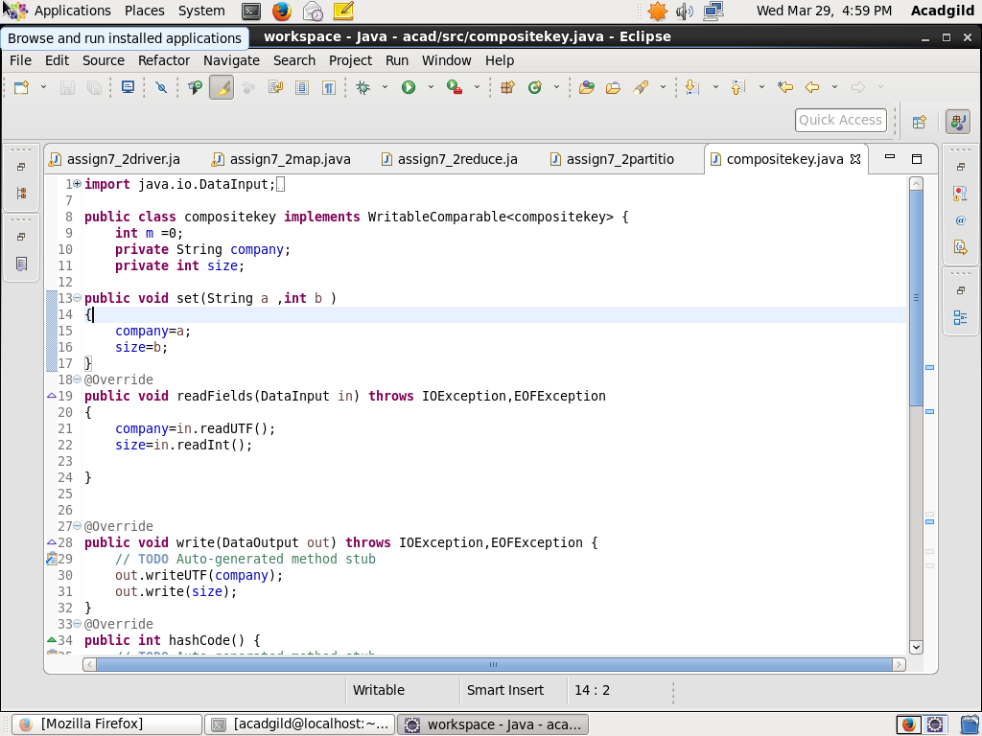

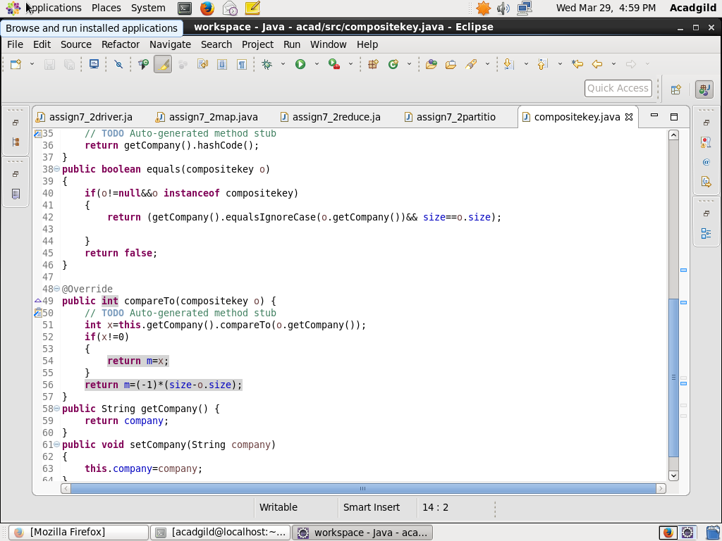

**//output**

