**Write a custom key to evaluate the number of people who died and the number of people who survived, along with their genders**

**//driver  
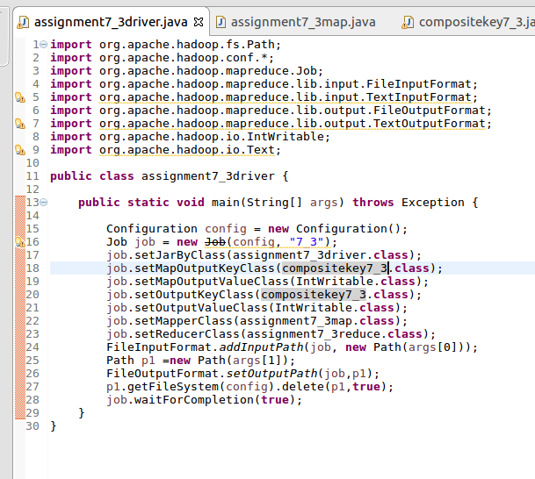**

**//mapper**

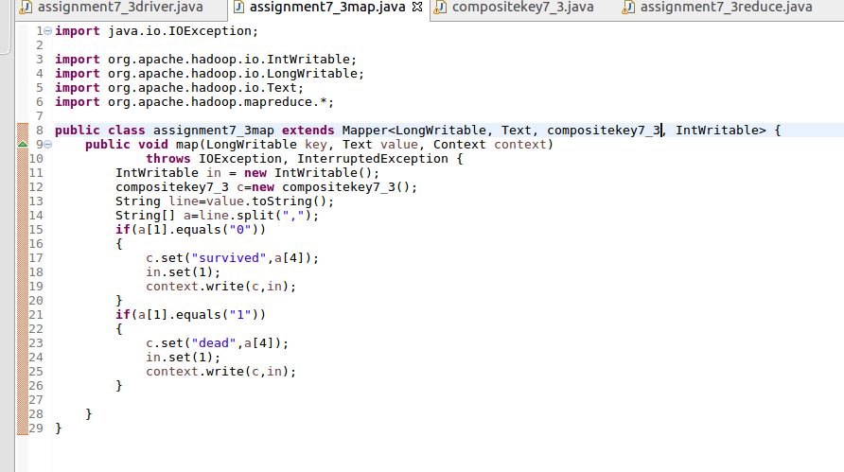

**//reducer**

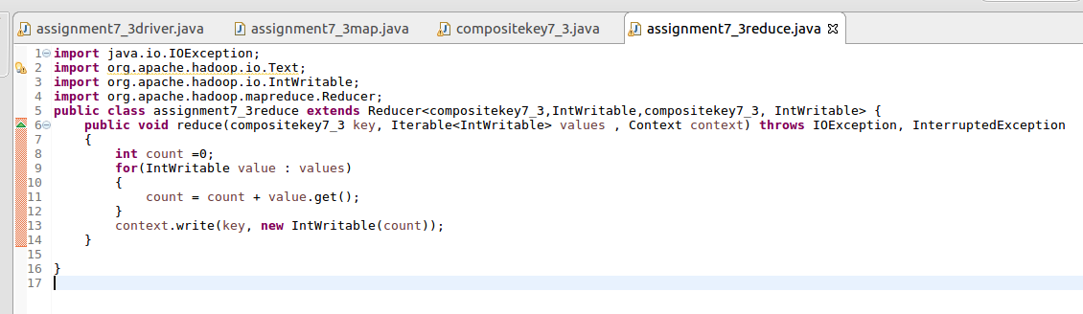

**//writable comparable class**

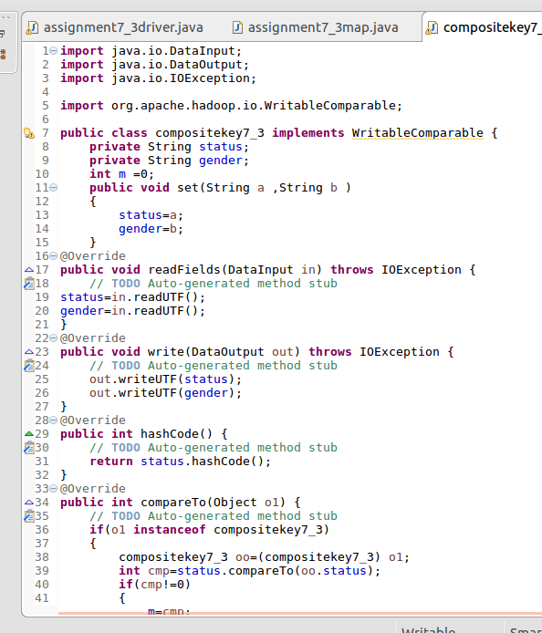

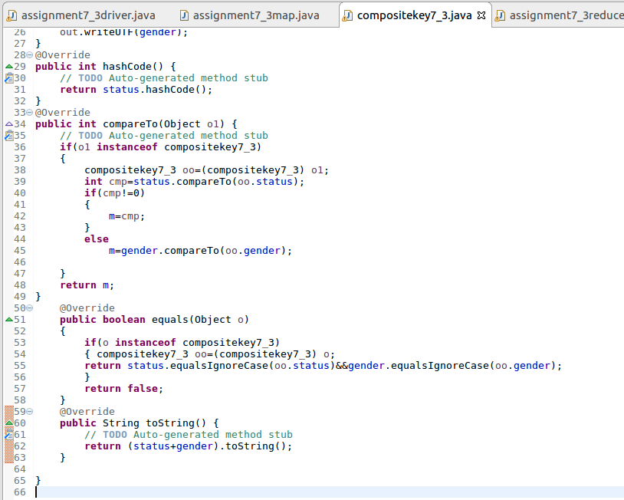

**//running the jarD:\assignment7\7.3run.png**

**//output**

