**Write a word count program using partitioner and implement the following logic in the partitioner words with length 5 should go into reducer 1 and words with length 6 should go into reducer 2 and the rest of the words should go into reducer 3.**

Note : You can use the dataset of your choice

driver

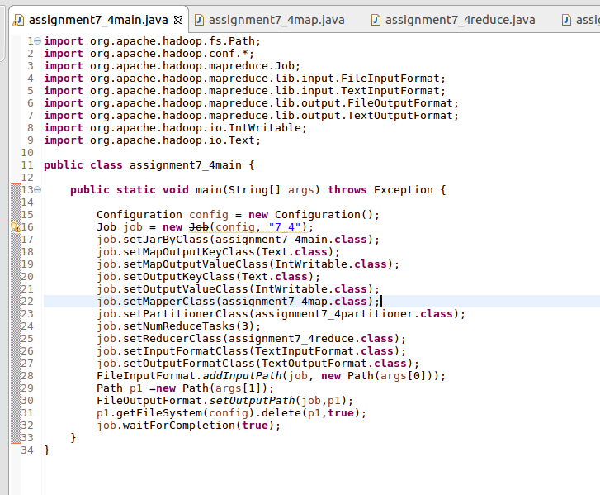

mapper

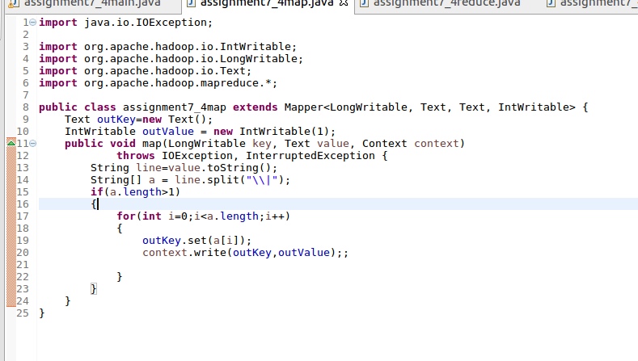

reducer

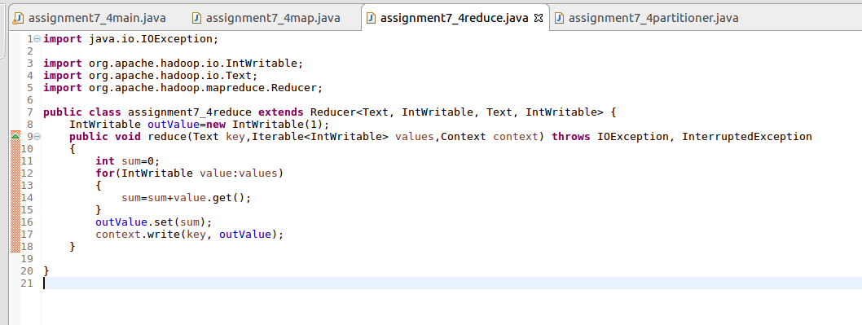

partitioner

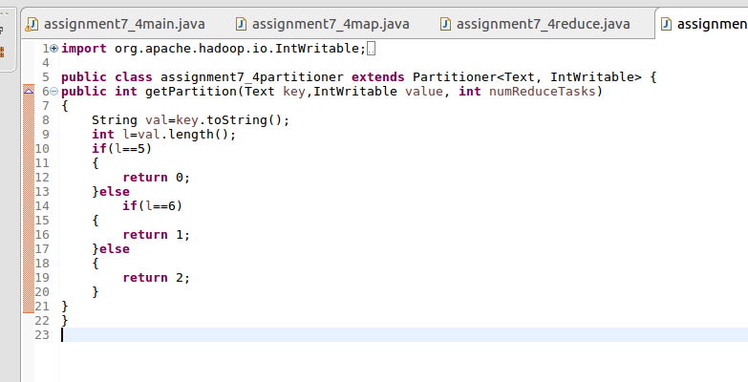

running the jar file

D:\assignment7\7.4run.png

output

