**Creating a directory flume_import in hdfs to store the imported file:**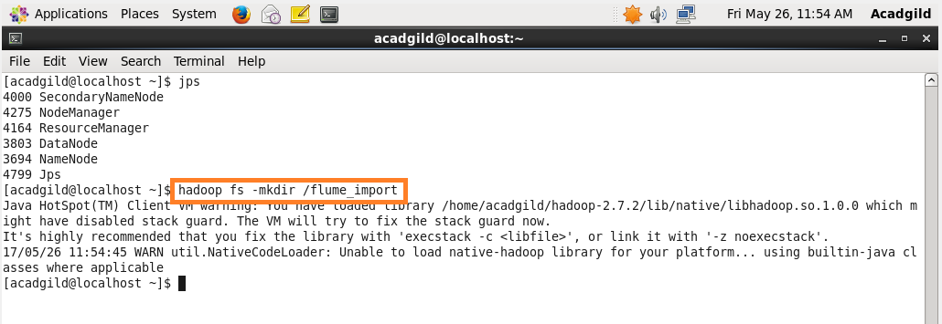

**Creating Acadgildconf file in flume’s conf directory:**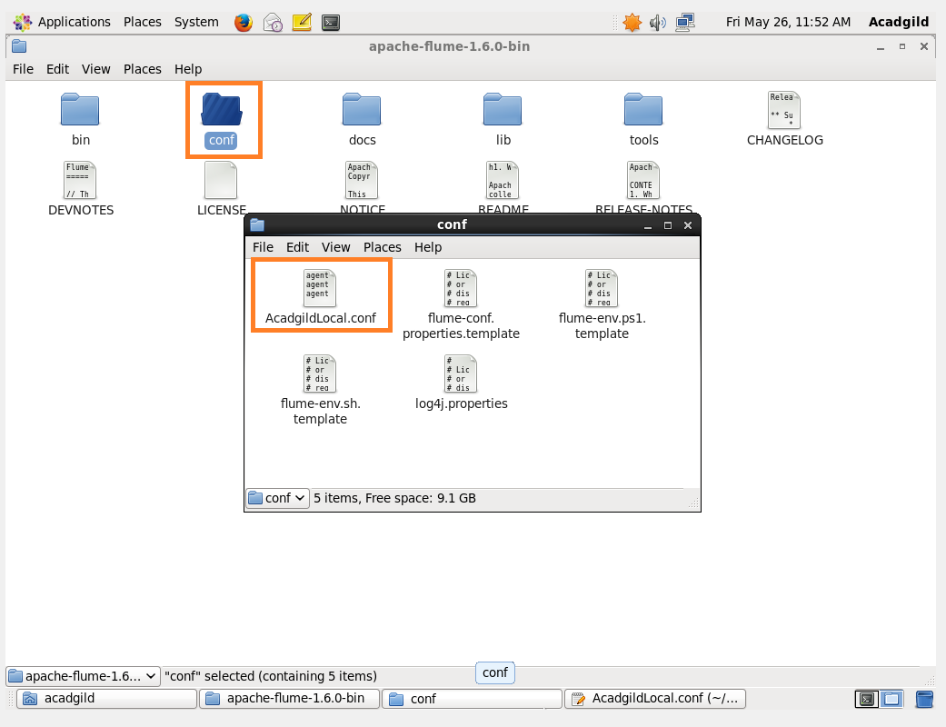

**Configuration file:**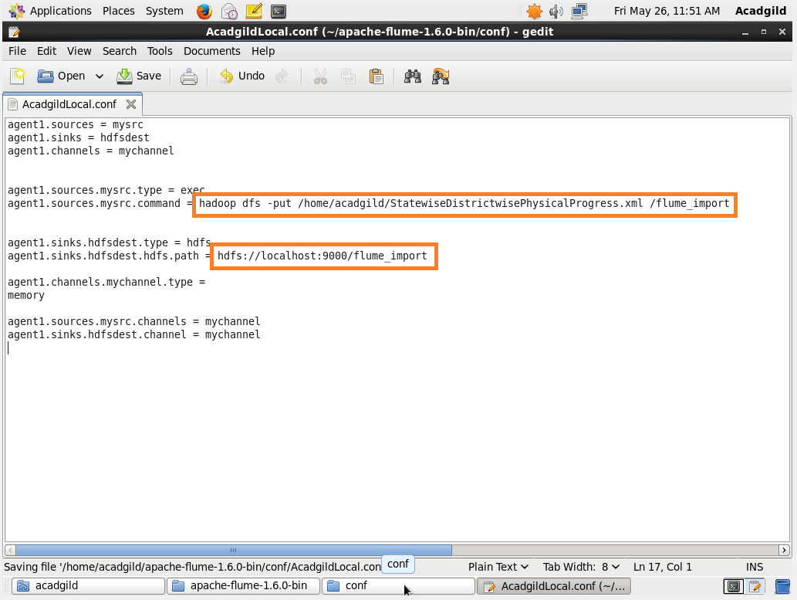

**Running the flume command:**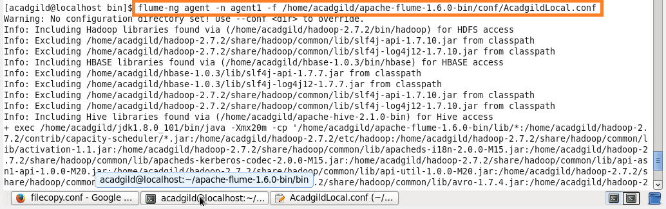

**Success message of flume:**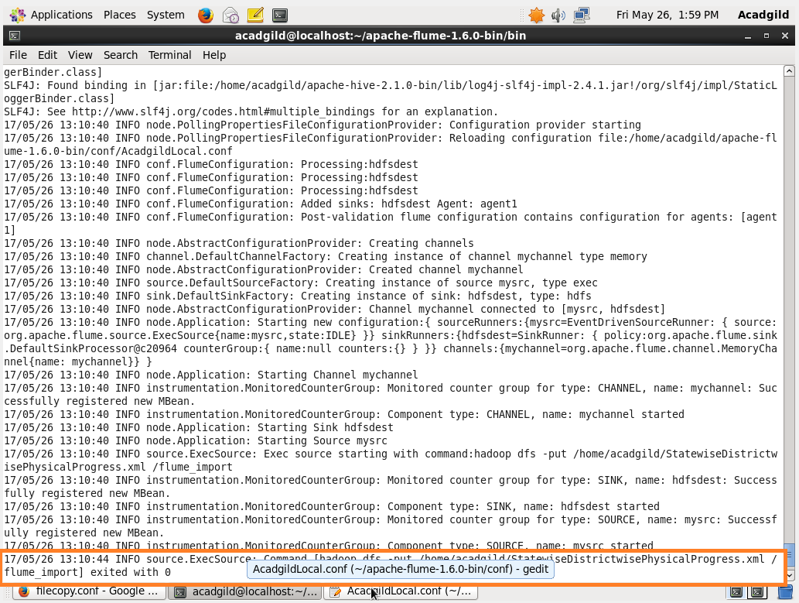

**Listing the flume_import which displays the imported file:**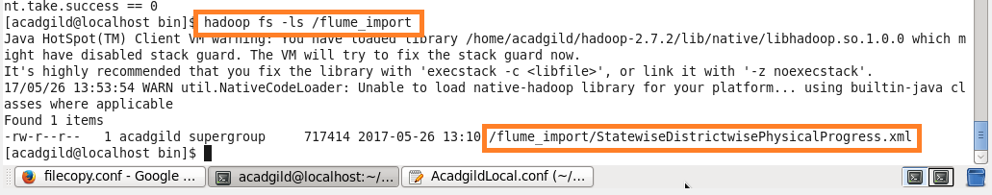

**Pig script to convert the xml file into csv file:**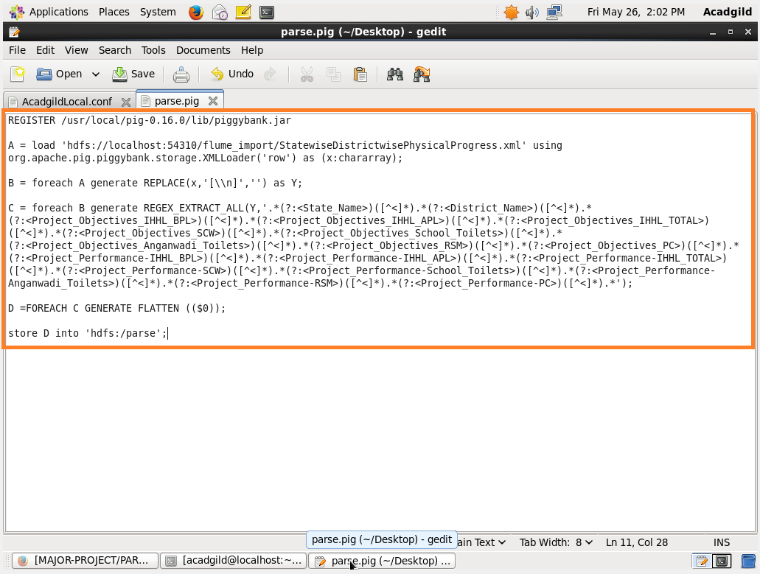

**Running the parse PigScript:**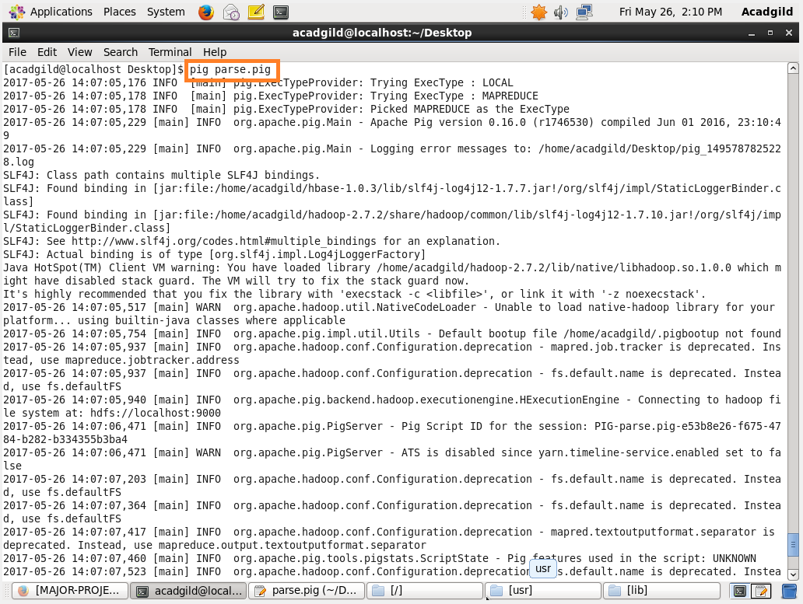

**Success message for running the parse PigScript:**

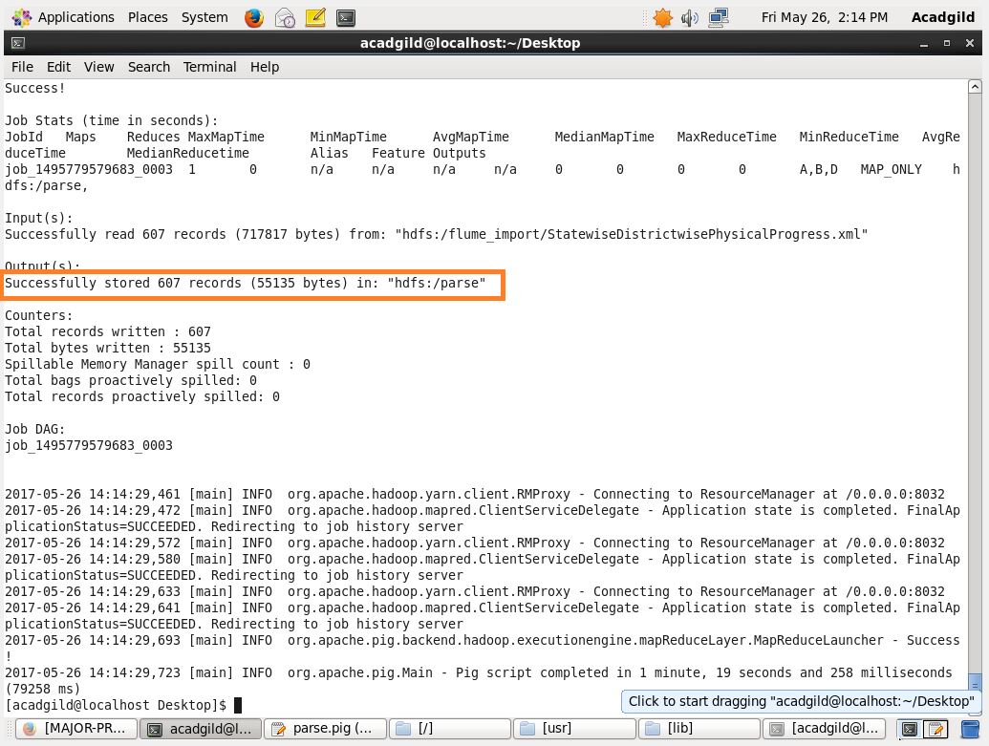

**Displaying the converted csv file:**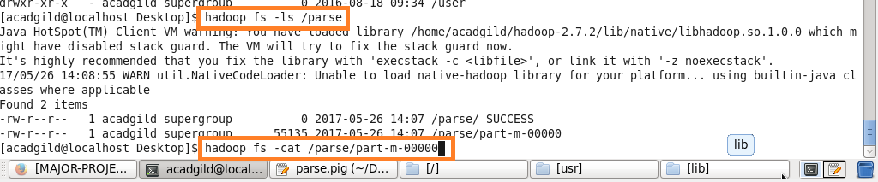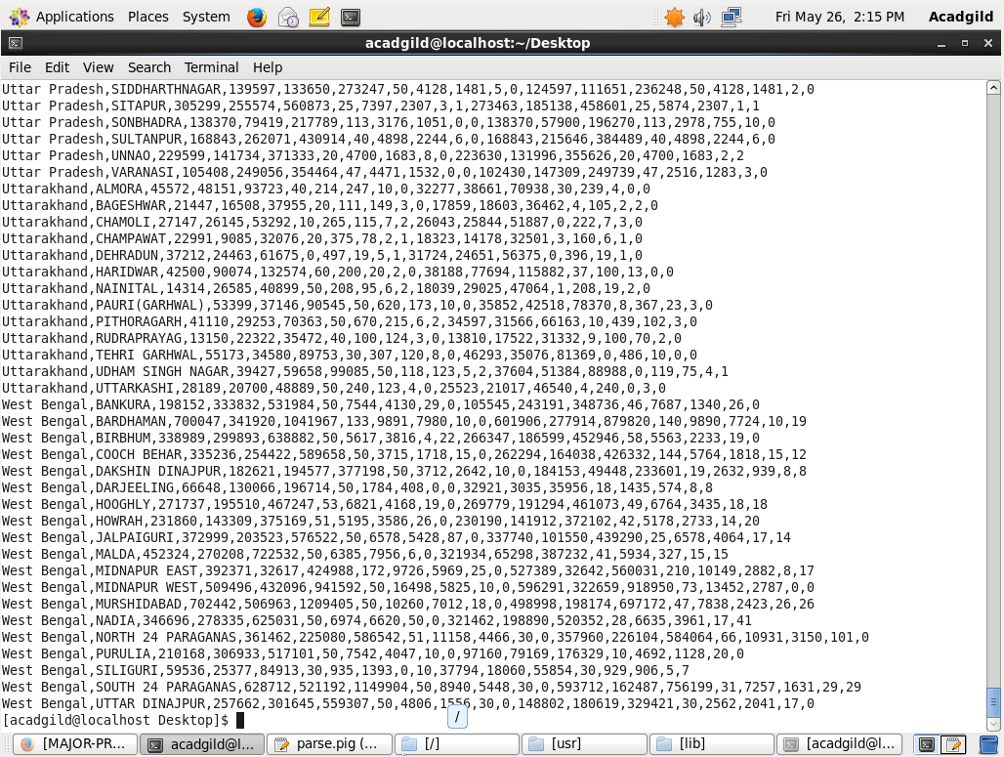

**Problem statement**

1. **Find out the districts who achieved 100 percent objective in BPL cards**

**PigScript for the above problem:**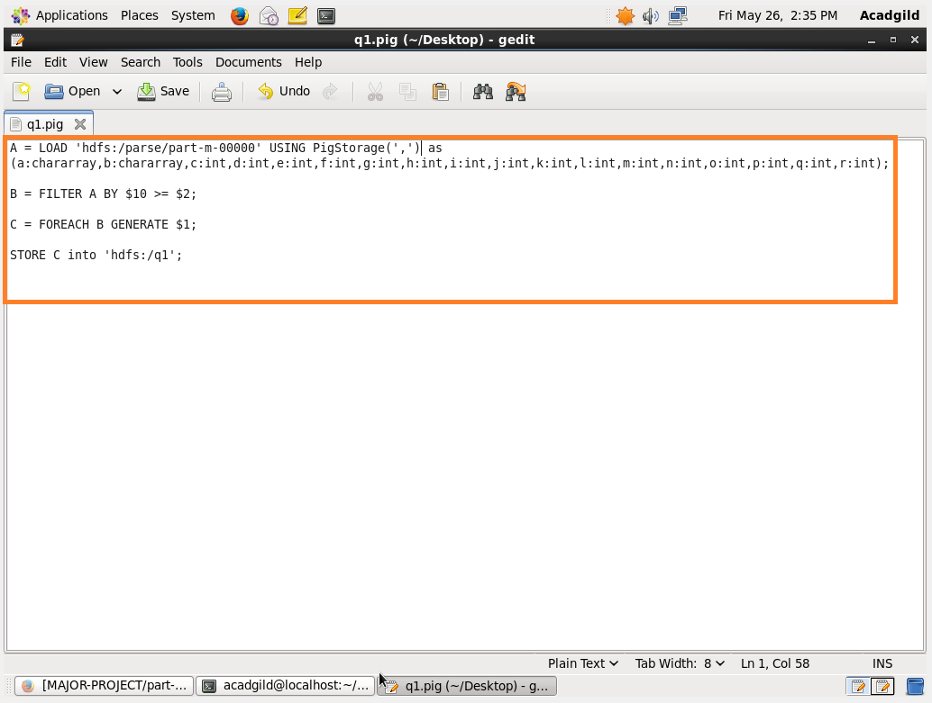

**Running the above PigScript:**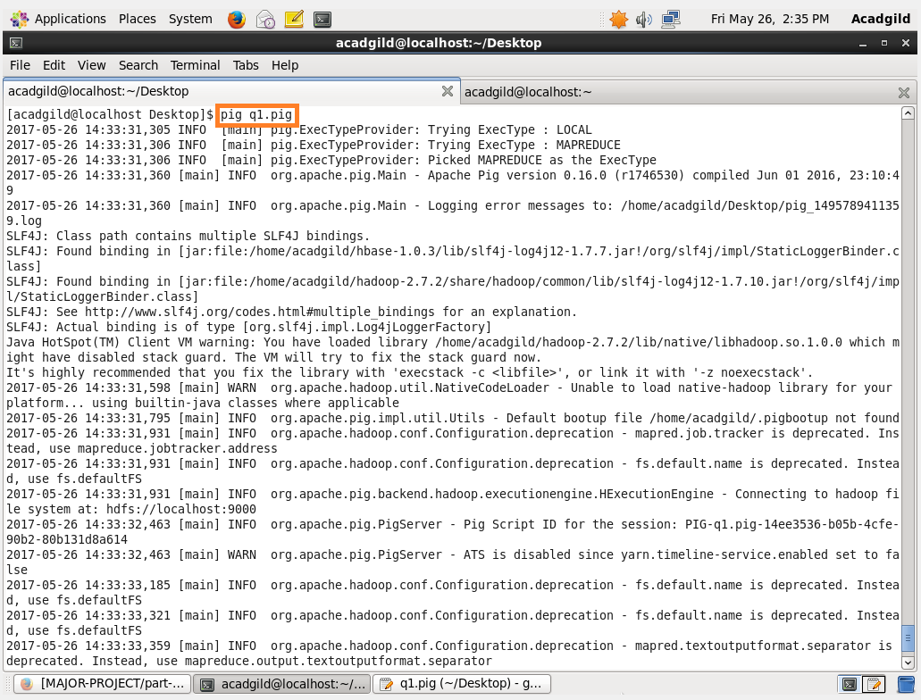

**Success message for running the above PigScript:**

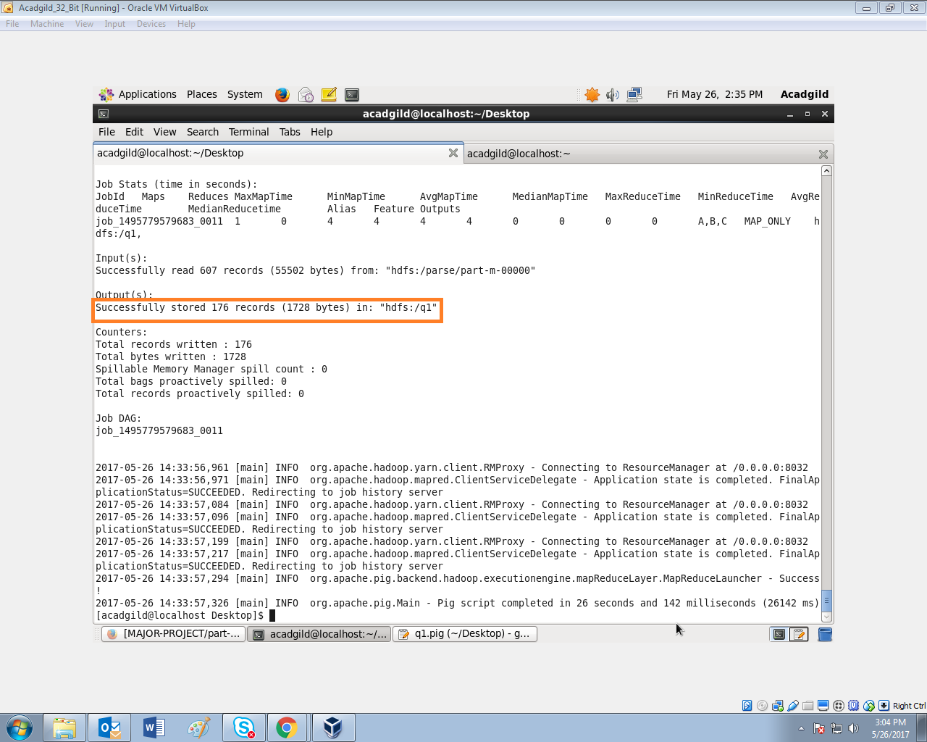

**Displaying the output for above problem:**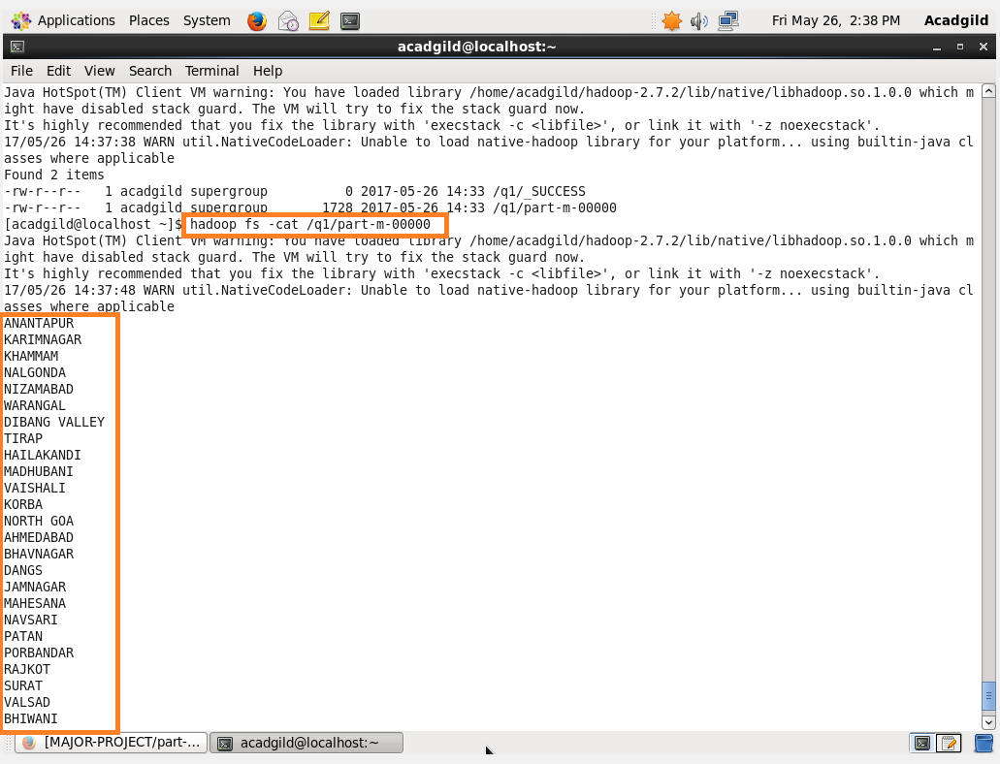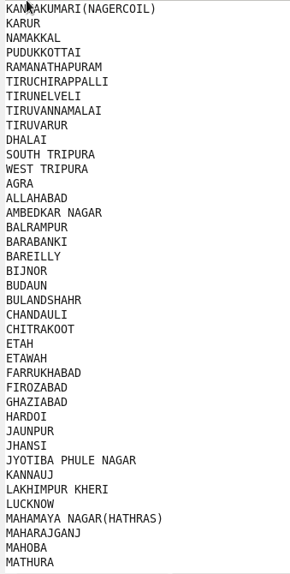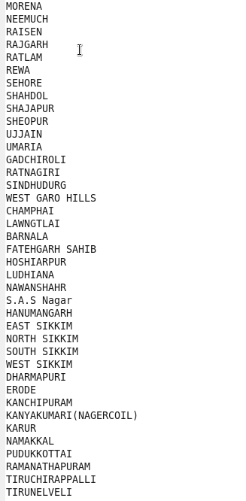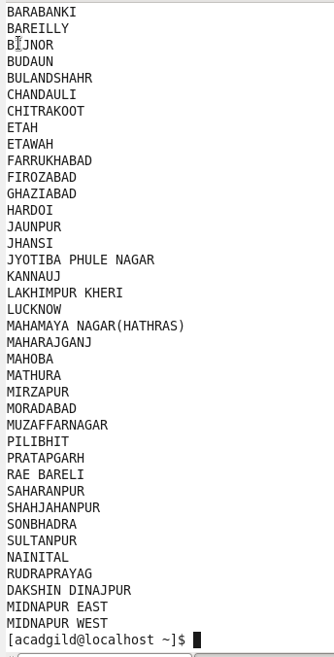

**The output has 176 records and I have included the output file in the repository in the name ‘OUTPUT1’.**

1. **Write a Pig UDF to filter the districts which have reached 80% of objectives of BPL cards.**

**PigScript for the above problem:**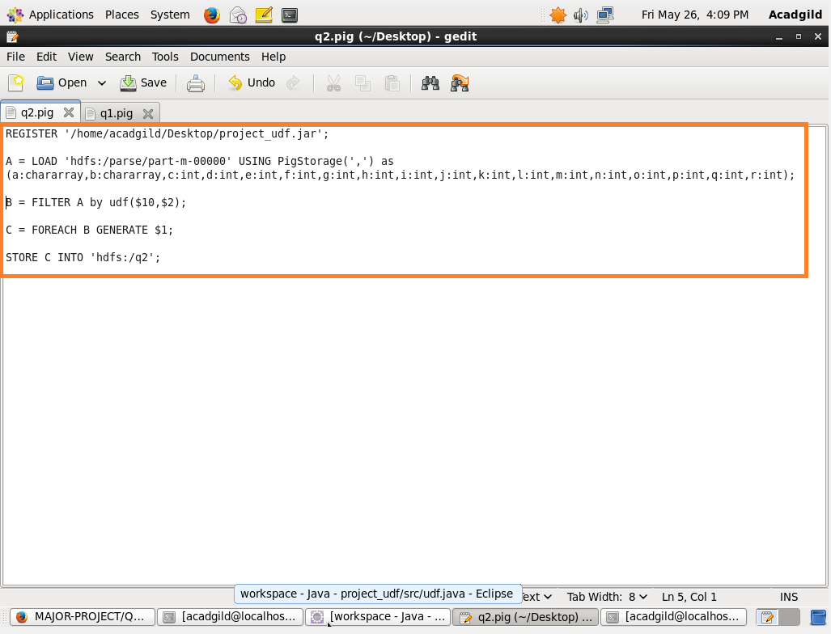

**UDF for the above PigScript:**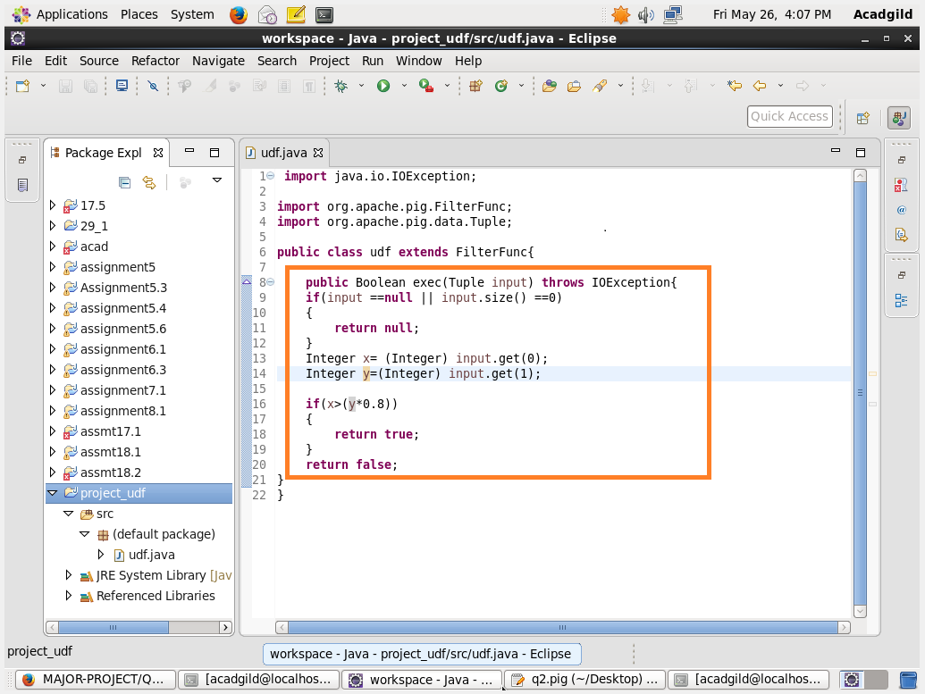

**Running the PigScript:**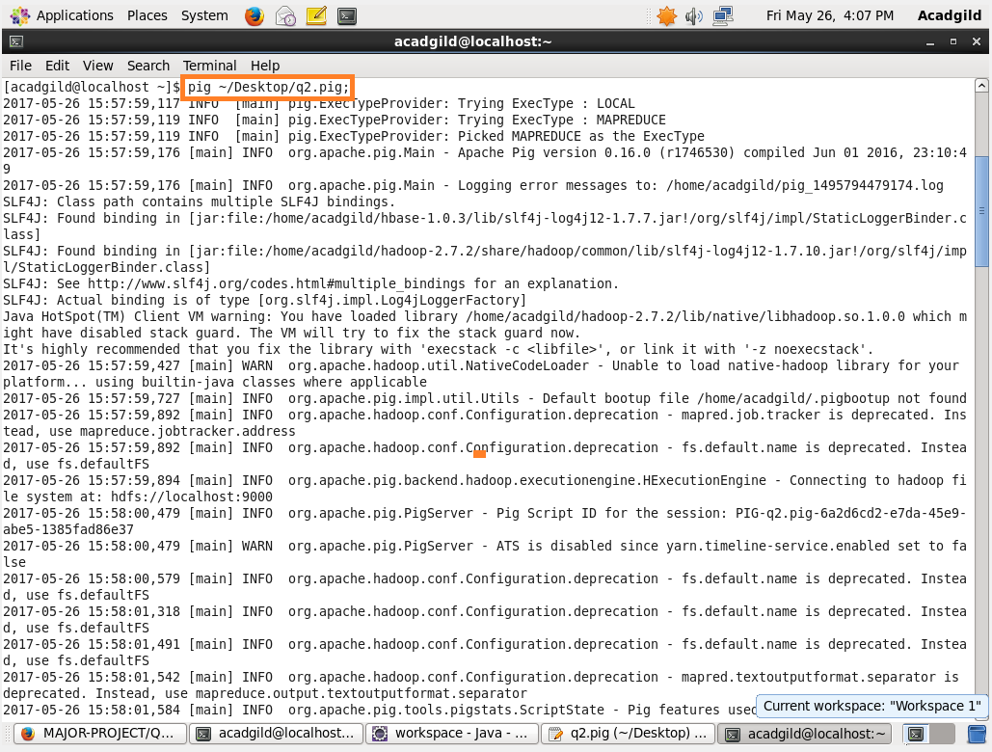

**Success message for running the pigscript:**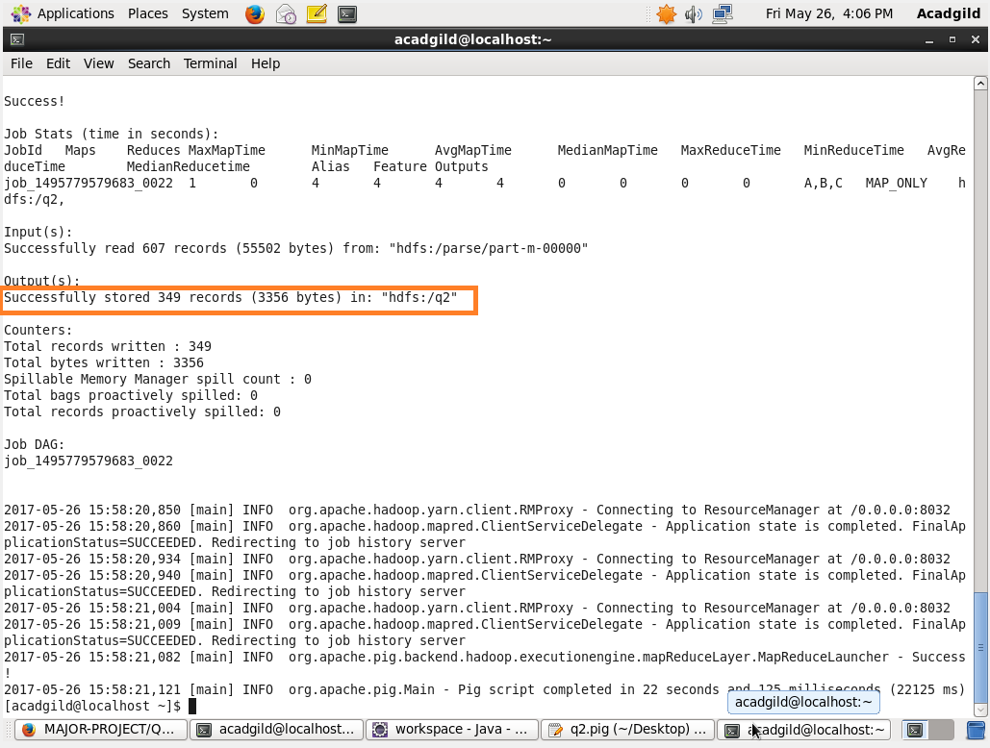

**Displaying the output:**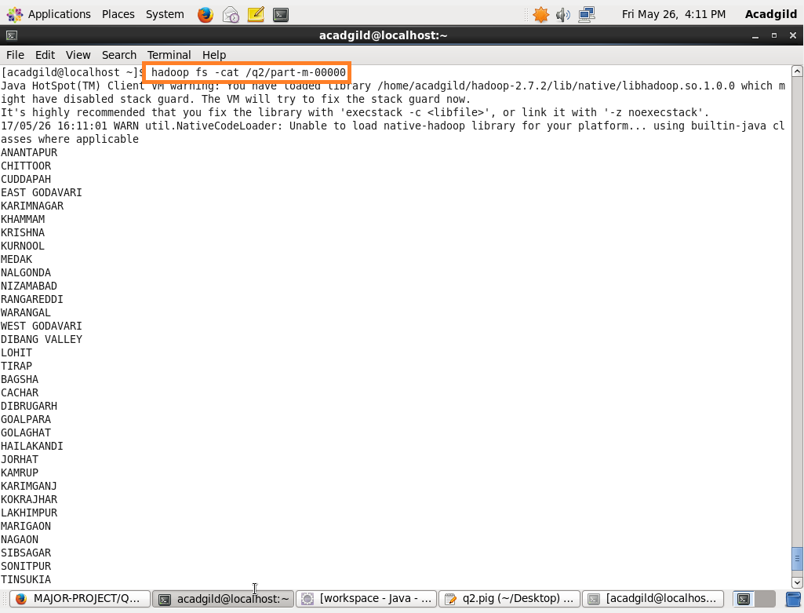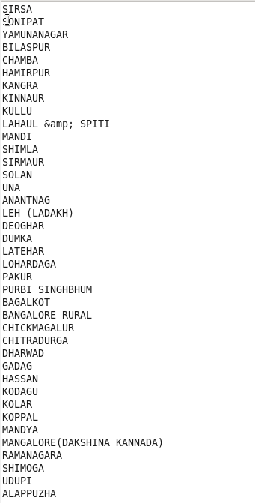

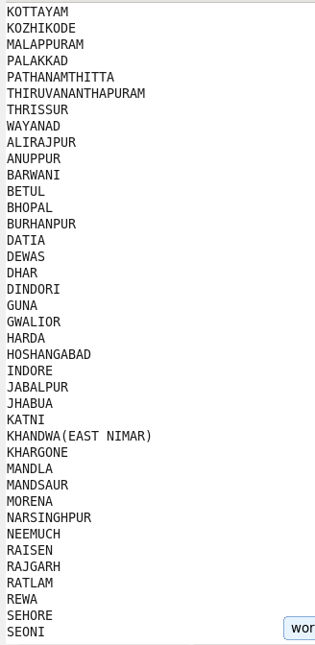

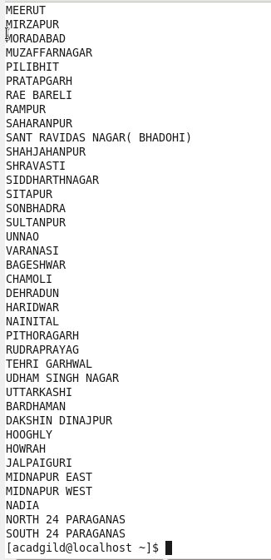

**The output has 349 records and I have included the output file in the repository in the name ‘OUTPUT2’.**

**Creating table in mysql to export the table from hdfs to mysql:**

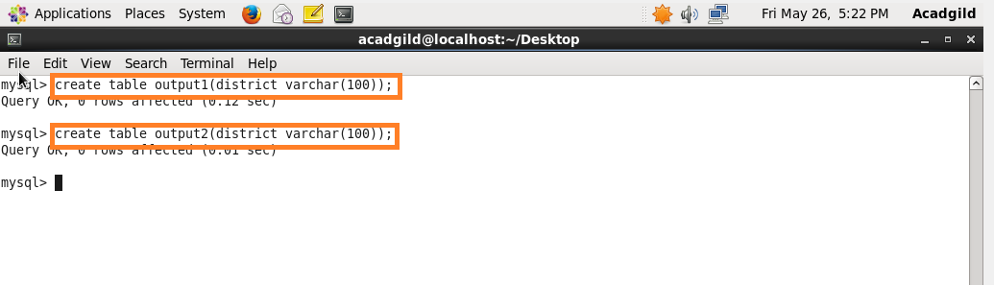

**Sqoop command to export the data from hdfs to mysql for output1:**

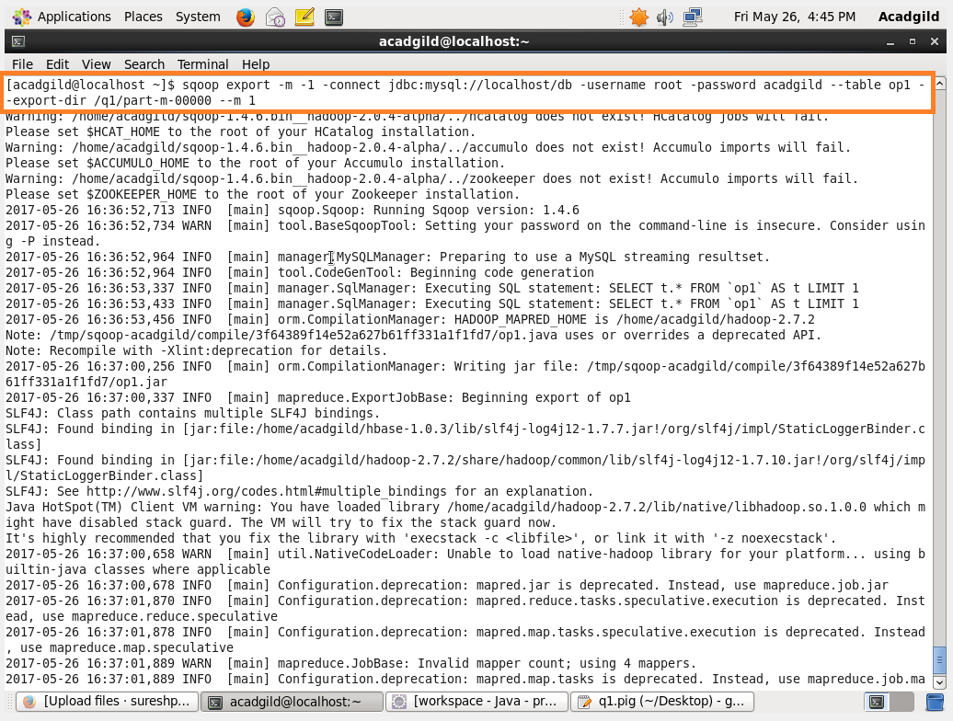

**Success message for the sqoop:**

**It has exported 176 records**

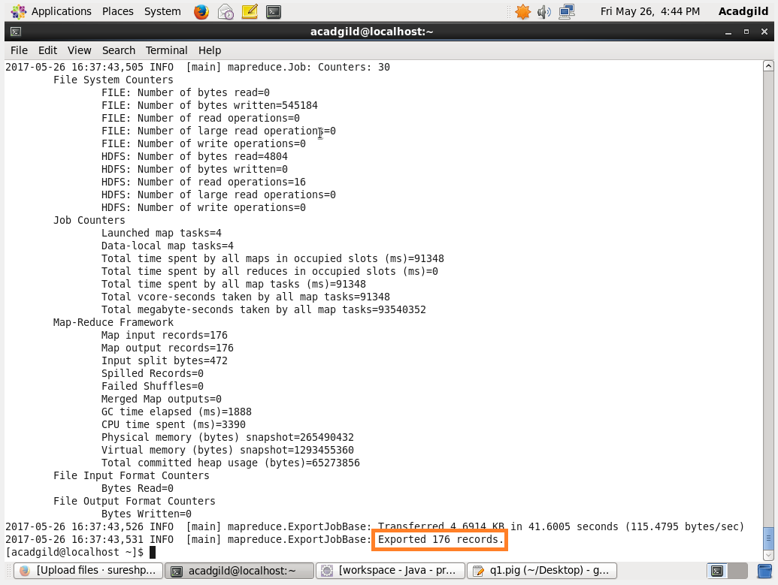

**Sqoop command to export the data from hdfs to mysql for output2:**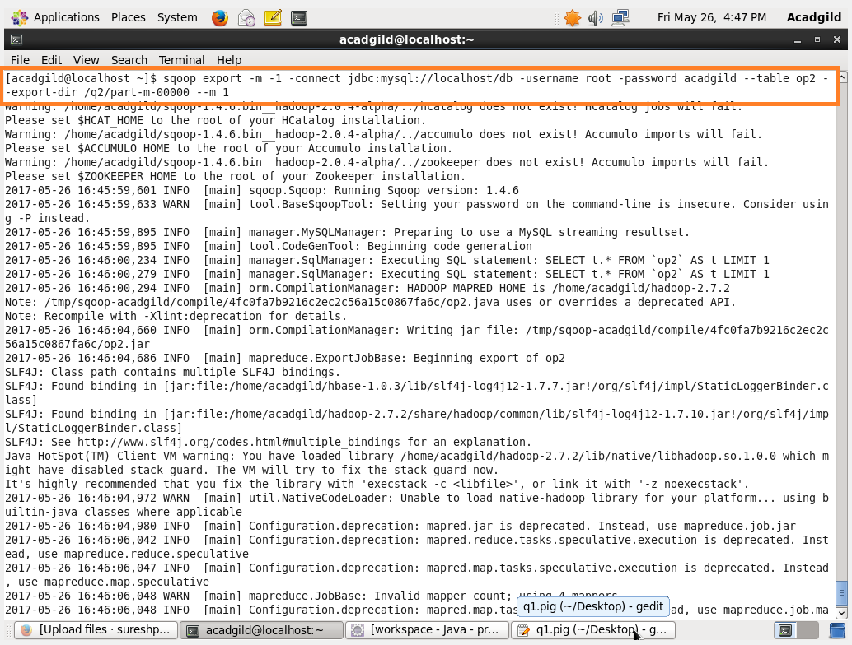

**Success message for the sqoop:**

**It has exported 349 records**

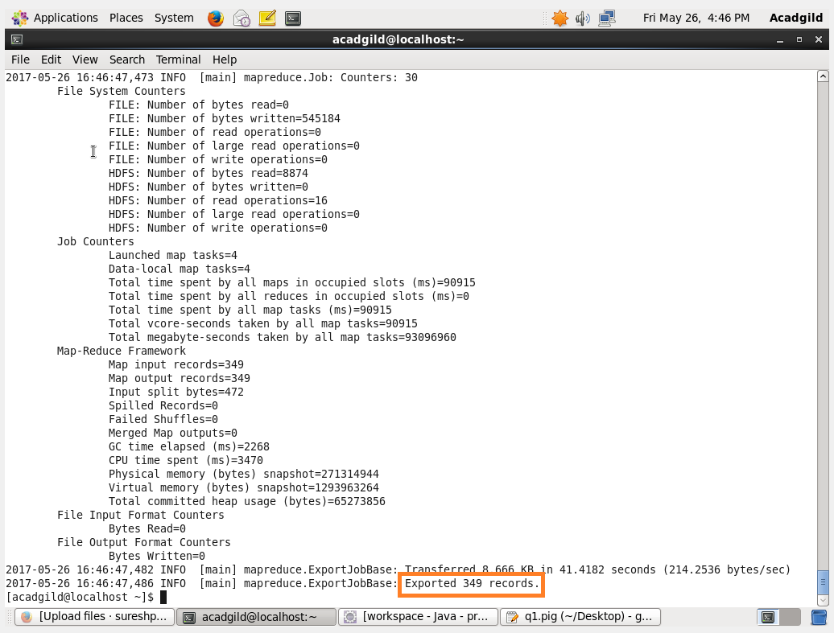

**Displaying the content of the table in mysql:**