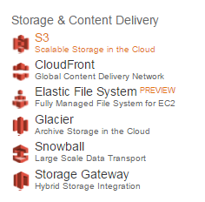
http://docs.aws.amazon.com/AmazonS3/latest/gsg/CreatingABucket.html

