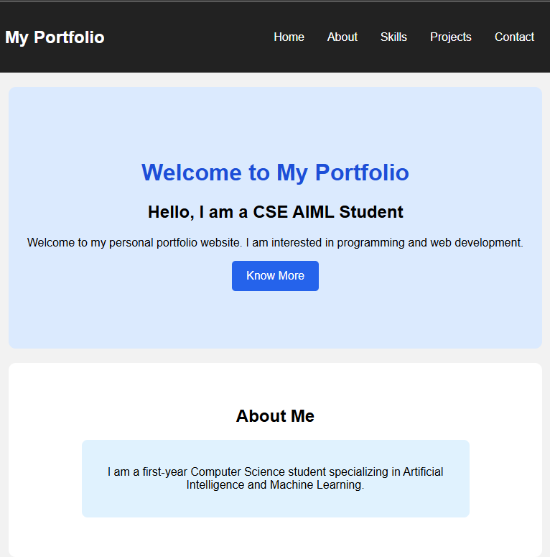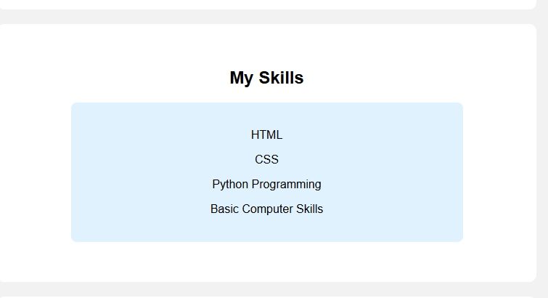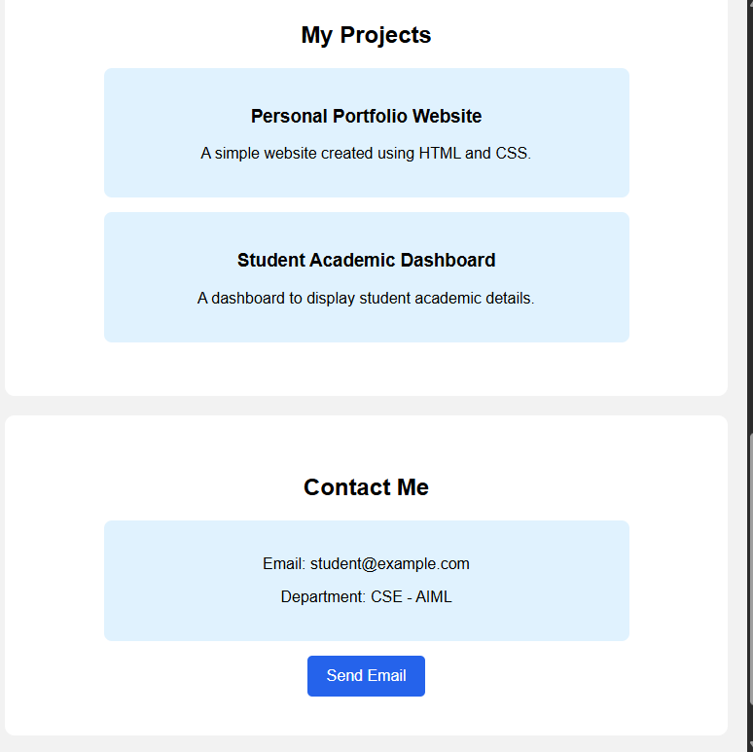
<title>Personal Portfolio Website</title>
<style>

body {
margin: 0;
font-family: Arial, sans-serif;
background-color: #f2f2f2;
}

/* Navigation Bar */
nav {
background-color: #222;
color: white;
padding: 15px;
display: flex;
justify-content: space-between;
align-items: center;
flex-wrap: wrap;
}

nav ul {
list-style: none;
display: flex;
flex-wrap: wrap;
}

nav ul li {
margin: 8px;
}

nav ul li a {
color: white;
text-decoration: none;
padding: 8px;
transition: 0.3s;
}

/* Navigation Hover Effect */
nav ul li a:hover {
color: yellow;
background-color: #444;
border-radius: 5px;
}

/* Common Section Styling */
section {
padding: 40px;
margin: 20px;
text-align: center;
background-color: white;
border-radius: 10px;
animation: fadeIn 1.5s;
}

/* Home Section */
#home {
background-color: #dbeafe;
padding: 80px 20px;
}

#home h1 {
color: #1d4ed8;
}

/* Buttons */
.btn {
display: inline-block;
background-color: #2563eb;
color: white;
padding: 12px 20px;
text-decoration: none;
border-radius: 5px;
transition: 0.3s;
}

.btn:hover {
background-color: #1e3a8a;
transform: scale(1.05);
}

/* Content Boxes */
.box {
background-color: #e0f2fe;
padding: 20px;
margin: 15px auto;
max-width: 500px;
border-radius: 8px;
transition: 0.3s;
}

.box:hover {
transform: translateY(-5px);
background-color: #bfdbfe;
}

/* CSS Animation */
@keyframes fadeIn {
from {
opacity: 0;
transform: translateY(20px);
}

to {
opacity: 1;
transform: translateY(0);
}
}

/* Footer */
footer {
background-color: #222;
color: white;
text-align: center;
padding: 15px;
}

/* Responsive Layout */
@media screen and (max-width: 600px) {

nav {
flex-direction: column;
}

nav ul {
flex-direction: column;
padding: 0;
text-align: center;
}

nav ul li {
margin: 5px;
}

section {
padding: 20px;
margin: 10px;
}

.box {
width: auto;
}
}

</style>
<!-- Navigation Bar -->
<nav>
<h2>My Portfolio</h2>

<ul>
<li><a href="#home">Home</a></li>
<li><a href="#about">About</a></li>
<li><a href="#skills">Skills</a></li>
<li><a href="#projects">Projects</a></li>
<li><a href="#contact">Contact</a></li>
</ul>
</nav>

<!-- Home Section -->
<section id="home">

<h1>Welcome to My Portfolio</h1>

<h2>Hello, I am a CSE AIML Student</h2>

<p>
Welcome to my personal portfolio website.
I am interested in programming and web development.
</p>

<a href="#about" class="btn">Know More</a>

</section>

<!-- About Section -->
<section id="about">

<h2>About Me</h2>

<div class="box">
<p>
I am a first-year Computer Science student
specializing in Artificial Intelligence and
Machine Learning.
</p>
</div>

</section>

<!-- Skills Section -->
<section id="skills">

<h2>My Skills</h2>

<div class="box">
<p>HTML</p>
<p>CSS</p>
<p>Python Programming</p>
<p>Basic Computer Skills</p>
</div>

</section>

<!-- Projects Section -->
<section id="projects">

<h2>My Projects</h2>

<div class="box">
<h3>Personal Portfolio Website</h3>
<p>A simple website created using HTML and CSS.</p>
</div>

<div class="box">
<h3>Student Academic Dashboard</h3>
<p>A dashboard to display student academic details.</p>
</div>

</section>

<!-- Contact Section -->
<section id="contact">

<h2>Contact Me</h2>

<div class="box">
<p>Email: student@example.com</p>
<p>Department: CSE - AIML</p>
</div>

<a href="mailto:student@example.com" class="btn">
Send Email
</a>

</section>

<!-- Footer -->
<footer>

<p>© 2026 My Portfolio Website</p>

</footer>

<title>Online Learning Platform</title>
<style>

/* Basic Styling */
body {
font-family: Arial, sans-serif;
background-color: #f2f5f9;
margin: 0;
padding: 20px;
}

/* Main Heading */
h1 {
text-align: center;
background-color: #172554;
color: white;
padding: 20px;
}

/* Course Categories */
.categories {
background-color: white;
padding: 20px;
margin: 20px auto;
text-align: center;
border-radius: 10px;
}

/* Course Cards */
.course-container {
display: flex;
justify-content: center;
flex-wrap: wrap;
gap: 20px;
}

.course-card {
background-color: white;
width: 280px;
padding: 20px;
border-radius: 10px;
box-shadow: 0 3px 8px #cccccc;
transition: 0.3s;
}

/* Card Hover Effect */
.course-card:hover {
transform: translateY(-5px);
}

/* Video Lesson Thumbnail */
.thumbnail {
background-color: #1e40af;
color: white;
height: 120px;
display: flex;
justify-content: center;
align-items: center;
border-radius: 8px;
}

/* Buttons */
button {
background-color: #2563eb;
color: white;
padding: 12px 20px;
border: none;
border-radius: 5px;
margin: 5px;
cursor: pointer;
transition: 0.3s;
}

button:hover {
background-color: #172554;
}

/* Progress Indicators */
progress {
width: 100%;
height: 15px;
}

/* Instructor Details */
h3 {
color: #1e40af;
}

/* Responsive Design */
@media screen and (max-width: 600px) {

body {
padding: 5px;
}

.course-container {
flex-direction: column;
align-items: center;
}

.course-card {
width: 85%;
}

button {
max-width: 100%;
}
}

</style>
<h1>ONLINE LEARNING PLATFORM</h1>

<!-- Course Categories -->
<div class="categories">

<h2>Course Categories</h2>

<button>Web Development</button>
<button>Python Programming</button>
<button>Artificial Intelligence</button>
<button>Data Science</button>

</div>

<h2 style="text-align:center;">Available Courses</h2>

<div class="course-container">

<!-- Course 1 -->
<div class="course-card">

<h2>Web Development</h2>

<div class="thumbnail">
▶ Video Lesson 1
</div>

<h3>Instructor Profile</h3>
<p>Name: John</p>
<p>Expertise: Web Development</p>

<h3>Course Description</h3>
<p>Learn HTML, CSS and website development.</p>

<h3>Learning Objectives</h3>
<ul>
<li>Learn HTML basics</li>
<li>Understand CSS styling</li>
<li>Create websites</li>
</ul>

<h3>Course Progress</h3>
<progress value="40" max="100"></progress>
<p>40% Completed</p>

<button>Enroll Now</button>

</div>

<!-- Course 2 -->
<div class="course-card">

<h2>Python Programming</h2>

<div class="thumbnail">
▶ Video Lesson 2
</div>

<h3>Instructor Profile</h3>
<p>Name: David</p>
<p>Expertise: Python Programming</p>

<h3>Course Description</h3>
<p>Learn Python programming from basic concepts.</p>

<h3>Learning Objectives</h3>
<ul>
<li>Learn Python syntax</li>
<li>Understand loops and conditions</li>
<li>Write Python programs</li>
</ul>

<h3>Course Progress</h3>
<progress value="60" max="100"></progress>
<p>60% Completed</p>

<button>Enroll Now</button>

</div>

<!-- Course 3 -->
<div class="course-card">

<h2>Artificial Intelligence</h2>

<div class="thumbnail">
▶ Video Lesson 3
</div>

<h3>Instructor Profile</h3>
<p>Name: Sarah</p>
<p>Expertise: Artificial Intelligence</p>

<h3>Course Description</h3>
<p>Learn AI concepts and real-world applications.</p>

<h3>Learning Objectives</h3>
<ul>
<li>Understand AI basics</li>
<li>Learn machine learning</li>
<li>Explore AI applications</li>
</ul>

<h3>Course Progress</h3>
<progress value="25" max="100"></progress>
<p>25% Completed</p>

<button>Enroll Now</button>

</div>

</div>
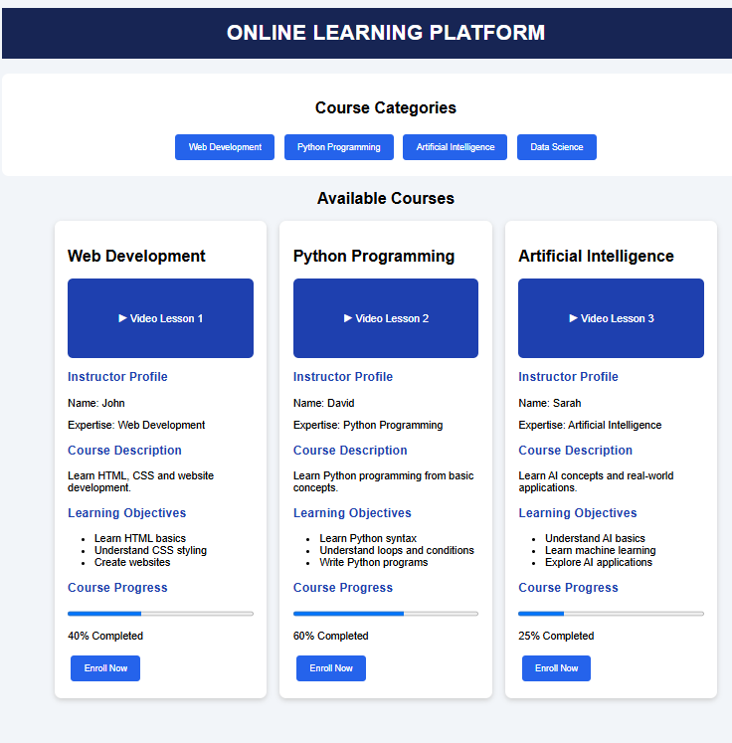

<!DOCTYPE html>
<html>
<head>
<title>Student Academic Dashboard</title>

<style>

/* Basic Styling */
body {
margin: 0;
font-family: Arial, sans-serif;
background-color: #f2f5f9;
}

/* Sidebar */
.sidebar {
width: 220px;
height: 100vh;
background-color: #172554;
color: white;
position: fixed;
padding: 20px;
box-sizing: border-box;
}

.sidebar h2 {
text-align: center;
}

.sidebar a {
display: block;
color: white;
text-decoration: none;
padding: 15px;
margin: 5px 0;
border-radius: 5px;
}

.sidebar a:hover {
background-color: #2563eb;
}

/* Main Content */
.main {
margin-left: 240px;
padding: 20px;
}

h1 {
color: #172554;
}

/* Student Details Card */
.student-card {
background-color: white;
padding: 20px;
border-radius: 10px;
box-shadow: 0 3px 8px #cccccc;
}

/* Dashboard Cards */
.card-container {
display: flex;
flex-wrap: wrap;
gap: 20px;
margin-top: 20px;
}

.card {
background-color: white;
padding: 20px;
width: 180px;
border-radius: 10px;
box-shadow: 0 3px 8px #cccccc;
flex: 1;
}

.card h3 {
color: #2563eb;
}

/* Tables */
table {
width: 100%;
border-collapse: collapse;
background-color: white;
margin-top: 15px;
}

th, td {
border: 1px solid #cccccc;
padding: 12px;
text-align: center;
}

th {
background-color: #172554;
color: white;
}

/* Progress Bars */
progress {
width: 100%;
height: 15px;
}

/* Announcements */
.announcement {
background-color: white;
padding: 15px;
margin: 10px 0;
border-left: 5px solid #2563eb;
border-radius: 5px;
}

/* Hover Effect */
.card:hover {
transform: translateY(-5px);
transition: 0.3s;
}

/* Responsive Design */
@media screen and (max-width: 700px) {

.sidebar {
width: 100%;
height: auto;
position: relative;
}

.sidebar a {
display: inline-block;
padding: 10px;
}

.main {
margin-left: 0;
padding: 10px;
}

.card-container {
flex-direction: column;
}

.card {
width: auto;
}

table {
font-size: 12px;
}
}

</style>
</head>

<body>

<!-- Sidebar -->
<div class="sidebar">

<h2>Student Dashboard</h2>

<a href="#home">Dashboard</a>
<a href="#details">Student Details</a>
<a href="#results">Semester Results</a>
<a href="#attendance">Attendance</a>
<a href="#subjects">Subjects</a>
<a href="#exams">Examination Schedule</a>
<a href="#announcements">Announcements</a>

</div>

<!-- Main Content -->
<div class="main">

<h1 id="home">Student Academic Dashboard</h1>

<!-- Student Details -->
<div class="student-card" id="details">

<h2>Student Details</h2>

<p><b>Name:</b> Ramu</p>
<p><b>Roll Number:</b> 101</p>
<p><b>Department:</b> CSE - AIML</p>
<p><b>Year:</b> First Year</p>
<p><b>Semester:</b> First Semester</p>

</div>

<!-- Dashboard Cards -->
<div class="card-container">

<div class="card">
<h3>Semester GPA</h3>
<h2>8.5</h2>
</div>

<div class="card">
<h3>Attendance</h3>
<h2>85%</h2>
</div>

<div class="card">
<h3>Total Subjects</h3>
<h2>5</h2>
</div>

</div>

<!-- Semester Results -->
<h2 id="results">Semester Results</h2>

<table>
<tr>
<th>Subject</th>
<th>Marks</th>
<th>Grade</th>
</tr>

<tr>
<td>Mathematics</td>
<td>85</td>
<td>A</td>
</tr>

<tr>
<td>Physics</td>
<td>90</td>
<td>A+</td>
</tr>

<tr>
<td>Programming</td>
<td>88</td>
<td>A+</td>
</tr>

<tr>
<td>English</td>
<td>80</td>
<td>A</td>
</tr>

<tr>
<td>Basic Electrical</td>
<td>82</td>
<td>A</td>
</tr>
</table>

<!-- Attendance -->
<h2 id="attendance">Attendance Percentages</h2>

<div class="card">

<p>Mathematics - 90%</p>
<progress value="90" max="100"></progress>

<p>Physics - 85%</p>
<progress value="85" max="100"></progress>

<p>Programming - 95%</p>
<progress value="95" max="100"></progress>

<p>English - 80%</p>
<progress value="80" max="100"></progress>

<p>Basic Electrical - 75%</p>
<progress value="75" max="100"></progress>

</div>

<!-- Subject Information -->
<h2 id="subjects">Subject Information</h2>

<table>

<tr>
<th>Subject Code</th>
<th>Subject Name</th>
<th>Faculty</th>
</tr>

<tr>
<td>CS101</td>
<td>Programming</td>
<td>Mr. Kumar</td>
</tr>

<tr>
<td>MA101</td>
<td>Mathematics</td>
<td>Mrs. Priya</td>
</tr>

<tr>
<td>PH101</td>
<td>Physics</td>
<td>Mr. Ravi</td>
</tr>

<tr>
<td>EN101</td>
<td>English</td>
<td>Mrs. Sita</td>
</tr>

<tr>
<td>EE101</td>
<td>Basic Electrical</td>
<td>Mr. Raj</td>
</tr>

</table>

<!-- Examination Schedule -->
<h2 id="exams">Examination Schedule</h2>

<table>

<tr>
<th>Subject</th>
<th>Exam Date</th>
<th>Time</th>
</tr>

<tr>
<td>Mathematics</td>
<td>10-12-2026</td>
<td>10 AM</td>
</tr>

<tr>
<td>Physics</td>
<td>12-12-2026</td>
<td>10 AM</td>
</tr>

<tr>
<td>Programming</td>
<td>15-12-2026</td>
<td>10 AM</td>
</tr>

<tr>
<td>English</td>
<td>17-12-2026</td>
<td>10 AM</td>
</tr>

<tr>
<td>Basic Electrical</td>
<td>19-12-2026</td>
<td>10 AM</td>
</tr>

</table>

<!-- Announcements -->
<h2 id="announcements">Announcements</h2>

<div class="announcement">
<p>1. Semester examinations will begin in December.</p>
</div>

<div class="announcement">
<p>2. Students must maintain minimum attendance.</p>
</div>

<div class="announcement">
<p>3. Submit all assignments before the deadline.</p>
</div>

</div>

</body>
</html>



