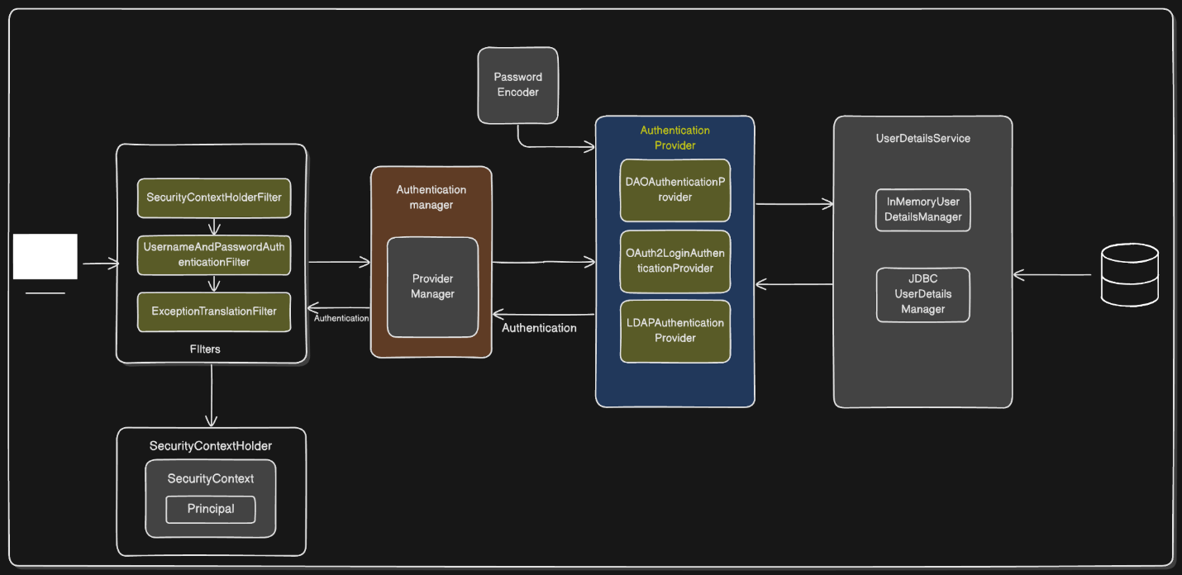

Difference Between Authentication and Authorization
Feature | Authentication 🔑 | Authorization 🔐
Definition | Verifies who the user is. | Determines what the user can do.
Question Answered | "Who are you?" | "What are you allowed to do?"
Process | Login with username/password, OTP, or biometric. | Checking permissions, roles, or access levels.
Responsible Component in Spring Security | AuthenticationManager, UserDetailsService | AccessDecisionManager, @PreAuthorize, @Secured
Example | Entering credentials to access an application. | After login, determining if the user can access admin-only pages.
Occurs When? | Before authorization. | After authentication.

Spring Security Architecture



Video Link : https://yt.openinapp.co/mkj8x
Spring Security Architecture Overview
This document explains all components shown in your Spring Security architecture diagram, focusing on the flow of authentication and the role of each module.

1. Filters Layer
Spring Security uses a chain of servlet filters. Each filter performs a specific security-related function.
SecurityContextHolderFilter
- The entry point for security context management.
- Retrieves the current SecurityContext (if present) and places it in SecurityContextHolder.
- Ensures security context is available for the request lifecycle.
UsernameAndPasswordAuthenticationFilter
- Intercepts login requests (typically /login).
- Extracts username and password.
- Creates a UsernamePasswordAuthenticationToken and sends it to the AuthenticationManager.

ExceptionTranslationFilter
- Catches security-related exceptions thrown during filter processing.
- Handles AuthenticationException and AccessDeniedException.
- Redirects to login page or returns 403 depending on context.

2. SecurityContextHolder
The central storage for all security information during a request.
SecurityContext
- Holds the currently authenticated user's details.
- Contains the Authentication object.
Principal
- The user identity object extracted from the Authentication object.
- Usually an instance of UserDetails.

3. Authentication Manager
Responsible for orchestrating authentication.
ProviderManager
- The default implementation of AuthenticationManager.
- Iterates over a list of AuthenticationProvider instances.
- Delegates authentication until one provider successfully authenticates.

4. Authentication Providers
Each provider knows how to validate a specific type of authentication.
DAOAuthenticationProvider
- Uses UserDetailsService and PasswordEncoder.
- Loads user details by username.
- Validates password.
OAuth2LoginAuthenticationProvider
- Handles OAuth2 login flows (Google, GitHub, etc.).
- Validates tokens and retrieves user info from the OAuth2 provider.
LDAPAuthenticationProvider
- Integrates with LDAP directories.
- Validates credentials and loads user authorities.

5. Password Encoder
- Responsible for hashing and verifying passwords.
- Common implementations include BCryptPasswordEncoder.
- Always applied by providers like DAOAuthenticationProvider.

6. UserDetailsService Layer
Resolves user information during authentication.
InMemoryUserDetailsManager
- Stores user details in memory.
- Useful for testing and simple setups.
JDBCUserDetailsManager
- Fetches users from a relational database.
- Uses predefined or custom SQL queries.

7. Database
- Stores user credentials and authorities when using JDBCUserDetailsManager.
- Authentication provider fetches user data from here.

Authentication Flow Summary
- Request enters the filter chain.
- UsernamePasswordAuthenticationFilter extracts credentials.
- Filter delegates to AuthenticationManager.
- AuthenticationManager calls each AuthenticationProvider.
- A matching provider loads the user using UserDetailsService.
- Password is verified via PasswordEncoder.
- Successful Authentication is stored in SecurityContextHolder.
- Subsequent requests use the stored context until cleared.

https://docs.spring.io/spring-security/reference/servlet/architecture.html

