Admin

1. **User Table**
2. name
3. email
4. password
5. status
6. role
7. **Student Table**
8. Name
9. Email
10. Mobile
11. Password
12. Status
13. **Subject Table**
14. subjectname
15. Status
16. **Course Table**
17. Coursename
18. Status
19. **Question Table**
20. subjectid
21. courseid
22. questiontext
23. option1
24. option2
25. option3
26. option4
27. correctoption
28. status
29. **Answer Table**
30. Questioned
31. Studentid
32. Selectedoption
33. **Answer Table**
34. Questioned
35. Studentid
36. Selectedoption
37. **Student Answer**

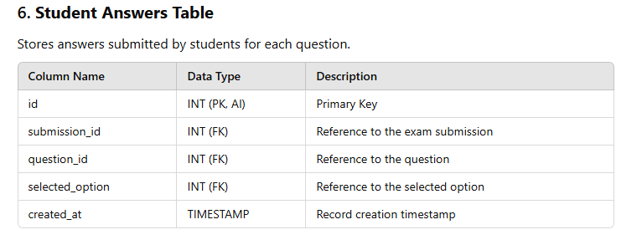

1. Submission_id
2. Question_id
3. Selected_option
4. **Subject**
5. Name
6. Status
7. **Question**

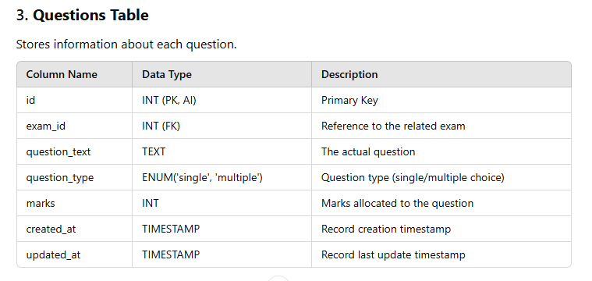

1. exam_id
2. question_text
3. question_type ENUM('single', 'multiple')
4. marks
5. **Exam**

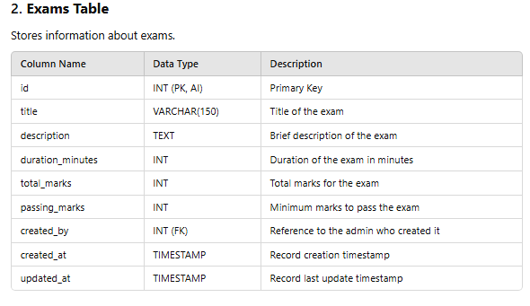

1. Title
2. duration_minutes
3. description
4. passing_marks
5. total_marks
6. created_by
7. Options
8. question_id
9. option_text
10. is_correct
11. **Exam Submissions**

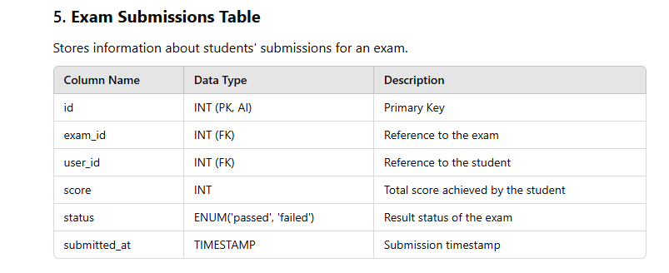

1. exam_id
2. student_id
3. score
4. status
5. submitted_at