Ex.No: 01  Date: | CREATION OF WEBPAGE FOR HOTSPOT INDICATION

AIM:
To create a webpage with the following using HTML
a) To embed a map in a webpage
b) To fix the hotspots in that map
c) Show all the related information when the hotspots are clicked.

PROGRAM:
<html>
<head>
<tittle> </tittle>
<style>
h1{
color:Blue;
background-color:white;
text-align:center;}
body{
background:Aqua;}
</style>
</head>
<body>
<h1> India Map</h1>
<div><center>
<img src="sa.jpg" alt="loading..." usemap="#cse"></div>
<map name="cse">
<areashape="poly" coords="197,631,218,627,221,611,238,599,267,589,259,602,253,635,238,663,227,673,209,690" href="tamilnadu.html">
<areashape="poly"coords="154,611,163,617,177,629,185,648,191,664,190,696,179,678,4,659,170,639,159,615" href="kerala.html">
<areashape="poly" coords="139,326,104,295,82,282,66,262,60,236,83,227,106,226,131,202,127,262,177,225,195,268,186,302"href="rajasthan.html">
<areashape="poly" coords="196,117,216,117,232,137,209,147,195,136"href="himachal.html">
<areashape="poly" coords="190,188,210,178,207,201,208,225,188,214,177,194"href="haryana.html">
<areashape="poly" coords="175,137,186,157,180,173,167,174,164,165"href="punjab.html">
</body>
</html>
tamilnadu.html
<html>
<head>
<style>
h1{
color:#6495ED;
text-decoration:underline;
text-decoration-color:#CCCCFF;
text-align:center;
background-color:white;}
body{
background-color:#ffcccc;}
p{
font-size:30px;
text-align:justify;
text-indent:50px;
margin:30px;
margin-top:100px;
font-style:italic;
color:cornflowerblue;}
a{
font-size:30px;
color:#0040ff;
text-decoration:none;}
a:hover{
color:#ff00ff;
text-transform:capitalize;}
.agar{
color:chartreuse;
text-align:center;}
.kural{
text-align:center;
background-color:azure;}
</style>
</head>
<body>
<marquee direction="down"><h1>Tamil nadu</h1></marquee>
<div><center>
<img src="tamil.jpg" height="200"width="500"></div>
<p>The State of Tamil Nadu has a hoary antiquity. Though early sangam classics throw historical references, we pass to recorded history only from the Pallavas.
The southern states of India were under the hegemony of the Cholas, the Cheras and the Pandyas for centuries. The Pallavas held supremacy from about the second quarter of the fourth century A.D. <br><br>They were the originators of the famous Dravidian style of temple architecture. The last Pallava ruler was Aparajita, in whose reign the later Cholas under Vijayalaya and Aditya asserted themselves by about the 10th century. At the end of the 11th century, Tamil Nadu was ruled by several dynasties like the Chalukyas, Cholas and Pandyas. In the two centuries that followed, the imperial Cholas gained paramountcy over South India.
Muslims gradually strengthened their position, which led to the establishment of the Bahamani Sultanate, by the middle of the 14th century. At the same time, the Vijayanagar Kingdom quickly consolidated itself and extended its sway over the whole of South India, and at the close of the century, Vijayanagar became the supreme power in South. However, it crumbled at the battle of Talikota in 1564 to the confederate forces of the DeccanSultans.
Even during the period of the tumultuous confusion that followed the battle of Talikota, European commercial interest had appeared as rivals in the area of South India.<br> <br>The Portuguese, the Dutch, the French and the English came in quick succession and established trading centres known as 'Factories'. East India Company, which had established its factory at Masulipatnam (now in Andhra Pradesh) in 1611, gradually annexed territories by encouraging enmity among the native rulers. Tamil Nadu was one of the first of British settlements in India. The State is the successor to the old Madras Presidency, which covered the bulk of the southern peninsula in 1901. The composite Madras State was later reorganised, and the present Tamil Nadu was formed.
Tamil Nadu is bounded on north by Andhra Pradesh and Karnataka, on the west by Kerala, on the east by the Bay of Bengal, and on the south by the Indian Ocean.
<p class="kural"> திருக்குறள்<p>
<p class="agar">அகர முதல எழுத்தெல்லாம் ஆதி<br>
பகவன் முதற்றே உலகு</p>
<marquee direction="right"><a href="india.html">go back</a></marquee></div>
</body>
</html>

kerala.html
<html>
<head>
<style>
h1{
color:beige;
text-decoration:none;
background-color:brown;
border:dotted;
text-align:center;}
body{
background-color:bisque;
margin:55px;}
p{
font-size:40px;
font-style:italic;}
.ker{
color:brown;}
.re{
color:dark orange;
font-size:40px;
text-align:left;
text-decoration:none;
background-color:white;}
.hr{
text-align:left;
}
.ar{
font-size:30px;
color:red;
text-decoration:none;}
</style>
</head>
<body>
<marquee direction="down"><h1>Kerala</h1></marquee>
<p>Kerala (English: /ˈkɛrələ/ KERR-ə-lə; Malayalam: [ke:ɾɐɭɐm] (audio speaker iconlisten)) is a state on the Malabar Coast of India.<p>[13] It was formed on 1 November 1956, following the passage of the States Reorganisation Act, by combining Malayalam-speaking regions of the erstwhile regions of Cochin, Malabar, South Canara, and Travancore.[14][15] Spread over 38,863 km2 (15,005 sq mi),<p class="ker"> Kerala is the 21st largest Indian state by area. It is bordered by Karnataka to the north</p></p></p>
<a href="ke.jpg">
<center><img src="ke.jpg" alt="my image" width="600" height="600">
<br><br><br><br><br><br>
<div class="re">Recommendations by the committees<br>
Use non-ligating vowel signs for u, ū, and r̥</div>
<div class="hr">
<a href="chart.jpg" >
<img src="chart.jpg" alt="my image" width="200" height="200"></div>
<br><br>
<div class="ar">
<marquee direction="right"><a href="india.html">go back</a></marquee></div>
</body>
</html>
rajasthan.html
<html>
<head>
<style>
#raj{
font-size:50px;
background-color:coral;
height:80px;
width:500px;
margin:20px;
border-style:ridge;
border-color:#C0C0C0;
font-family:'Smokum',cursive;}
p{
margin:30px;
text-align:left;
font-size:40px;
margin-top:55px;
color:#8A2BE2;
font-family:'Smokum', cursive;}
body{
background-color:#F0E68C;
border-color:red;}
.hindi{
font-size=55px;
color:red;
text-decoration:underline;
text-align:center;}
a{
font-size:30px;
color:#0040ff;
text-decoration:none;}
a:hover
{
color:#ff00ff;
text-transform:capitalize;}
</style>
</head>
<body>
<marquee direction="down"><center><h1 id="raj"> Rajasthan</h1></marquee>
<p> It covers 342,239 square kilometres (132,139 sq mi) or 10.4 percent of India's total geographical area. It is the largest Indian state by area and the seventh largest by population. It is on India's northwestern side, where it comprises most of the wide and inhospitable.<br><br>Thar Desert (also known as the Great Indian Desert) and shares a border with the Pakistani provinces of Punjab to the northwest and Sindh to the west, along the Sutlej-Indus River valley.
It is bordered by five other Indian states: Punjab to the north;Haryana and Uttar Pradesh to the northeast;Madhya Pradesh to the southeast; and Gujarat to the southwest. Its geographical location is 23.3 to 30.12 North latitude and 69.30 to 78.17 East longitude, with the Tropic of Cancer passing through its southernmost tip.</p>
<tableborder="1" bordercolor="#228B22" cellspacing="0"cellpadding="2">
<tr>
<th><img src="jaipur.jpg"></th>
<th><img src="thar.jpg"></th>
<th><img src="tyh.jpg"></th> </tr>
</table><br><br>
<p class="hindi">"हाय मैं अच्छा हूँ तुम कैसे हो लेकिन मैं बहुत दुखी हूँ।"<p>
<marquee direction="right"><a href="india.html">go back</a></marquee>
</body>
</html>
himachal.html
<html>
<head>
<link rel="stylesheet" href="https://fonts.googleapis.com/css?family=Audiowide|Sofia|Trirong">
<style>
h1{

background-color:#00ffbf;
height:70px;
width:400px;
padding-top:20px;
border:dotted;
border-color:#ff00bf;
font-family: "Sofia", sans-serif;}
p{
font-size:20px;
font-family: "Sofia", sans-serif;
margin:50px;}
body{
background-color:#ffb3b3;}
.har{
color:#ff0040;
text-align:center;}
a{
font-size:30px;
color:#0040ff;
text-decoration:none;}
a:hover{
color:#87CEFA;
text-transform:capitalize;}
</style>
</head>
<body>
<marquee direction="down"><center><h1> Himachal</h1></marquee>
<p>Himachal Pradesh (/hɪˌmɑːtʃəl prəˈdɛʃ/; Hindi: [ɦɪˈmɑːtʃəl pɾəˈdeːʃ] (audio speaker iconlisten); lit. "Province of the Snow-laden Mountains"[16]) is a state in the northern part of India. Situated in the Western Himalayas, it is one of the thirteen mountain states and is characterized by an extreme landscape featuring several peaks and extensive river systems. Himachal Pradesh is the northernmost state of India and shares borders with the union territories of Jammu and Kashmir and Ladakh to the north, and the states of Punjab to the west, Haryana to the southwest, Uttarakhand to the southeast and a very narrow border with Uttar Pradesh to the south. The state also shares an international border to the east with the Tibet Autonomous Region in China. Himachal Pradesh is also known as Dev Bhoomi, meaning 'Land of God'[17] and Veer Bhoomi which means 'Land of Braves'.[18]</p><p>The predominantly mountainous region comprising the present-day Himachal Pradesh has been inhabited since pre-historic times having witnessed multiple waves of human migrations from other areas.[19] Through its history, the region was mostly ruled by local kingdoms some of which accepted the suzerainty of larger empires. Prior to India's independence from the British, Himachal comprised the hilly regions of Punjab Province of British India. After independence, many of the hilly territories were organized as the Chief Commissioner's province of Himachal Pradesh which later became a union territory. In 1966, hilly areas of neighboring Punjab state were merged into Himachal and it was ultimately granted full statehood in 1971.</p><p class="har">"इंटरनेट प्रोग्रामिंग बहुत आसान है। हम इस विषय को आसानी से सीख सकते हैं"</p><br>
<img src="him1.jpg">
<marquee direction="right"><a href="india.html">go back</a></marquee></div>
</body>
</html>
haryana.html
<html>
<head>
<link href="https://fonts.googleapis.com/css2?family=Cinzel:wght@500&family=Smokum&display=swap" rel="stylesheet">
<style>
h1{

background-color:#00ffbf;
height:70px;
width:400px;
padding-top:20px;
border:dotted;
border-color:#ff00bf;
font-family: 'Cinzel', serif;}
p{
font-size:20px;
font-family:'Cinzel', serif;}
body{
background-color:#ff9999;}
.har{
color:#ff0040;}
a{
font-size:30px;
color:#0040ff;
text-decoration:none;}
a:hover
{
color:#87CEFA;
text-transform:capitalize;}

</style>
</head>
<body>

<marqueedirection="down"><center><h1> Haryana</h1></marquee>
<p>Indian state located in the northern-part of the country.</p>
<p>it was carved out of the former state of East Punjab on 1 November 1966 on a linguistic basis. It is ranked 21st in terms of area, with less than 1.4% (44,212 km2 or 17,070 sq mi) of India's land area.[1][12] The state capital is Chandigarh, which it shares with the neighboring state of Punjab, and the most populous city is Faridabad, which is a part of the National Capital Region. The city of Gurgaon is among India's largest financial and technology hubs.[13] Haryana has 6 administrative divisions, 22 districts, 72 sub-divisions, 93 revenue tehsils, 50 sub-tehsils, 140 community development blocks, 154 cities and towns, 7,356 villages, and 6,222 villages panchayats.[12][14]</p>
<p>Haryana contains 32 special economic zones (SEZs), mainly located within the industrial corridor projects connecting the National Capital Region.[12][15] Gurgaon is considered one of the major information technology and automobile hubs of India.[16][17] Haryana is the 11th-highest ranking among Indian states in human development index.[10] The economy of Haryana is the 13th largest in India, with a gross state domestic product (GSDP) of ₹7.65 trillion (US$100 billion) and has the country's 5th-highest GSDP per capita of ₹240,000 (US$3,100).[9]</p>
<center><table border=#ff9999>
<tr>
<td><img src="har.jpg"></td>
<td><img src="h1.jpg"></td>
<td><img src="h2.jpg"></td>
</tr>
</table>
<p class="har">"इंटरनेट प्रोग्रामिंग बहुत आसान है। हम इस विषय को आसानी से सीख सकते हैं"</p>
<marquee direction="right"><a href="india.html">go back</a></marquee></div>
</body>
</html>
punjab.html
<html>
<head>
<style>
#raj{
font-size:50px;
background-color:#90EE90;
height:80px;
width:500px;
margin:20px;
border-style:ridge;
border-color:#C0C0C0;
font-family:'Smokum', cursive;}
p{
margin:30px;
text-align:left;
font-size:40px;
margin-top:55px;
color:#8A2BE2;
font-family:'Smokum', cursive;}
body{
background-color:cyan;
border-color:red;}
.hindi{
font-size=55px;
color:red;
text-decoration:underline;
text-align:center;}
a{
font-size:30px;
color:#0040ff;
text-decoration:none;}
a:hover
{
color:#87CEFA;
text-transform:capitalize;}
</style>
</head>
<body>
<marquee direction="down"><center><h1 id="raj"> Punjab</h1></marquee>
<p>Indian states of Himachal Pradesh to the north and northeast, Haryana to the south and southeast, and Rajasthan to the southwest; by the Indian union territories of Chandigarh to the east and Jammu and Kashmir to the north. </p><p>It shares an international border by Punjab, a province of Pakistan to the west.[7] The state covers an area of 50,362 square kilometres (19,445 square miles), which is 1.53% of India's total geographical area,[8] making it the 19th-largest Indian state by area out of 28 Indian states (20th largest, if UTs are considered).</p>
<p class="hindi">"हाय मैं अच्छा हूँ तुम कैसे हो लेकिन मैं बहुत दुखी हूँ।"<p>
<img src="pu.jpg" height="600" width="1000">
<marquee direction="right"><a href="india.html">go back</a></marquee>
</body>
</html>

Output:
India.html
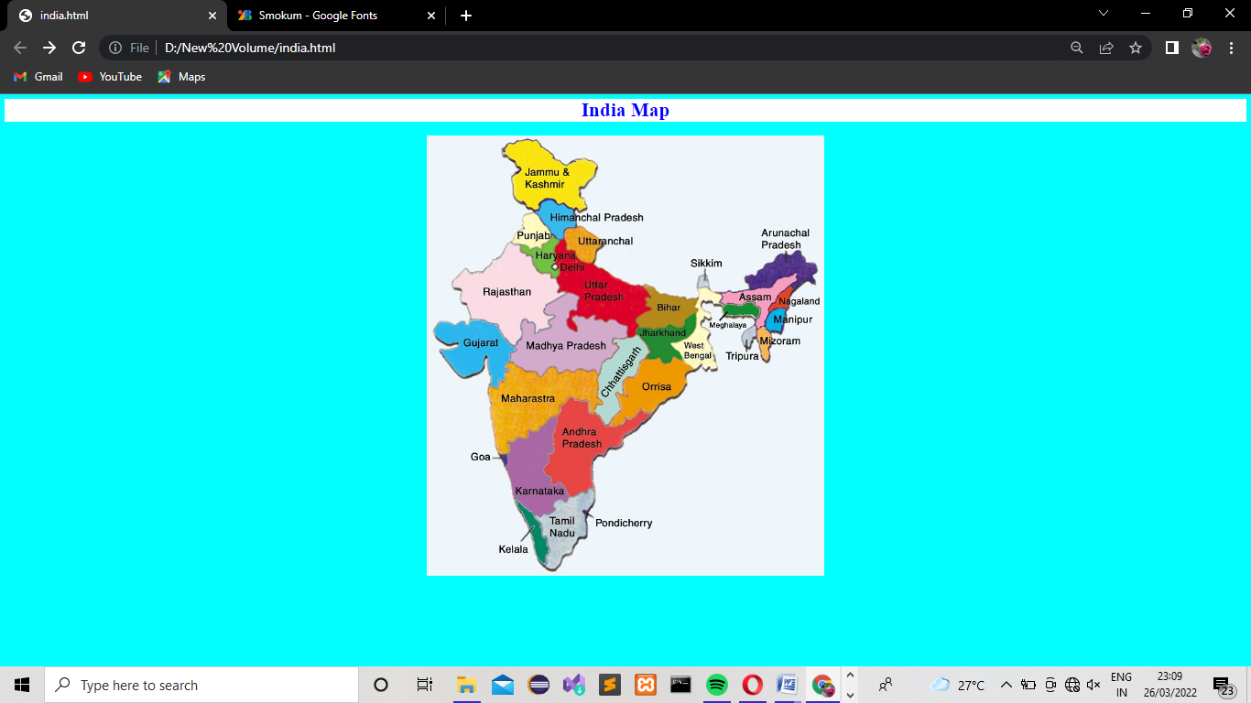

tamilnadu.html

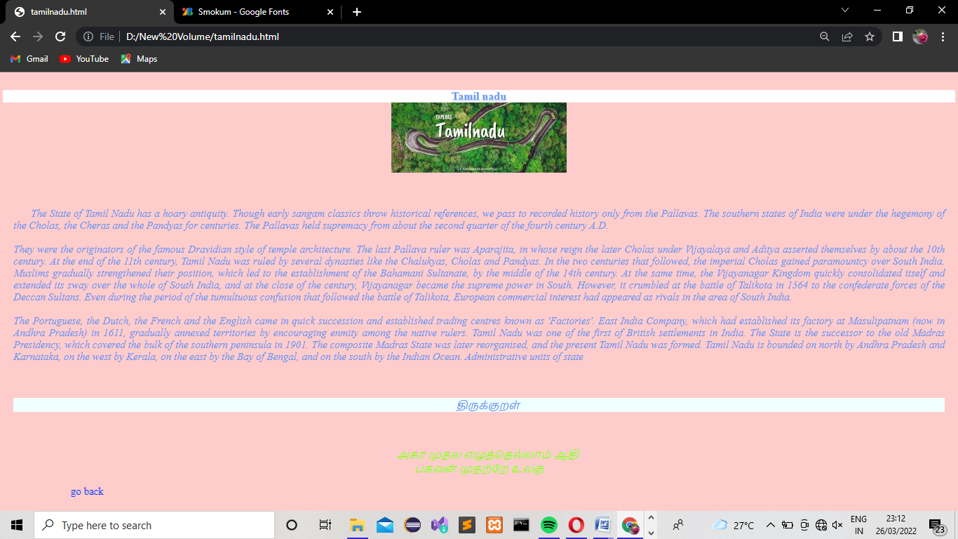

kerala.html
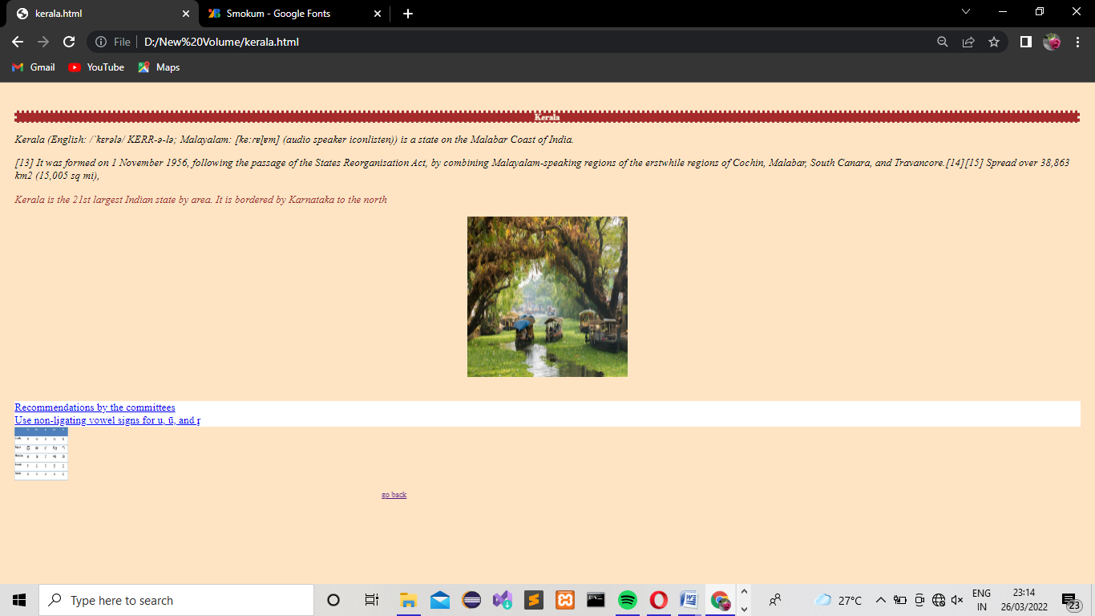

rajasthan.html
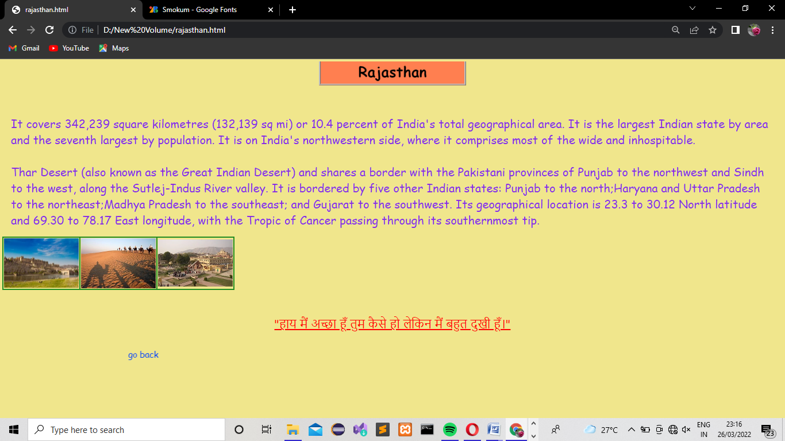

himachal.html

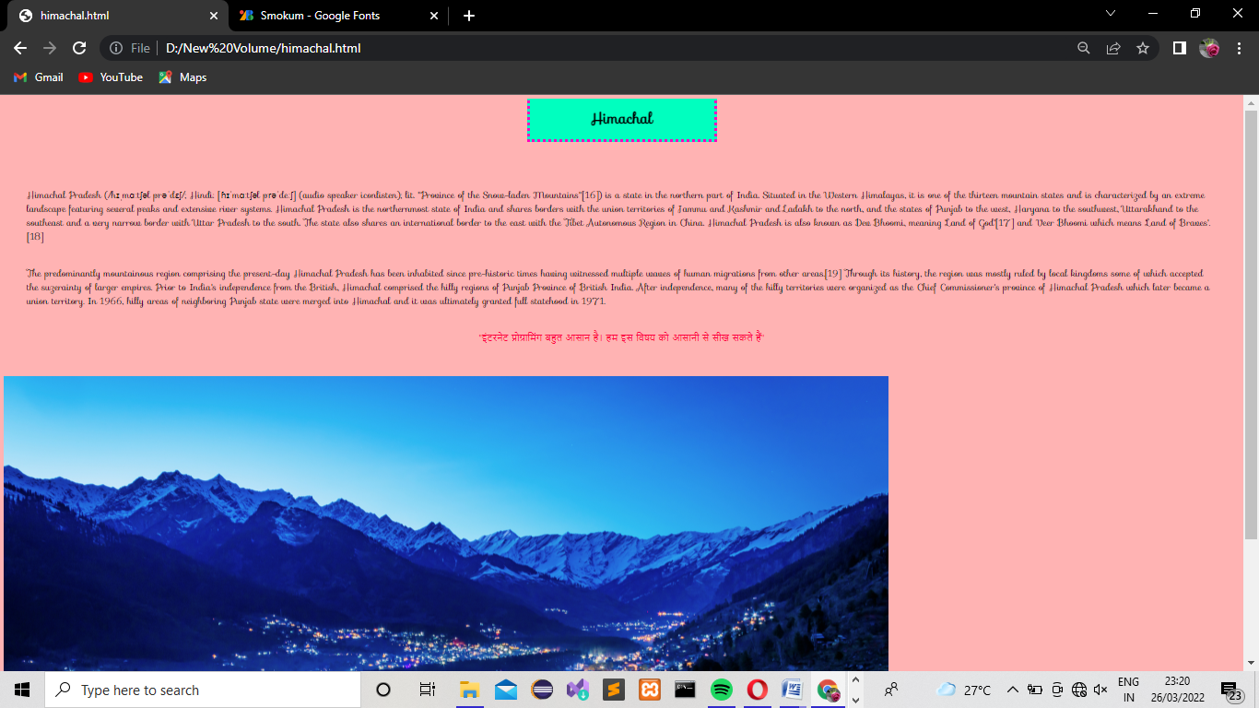

haryana.html
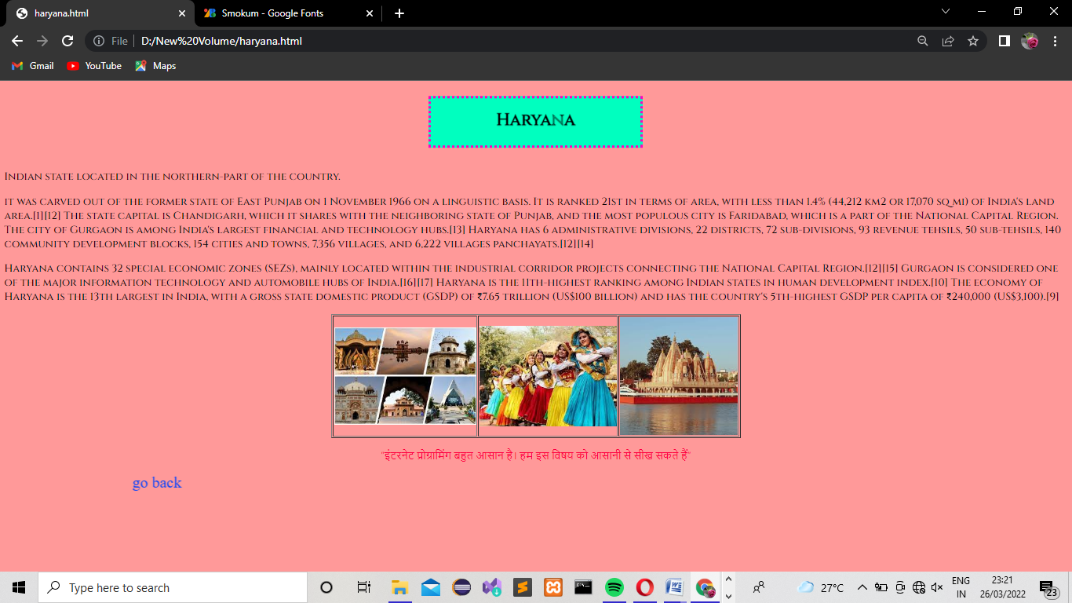

punjab.html
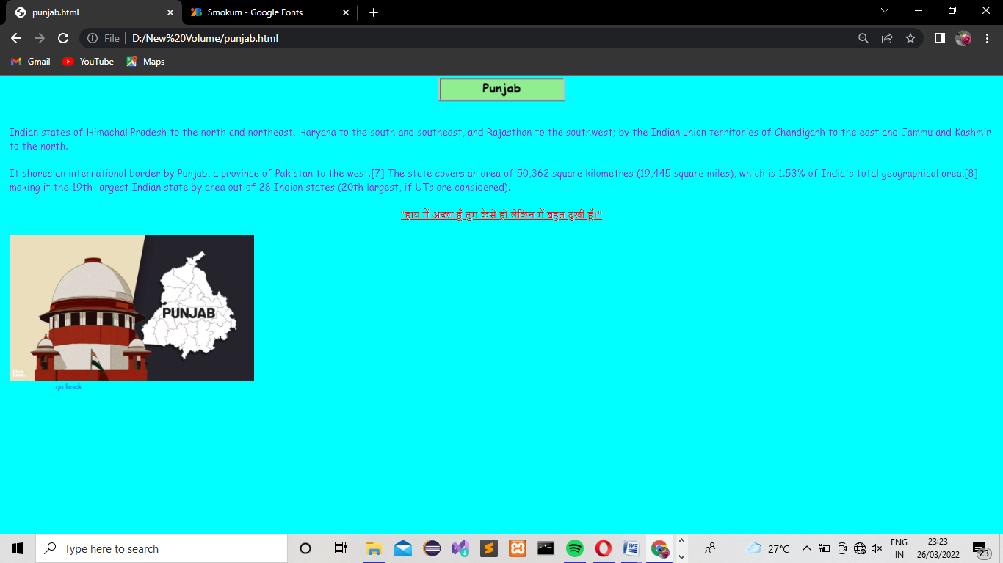

RESULT:
Thus the webpage for indication of hotspots on map is created and executed successfully.

