Phase: 2 : Week-01 Assignment :
Home Assignment:
Build a Document Question Answering (Document QA) Agent
list of nodes :
1.Manual Trigger
2.Read /write files from disk
3.Extract from file
4.Basic LLM chain
N8N workflow :
============
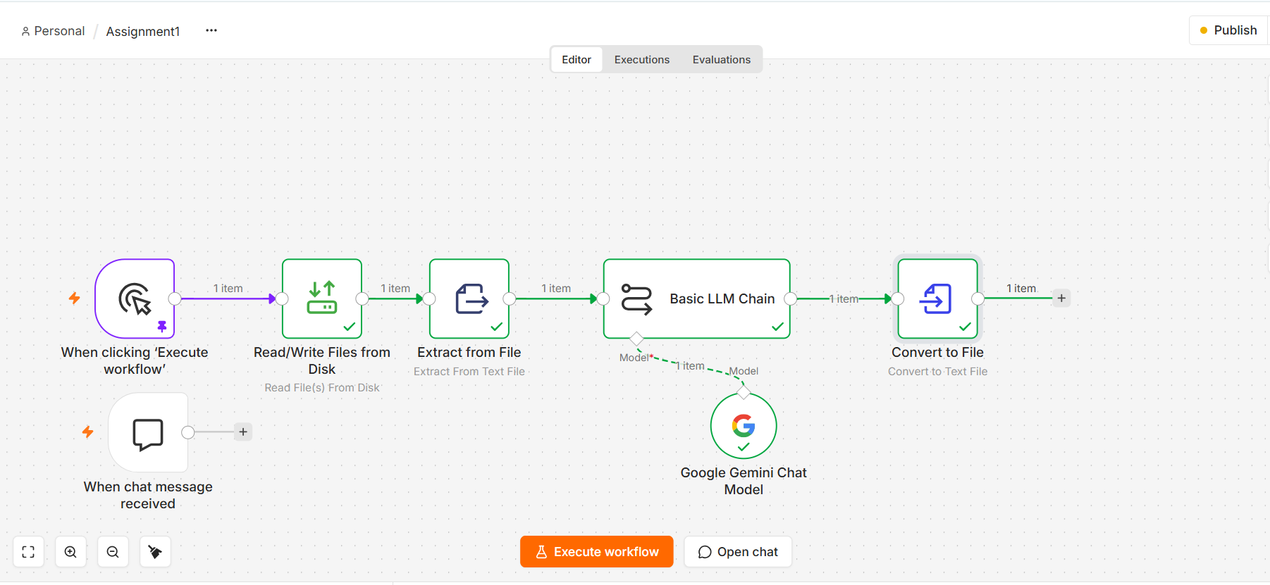
Input:
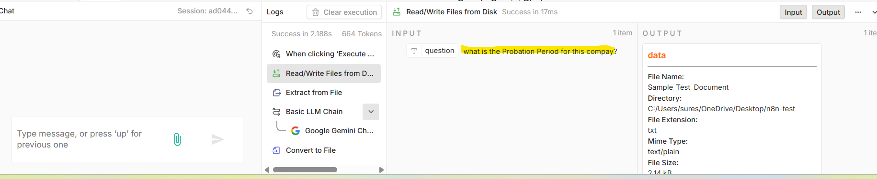

Output via LLM model :
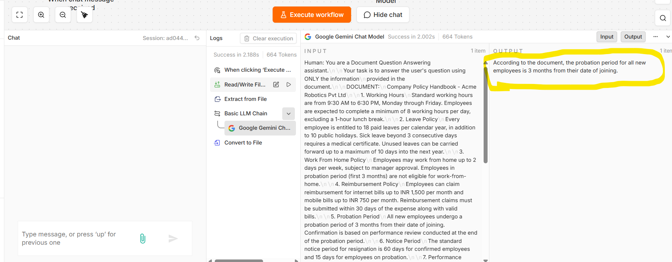

Converted as text :
