Assignment : Retrieval Implementation
Retrieval Backend:
Phase 1 and 2 - Readiness
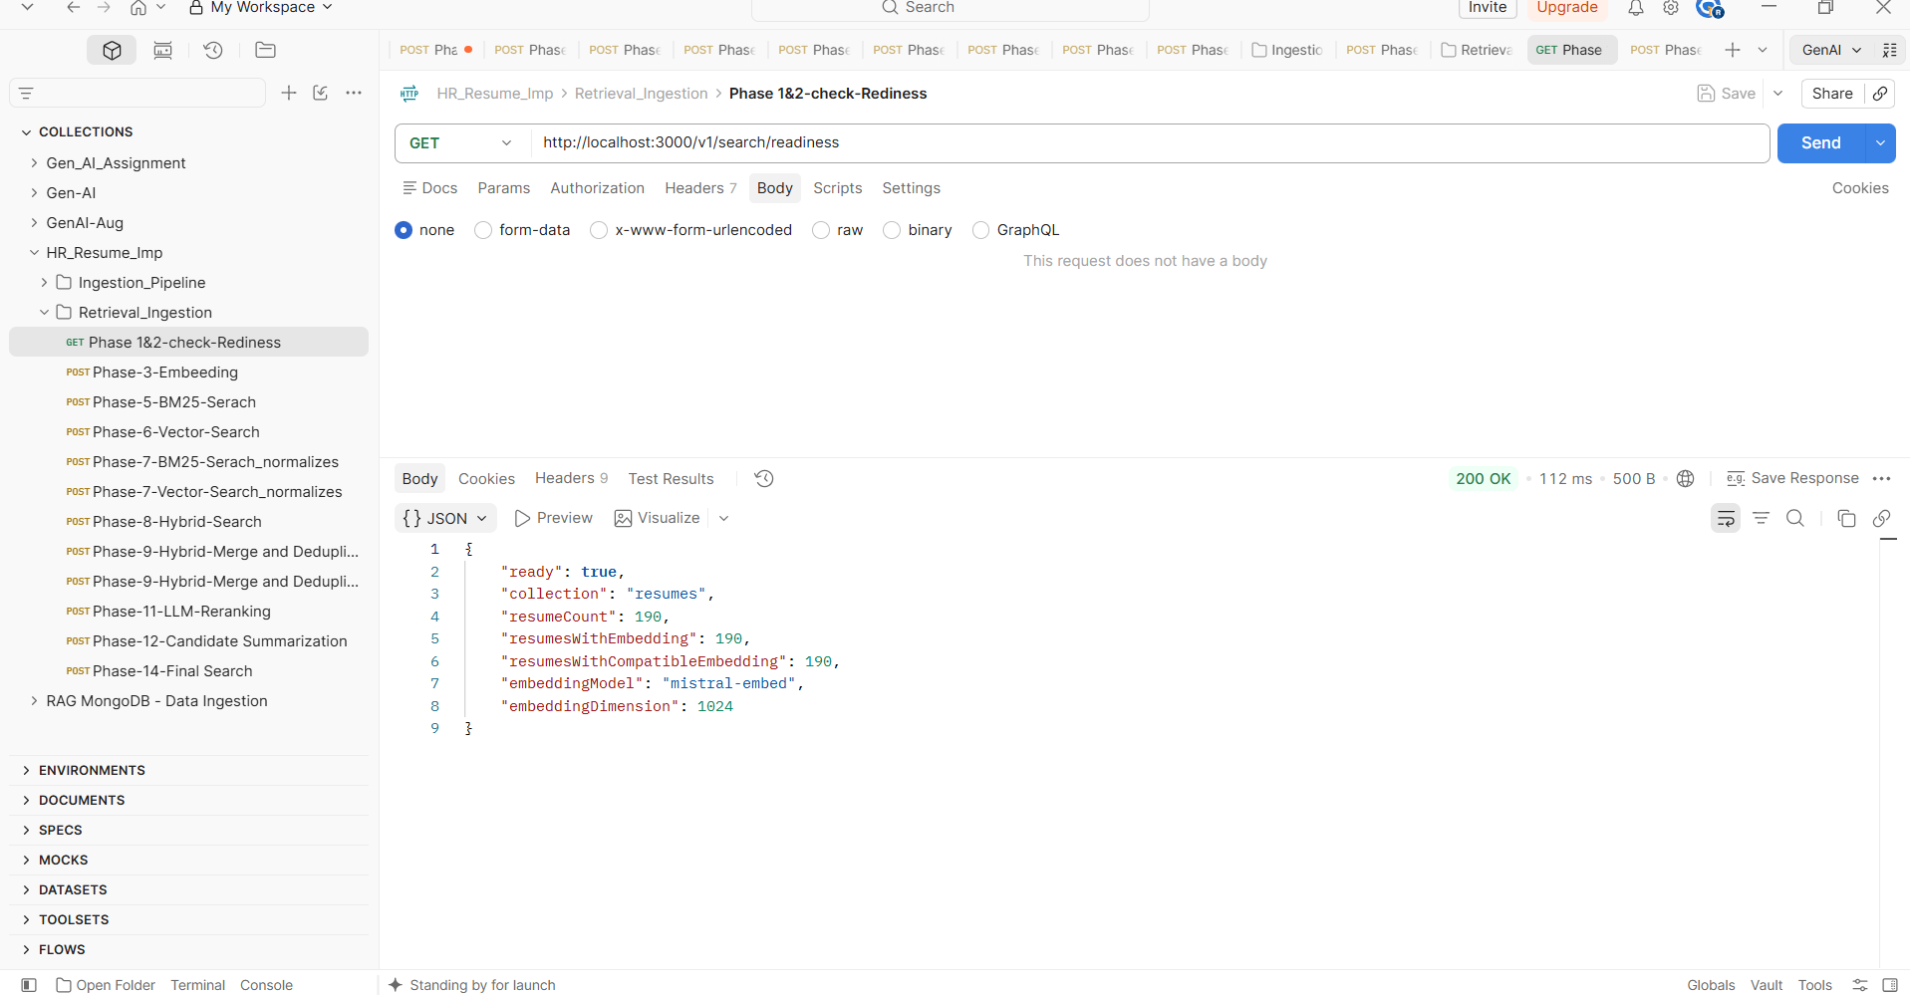
Phase 3 : Embedding
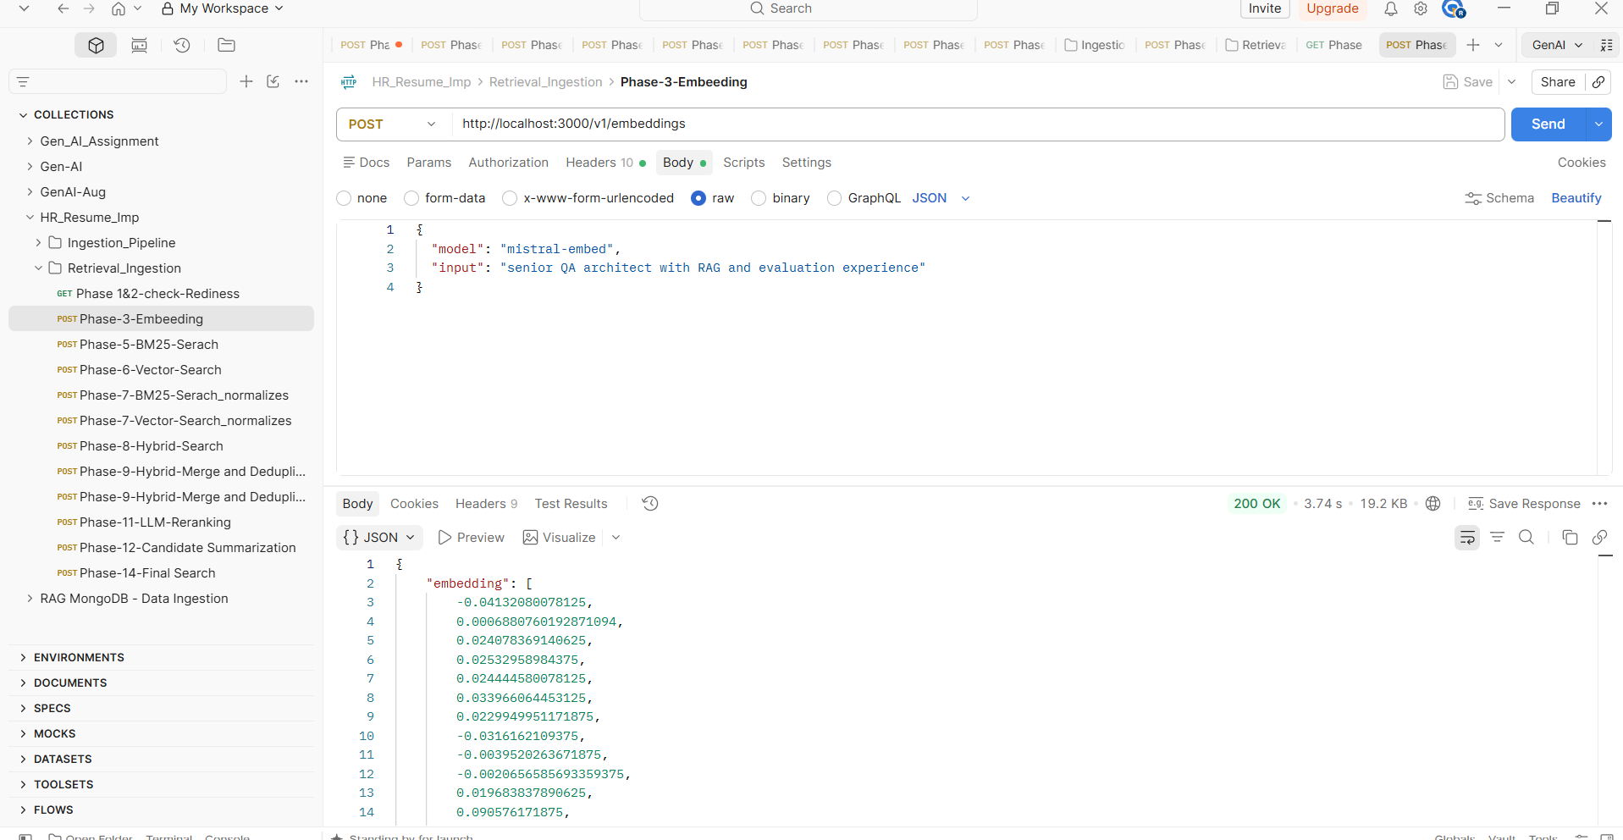
Phase 5 : BM25 search
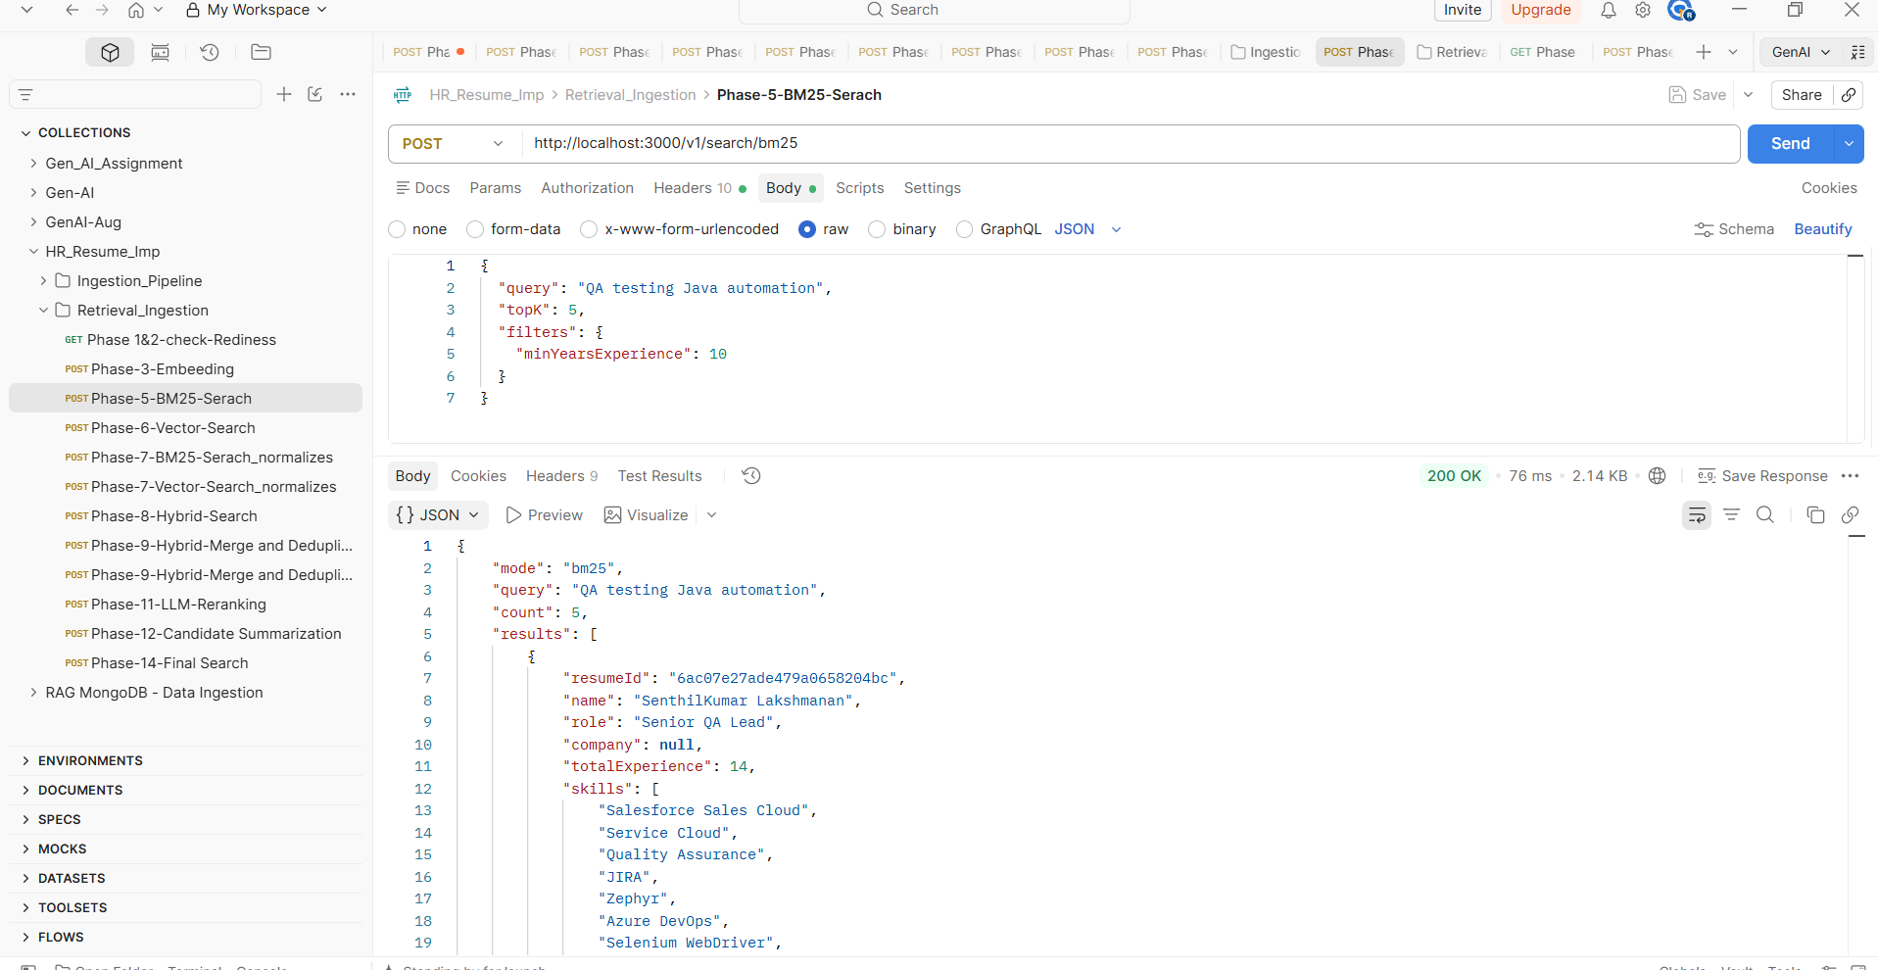
Phase 6 : Vector search
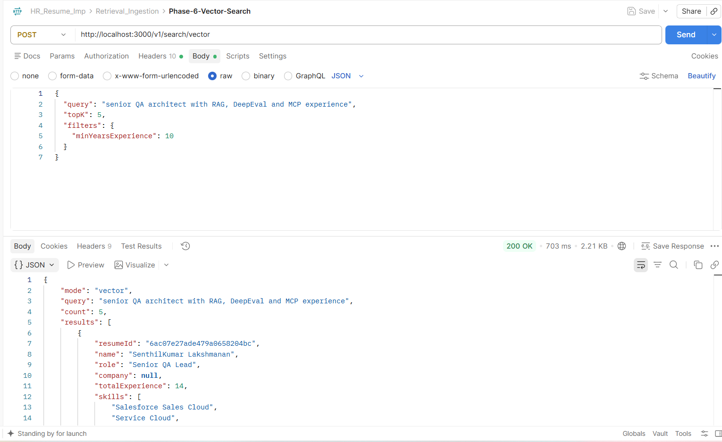
Phase 7 : Normalization
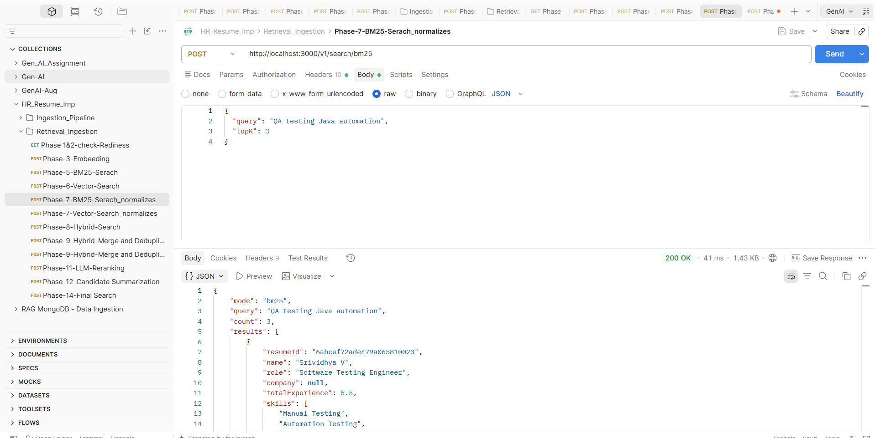
Phase 8: Hybrid search
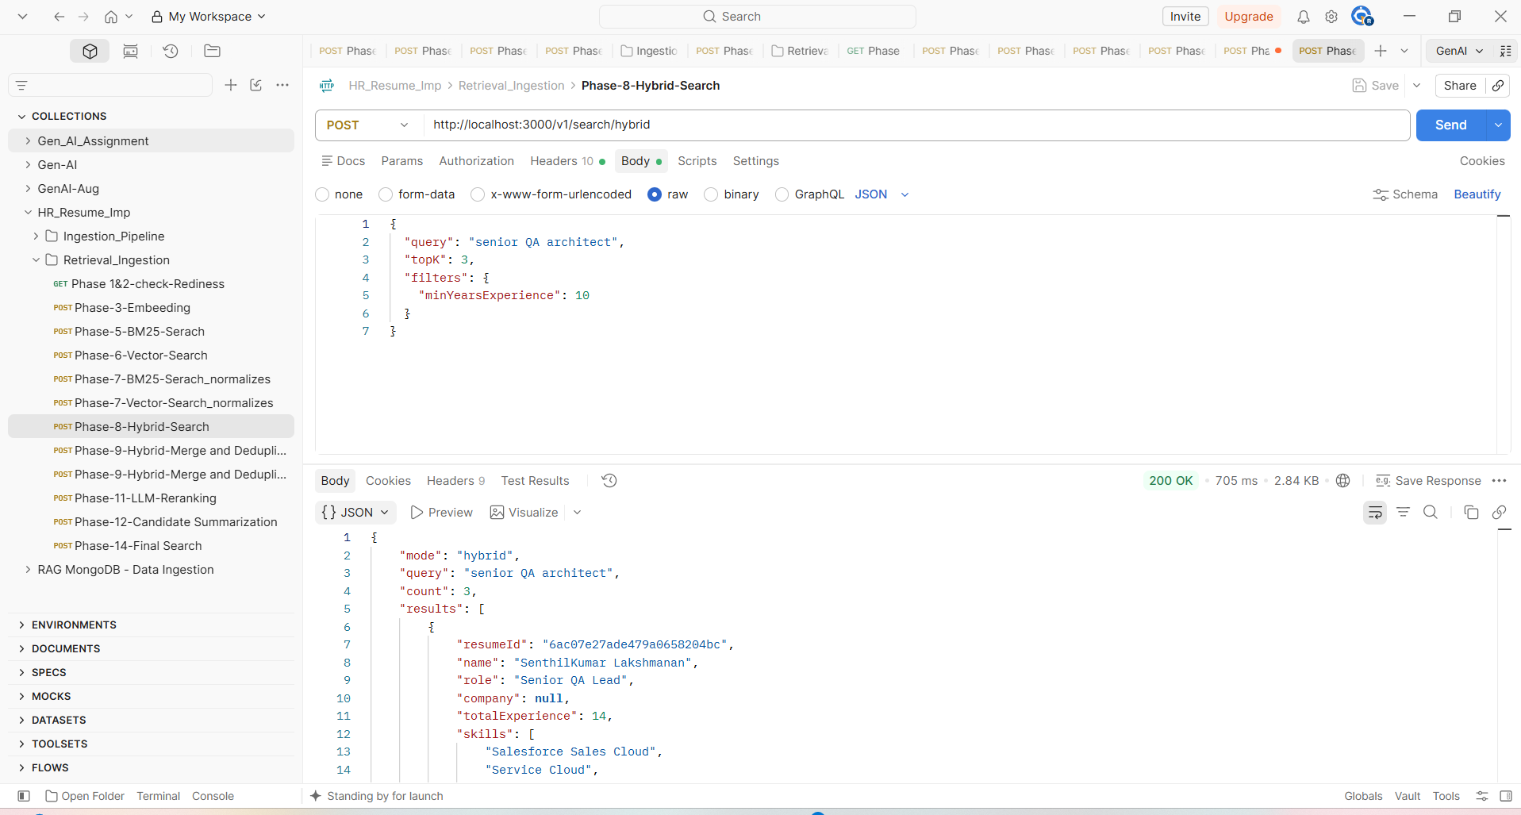
Phase 11:LLM Reranking
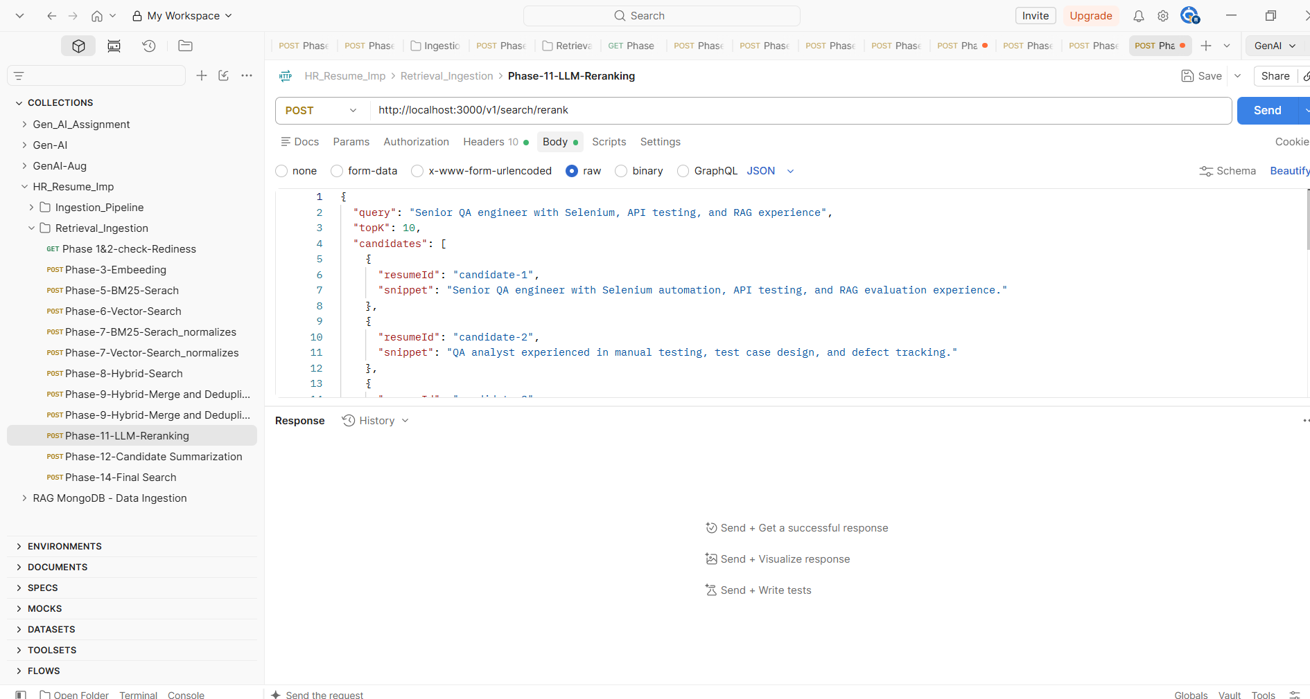
Phase 12 : Candidate summarize
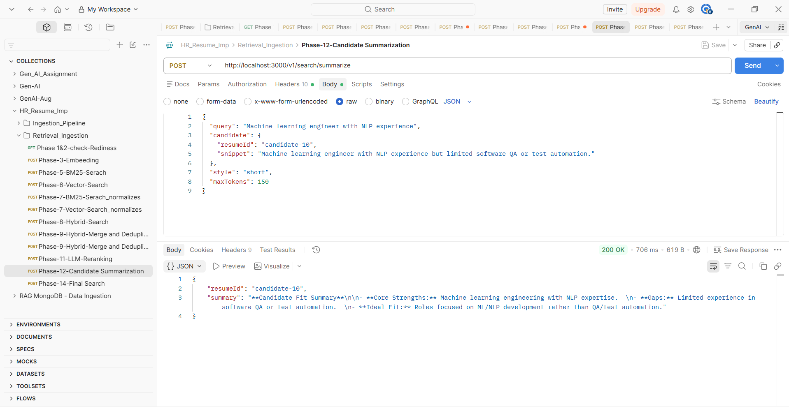

Phase 14:E2E
