Week-3 -Day-1: Assignment
Playwright typescript Implementation :
Logo change , Model added and playwright script:
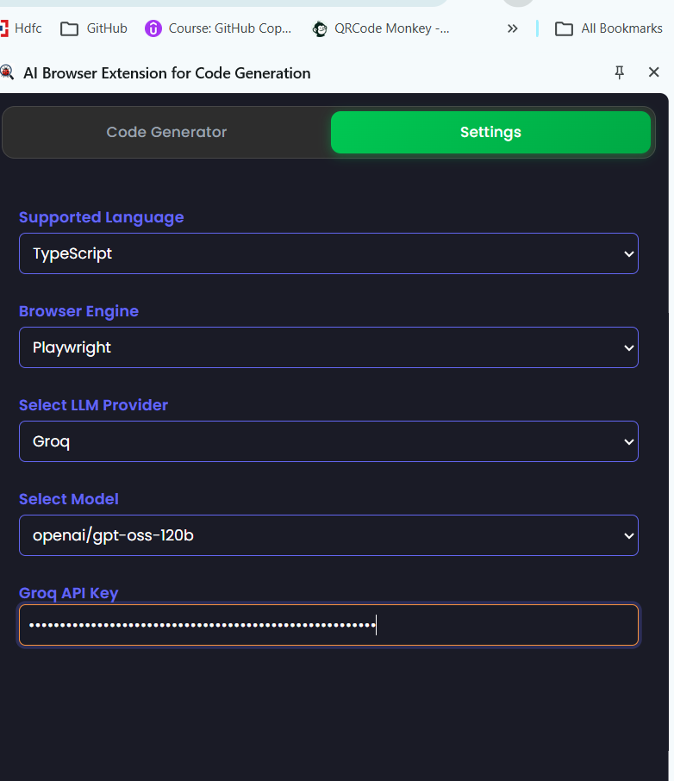
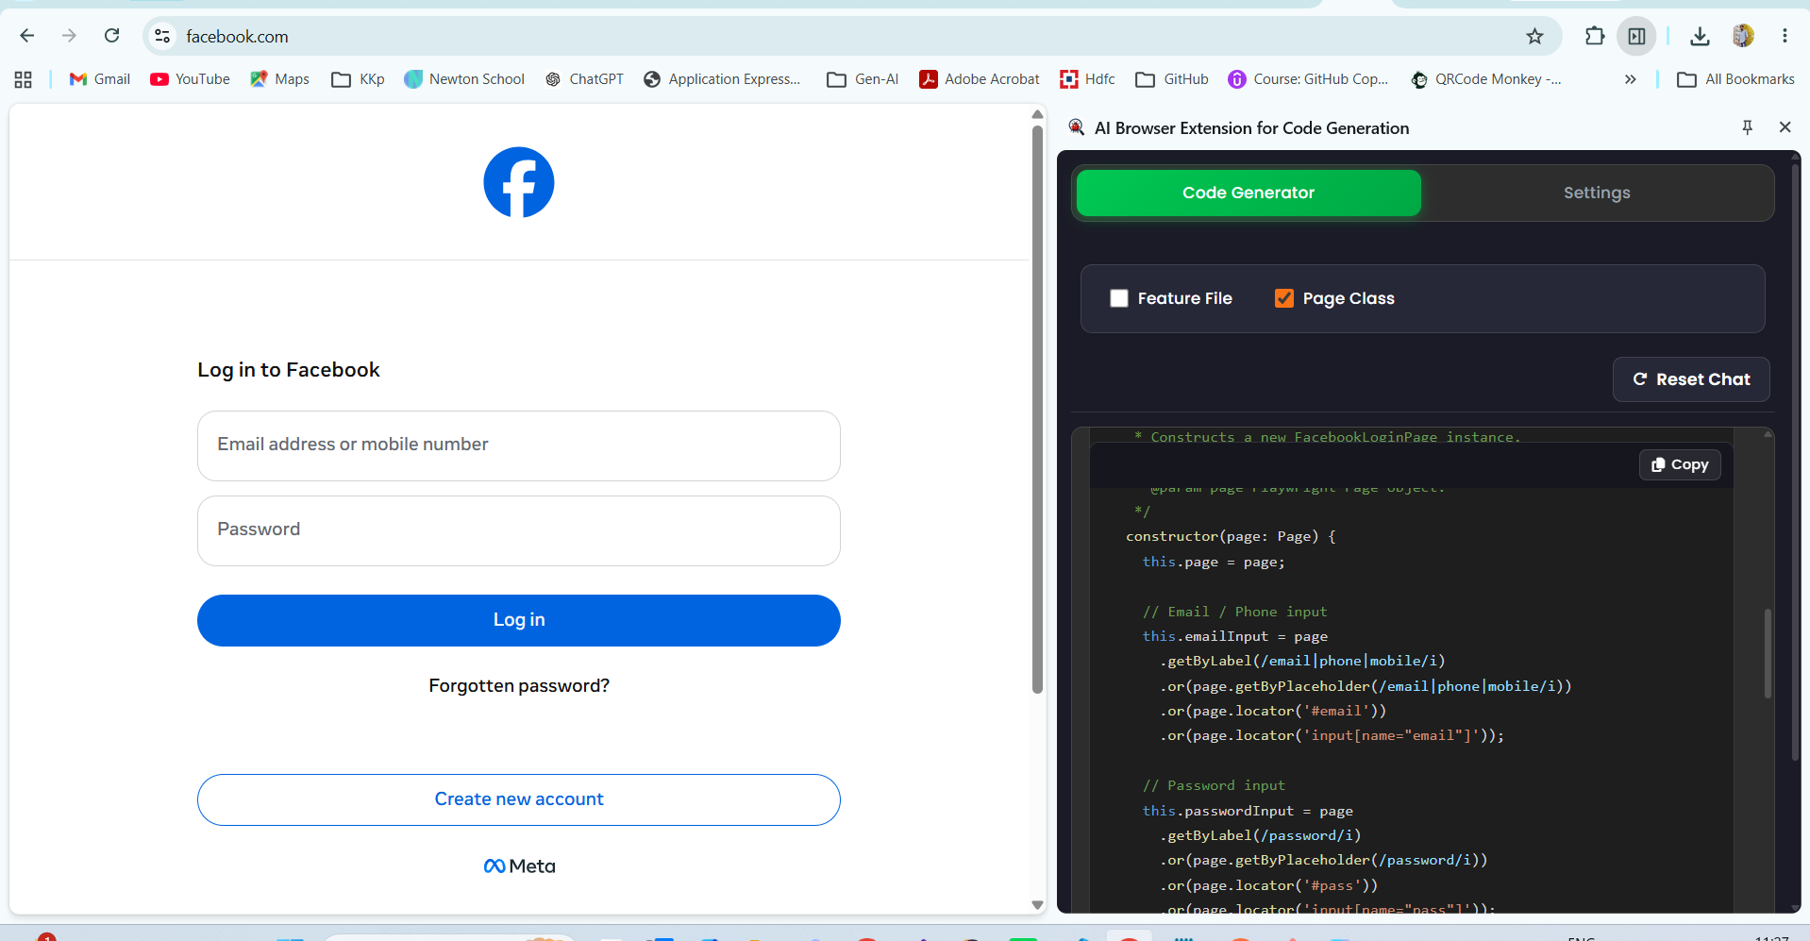
generated code :

import { Page, Locator } from '@playwright/test';

/**
* Page Object Model for Facebook's login page.
*
* This class encapsulates all interactions with the login form,
* providing a clean API for test scripts while handling
* common pitfalls such as flaky elements, network delays,
* and transient failures.
*
* @remarks
* - Uses semantic Playwright locators (`getByRole`, `getByLabel`, etc.) wherever possible.
* - Includes retry logic for flaky operations.
* - Provides explicit wait strategies before interacting with elements.
* - Exposes high‑level actions (`login`, `clickForgotPassword`, etc.) for reuse across flows.
*/
export class FacebookLoginPage {
readonly page: Page;

// Page level locators
readonly emailInput: Locator;
readonly passwordInput: Locator;
readonly loginButton: Locator;
readonly errorMessage: Locator;
readonly forgotPasswordLink: Locator;
readonly createAccountLink: Locator;

/**
* Constructs a new FacebookLoginPage instance.
*
* @param page Playwright Page object.
*/
constructor(page: Page) {
this.page = page;

// Email / Phone input
this.emailInput = page
.getByLabel(/email|phone|mobile/i)
.or(page.getByPlaceholder(/email|phone|mobile/i))
.or(page.locator('#email'))
.or(page.locator('input[name="email"]'));

// Password input
this.passwordInput = page
.getByLabel(/password/i)
.or(page.getByPlaceholder(/password/i))
.or(page.locator('#pass'))
.or(page.locator('input[name="pass"]'));

// Login button
this.loginButton = page
.getByRole('button', { name: /log in/i })
.or(page.getByText(/log in/i))
.or(page.locator('button[name="login"]'));

// Error message container
this.errorMessage = page.locator(
'[role="alert"], .error-message, [data-testid="error"]'
);

// Forgot password link
this.forgotPasswordLink = page
.getByRole('link', { name: /forgot password/i })
.or(page.getByText(/forgot password/i));

// Create new account link
this.createAccountLink = page
.getByRole('link', { name: /create new account/i })
.or(page.getByText(/create new account/i));
}

/**
* Navigates to Facebook's login page and waits for the network to idle.
*
* @throws {Error} If navigation fails or the page does not load within timeout.
*/
async goto(): Promise<void> {
try {
await this.page.goto('https://www.facebook.com/', {
waitUntil: 'networkidle',
timeout: 30000,
});
await this.page.waitForLoadState('networkidle', { timeout: 30000 });
} catch (e) {
throw new Error(`Failed to navigate to Facebook login page: ${e}`);
}
}

/**
* Waits until the login form is visible and ready for interaction.
*
* @throws {Error} If the email input does not become visible in time.
*/
async expectPageLoaded(): Promise<void> {
try {
await this.emailInput.waitFor({ state: 'visible', timeout: 15000 });
await this.passwordInput.waitFor({

