Week – 3 – Day-02 Assignment :
Integrate the Jira with this existing codebase
Ui with Jira integration :
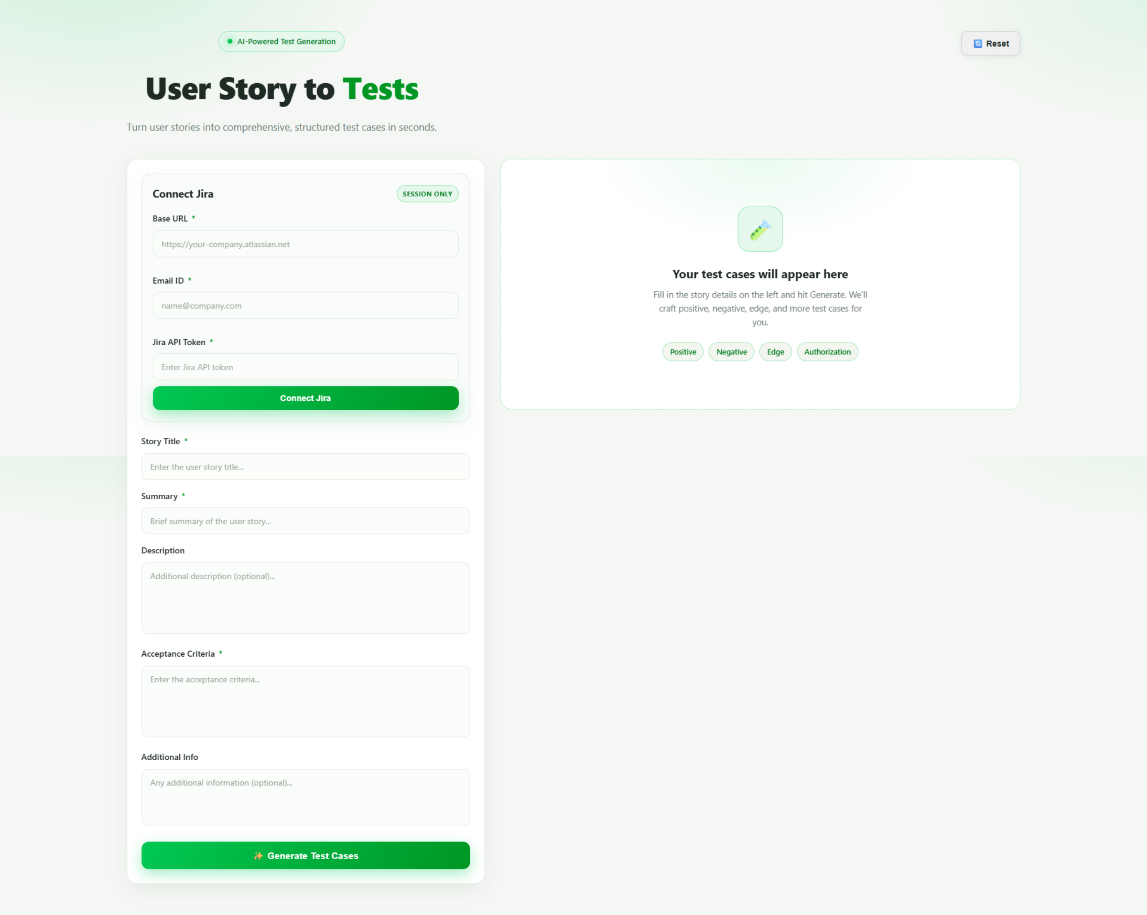
Output :
Reset button:
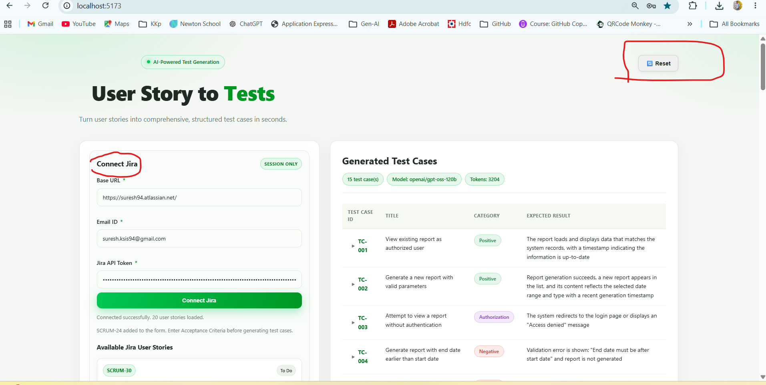
Download button , Direct Jira board link and add to form to create tests cases:
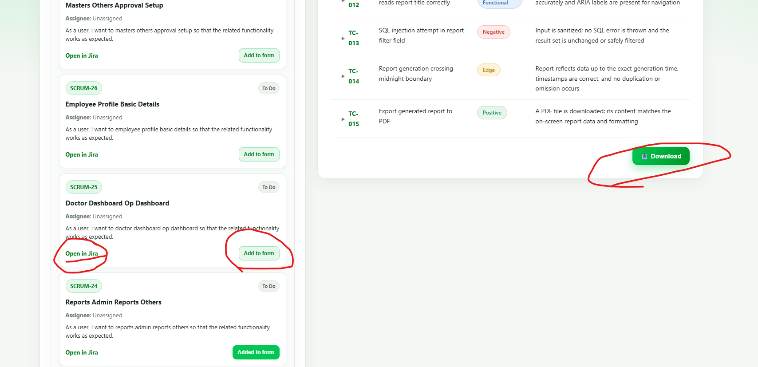
After click the add form button :
