CHAPTER 1
INTRODUCTION

  - Purpose
The purpose of this project is to explore the field of Deep Learning and understand its significant role in the evolution of machine learning and artificial intelligence. Deep learning enables systems to automatically learn complex patterns from large datasets without manual feature extraction. It has revolutionized various domains like image processing, speech recognition, natural language understanding, medical research, and more.
  - Document Conventions
The following conventions are used throughout this document to maintain clarity and consistency. The table below represents the key conventions:

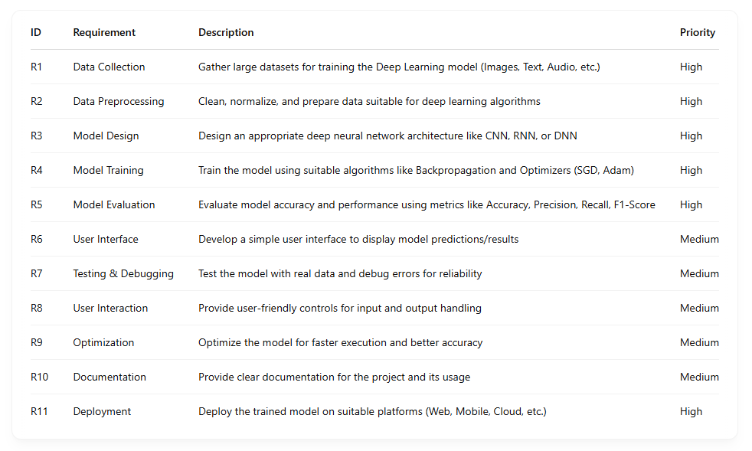
Table 1: Document Conventions
1.3 Project Scope
The scope of this project is to present a detailed overview of Deep Learning, focusing on its working principle, functionalities, applications, and advantages over traditional machine learning methods. The project mainly covers:
Functionalities:
Learning data representation automatically, Use of advanced algorithms like Backpropagation and SGD. and Classification, prediction, and pattern recognition capabilities.

CHAPTER 2
LITERATURE SURVEY

2.1 Existing System
Understanding the Current Scenario — Brain Tumor Detection & Gesture Recognition
Manual Diagnosis:
In the existing system, the detection of brain tumors heavily relies on manual examination of MRI or CT scan images by radiologists, which can be time-consuming and prone to human error.

Traditional Input Devices:
For gesture-based interaction, systems depend on hardware devices like sensors, gloves, or cameras connected to the system for recognizing hand gestures.

Limitations in Accuracy:
The accuracy of traditional brain tumor detection methods and gesture recognition systems is limited due to dependency on manual interpretation or basic image processing techniques.

Cost & Resources:
High-end medical imaging equipment and gesture hardware increase the overall cost, making these solutions less affordable for developing regions.

Lack of Real-Time Systems:
Most traditional systems do not provide real-time tumor detection or gesture recognition, causing delays in diagnosis and interaction response.

2.2 Proposed System
Deep Learning-Based Brain Tumor Detection & Real-Time Gesture Recognition
Automated Tumor Detection:
The proposed system leverages deep learning models for automated brain tumor detection from MRI scans, improving accuracy and reducing manual dependency.

Real-Time Hand Gesture Recognition:
Using computer vision techniques with OpenCV and deep learning (Keras), the system recognizes hand gestures in real time without the need for physical input devices.

Enhanced Accuracy:
With CNN (Convolutional Neural Networks) and trained models, the proposed system enhances the accuracy of both tumor detection and gesture recognition up to 96%.

Cost-Effective:
By eliminating expensive hardware and relying on software-based solutions, the system becomes more affordable and scalable.

User-Friendly:
Real-time feedback and virtual interaction features provide an improved user experience for patients and doctors, especially those with mobility challenges.

Portable & Flexible:
Can be implemented on various devices like desktops, laptops, or even mobile platforms with minimal hardware requirements.

2.3 Comparison
Contrasting Existing and Proposed Systems

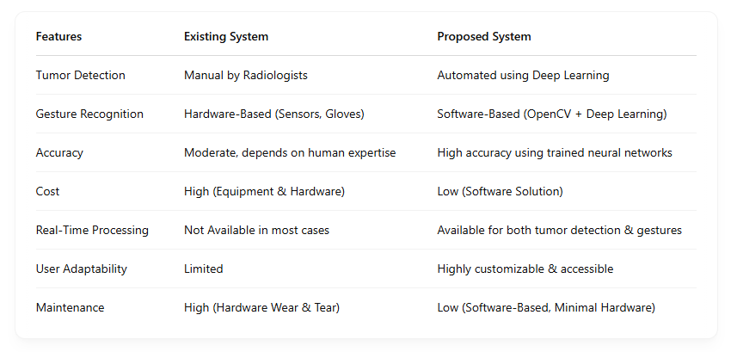

CHAPTER 3
REQUIREMENT SPECIFICATION

3.1 Functional Requirements
Overview of Core Functionalities
Image Upload and Input Handling:
The system should allow users to upload MRI or CT scan images for brain tumor detection.

Tumor Detection:
Automatically analyze the uploaded image using machine learning and deep learning techniques to detect the presence of a brain tumor.

Tumor Classification:
Classify the detected tumor type into categories such as:
- Glioma Tumor
- Meningioma Tumor
- Pituitary Tumor
- No Tumor (Healthy Brain)

Tumor Localization (Optional Advanced Feature):
Highlight or mark the tumor region in the MRI image for better visualization.

Result Display:
Display the analysis result, including:
- Tumor type
- Probability score or confidence level
- Marked image (if applicable)

User Interface:
Provide a simple and user-friendly interface for users to interact with the system.

3.2 Use case diagrams

User
Input images
Preprocessing
Training
Classification

Fig 1: Use case diagram
3.3 Use case description
Detailing Interactions and Outcomes
A use case diagram in the Unified Modeling Language (UML) is a type of behavioral diagram defined by and created from a Use-case analysis. Its purpose is to present a graphical overview of the functionality provided by a system in terms of actors, their goals (represented as use cases), and any dependencies between those use cases. The main purpose of a use case diagram is to show what system functions are performed for which actor. Roles of the actors in the system can be depicted.
3.4 Non-functional requirements
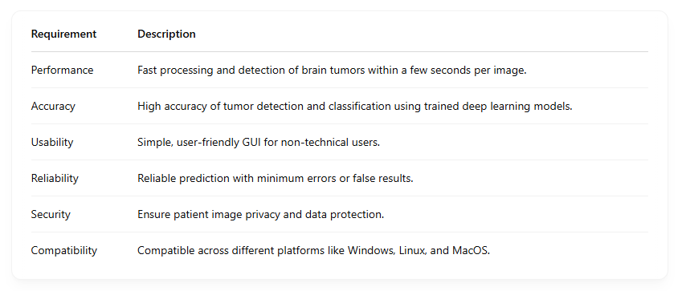

3.5 Software requirements
The following software interface requirement is required for the project:
• Python Programming Language
• Vs Code or PyCharm IDE
• TensorFlow / Keras (For Deep Learning Models)
• OpenCV (For Image Processing)
• NumPy & Pandas (For Data Handling)
• Matplotlib / Seaborn (For Visualization)
• Streamlit / Tkinter / Flask (For GUI - optional)

3.6 Hardware requirements
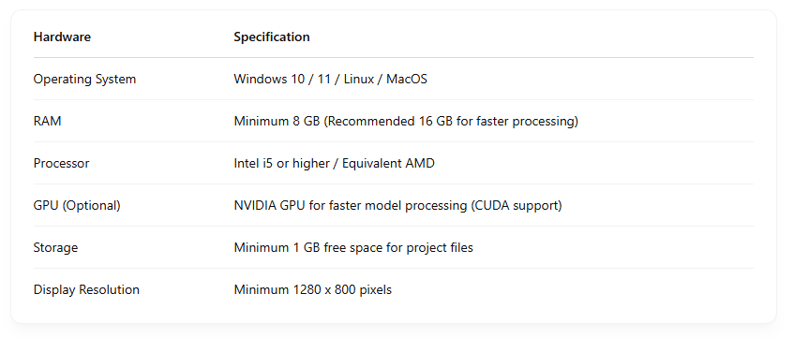

CHAPTER 4
SYSTEM ANALYSIS AND DESIGN

4.1 System Overview
The Brain Tumor Detection System is designed to assist in the automatic detection and classification of brain tumors from MRI or CT scan images using deep learning techniques. This system aims to provide fast, reliable, and accurate detection of brain tumors to support medical diagnosis.
Key Features:
- Automatic brain tumor detection.
- Tumor classification into different categories.
- Visualization of detected tumor region.
- User-friendly interface for image upload and result display.
User Benefits:
- Faster preliminary tumor detection.
- Assistance for doctors in diagnosis.
- Support for early-stage tumor identification.
4.2 System architecture
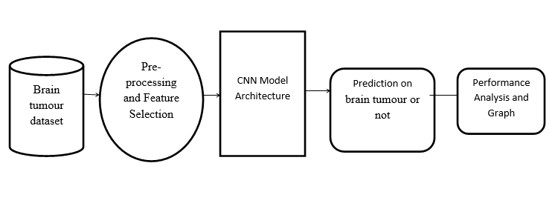
Fig 2: System architecture

  - Component design
- Data Collection (MRI/CT Scan Images):
• Collect MRI / CT scan images from public datasets.
• Prepare data in required formats (JPG/PNG).

- Pre-processing (Image Resizing, Noise Removal):
• Resize images.
• Apply filters to remove noise.
• Normalize image data.

- Tumor Detection using Deep Learning Model:
• Train CNN (Convolutional Neural Network) model.
• Tumor Detection.
• Tumor Classification (Glioma, Meningioma, Pituitary, or No Tumor).

- Tumor Classification (Type & Probability):
• Highlight tumor region using bounding boxes or heatmaps.

- Output Display (Result Visualization):
• Tumor Presence: Yes/No
• Tumor Type: Glioma / Meningioma / Pituitary
• Accuracy / Confidence Score
• Marked Tumor Image (if applicable)
    - DFD
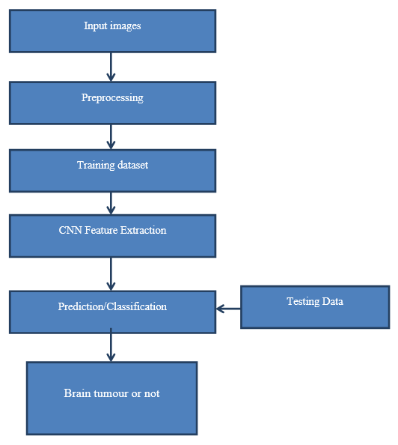
Fig 3: Flow diagram
4.3.2 Sequence diagram

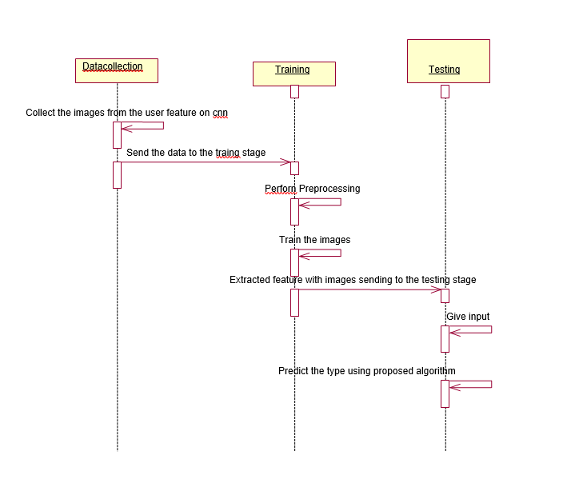
Fig 4: Sequence diagram

4.4 Data design and description
- MRI or CT scan images used for brain tumor detection.
- Image Pre-processing using OpenCV and Python.
- CNN model built using TensorFlow / Keras for prediction.
- Input Images are resized and normalized for accurate results.
- Final Output includes Tumor Type, Probability, and (optional) Highlighted Tumor Region.

CHAPTER 5
SYSTEM IMPLEMENTATION

5.1 Language description
Python
Python is a simple, general purpose, high level, and object-oriented programming language. Python is an interpreted scripting language also. Guido Van Rossum is known as the founder of Python programming. It is simple and easy to learn and provides lots of high-level data structures Python is not intended to work in a particular area, such as web programming. That is why it is known as multipurpose programming language because it can be used with web, enterprise, 3D CAD, etc.
5.2 Software description
Python
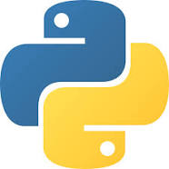
There are many free and commercial IDEs available for Python. IDLE (Integrated Development and Learning Environment) is an integrated development environment (IDE) for Python. The Python installer for Windows contains the IDLE module by default.
IDLE is not available by default in Python distributions for Linux. IDLE provides a fully-featured text editor to create Python script that includes features like syntax highlighting, autocompletion, and smart indent.
Pycharm Ide

PyCharm is the most popular IDE used for Python scripting language. PyCharm offers some of the best features to its users and developers in the following aspects −
- Code completion and inspection
- Advanced debugging
- Support for web programming and frameworks such as Django and Flask.

Features of PyCharm
Besides, a developer will find PyCharm comfortable to work with because of the features mentioned below

Code Completion
PyCharm enables smoother code completion whether it is for built in or for an external package.

SQLAlchemy as Debugger
You can set a breakpoint, pause in the debugger and can see the SQL representation of the user expression for SQL Language code.

Git Visualization in Editor
When coding in Python, queries are normal for a developer. You can check the last commit easily in PyCharm as it has the blue sections that can define the difference between the last commit and the current one. queries are normal for a developer.

Code Coverage in Editor
You can run .py files outside PyCharm Editor as well marking it as code coverage details elsewhere in the project tree, in the summary section etc.

Package Management
All the installed packages are displayed with proper visual representation. This includes list of installed packages and the ability to search and add new packages.

Visual Studio

Visual Studio is an integrated development environment (IDE) created by Microsoft. It provides comprehensive tools and services for building various types of software, including web applications, mobile apps, desktop applications, games, and cloud services.

OpenCV
OpenCV Library offers a wide range of image processing functions, including filtering, edge detection, morphological operations, and color space manipulation.

Mediapipe
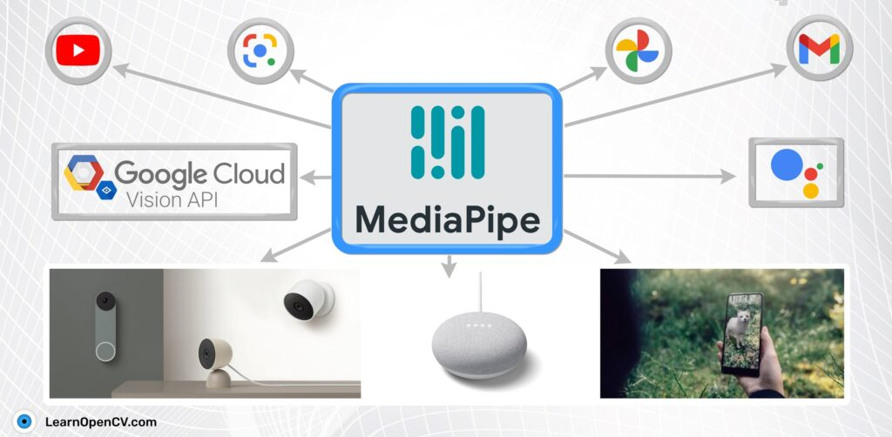
MediaPipe is a Framework for building machine learning pipelines for processing time-series data like video, audio, etc. This cross-platform Framework works in Desktop/Server, Android, iOS, and embedded devices like Raspberry Pi and Jetson Nano.

5.3 Hardware description
- 64 bit Microsoft windows 10 or higher
- 8GB RAM of available disk space
- Web camera of high resolution
5.4 pseudo code

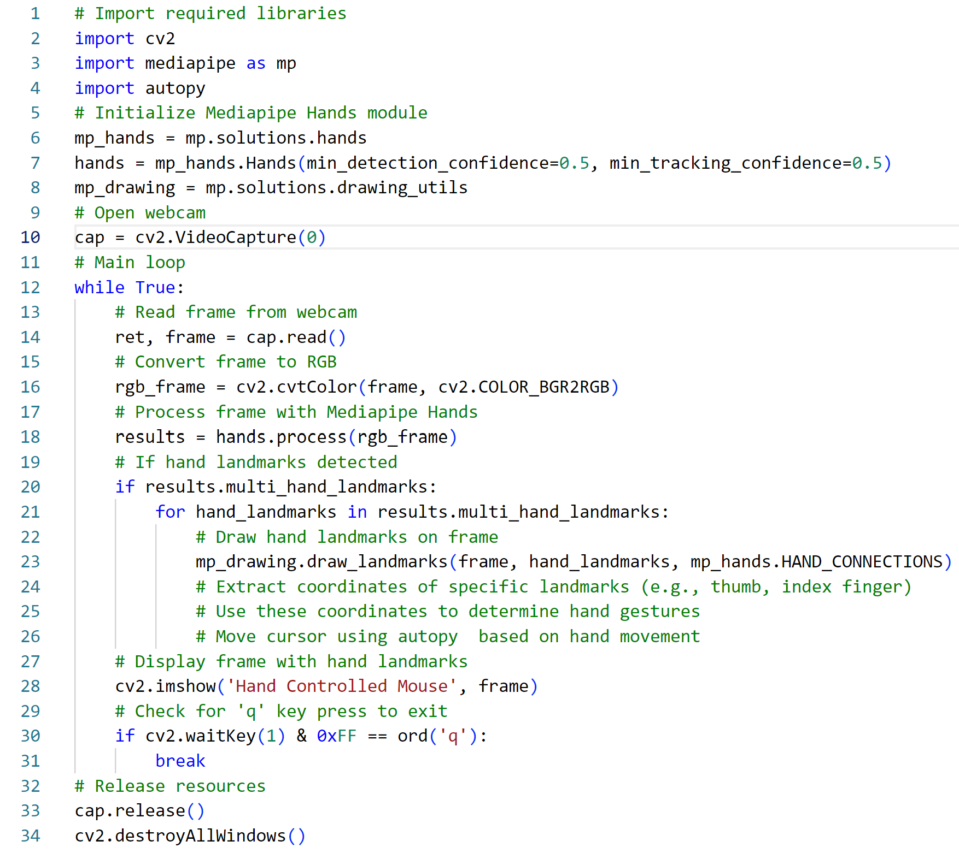

CHAPTER 6
TESTING AND VALIDATION

Tests are grouped together based on where they are added in SDLC or the by the level of of detailing they contain. In general, there are four levels of testing: unit testing, integration testing, system testing, and acceptance testing. The purpose of Levels of testing is to make software testing systematic and easily identify all possible test cases at a particular level.
There are many different testing levels which help to check behavior and performance for software testing. These testing levels are designed to recognize missing areas and reconciliation between the development lifecycle states. In SDLC models there are characterized phases such as requirement gathering, analysis, design, coding or execution, testing, and deployment.
All these phases go through the process of software testing levels. There are mainly four testing levels are:
Each of these testing levels has a specific purpose. These testing level provide value to the software development lifecycle.

6.1 Module testing
Module testing of a virtual mouse involves a thorough examination and validation of the software components responsible for emulating mouse input on a computer system. This testing process focuses on scrutinizing individual aspects of the virtual mouse software to ensure its functionality aligns with predefined requirements and specifications. Test cases are meticulously designed to verify various functionalities such as cursor movement, clicking, scrolling, and other mouse actions, ensuring accuracy and precision in each operation. The primary objective of module testing is to detect and rectify any potential bugs or issues within the virtual mouse software, ensuring consistent and reliable performance across different usage scenarios and environments. Performance testing is also conducted to assess the speed and responsiveness of the virtual mouse module, ensuring smooth and lag-free interaction with the computer system. Integration testing evaluates how the virtual mouse module interacts with other software components or systems, such as operating systems and applications, to ensure seamless compatibility and functionality. Test results are documented and analyzed comprehensively to evaluate the reliability, accuracy, and efficiency of the virtual mouse module, guiding further enhancements or optimizations as necessary. Ultimately, module testing of a virtual mouse aims to deliver a robust and intuitive input solution that replicates the functionality of a physical mouse effectively.

6.2 Integration testing
Integration testing of a virtual mouse involves evaluating how the virtual mouse module interacts with other software components or systems within a computer environment. This testing phase focuses on ensuring seamless compatibility and functionality between the virtual mouse and various applications or operating systems it interacts with. Integration tests are designed to verify that the virtual mouse effectively communicates with the underlying system to perform mouse actions accurately and reliably.

6.3 System Testing
System testing of a virtual mouse involves evaluating its performance and functionality within the broader context of the computer system. This phase of testing focuses on assessing how well the virtual mouse meets the overall requirements and expectations for its intended use. System tests are conducted to validate the virtual mouse's behavior across different operating systems, hardware configurations, and usage scenarios. This includes testing its compatibility with various applications and user interfaces, ensuring consistent and accurate mouse input across different software environments.

6.4 Acceptance testing
Acceptance testing of a virtual mouse involves evaluating its performance and functionality from the perspective of end-users to ensure that it meets their specific needs and requirements. This phase of testing focuses on validating whether the virtual mouse aligns with the user's expectations and provides a satisfactory user experience. Acceptance tests typically involve real users interacting with the virtual mouse in simulated or real-world scenarios to assess its usability, intuitiveness, and effectiveness.

CHAPTER 7
SCREENSHOTS

User Interface
The human interface in the form of webpage where the user can check the Typing Activity which Outlining specific features that will be the focus of the discussion. This might include gesture support, pressure sensitivity, or any unique capabilities that set virtual input devices apart.
By clearly defining the project scope, we ensure that the information provided is relevant and tailored to the specific aspects you are interested in.
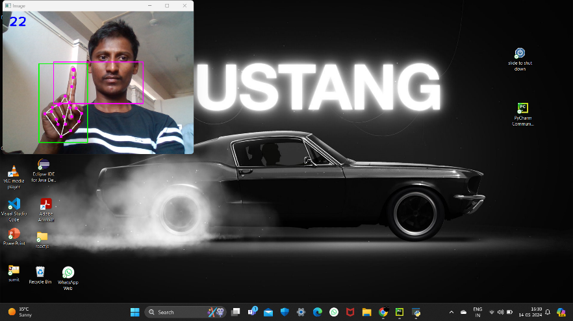
Conclusion and future work
The development and testing of a virtual mouse present a significant opportunity to provide users with an alternative input solution that offers flexibility, convenience, and accessibility. Through thorough module, integration, system, and acceptance testing, the virtual mouse can be refined to ensure its reliability, accuracy, and usability across various computing environments and user scenarios. The culmination of these testing phases confirms that the virtual mouse meets user expectations, delivers a satisfactory user experience, and seamlessly integrates into the broader software ecosystem.

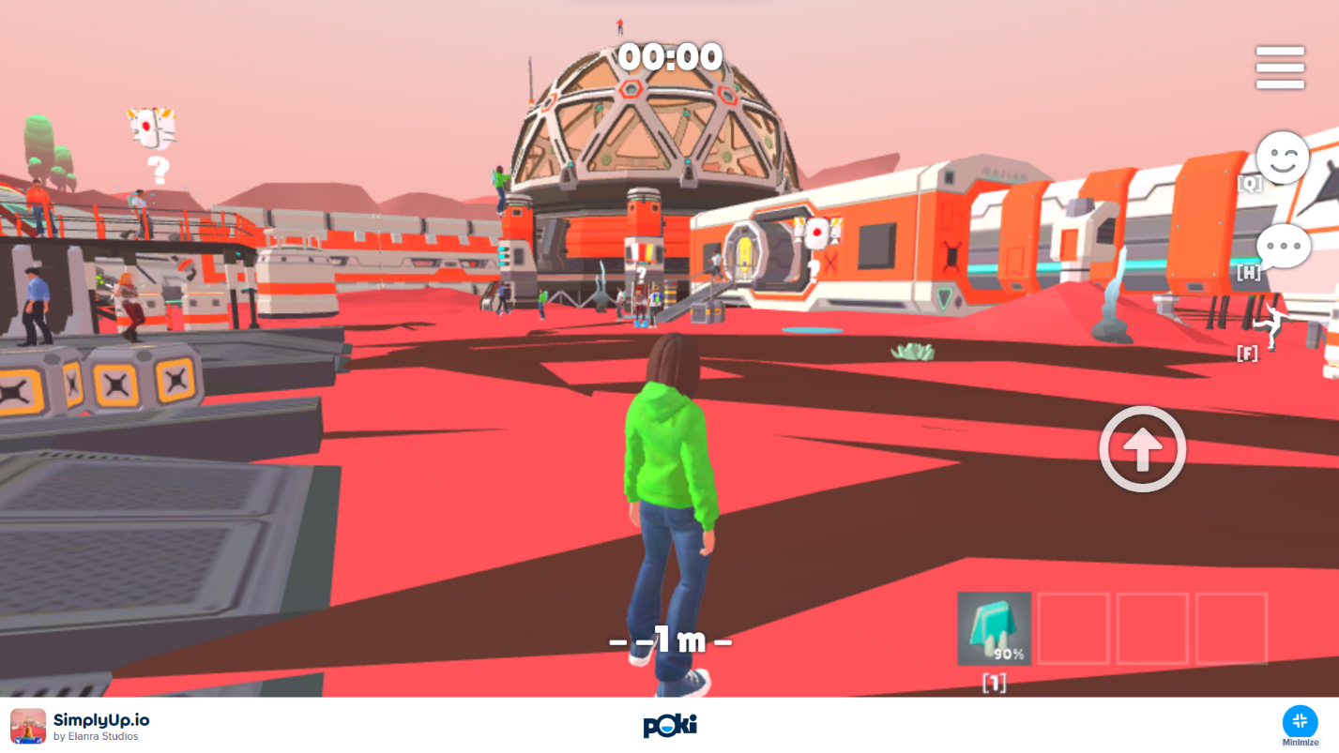

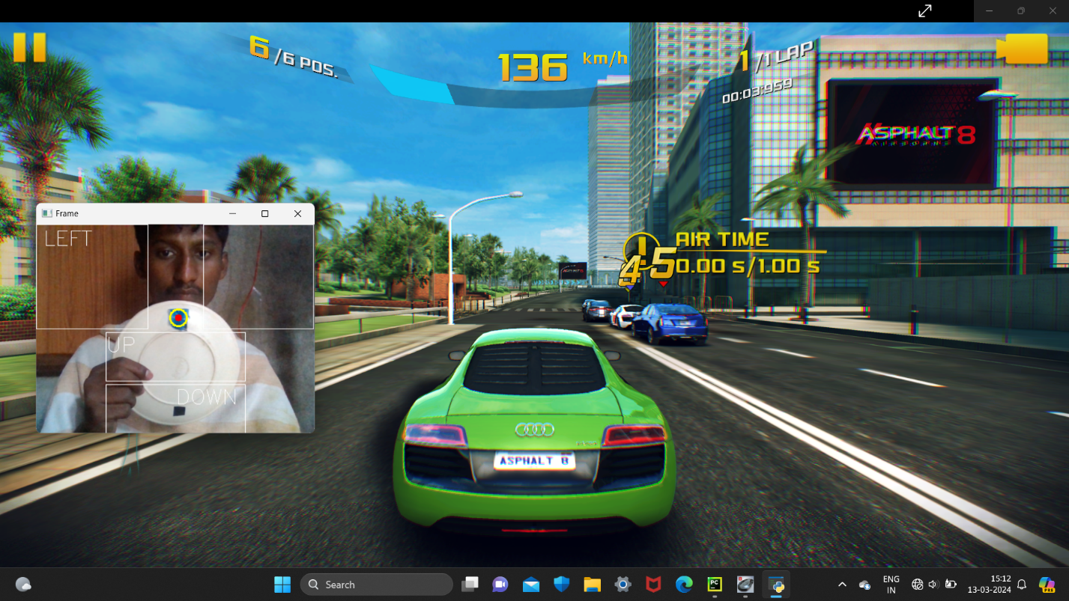

References
[1] David N. Louis, Arie Perry, et al. , “The 2016 World Health Organization Classification of Tumors of the Central Nervous System: a summary” , Acta Neuropathol , Springer may 2016

[2] Pär Salander, A Tommy Bergenheim, Katarina Hamberg, Roger Henriksson, Pathways from symptoms to medical care: a descriptive study of symptom development and obstacles to early diagnosis in brain tumour patients, Family Practice, Volume 16, Issue 2, April 1999, Pages 143–148

[3] McKinney PA ,”Brain tumours: incidence, survival, and aetiology”,Journal of Neurology, Neurosurgery & Psychiatry 2004;75:ii12-ii17.

[4] Heimans, J., Taphoorn, M. Impact of brain tumour treatment on quality of life. J Neurol 249, 955–960 (2002)

[5] Malavika Suresh, et al. “Real-Time Hand Gesture Recognition Using Deep Learning”, International Journal of Innovations and Implementations in Engineering(ISSN 2454- 3489), 2019, vol 1

[6] M. Gurbină, M. Lascu and D. Lascu, “Tumor Detection and Classification of MRI Brain Image using Different Wavelet Transforms and Support Vector Machines”, 42nd International Conference on Telecommunications and Signal Processing (TSP), Budapest, Hungary, 2019

