Attendance Report Employee wise.



|

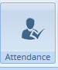 Attendance Report

|

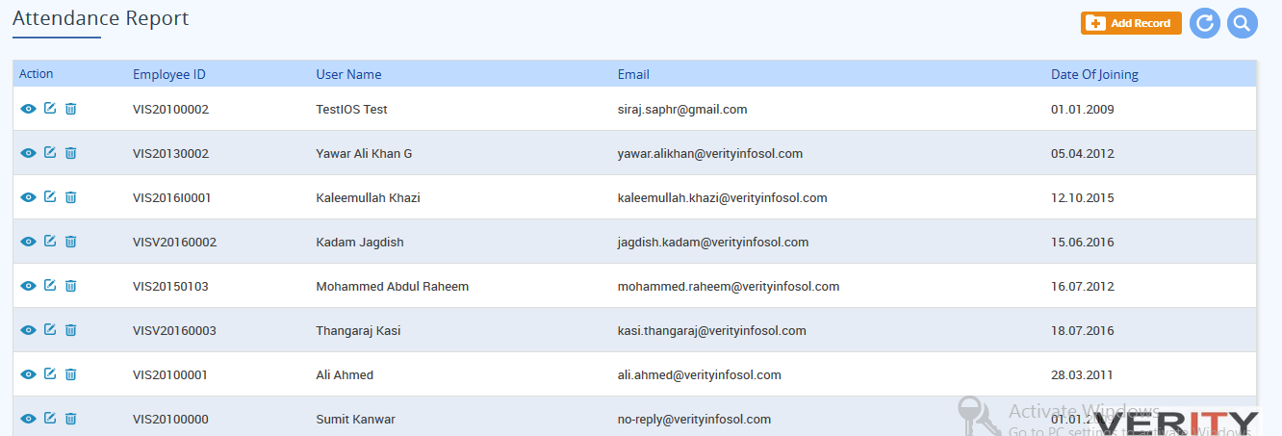

|

 Click on Edit.

