**Top Seller Technical Changes:**

**Java Interfaces:**

Dao Layer:

TopSellableDao

Method : getTopSellableProducts

Service Layer:

TopSellableService

Method : getTopSellableProducts

**Java Interfaces Impl:**

Dao Layer:

TopSellableDaoImpl

Method:

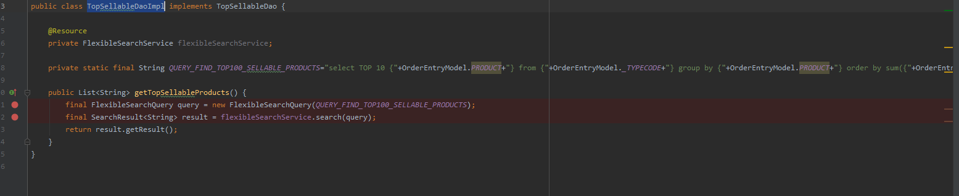

Search Query:

private static final String *QUERY_FIND_TOP100_SELLABLE_PRODUCTS*="select TOP 10 {"+OrderEntryModel.*PRODUCT*+"} from {"+OrderEntryModel.*_TYPECODE*+"} group by {"+OrderEntryModel.*PRODUCT*+"} order by sum({"+OrderEntryModel.*PRODUCT*+"}) desc";

Service Layer:

TopSellableServiceImpl

Method:

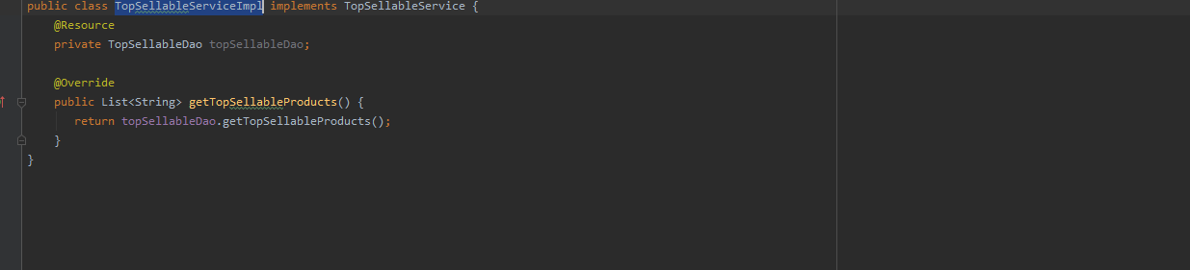

Util Class:

TopSellableUtil

This class will be load the top 10 sold Products from based on Quantity .

And result we should keep in global Variable for JVM (means static list) this way we can avoid number of DB calls.

It similar to web.xml init Param.

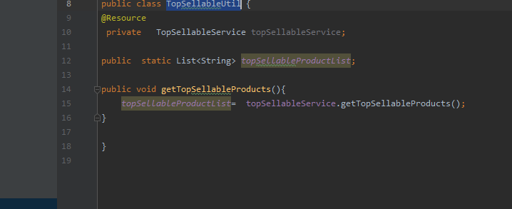

**Value Provider:**

TopSellableValueProvider

In this class if any of Product contains in top Product list then we are indexing this Product as TopSellableProduct as true

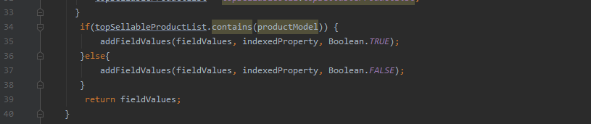

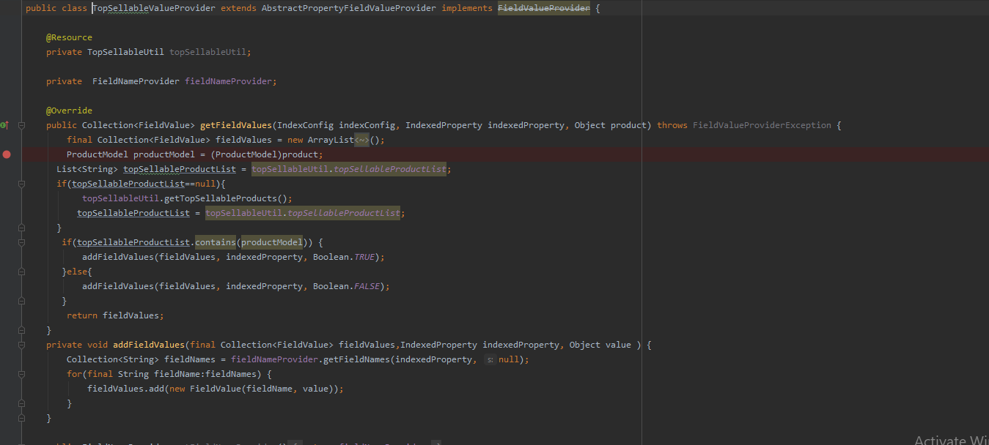

Beans.xml :

To display whether this Product is TopSellable or not we need flag that we have to define in Product Data

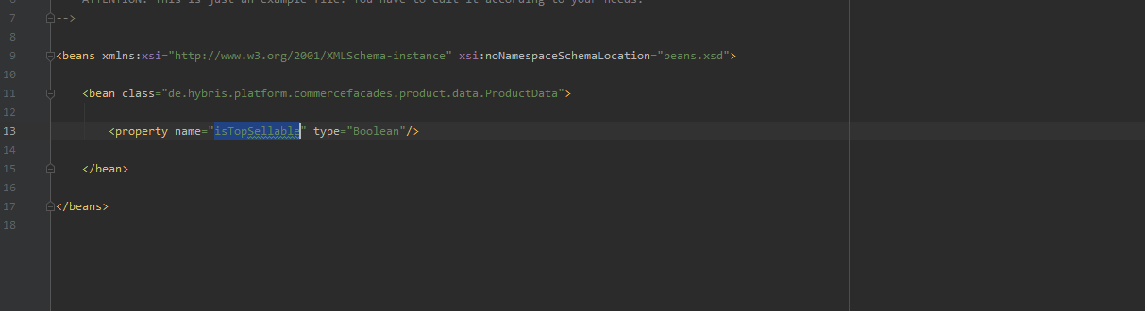

Search Result Populator:

TopSellableSearchResultVariantProductPopulator

this class Populate solr result data into Product data 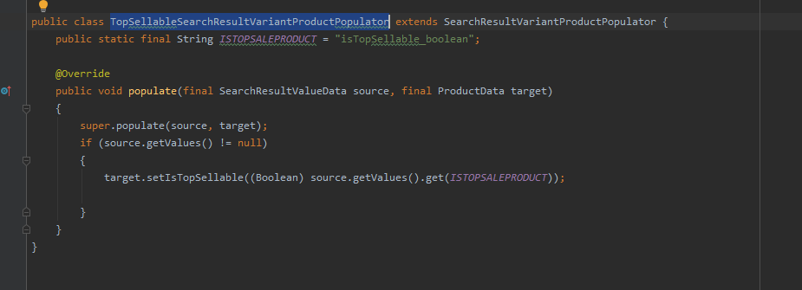

JSP Change :

**productListerGridItem.tag**

if Sellable show tag value

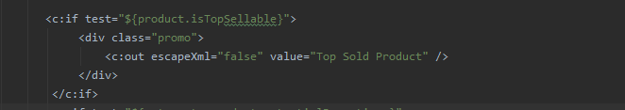

Impex:



**Note : We have to write an interceptor on OrderEntry. this class class will update global list(yet to implement)**

**Bonus:**

**Sort Implementation:**

**Impex:**

$lang=en

$indexedType=powertoolsProductType

# Define the available sorts

INSERT_UPDATE SolrSort;&sortRefID;indexedType(identifier)[unique=true];code[unique=true];useBoost;name[lang=$lang]

;sortRef1;$solrIndexedType;relevance;true

;sortRef2;$solrIndexedType;topRated;false

;sortRef3;$solrIndexedType;name-asc;false

;sortRef4;$solrIndexedType;name-desc;false

;sortRef5;$solrIndexedType;price-asc;false

;sortRef6;$solrIndexedType;price-desc;false

;sortRef7;$solrIndexedType;topsellable-desc;false

# Define the sort fields

INSERT_UPDATE SolrSortField;sort(indexedType(identifier),code)[unique=true];fieldName[unique=true];ascending[unique=true]

;$solrIndexedType:relevance;inStockFlag;false

;$solrIndexedType:relevance;score;false

;$solrIndexedType:topRated;inStockFlag;false

;$solrIndexedType:topRated;reviewAvgRating;false

;$solrIndexedType:name-asc;name;true

;$solrIndexedType:name-desc;name;false

;$solrIndexedType:price-asc;priceValue;true

;$solrIndexedType:price-desc;priceValue;false

;$solrIndexedType:topsellable-desc;isTopSellable;false

# Define the available sorts

UPDATE SolrSort;indexedType(identifier)[unique=true,default=$indexedType];code[unique=true];name[lang=$lang]

;;name-asc;Name (ascending);

;;name-desc;Name (descending);

;;price-asc;Price (lowest first);

;;price-desc;Price (highest first);

;;relevance;Relevance;

;;topRated;Top Rated;

;;topsellable-desc;Popularity;

Query Populator:

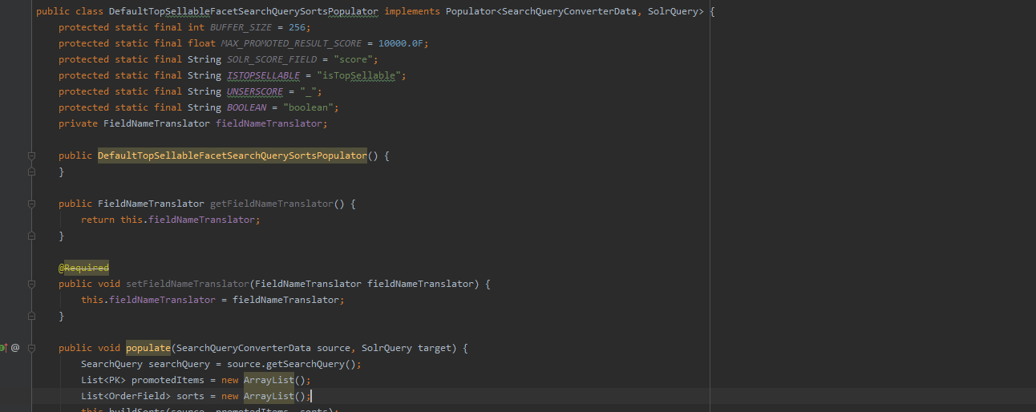

Xml Changes:

