Datastax
Round 2
Flight Exercise

Suresh Siva
August 26th, 2019

https://github.com/sureshsivva/dsx-flight-analytics
suresh1988.siva@gmail.com

Contents
1. Introduction 1
1.1. Purpose 1
1.2. High-level steps 1
2. Exploratory Analysis 2
2.1. Environment 2
2.2. Analysis 2
2.3. Inferences 2
2.4. Model evaluation with single node DSE 4
3. Multi-node Datacenter Installation & Configuration 5
3.1. Overview 5
3.2. Hardware Used 5
3.3. Software Used 5
3.4. Prerequisites 6
3.5. Ansible Setup 6
3.6. Ansible Playbook Creation 6
3.7. Ansible playbook execution 7
4. Job Script 8
4.1. Overview 8
5. Flights Model Load 9
5.1. Overview 9
5.2. Steps Involved 9
5.3. Total records loaded into flights table 10
5.4. Were there any errors during loading? 10
6. Airport Departure & Flights Airtime Model Load 11
6.1. Airport Departure Model analysis 11
6.2. Flights Airtime Model Analysis 11
6.3. Implementation 12
7. Queries 13
7.1. Overview 13
7.2. How Many flights originated from ‘HNL’ airport on 2012-01-25? 13
7.3. How many airport codes start with letter ‘A’? 13
7.4. What originating airport had had most of the flights on ‘2012-01-23’? 13
7.5. Batch update all ‘BOS’ airport codes with ‘TST’ airport code using spark 14
7.6. What is the route having most delays? 15
7.7. Is the airport activity a factor of the delay? 16
7.8. Do airports generate delay at arrival and departure the same way? 16

Introduction

Purpose

The purpose of this document is to explain about the efforts that I have taken to understand and solve the lab exercise assigned to me during the round 2 of Datastax evaluation.
I was given the flights dataset to explore, with that I have to,
- Install and Configure the Datastax Enterprise (DSE) environment
- Enable Search or Analytics components
- Create data models
- Import data into DSE core
- Answer the questions asked about flight dataset using DSE Search or Analytic components.

This exercise is timed out for 2 weeks which will be due for submission by 26th August. I also understood that I have to do my best to better understand the problem statement, environment setup, find answers to the questions on my own without asking for much help.

High-level steps
I have started working on this exercise from last week and attempted to solve the exercise in phased manner with the limited time I have been getting over last 2 weeks.

Below are the steps that I followed over the time to address this exercise.

- Exploratory analysis on dataset to understand available data.
- Correct the dataset and table model to fit the data format.
- Setup single node DSE dev environment with Analytics.
- Load corrected flights records into DSE table.
- Ensure all rows and columns are correctly represented.
- Detect outlier/unmeaningful data.
- Determine the best table model for derived tables.
- Explore the base and derived tables to answer the questions.
- Determine how to sketch the programmatic data load and analysis.
- Determine how to scale out the DSE cluster.
- Provision the multiple node environment.
- Implement the Analytics programs and auto install steps.
- Commit codes to repository and document the steps.

Exploratory Analysis

Environment
- Tool: Spark-Shell command line
- OS: Windows
I have opted to use the DSE Analytics to solve the exercise. So, to begin with, I have installed Spark 2.4 on windows and utilized the Spark Dataframe to directly source the flight dataset and started working on analysis.

Analysis
I have analyzed the below aspects of the given data set.
- Number of column and rows
- Mapping column names and possible immediate types
- Mapped the types to the given flights table model
- Analyzed the distribution of data
- Understood the partial values and outliers
- Derived the best fitting flights base model
You can view the Spark command line queries used, spark shell usages and analysis results from below links,
https://github.com/sureshsivva/dsx-flight-analytics/blob/master/analysis/spark-shell%20-commands
https://github.com/sureshsivva/dsx-flight-analytics/blob/master/analysis/exploratory_analysis_complete
https://github.com/sureshsivva/dsx-flight-analytics/tree/master/analysis/result_files
https://github.com/sureshsivva/dsx-flight-analytics/blob/master/analysis/images/expl_analysis_sparkshell.jpg

Inferences
Please refer below the table explaining mapping between given flight model & dataset
Table columns | Table DataTypes | Dataset Types | Table comments
ID | int | int | correct format, unique
YEAR | int | int | correct format
DAY_OF_MONTH | int | int | correct format
FL_DATE | timestamp | Date | has value needed, need to resolve as Timestamp
AIRLINE_ID | int | int | correct format
CARRIER | varchar | varchar | correct format
FL_NUM | int | int | correct format
ORIGIN_AIRPORT_ID | int | int | correct format
ORIGIN | varchar | varchar | correct format
ORIGIN_CITY_NAME | varchar | varchar | correct format
ORIGIN_STATE_ABR | varchar | varchar | correct format
DEST | varchar | varchar | correct format
DEST_CITY_NAME | varchar | varchar | correct format
DEST_STATE_ABR | varchar | varchar | correct format
DEP_TIME | timestamp | int | wrong, just has HHMM, need to resolve as Timestamp with fl_date's help, will be helpful in delay analysis
ARR_TIME | timestamp | int | wrong, just has HHMM, need to resolve as Timestamp with fl_date and actual_elapsed_time and time zone help, will be helpful in delay analysis
ACTUAL_ELAPSED_TIME | timestamp | int | wrong, is in minutes, it’s a duration, can't be timestamp
AIR_TIME | timestamp | int | wrong, is in minutes, it’s a duration, can't be timestamp
DISTANCE | int | int | correct format

The observations are listed below,
- The 3 highlighted “Table_Datatypes” columns needs additional work to map the values to table.
- Out of them ACTUAL_ELAPSED_TIME & AIRTIME types need to be changed.
- ACTUAL_ELAPSED_TIME & AIRTIME values are in minutes. They can not be converted as timestamps.
- They both can be actually stored as Duration data type in Cassandra, but the Cassandra-Spark connector doesn’t have direct mapping support. Hence int data type will be ideal for them.
- FL_DATE column value can be resolved as timestamp easily.
- We need to make additional handling to resolve DEP_TIME & ARR_TIME columns’ values as timestamp.
- The are actually in HHMM time format, means they follow 24-hour format.
- DEP_TIME column can be easily resolved to timestamp by combining FL_DATE.
- For most of the ARR_TIME values can be also resolved as timestamp, but there will be few flights actually arriving in the next day might be mapped to the FL_DATE back.
- To avoid this, we need extra handling for ARR_TIME to make sure it correctly falls into the next in such cases.
- As DEP_TIME and ARR_TIME columns are in their location’s time zone, it will be better to convert to UTC time zone by respective airport location’s time zone. airport code, city and state.
- It will be very helpful to derive delay analysis to compare the UTC time values

The new flights table definition based on the above observations will be as available in the below link,
https://github.com/sureshsivva/dsx-flight-analytics/blob/master/src/main/scala/com/datastax/flights/batch/common/CqlDmlExecutor.scala
https://github.com/sureshsivva/dsx-flight-analytics/wiki/Data-Analysis

Model evaluation with single node DSE
I have setup a single node DSE Analytics environment on my WSL (Windows Subsystem for Linux) and started evaluating flights table’s data model changes and successfully using Spark Dataframe DLS expressions.
Also started exploring the best table model design for the downstream tables. Please find below screenshots of the single node DSE usage.
https://github.com/sureshsivva/dsx-flight-analytics/blob/master/analysis/images/expl_analysis_dse.jpg
https://github.com/sureshsivva/dsx-flight-analytics/blob/master/analysis/images/expl_analysis_dse_cqlsh.jpg
https://github.com/sureshsivva/dsx-flight-analytics/blob/master/analysis/images/expl_analysis_dsespark.jpg
https://github.com/sureshsivva/dsx-flight-analytics/blob/master/analysis/spark-shell%20-commands

As I had gotten promising results from the evaluation, I had planned to
(1) to scale out DSE cluster and wished to do it through Ansible based Automatic deployment.
(2) to start building the Spark Scala application in parallel to put together all the things observed during analysis phase and to build an easy to batch application.
I would like to take a pause here on Analysis phase as most of them are implemented in actual multi-node DSE datacenter with full volume, so we shall review the actual system from the architecture to query execution which will be in the same order of the tasks and question asked in exercise.

Multi-node Datacenter Installation & Configuration

Overview
A multi-node DSE Analytics cluster will be used to do all of the given exercise tasks and please refer the following architecture diagram which consists of a DSE Analytics Datacenter hosted on the Google Cloud Platform’s (GCP) Compute Engines. This data center will be called as DSXDC1, which has 3 nodes attached, all them are enabled with Analytics mode. Additionally, DSE Opscenter application is also installed on one of the nodes. All of these installations involved in this cluster are done by Ansible controller running on Desktop.
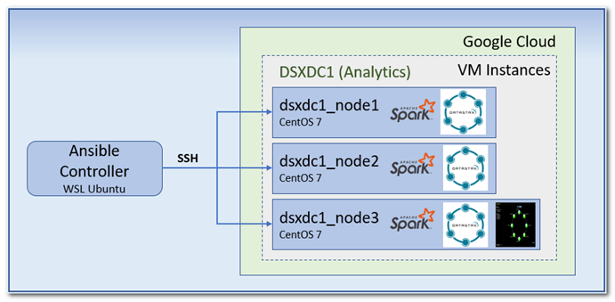

Hardware Used
Platform : GCP
Machine Type : n1-standard-8 (8 vCPUs, 30 GB memory)
Total Nodes : 3 VMs
Hard Drive : HDD enabled (30GB)

Software Used
Operating Sys. : CentOS 7
DSE version : 6.7.4
Java Version : 1.8
Spark version : 2.2.3.4
Ansible version : 2.8.4

Prerequisites
- All VMs operating systems should be CentOS/RHEL based
- All VMs should have the TCP ports opened
- A user with sudo access

Ansible Setup
- Installed Ansible 2.8.4 on Windows desktop’s Subsytem for Ubuntu (WSL)
- Configured Ubuntu user’s SSH public key to all 3 VMs and verified passwordless login.
https://github.com/sureshsivva/dsx-flight-analytics/blob/master/scripts/nodeinstall_manual_steps_followed

Ansible Playbook Creation
- Grouped below 3 Google VMs under the host group dc1
[dc1]
dc1_node1 ansible_host=35.225.115.125
dc1_node2 ansible_host=35.202.218.171
dc1_node3 ansible_host=34.67.91.2
- Created 3 roles [dependencies, datastax, opscenter]
- Configured common variables on host groups and role’s defaults
- Configured host specific variables on every host file in inventory
- Used templates to source the common and host specific configurations from inventory group, host specific files and role defaults.
- The configuration files created through templates for every node are,
  - cassandra.yaml
    - will be placed at /etc/dse/cassandra/cassandra.yaml
    - configurations modified are,
      - cluster_name
      - listen_address
      - native_transport_address
      - seed_provider
      - endpoint_snitch
      - num_tokens

  - cassandra-rackdc.properties
    - will be placed at /etc/dse/cassandra/cassandra-rackdc.properties
    - configurations modified are,
      - dc
      - rack
  - dse
    - will be placed at /etc/default/dse
    - configuration modified is,
      - SPARK_ENABLED
- Created an Ansible playbook (dse_install_enable_book.yaml) with sudo user to run all three roles in order for every VM, and all 3 VMs are handled in parallel.
https://github.com/sureshsivva/dsx-flight-analytics/tree/master/ansible-deployment

Ansible playbook execution
Configured the single playbook to run and install everything required for DSE, and DSE itself, confirm if DSE has started on all nodes and then finally the Opscenter.
Ansible play book run will result in creation of 3 node DSE Analytics datacenter.
Please verify the ansible run results in following screenshots,
https://github.com/sureshsivva/dsx-flight-analytics/blob/master/analysis/images/ansible_3nodes_install_part1.jpg
https://github.com/sureshsivva/dsx-flight-analytics/blob/master/analysis/images/ansible_3nodes_install_part2.jpg
https://github.com/sureshsivva/dsx-flight-analytics/blob/master/ansible-deployment/logs/dc1_3nodes_install.log
https://github.com/sureshsivva/dsx-flight-analytics/blob/master/analysis/images/ansible_opscenter_install_part2.jpg
https://github.com/sureshsivva/dsx-flight-analytics/blob/master/analysis/images/dc1_3nodes_cluster_details.jpg

Job Script

Overview
The job shell script will be helpful in orchestrating the various activities that we involve with the DSE datacenter. This script will take care of the
- Environment preparation
- Master url selection
  - Used dse client-tool command to get recent master
- logging
- Parameter substitution
- Easy run types as per the activity groups
- Uploads the datasets to the DSEFS directories.

All the data related activities are group into 3 run types, based on the relevant Scala object is invoked by the shell script and redirects the logs to log file created for the job. Also prepares the job.properties for the job.

- load is for loading the clear processed flights dataset into the flights table.
- downstream is for preparing the airports departures and flights airtime tables
- queries is for extracting the answers for all the questions using Analytics.

Refer the script file using the below url and also the sample deploy zip is also list,
https://github.com/sureshsivva/dsx-flight-analytics/blob/master/scripts/process_flight_dataset.sh
https://github.com/sureshsivva/dsx-flight-analytics/blob/master/scripts/job_script.zip

The usage of the job scripts will be explained in the following sections.

Flights Model Load

Overview
This section is to explain the process that I followed to clean and transform the given flights dataset and I have resolved it to the canonical with whatever I learned through the data analysis phase. This process is going to consider all of the inferences from the section 2.3. Mostly utilized Spark Dataframes for this task.

Steps Involved
- com.datastax.flights.batch.dataload.FlightsInputLoader is the class responsible for processing the flights table model load.
https://github.com/sureshsivva/dsx-flight-analytics/blob/master/src/main/scala/com/datastax/flights/batch/dataload/FlightsInputLoader.scala
- As it is the very fist step in the data related process, there won’t be any application related keyspaces available yet.
https://github.com/sureshsivva/dsx-flight-analytics/blob/master/analysis/images/flightmodel_load/flightmodel_before_exec.jpg
- Same function can be also called through the job scripts load run type.
https://github.com/sureshsivva/dsx-flight-analytics/blob/master/analysis/images/flightmodel_load/flightmodel_exec_invoke.jpg
- Spark master url and cassandra host were configured in the SparkSession.
- This process will immediately create default keyspace and flights table with all the column and types determined through analysis.
- I configured this object to utilize an airports public dataset (usa_airports_details.csv) which helps in finding the time zone of ORIGIN and DEST airports. This time zone will be helpful in converting to UTC time.
- Then the process loads the flights data directly from dataset csv file with the possible data types that we can directly map using StructType.
- Now the flights Dataframe is joined with Airports Dataframe twice to fetch time zone id of both ORIGIN and DEST airport codes.
- Also defined an UDF that if capable of taking timestamp in any time zone and returns the converted timestamp in UTC.
- Next step is to frame local timestamp using FL_DATE with DEP_TIME and derive the complete DEP_TIME in UTC according ORIGIN time zone.
- Similarly framing the local timestamp using FL_DATE and ARR_TIME and return converted timestamp in UTC
  - This ARR_TIME_UTC_MS_TMP timestamp can be wrong at few cases where the where actually arriving the next day, but we have mapped it to FL_DATE.
  - This is solved by the UDF timestampFixUDF which detects such cases and makes it to fall into the next day.
- By now the process will map the Dataframe’s fields as per base flights table’s name and data type.
- Final step is to configure the cassandra-spark connector related write configurations and start writing the records into given flights table model.
- Flights table definition can be found from below link, only used the ID as primary key.
https://github.com/sureshsivva/dsx-flight-analytics/blob/master/src/main/scala/com/datastax/flights/batch/common/CqlDmlExecutor.scala
- dsetool status and load job logs are available below,
https://github.com/sureshsivva/dsx-flight-analytics/blob/master/analysis/images/flightmodel_load/flightmodel_dsetool_after_exec.jpg
https://github.com/sureshsivva/dsx-flight-analytics/blob/master/analysis/images/flightmodel_load/flightmodel_after_exec.jpg
https://github.com/sureshsivva/dsx-flight-analytics/blob/master/analysis/images/flightmodel_load/flightmodel_load.log.txt

Total records loaded into flights table
- Total number of rows after flight model load is 1048576
https://github.com/sureshsivva/dsx-flight-analytics/blob/master/analysis/images/flightmodel_load/flightmodel_after_exec.jpg

Were there any errors during loading?
- No errors were reported. Rows count from flight dataset and populated flights table are equal.
- There might have been issues occurred as given below in case if we didn’t change data type of ACTUAL_ELAPSED_TIME and AIR_TIME.
https://github.com/sureshsivva/dsx-flight-analytics/blob/master/analysis/images/error_dep_arr_timestamp.jpg

Airport Departure & Flights Airtime Model Load

Airport Departure Model analysis
“New table should return list of all flights leaving a particular airport sorted by time”
- Query’s major where condition will have ORIGIN airport code, here
  - ORIGIN can be the Partition key
  - ORIGIN can be a secondary index
    - During my analysis with single node DSE environment, I tried a table with ORGIN as secondary index and (ID, DEP_TIME) as primary key.
    - This has worked well as long as I query only with the ORIGIN
    - But for the forth coming questions, 2 of them will be reading this table (since this table has better indexing in either case on ORIGIN) with ORIGIN and date value, which was causing full table scan since I skipped ID partition key.
- Sorted by time
  - DEP_TIME as clustering column, in ASC order
- Should list ALL flights leaving an airport
  - ID should be part of the primary key
- So (ORIGIN, DEP_TIME, ID) will be a better fit as far as I know.
https://github.com/sureshsivva/dsx-flight-analytics/blob/master/src/main/scala/com/datastax/flights/batch/common/CqlDmlExecutor.scala

Flights Airtime Model Analysis
“New table should provide carrier, origin and destination for a flight on 10mins buckets of time ”
- Query’s major where condition will be flight identifier FL_NUM, as it seems with bucket, we need all flight occurrences(ID) of a FL_NUM bucketized by 10mins of airtime.
  - FL_NUM will be the primary key
  - CEIL(AIR_TIME/10.0)*10 will be the easily readable bucket value
    - Ex. Flights with 51, 59, 60 mins AIR_TIME will fall into the same “60” bucket.
  - ID will be also part of the primary key to represent all rows
  - (FL_NUM, CEIL(AIR_TIME/10.0)*10, ID) will be the primary key
https://github.com/sureshsivva/dsx-flight-analytics/blob/master/src/main/scala/com/datastax/flights/batch/common/CqlDmlExecutor.scala

Implementation
- Both AIRPORT_DEPARTURES and FLIGHT_AIRTIME models are implemented through same object com.datastax.flights.batch.dataload.DownstreamTablesLoader object
https://github.com/sureshsivva/dsx-flight-analytics/blob/master/src/main/scala/com/datastax/flights/batch/dataload/DownstreamTablesLoader.scala
- Utilized Spark RDD style processing for this module, just did this like an experiment.
- The code first configures the Cassandra configurations in SparkConf and loads only the required columns as base RDD[CassandraRow] in method writeAirportDepartures()
- We can use this base RDD[CassandraRow] to directly populate the airports_departure table. Only a subset of columns will be directly inserted without any further processing using saveToCassandra().
- We can still use the same base RDD[CassandraRow] to prepare the format required for the flights_airtime table.
- On every CassandraRow, we have to add a column with derived from the 6.2 section’s AIR_TIME bucket calculation. Here dividing by decimal value so the division will return floating point value, which can be easily elevated by CEIL method to next whole number.
- New RDD is persisted through same saveToCassandra() method by writeFlightsAirtime()
https://github.com/sureshsivva/dsx-flight-analytics/blob/master/analysis/images/downstream_model/downstream_cql_before_execution.jpg
https://github.com/sureshsivva/dsx-flight-analytics/blob/master/analysis/images/downstream_model/downstream_execution_invocation.jpg
https://github.com/sureshsivva/dsx-flight-analytics/blob/master/analysis/images/downstream_model/downstream_load.log
https://github.com/sureshsivva/dsx-flight-analytics/blob/master/analysis/images/downstream_model/downstream_cql_after_execution.jpg
https://github.com/sureshsivva/dsx-flight-analytics/blob/master/analysis/images/downstream_model/downstream_rowcount_after_execution.jpg

Queries

Overview

All of the query result extraction processing functions are combined in the com.datastax.flights.batch.insights.QueryInsightsWorker object.

How Many flights originated from ‘HNL’ airport on 2012-01-25?
- This query is executed on Airports_Departure table
- It’s a simple operation to count number rows matching the above 2 conditions.
- Analyzed the DAG execution plan and the ORIGIN predicate was pushed down.
https://github.com/sureshsivva/dsx-flight-analytics/blob/master/analysis/images/query1_dag_explain.jpg
- Query execution results are,

How many airport codes start with letter ‘A’?
- This query is executed on Airports_Departure table
- To filter the ORIGIN column with startsWith(‘A’) and find count of distinct matching airports
- Analyzed the DAG execution plan and the ORIGIN predicate was pushed down.
- https://github.com/sureshsivva/dsx-flight-analytics/blob/master/analysis/images/query2_dag_explain.jpg
- Query execution results are,

What originating airport had had most of the flights on ‘2012-01-23’?
- This query is executed on Airports_Departure table
- To filter based on a date and find the ORIGIN airport having maximum count of rows.
- Analyzed the DAG execution plan and no predicate push down has happened since we don’t have filters on partitioning keys
https://github.com/sureshsivva/dsx-flight-analytics/blob/master/analysis/images/query3_dag_explain.jpg

Batch update all ‘BOS’ airport codes with ‘TST’ airport code using spark
- Have to update both ORIGIN and DEST references
- dx_exercise key space has 3 tables,
  - flights
    - To read all rows’ IDs which have ORIGIN as ‘BOS’
    - To write back to the same table with new ORIGIN column value as ‘TST’ with save mode set as APPEND
    - To read all rows’ IDs which have DEST as ‘BOS’
    - To write back to the same table with new DEST column value as ‘TST’ with save mode set as APPEND
  - airport_departures
    - To read all rows’ (FL_NUM, AIRTIME_BUCKET, ID) which have ORIGIN as ‘BOS’
    - To write back to the same table with new ORIGIN column value as ‘TST’ with save mode set as APPEND
    - To read all rows’ (FL_NUM, AIRTIME_BUCKET, ID) which have DEST as ‘BOS’
    - To write back to the same table with new DEST column value as ‘TST’ with save mode set as APPEND
  - flights_airtime
    - this table’s ORIGIN update is complex as the partitioning key itself is ORIGIN
    - I implemented a workaround for this,
      - to read (ORIGIN, DEP_TIME, ID) with all other columns where ORIGIN is ‘BOS’
      - Drop the actual ORIGIN column and add new ORIGIN column with ‘TST’ static value to the cached rows.
      - Write back to the same table with the new key combinations. But still we have ORIGIN == ‘BOS’ rows existing in table.
      - For this, I have configured a delete table command to delete all rows which have ORIGIN == ‘BOS’
    - DEST == ‘BOS’ scenario is exactly similar to the previous table’s update case.
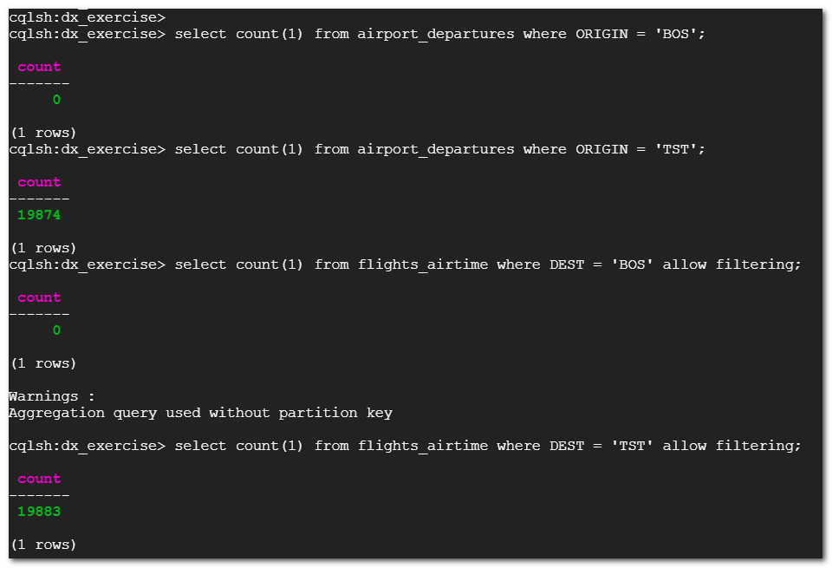

What is the route having most delays?

- A flight is delayed if ( (ARR_TIME – DEP_TIME)/60) –ACTUAL_ELAPSED_TIME > 0
- There were many records having ACTUAL_ELAPSED_TIME = AIR_TIME, which is logically not possible.
- Also, those records most of the time produce inconsistent delay summaries whenever I had evaluated them. So, I have excluded the flights whichever has ACTUAL_ELAPSED_TIME = AIR_TIME
- Based on this I setup the aggregate on the combination of ORIGIN-DEST and sorted descending based on the count of rows.
- The route with most delay is ,
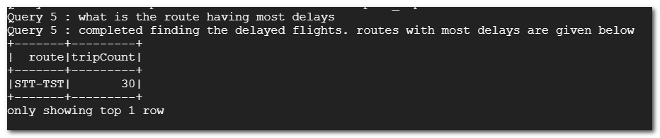

Is the airport activity a factor of the delay?
With the given data, I assume that the (ACTUAL_ELAPSED_TIME – AIR_TIME) is spend at the airports for airport activities.
- To answer this, I calculated mean of (ACTUAL_ELAPSED_TIME – AIR_TIME) from both flights arrived on time and delayed flights.
- If( Mean of delayed flights airport time > Mean of on time flights airport time) then airport activities are a factor of the delay.
- No, Airports activity are not the factor for delay.

Do airports generate delay at arrival and departure the same way?
- I am not able to determine this since the dataset doesn’t have the columns explaining about the actual and touch down timings.
- I believe without those 2 pointers, I will not be able to associate the delay with arrival and departure individually.

All Query results,
