MS Excel
Lab Book

____________________________________________________________________________________
Copyright © 2015 IGATE Corporation. All rights reserved. No part of this publication shall be reproduced in any way, including but not limited to photocopy, photographic, magnetic, or other record, without the prior written permission of IGATE Corporation.
IGATE Corporation considers information included in this document to be Confidential and Proprietary.

- Grouping

Goals | In this example we will total rows of related data and collapse a group of columns.
Time | 40 minutes

Step 1: First, sort the data on the Company column.

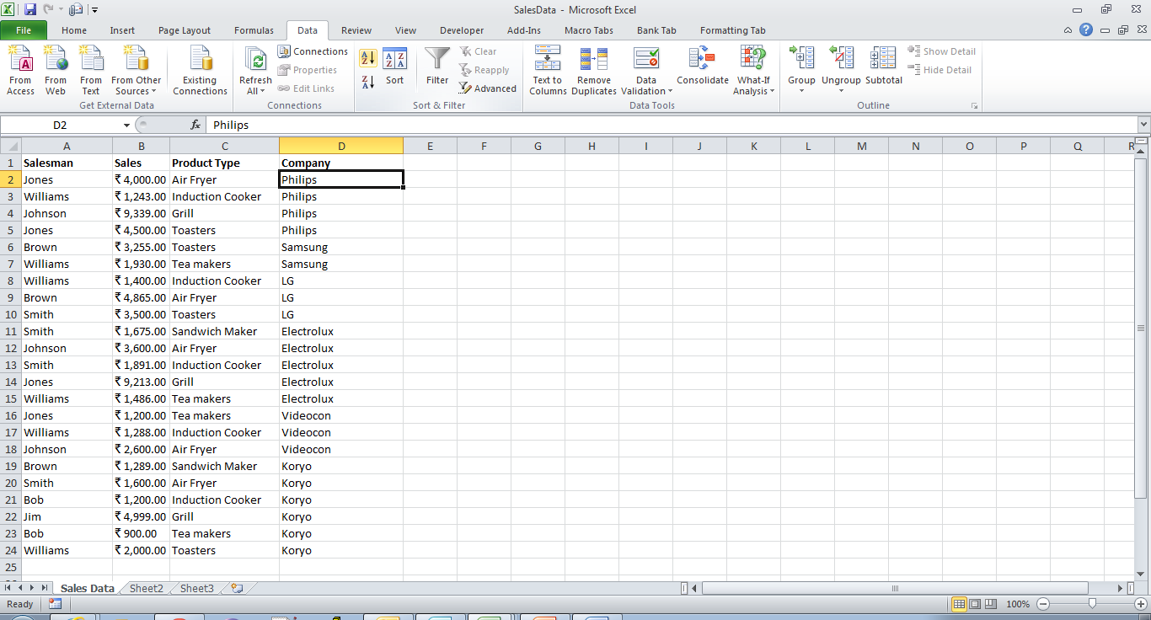
Step 2 : Select the rows or columns you wish to group.

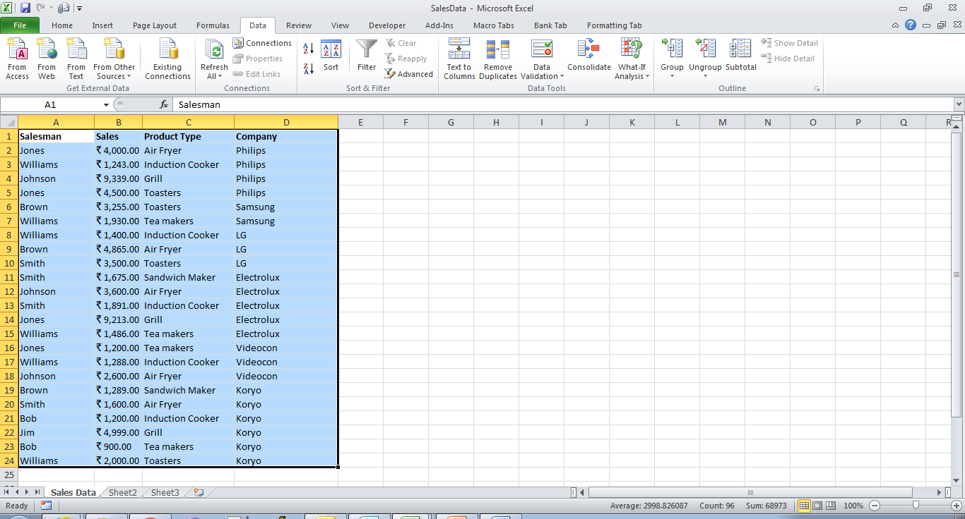

Step 3 : The selected rows or columns will be grouped.

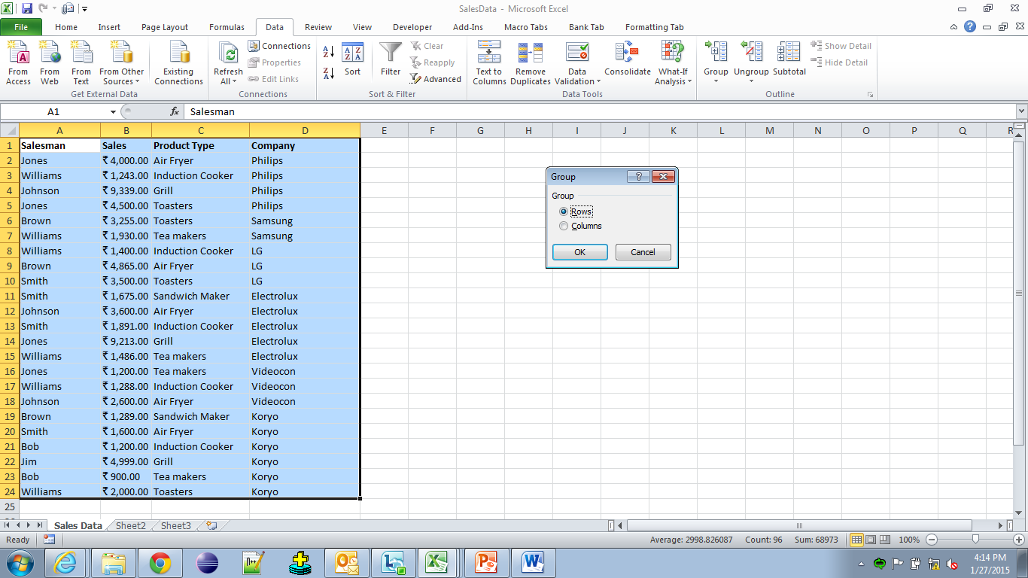

Row Grouping :
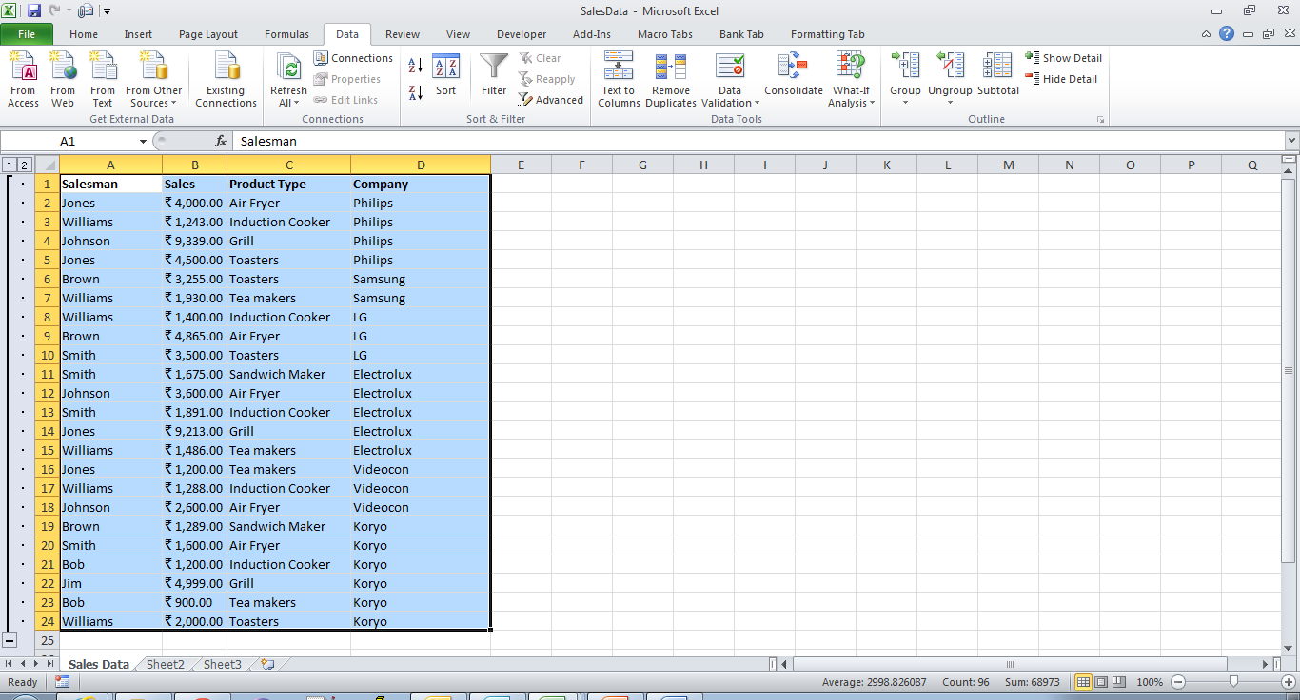

Column Grouping :

Select Each Column and perform the Group command.
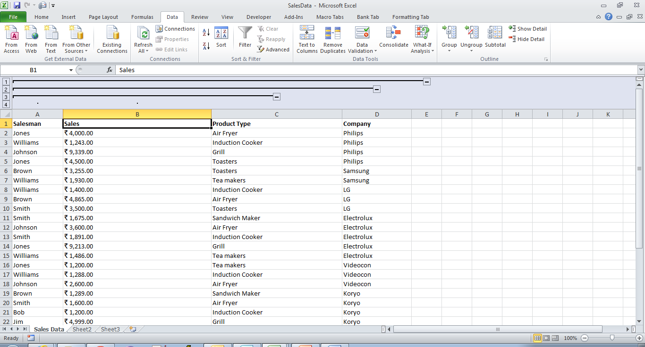

Step 4 : To hide a group, click the Hide Detail button Image of the Hide detail button . To show a hidden group, click the Show Detail button Image of the Show detail button .

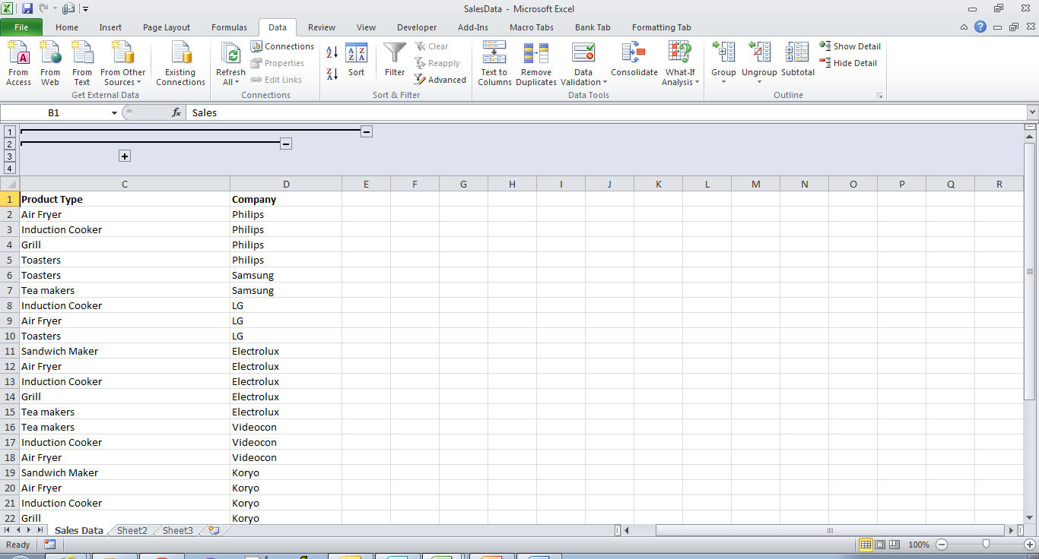

- Subtotal

Goals | To get the total sales done by each salesperson.
Time | 30 minutes

Solution :
Step 1 : Sort the Salesman column.
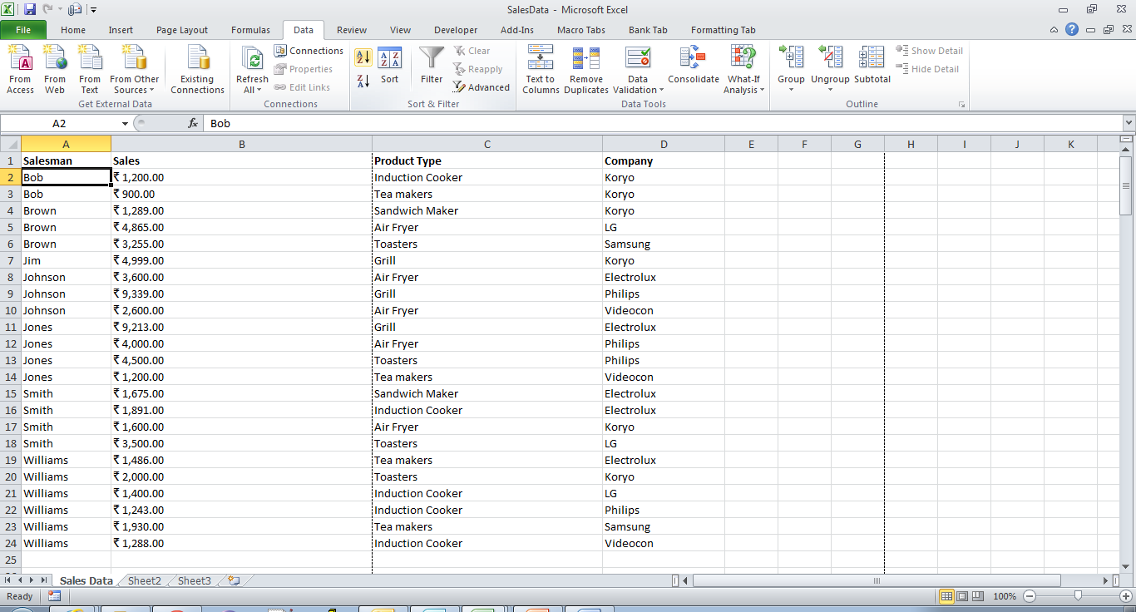

Step 2 : Goto Data tab → Subtotal. Make the below selections in Subtotal dialog box.
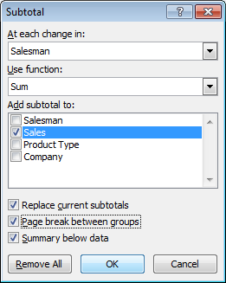

Step 3 : Check the below output.
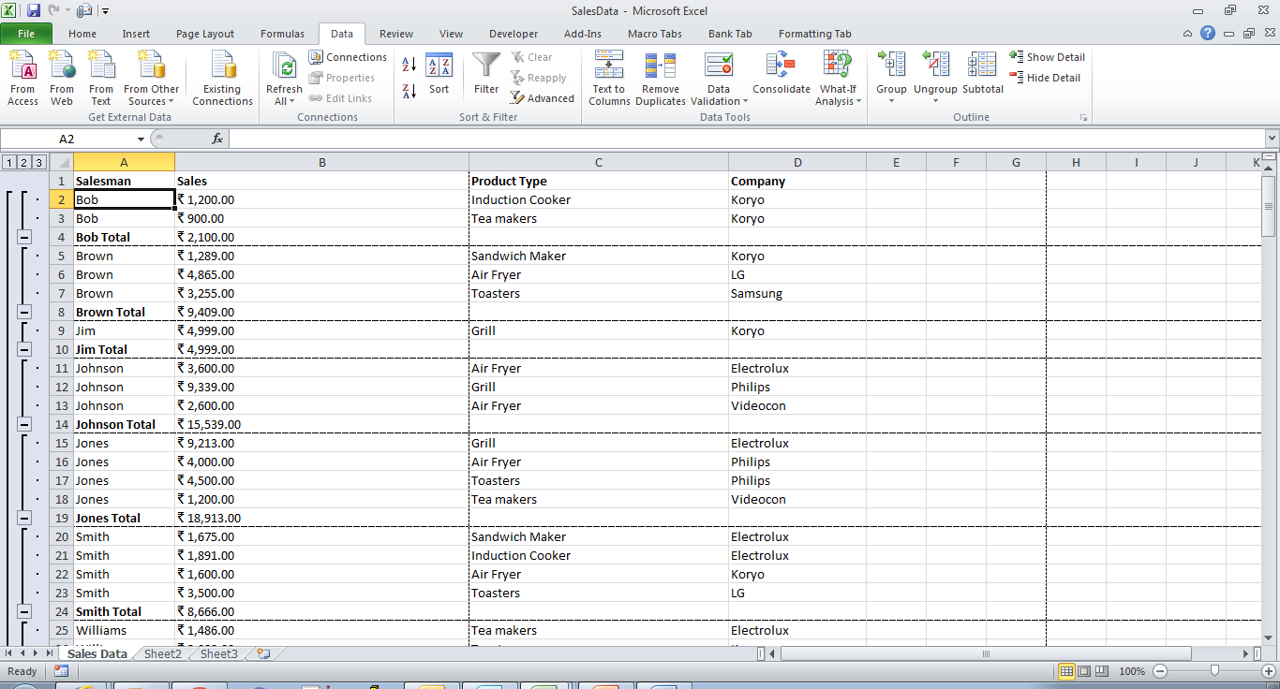
Step 4 : Collapse each row and check the below output.

