https://www.openscience.nl/sites/open_science/files/media-files/final_npos2030_ambition_document_and_rolling_agenda.pdf
NPOS commits to the following guiding principles:

- Scientific knowledge is a public good and access to it is a universal right
Open scientific knowledge is intended to contribute to collective benefits. To this end,
academia should be equitable and fair: it should provide equality of opportunities for
everyone to access, participate in, benefit2 and learn from, and contribute to the scientific process and its outputs.

- Scientific outputs and processes must be as open as possible, but as restricted as necessary
Transparency about the processes of creating and sharing scientific knowledge is the
central tenet of Open Science, and a boundary condition to all of its core values. Scientific outputs and processes should be Findable, Accessible, Interoperable and Reusable (FAIR).
However, there are valid reasons to restrict access to outputs or processes (e.g.,
compliance with privacy regulations, or when dealing with intellectual property, non-
disclosure agreements or knowledge security). This does not mean these outputs and
processes must be fully closed: in many cases, the meta-information can be made
available. That is why the NPOS adheres to the principle that scientific outputs and
processes should be ‘as open as possible, but as restricted as necessary’.

- Reproducibility and scrutiny are essential to safeguard the quality and integrity of scientific work
More openness about the scientific process and its outputs allows for reproducibility (i.e., repeating the same analysis with the same data, by a different analyst), replicability (i.e., similar findings using new data), and reuse.
By scrutinising results and their underlying materials and processes, the integrity of the
work can be safeguarded, and its claims verified. Reproducibility, replicability, (open) peer review and verification (re)build trust in scientific knowledge and a strong foundation for subsequent work, which improves the quality of research and education and speeds up scientific progress.

- Diversity, equity, and inclusiveness are crucial for the success of Open Science
Open Science embraces the diversity of topics, disciplines, practices, languages, outputs, and processes of different (scientific and societal) communities. The scientific community itself needs to be representative of the society it aims to serve. Diversity, equity, and inclusion within the research community are crucial for the success of Open Science.
Collaboration and participation should be promoted, both within the scientific community and outside. This includes researchers, teachers, professionals, and research institutions (universities, academic medical centres, universities of applied sciences, research and technology organisations, enterprises), funding organisations, publishers, service organisations, companies, NGO’s, governmental organisations and citizens.

- Academic and digital sovereignty must be safeguarded
To guarantee scientific knowledge as a public good for collective benefit, it is important to consider the sustainability, governance, and financial models of scholarly infrastructure, (retention of) copyright and open licensing of scientific work. The risks of becoming more and more dependent on commercial or foreign providers and their terms of use in all stages of the research life cycle asks for open (not-for-profit) alternatives for digital services and regulation.
Academic sovereignty is the ability to autonomously take decisions on policies and the
content and organisation of research and education, and determine the role of academia in society. Digital sovereignty entails autonomy regarding sustainable digital information services and infrastructure. Concerted actions are needed to maintain (or retrieve) academic sovereignty. Joint understanding of principles and frameworks is needed, as are collective actions for implementing those principles in public systems as well as commercial ones. This includes assessment which data, output and services are critical and must be publicly steered to safeguard academic sovereignty. The infrastructures for research (meta)data and research assessment should serve the community and be designed, used, and maintained according to scholarly values.

https://zenodo.org/records/6074944

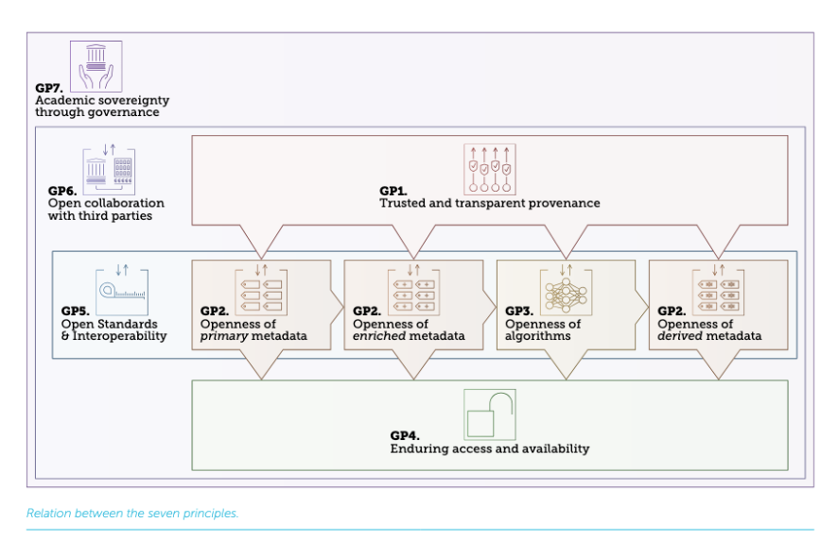
Seven Guiding Principles for Open Research Information

https://openscholarlyinfrastructure.org/posi-v1.1/

The Principles of Open Scholarly Infrastructure

Governance

Coverage across the scholarly enterprise – research transcends disciplines, geography, institutions, and stakeholders. Organisations and the infrastructure they run need to reflect this.
Stakeholder Governed – a board-governed organisation drawn from the stakeholder community builds confidence that the organisation will take decisions driven by community consensus and a balance of interests.
Non-discriminatory participation or membership – we see the best option as an “opt-in” approach with principles of non-discrimination and inclusivity where any stakeholder group may express an interest and should be welcome. Representation in governance must reflect the character of the community or membership.
Transparent governance – to achieve trust, the processes and policies for selecting representatives to governance groups should be transparent (within the constraints of privacy laws).
Cannot lobby – infrastructure organisations should not lobby for regulatory change to cement their own positions or narrow self-interest. However, an infrastructure organisation’s role is to support its community, and this can include advocating for policy changes.
Living will – a powerful way to create trust is to publicly describe a plan addressing the conditions under which an organisation or service would be wound down. It should include how this would happen and how any assets could be archived and preserved when passed to a successor organisation or service. Any such organisation or service must adopt POSI and honour the POSI principles.
Formal incentives to fulfil mission & wind-down – infrastructures exist for a specific purpose, and that purpose can be radically simplified or even rendered unnecessary by technological or social change. Organisations and services should regularly review community support and the need for their activities. If it is possible, the organisation or service (and staff) should have direct incentives to deliver on the mission and wind down.

Sustainability

Time-limited funds are used only for time-limited activities – operations are supported by sustainable revenue sources - whereas time-limited funds are used only for time-limited activities. Depending on grants to fund ongoing and/or long-term infrastructure operations fully makes them fragile and distracts from building core infrastructure.
Goal to generate surplus – organisations (or services) that define sustainability based merely on recovering costs are brittle and stagnant. It is not enough to merely survive; organisations and services have to be able to adapt and change. To weather economic, social and technological volatility, they need financial resources beyond immediate operating costs.
Goal to create financial reserves – a high priority should be having ring-fenced financial reserves, separate from operating funds, that can support implementing living will plans, including a complete, orderly wind down or transition to a successor organisation, or major unexpected events.
Mission-consistent revenue generation – revenue sources should be evaluated against the infrastructure’s mission and not run counter to the aims of the organisation or service.
Revenue based on services, not data – data related to the running of the scholarly infrastructure should be community property. Appropriate revenue sources might include value-added services, consulting, API Service Level Agreements or membership fees.

Insurance

Open source – all software and assets required to run the infrastructure should be available under an open-source licence. This does not include other software that may be involved with running the organisation.
Open data (within constraints of privacy laws) – For an infrastructure to be forked (reproduced), it will be necessary to replicate all relevant data. The CC0 waiver is the best practice in making data openly and legally available. Privacy and data protection laws will limit the extent to which this is possible.
Available data (within constraints of privacy laws) – it is not enough that the data be “open” if there is no practical way to obtain it. Underlying data should be made easily available via periodic open data dumps.
Patent non-assertion – the organisation should commit to a patent non-assertion policy or covenant. The organisation may obtain patents to protect its own operations but not use them to prevent the community from replicating the infrastructure.

