CSCU9N5

Assignment

Student no: 2320512

Title: Learn Instruments

Main file name: learnInstruments.html

Description of the general concept

This is a web app for learning to play various songs on different music instruments. Even though prototype shows 4 instruments with very limited amount of notes for them, the capabilities of full version could be far beyond that (i.e. notes available could be pre-populated dynamically from the internet). It is aimed for big variety of people from those who want to learn how to play a music instrument to professionals who just want to play a particular song or practice on difficult songs. There are few different possibilities of it being delivered depending on whether it is self-contained (holds full database of note sheets inside it) or needs internet access to dynamically find relevant note sheets. If it is self-contained it could be delivered through external storage devices like CD’s or pen drives and web just like all other proprietary software. However, if it is not self-contained then the best way to deliver it would probably be through web server since smaller devices (e.g. phones) might not be powerful enough or have internet speed required to dynamically get all the src files on time.

Details of design

Hierarchical navigation map.  
Note: Navigation bar capabilities are not shown in the map to keep it simple and not messy.

Violin Difficulty Page

Trumpet Difficulty Page

Guitar Difficulty Page

Saxophone Difficulty Page

**Instrument selection (or home) page**

Not implemented page

Not implemented page

Beginner  
Choose song page

Advanced  
Choose song page

Winter Wonderland play page

The Pink Panther play page

La Montanara play page

Hardcore  
Choose song page

London Bridge is Falling Down play page

Not implemented page

Trumpet buddies play page

Design:

1. Dominant colours are black, grey and white. While other colours allow users to make decisions more intuitively (green – easy/newbie, orange – medium/warning, red – hard/problematic, blue – revert/stability) it does not make a massive difference on information provided to the user and that is being considerate for colour blind users.
2. Users tend to click on things relevant to what they want, thus I decided to make the navigation through pages as much by clickable images as possible.  
   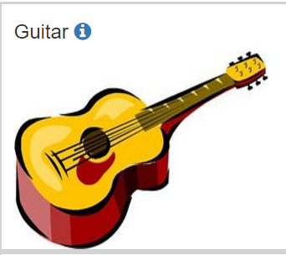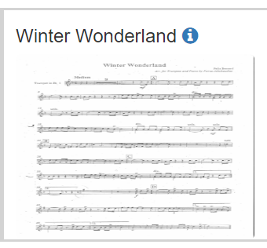
3. Buttons have icons that represents the function which will be done after the button is clicked. This allows users who are unable to read (i.e. does not know the language) to still be able to use the web app.  
   
4. All pages can access all other hierarchically lower pages to them using navigation bar or they can go one level below using blue button at the bottom of each page. (i.e a person can go from trumpet buddies play page can go directly to trumpet difficulty page, all not implemented pages can go directly to previously selected instrument difficulty page or instrument selection (home) page.  
   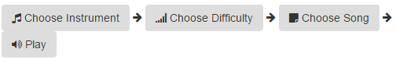
5. All images have appropriate “alt” attributes to be screen-reader friendly.
6. Most users hate too many effects on web pages and titles them as being “too flashy”. Thus, I decided to just add a nice fade-in effect to every page which makes navigation look nice and does not annoy even the pickiest users.
7. Important instructions are written in a grey box at the top of the page and uses bigger font to get users attention. Instructions are short and playful because most users do not feel entertained by reading long plain texts.  
   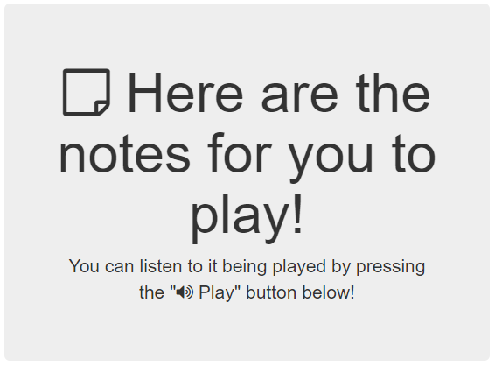

There should be 3 types of users:

1. A person who wants to learn how to play a particular music instrument.
2. A person who wants to practice on playing a particular music instrument.
3. A person who wants to learn to play a particular song on a particular instrument.

Storyboards:  
Note: Since I only implemented trumpet for this prototype, my actors will both be interested in playing trumpet.

1. This actor has a task to learn about instruments, pick the preferred one and learn to play it.
   1. Since he has not decided yet which instrument he wants to learn to play with, he hovers over blue info icons and after that decides to go with trumpet, so he right-clicks on it.
   2. Since he just wants to learn to play he clicks on “Beginner” button.
   3. Since he knows nothing about trumpet or songs he starts from the first song which is “Sounds”
   4. He sees the notes, he can attempt to play it with trumpet. He can listen to a recording of me playing to better understand how to do it. Now he knows how to play an instrument he picked and his task is completed. Soon he gets bored of this song and wants to play another one, so he either clicks “Next notes” or clicks “Choose Difficulty” in navigation bar to select higher level and then follows the same process as described in step C.  
       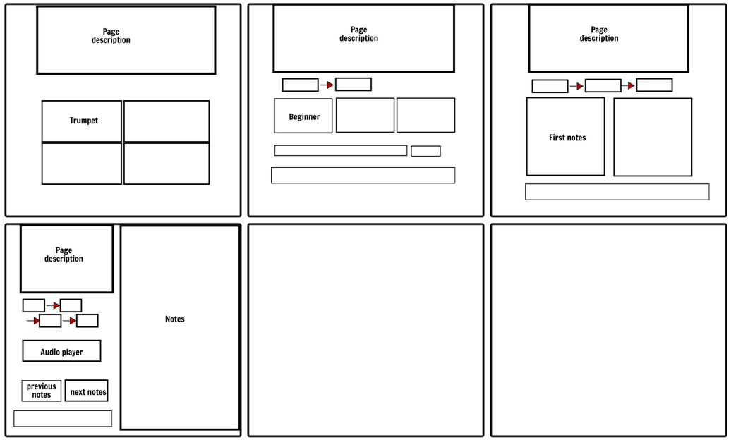
2. This actor is a trumpet professional who wants to stay in shape or become better.
   1. He sees trumpet and clicks on it. He does not go through info icons since he knows almost everything about the instrument and he does not care about other instruments either.
   2. He knows well that he is a hardcore trumpeter so he clicks on hardcore without hesitation.
   3. Since he knows he wants to play “The Pink Panther” because that song requires some real guts, he clicks on it. (Reminder: in full version there would be much more songs available than in prototype)
   4. He keeps playing both solo and together with my recording to get a nice duo. (Two good trumpeters is always better than one, right?)  
      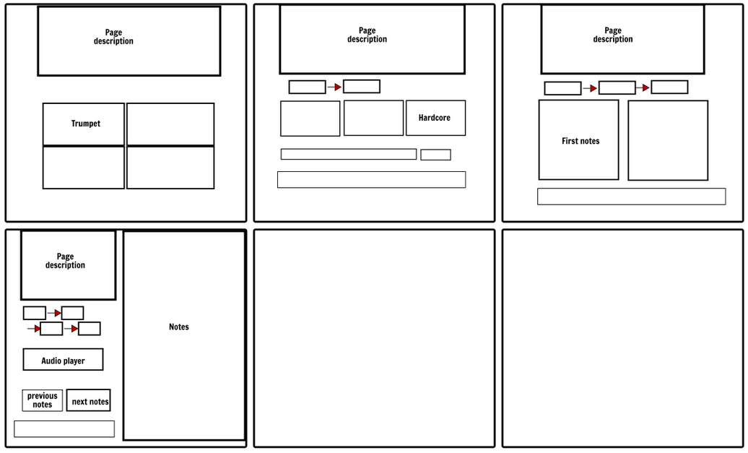

To conclude: it is easy to navigate my web app since getting from point A to point Z only 3-4 clicks are required. Also it only requires 1 click on navigation bar to go back by however many levels a user wants (i.e. from last page to second page, third page to first page and so on).

Prototyping: I used vertical prototype since pages for all instruments would look almost exactly the same and would provide same features. I chose to go trumpet path since I am a trumpeter myself and have/can make the files required by this app. Trumpet is fully implemented with an exception of number of notes available and search bar functionality. The prototype contains images of instruments and notes and audio files of me performing the songs.

Usability testing

Full test would include 15 testers with various backgrounds and abilities/disabilities and would do these tests:

1. Functionality tests
2. Check how intuitive the design of web is overall
3. Check how difficult it becomes for users to navigate when all text is converted to unknown language
4. Check how web app would look in greyscale
5. Checking how well/bad web looks for colour blind people 5. Check how screen reader friendly the program is.

Because of the lack of time I will run test 1 (functionality) and test 3 (greyscale) myself and then take a sample of 5 people with different nationalities, genders and backgrounds and run test 2 to make sure it my web is easy to use and that it delivers the information across well enough. I will also run w3c html validator, try to use my web on different browsers, and run “Bureau of internet accessibility” accessibility test.

References

1. Technologies used:
   1. Twitter Bootstrap 3.3.7 css library
   2. JQuery 1.12.4 which is needed for bootstrap and comes in the same package
   3. FontAwesome 4.7.0 css library which also comes with bootstrap as standard
2. Instrument images:
   1. Trumpet <http://worldartsme.com/images/animated-trumpet-clipart-1.jpg>
   2. Guitar <https://encrypted-tbn0.gstatic.com/images?q=tbn:ANd9GcQsacxkmwBJqKLYvlmUEeQ7UEsRFfdtvQ5s2sq2Pq1scq5b3zpEvg>
   3. Saxophone <http://images.clipartpanda.com/saxophone-clip-art-saxophone_clipart.png>
   4. Violin <http://www.cliparts101.com/files/101/BE965E05C44E460D65BFAAFBCB9D6987/VIOLIN.png>
3. Notes:
   1. Begginer notes:
      1. “notes00.jpg” - Trumpet Buddies <https://trumpetbuddies.wikispaces.com/Notes+and+Music>
      2. “notes01.jpg” – English traditional singing game song “London Bridge Is Falling Down”
   2. Advanced notes:
      1. “notes10.jpg” – Toni Ortelli – “La Montanara” (also known as “Song of the mountains”)
      2. “notes11.jpg” – Felix Bernard – “Winter Wonderland”
   3. Hardcore:
      1. “notes20.jpg” - Henry Mancini – “The Pink Panther Theme”
   4. “sample.jpg” – Compositor John Williams – Theme from “Jurassic Park”
4. Sound output: All playbacks for notes had been played and recorder by myself.