To: ITCM 2025 Workshop Co-Chairs / IEEE Publication Team
Subject: Request for Erratum – Paper ID: S07232
Paper Title: ChatGLM-FGIDs-TCM: A Knowledge-Integrated Large Language Model for Clinical Decision Support in Traditional Chinese Medicine
Submission Password: p2323785
Dear Workshop Co-Chairs and IEEE Editorial Team,
On behalf of all co-authors, I am writing to respectfully request the issuance of an Erratum to correct an oversight in the final manuscript submission of our above-referenced paper, which has been accepted for publication in the IEEE ITCM 2025 proceedings.
We sincerely thank you for the acceptance of our paper and for the valuable review comments provided by the program committee members.
Error Description: Due to an unintentional oversight during the final manuscript upload, the corresponding author was not properly marked in the submission system.
Requested Correction via Erratum: We kindly request that the following information be officially supplemented in the published version:
1. Corresponding Author Designation
Ling Zhu (Email: jjzhuling@163.com) is the official corresponding author of this paper.
2. Co-First Authors Statement
Wanting Zheng and Yuanyuan Tong are co-first authors, contributing equally to this work.
3. Author Contributions
Author | Contributions
Yuanyuan Tong (Co-first Author) | Conceptualization; Writing – Original Draft
Wanting Zheng (Co-first Author) | Conceptualization; Writing – Original Draft
Ling Zhu (Corresponding Author) | Conceptualization; Funding Acquisition; Resources; Supervision; Writing – Review & Editing
Tong Gao | Data Curation; Methodology; Software; Investigation; Formal Analysis
All authors have read and approved the final manuscript.
Reason for Correction: This correction is important because Professor Ling Zhu serves as the lead supervisor and primary contact for this work. Proper corresponding author designation is essential for accurate communication during and after the publication process.
Author Consent: All co-authors have been informed of and have consented to this correction request.
We sincerely apologize for any confusion this oversight may have caused and greatly appreciate your understanding and assistance. Please let us know if any additional documentation or formal confirmation from all authors is required to process this Erratum.
Thank you very much for your consideration.
Yours sincerely,
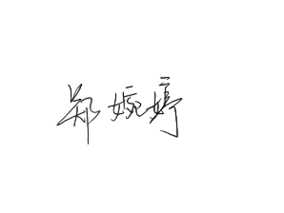
On behalf of all co-authors
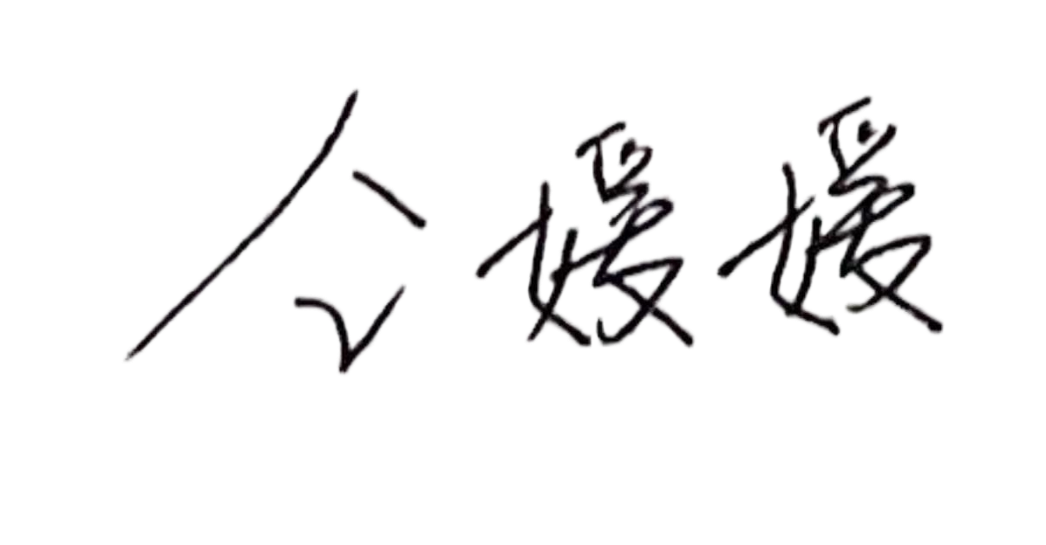

收件人：ITCM 2025 研讨会共同主席 / IEEE 出版团队
主题：勘误申请——论文编号：S07232
论文题目：ChatGLM-FGIDs-TCM：面向中医临床决策支持的知识集成大语言模型
投稿密码：p2323785
尊敬的会议主席及 IEEE 编辑团队：
我谨代表全体合著者，正式申请发布一份勘误（Erratum），以更正并补充我们在最终稿件提交过程中因疏忽遗漏的重要信息。上述论文已被 IEEE ITCM 2025 会议录用并拟收录于会议论文集中。
我们衷心感谢会议对本论文的接收，并感谢程序委员会成员提出的宝贵审稿意见。
错误说明：由于最终稿件上传过程中的非故意疏忽，通讯作者信息未能在投稿系统中得到正确标注。
申请勘误补充内容：我们恳请在正式出版版本中补充以下信息：
1. 通讯作者标注
朱玲（Ling Zhu，Email: jjzhuling@163.com）为本文正式通讯作者。
2. 共同第一作者声明
郑婉婷（Wanting Zheng）与仝媛媛（Yuanyuan Tong）为共同第一作者，对本文贡献相等。
3. 作者贡献
作者 | 贡献
仝媛媛（共同第一作者） | 概念构思；初稿撰写
郑婉婷（共同第一作者） | 概念构思；初稿撰写
朱玲（通讯作者） | 概念构思；经费获取；资源支持；监督指导；审阅与修改
高彤 | 数据整理；方法设计；软件实现；调查研究；形式分析
全体作者均已阅读并同意最终稿件。
更正原因：本次更正十分重要，因为朱玲教授为本研究的主要指导教师及主要联系人。正确标注通讯作者有助于确保出版过程及论文发表后的学术沟通准确、顺畅。
作者同意：全体合著者均已知悉并同意本次勘误申请。
对于此次疏忽可能造成的任何困扰，我们深表歉意，并衷心感谢贵方的理解与协助。如处理本次勘误需要提供其他材料或全体作者的正式确认，请随时告知。
谨此致谢。
此致
敬礼

