# In-class activity 1B

Name: Ben Soto

### Requirements

* STM32 L476RG Nucleo board
* STM32CubeIDE
* Lecture slides and hands-on files in class.

### Instructions

#### Understand the GPIO register and how to use the debugger to observe input signal.

Step 1: (Create a project and enable SWD)

Connect the board to an USB port.

Launch STM32CubeIDE and choose the default working directory.

Click on File, New, then STM32 Project as below.

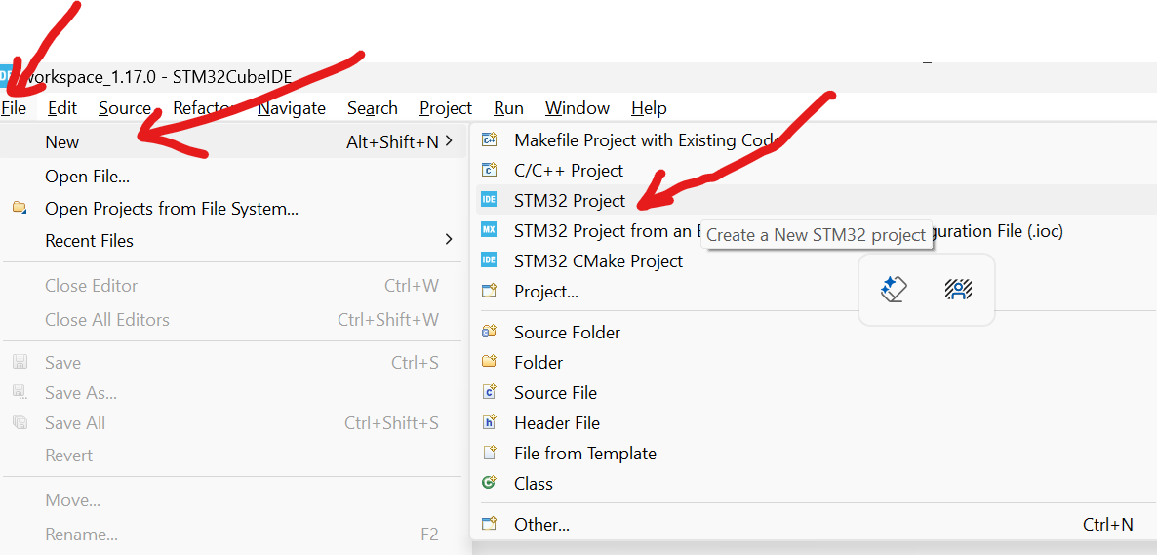

In the target selection, type STM32L476RGT6 as below.

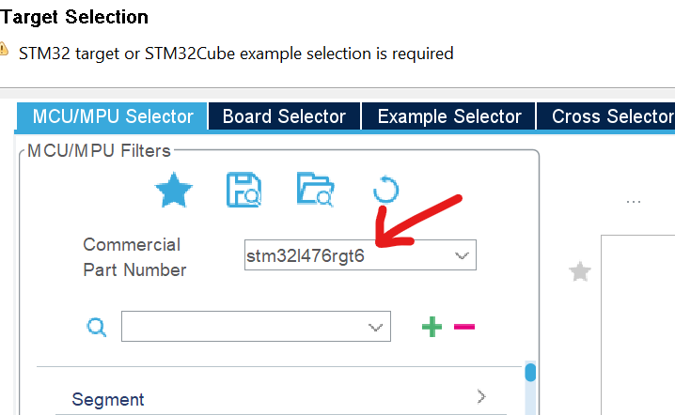

Choose the first one in the list and click on Next.

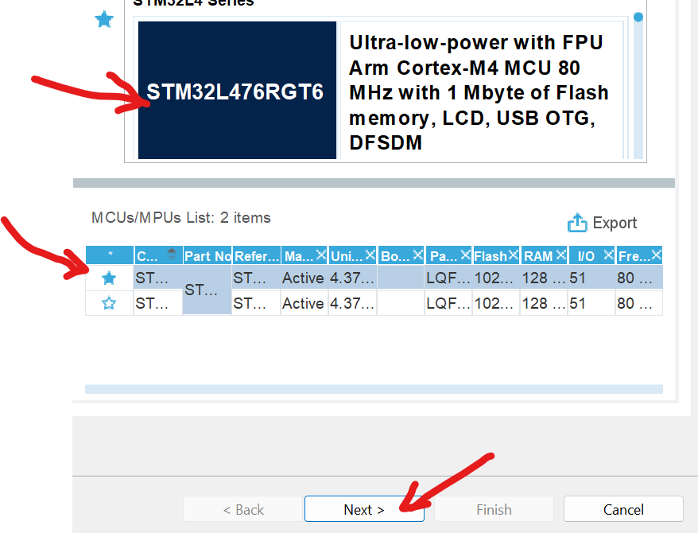

Create a Project Name such as InClassActivity1B then click on Finish.

Step 2 (Configure the on-board LED on PA5)

Click on the PA5 and configure it as GPIO_Output as below.

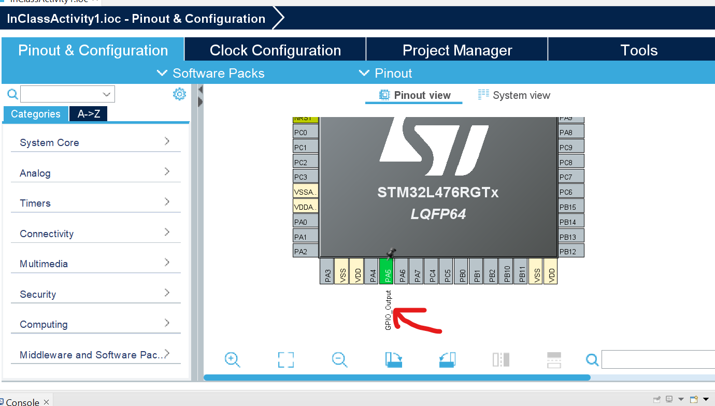

Step 3: Click GPIO to check PA5 configuration.

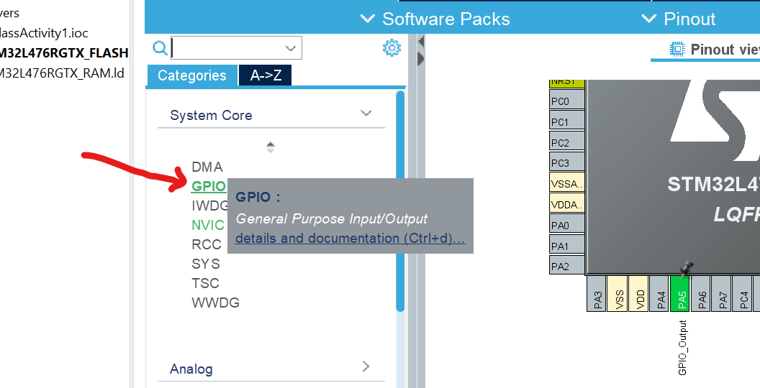

Ch

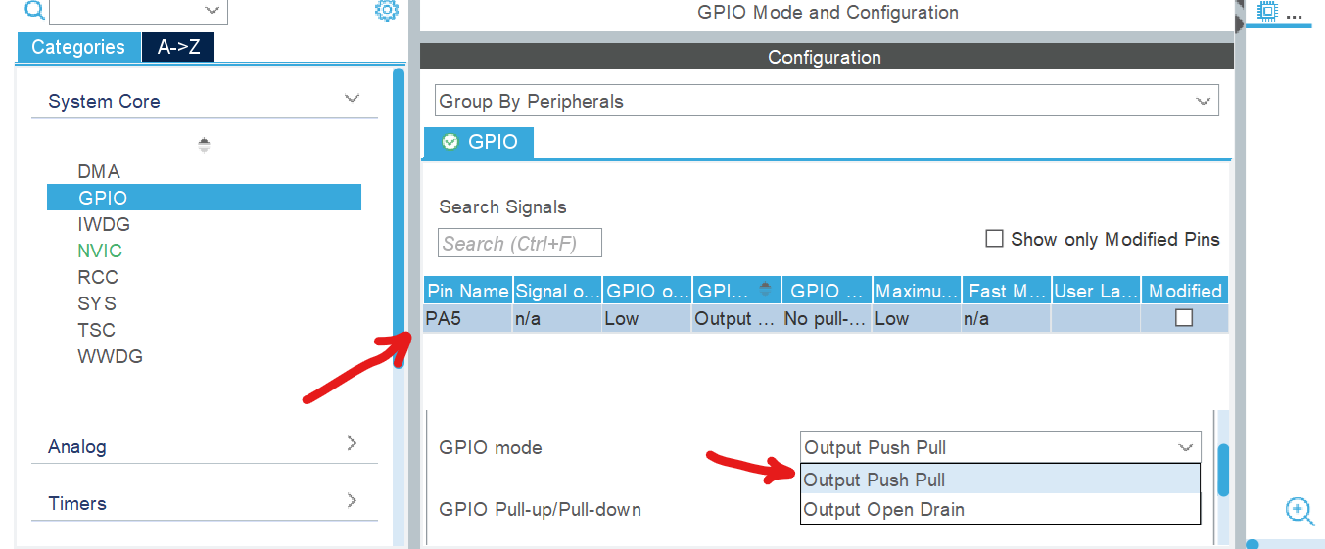

Step 4: Choose PA5 output as Push Pull.

Step 5: Enable SWD (for debugger) under System Core.

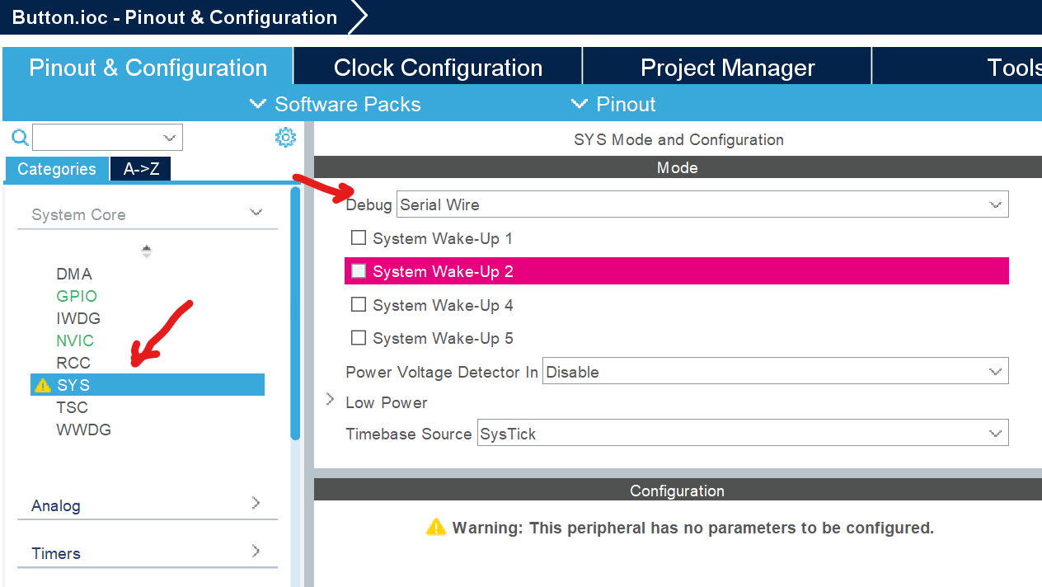

Step 6: Review the datasheet from canvas to find where the “blue” pushbutton is connected and make the pin as input.

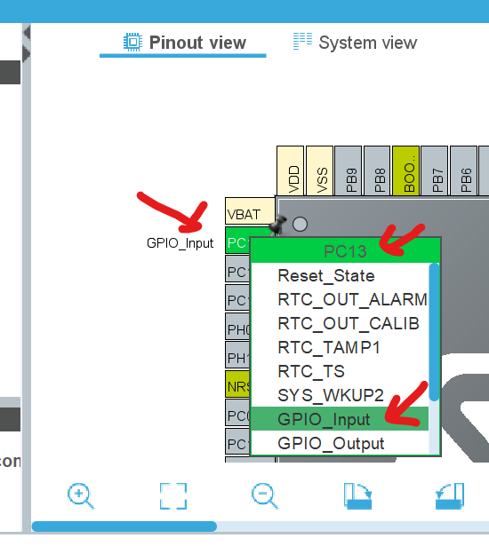

The “blue” button is connected to GPIOC pin 13. Make it input as shown above.

Step 7: Check the schematic diagram to decide if the button input needs an internal pull-up. (Screenshot and paste under the figure below with the schematic diagram where makes you to decide the need or no need of a pull-up resistor for PC13.)

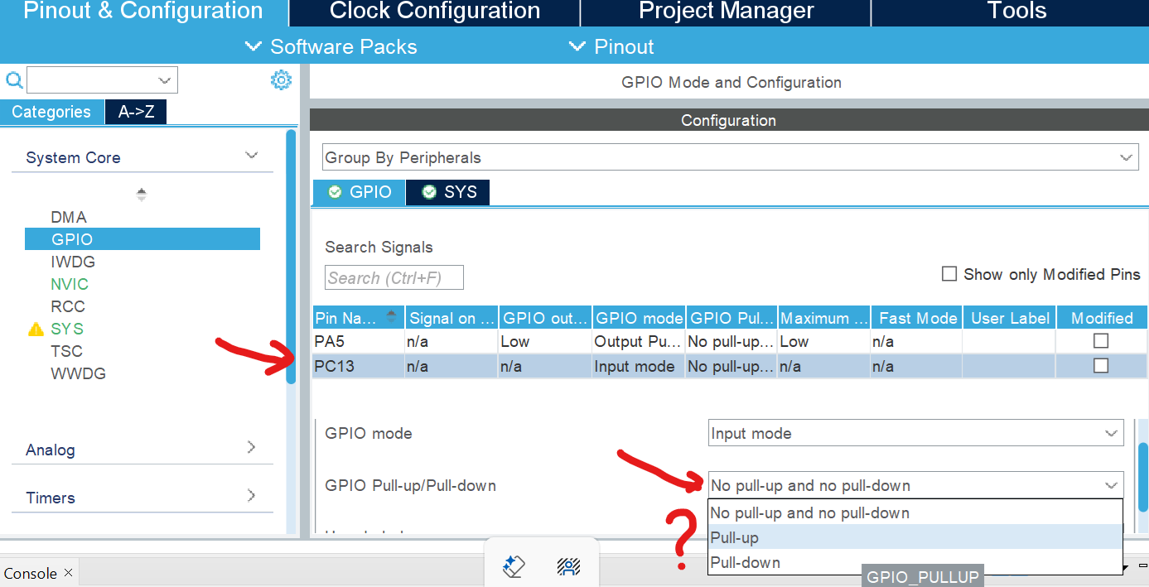

No need a pull up resistor since there is already one (R30).

Step 8: Set up clock to be High Speed Internal with PLL to bump to 80MHz to all buses.

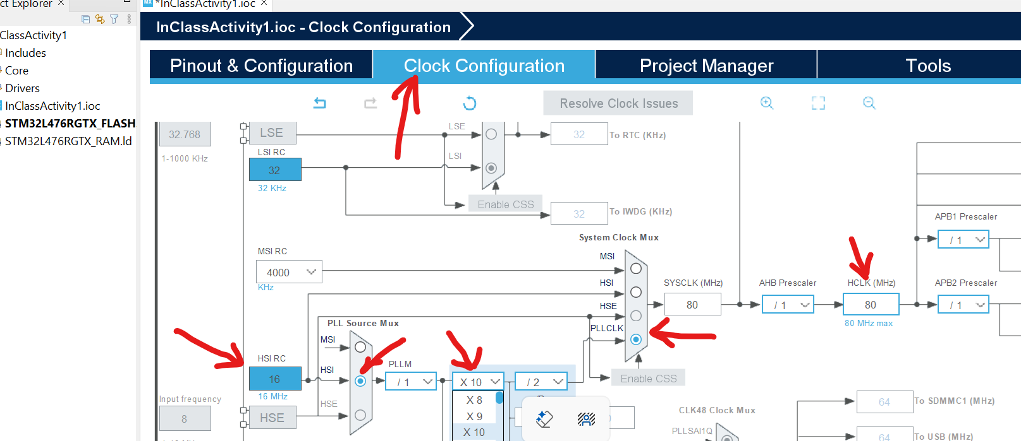

Make sure all buses run at 80MHz.

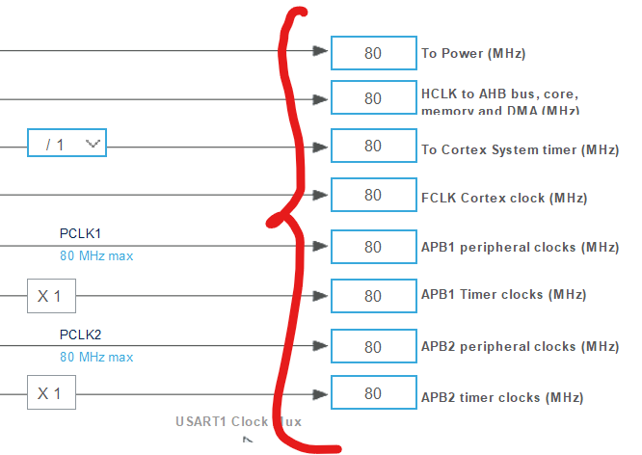

Step 9: After configuration (ioc) is done, click on the diskette to save and let it generate code as well as open perspective as shown.

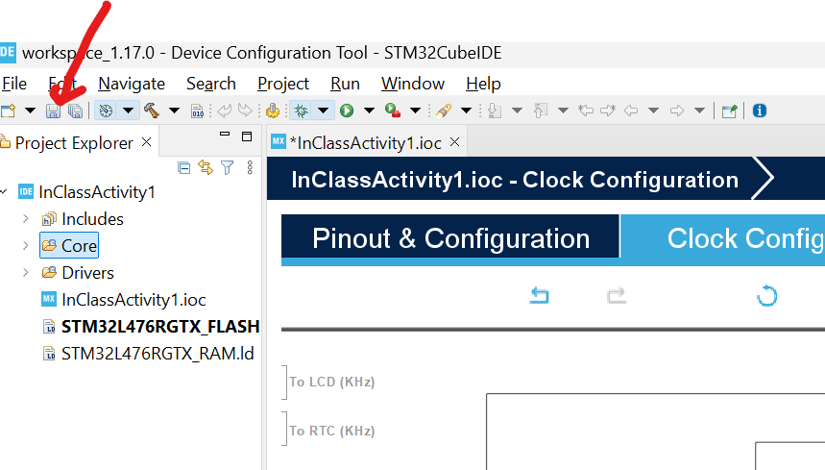

Step 10: Click on Core, Src, main.c in the Project Explorer pane and type codes as below.



…

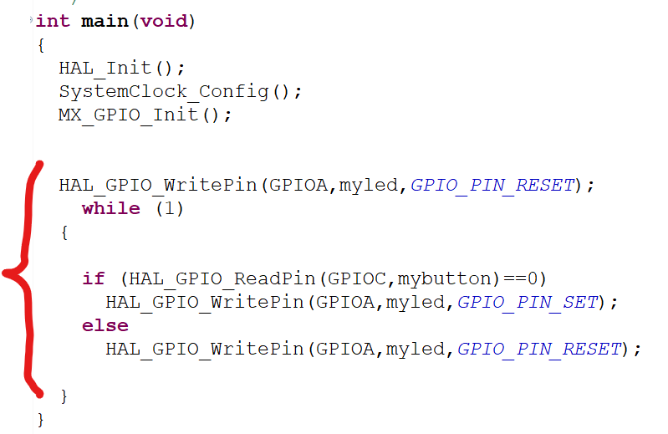

Use “// “ to add comment below each line. The comments should explain what the instruction intends to do. Screenshot and paste your code and comments below.

Step 11: Click on Project, Build Configurations, Set Active and Debug.

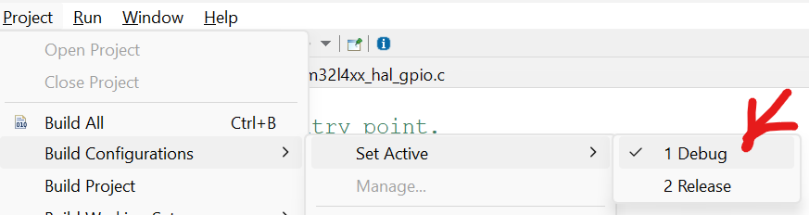

Step 12: Click on Project, Build All.

Step 13: Clock Project, Properties, then C/C++ Build then Settings. Make Optimization level to None under GCC C compiler.

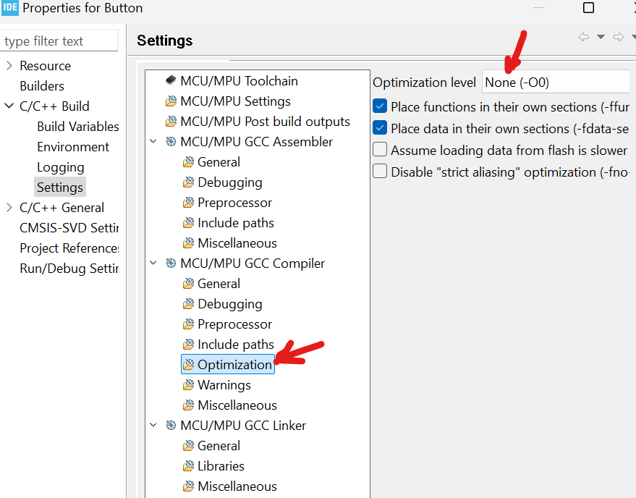

Make Debugging to Maximum.

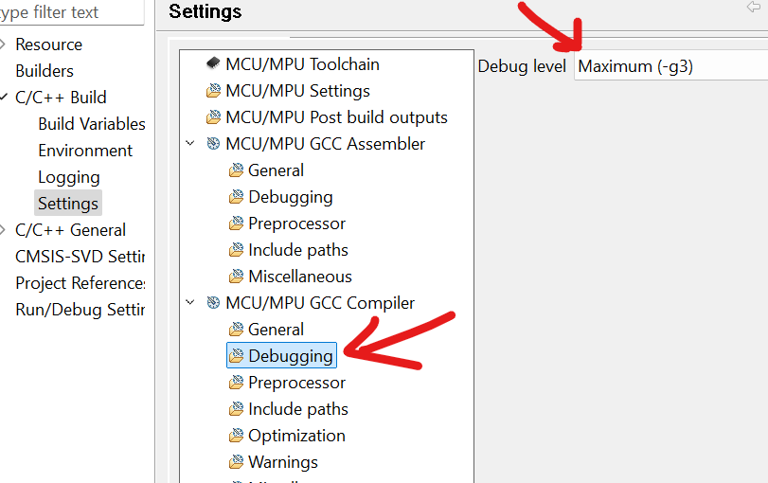

Then Project, Build All again.

Step 14:

Make sure the project name on the left is highlighted. Then, click on the Run, Debug As.

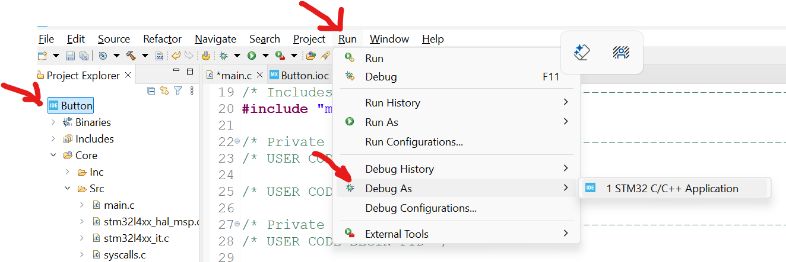

Step 15: Click “Switch” then the debugger window will be open as below.

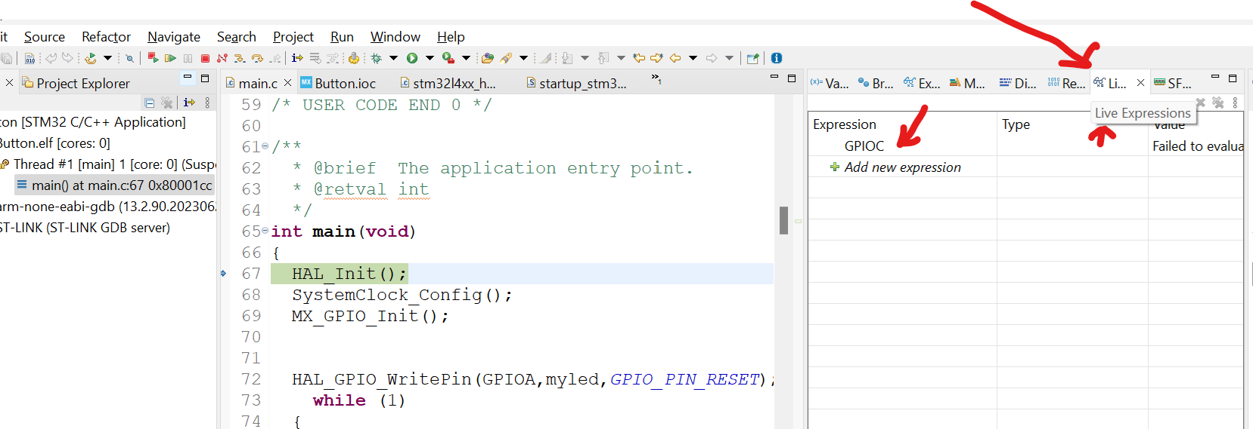

Click on Live Expressions and type GPIOC as shown above.

Step 16: Use F6 or the following icons as shown to debug.

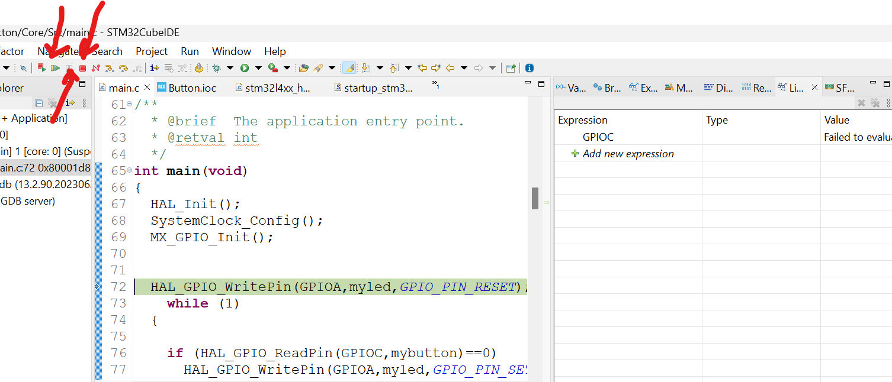

Step 17: Observe the GPIOC-> IDR. This exercise demonstrate real-time data observation and the LED should be turned on when the pushbutton is pressed.

Screenshot the GPIOC->IDR and GPIOA->ODR below to verify when the button is pushed or released and the status of the LED.

Submit this document for grading.

No Press:

With Press:

### Lab resources:

### ST Reference Documentation:

* STM32L4xxxx Reference Manual [RM0351](https://www.st.com/resource/en/reference_manual/rm0351-stm32l47xxx-stm32l48xxx-stm32l49xxx-and-stm32l4axxx-advanced-armbased-32bit-mcus-stmicroelectronics.pdf)
* STM32L476xx Datasheet [DS10198](https://www.st.com/resource/en/datasheet/stm32l476rg.pdf)
* STM32L4A6xx Datasheet [DS11584](https://www.st.com/resource/en/datasheet/stm32l4a6rg.pdf)
* STM32L496xx Datasheet [DS11585](https://www.st.com/resource/en/datasheet/stm32l496zg.pdf)
* NUCLEO-L476RG Users Manual [UM1724](https://www.st.com/resource/en/user_manual/um1724-stm32-nucleo64-boards-mb1136-stmicroelectronics.pdf)
* NUCLEO-L4x6ZG Users Manual [UM2179](https://www.st.com/resource/en/user_manual/um2179-stm32-nucleo144-boards-mb1312-stmicroelectronics.pdf)
* STM32CubeIDE Users Manual [UM2609](https://www.st.com/resource/en/user_manual/um2609-stm32cubeide-user-guide-stmicroelectronics.pdf)