When compiled for running this:

#include "c:\OpenCV\sources\samples\cpp\tutorial_code\core\how_to_scan_images\how_to_scan_images.cpp"

Got :

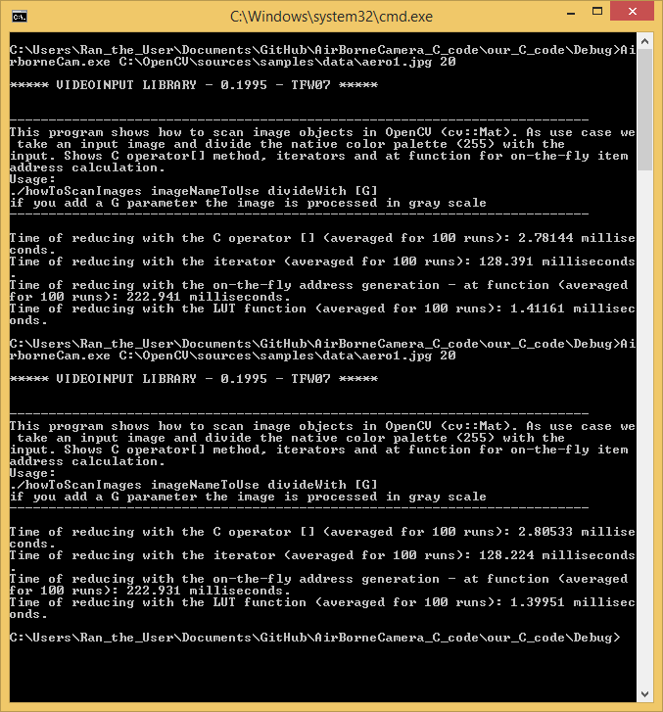

----------------------

When time measuring optical flow on this video :

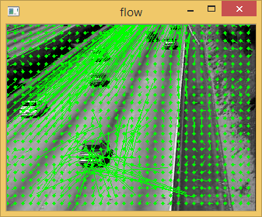

Got performance of :

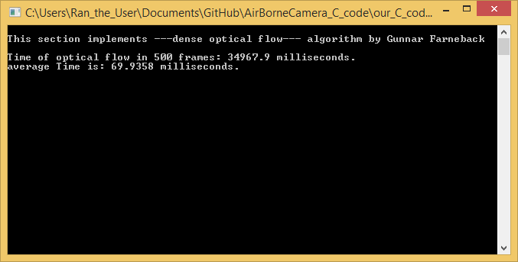

The video resolution is :

Size newSize(400, 225); //(_Tp _width, _Tp _height);