Set wifi :

<https://wiki.onion.io/get-started>

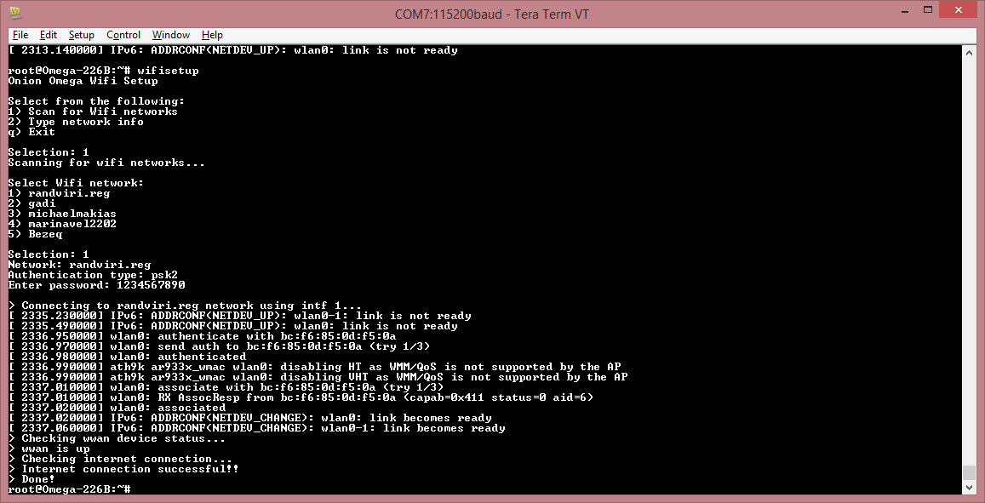



**Step 7**: Run oupgrade :

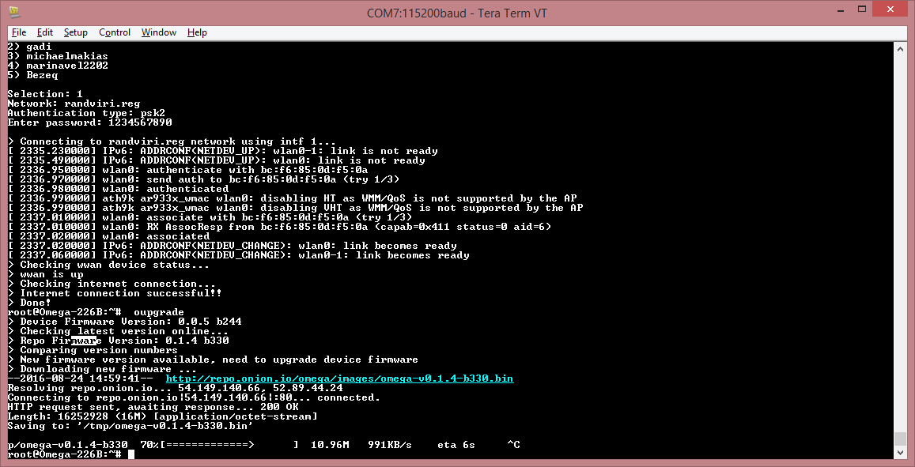

**Step 8**: Enjoy! Check out the [**Tutorials section**](https://wiki.onion.io/Tutorials/Contents) or the [**Project guides**](https://wiki.onion.io/Projects/Contents) for ideas on what to do next!

To check:

Onion Omega WiFi USB Webcam Stream : <https://www.youtube.com/watch?v=3rKjeB_JqD0>

(<https://github.com/OnionIoT> )