CS 255 System Design Document
DriverPass
Ed Adams
CS 255 System Analysis and Design

UML Diagrams

UML Use Case Diagram
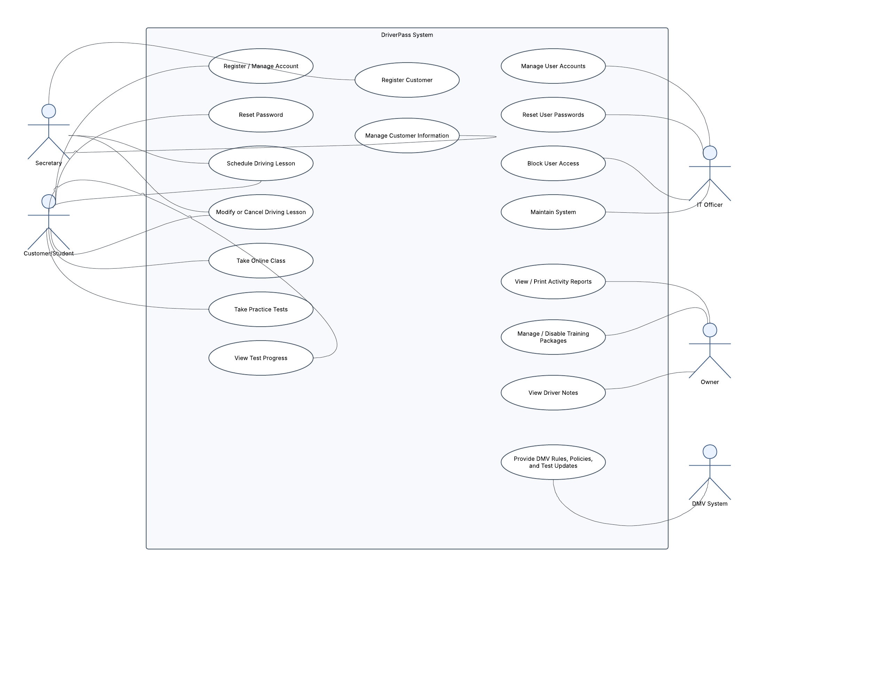

UML Activity Diagrams
Schedule Driving Lesson
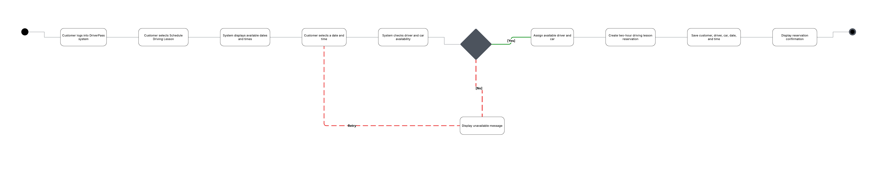

Take Practice Test
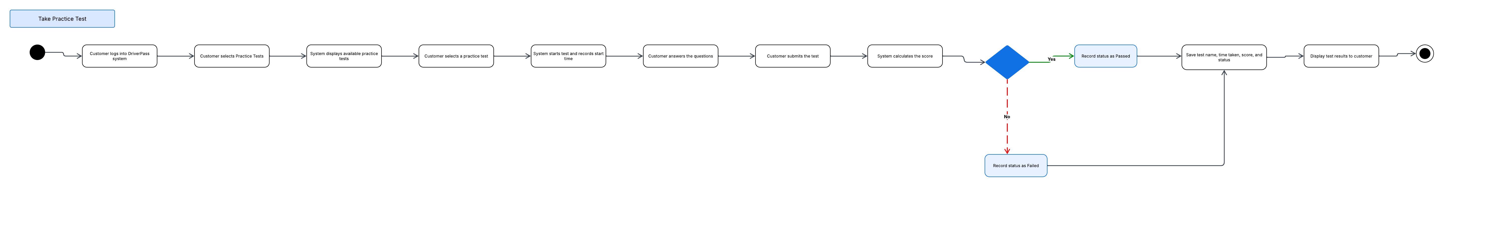

UML Sequence Diagram
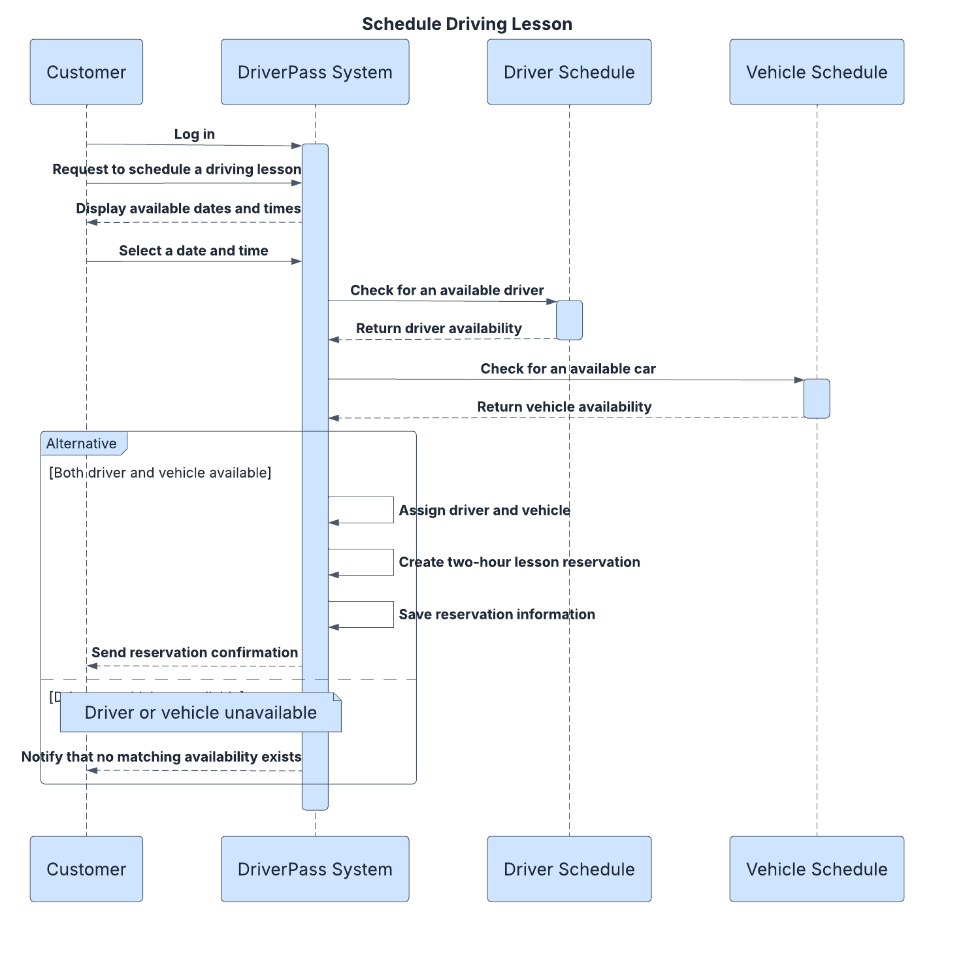

UML Class Diagram
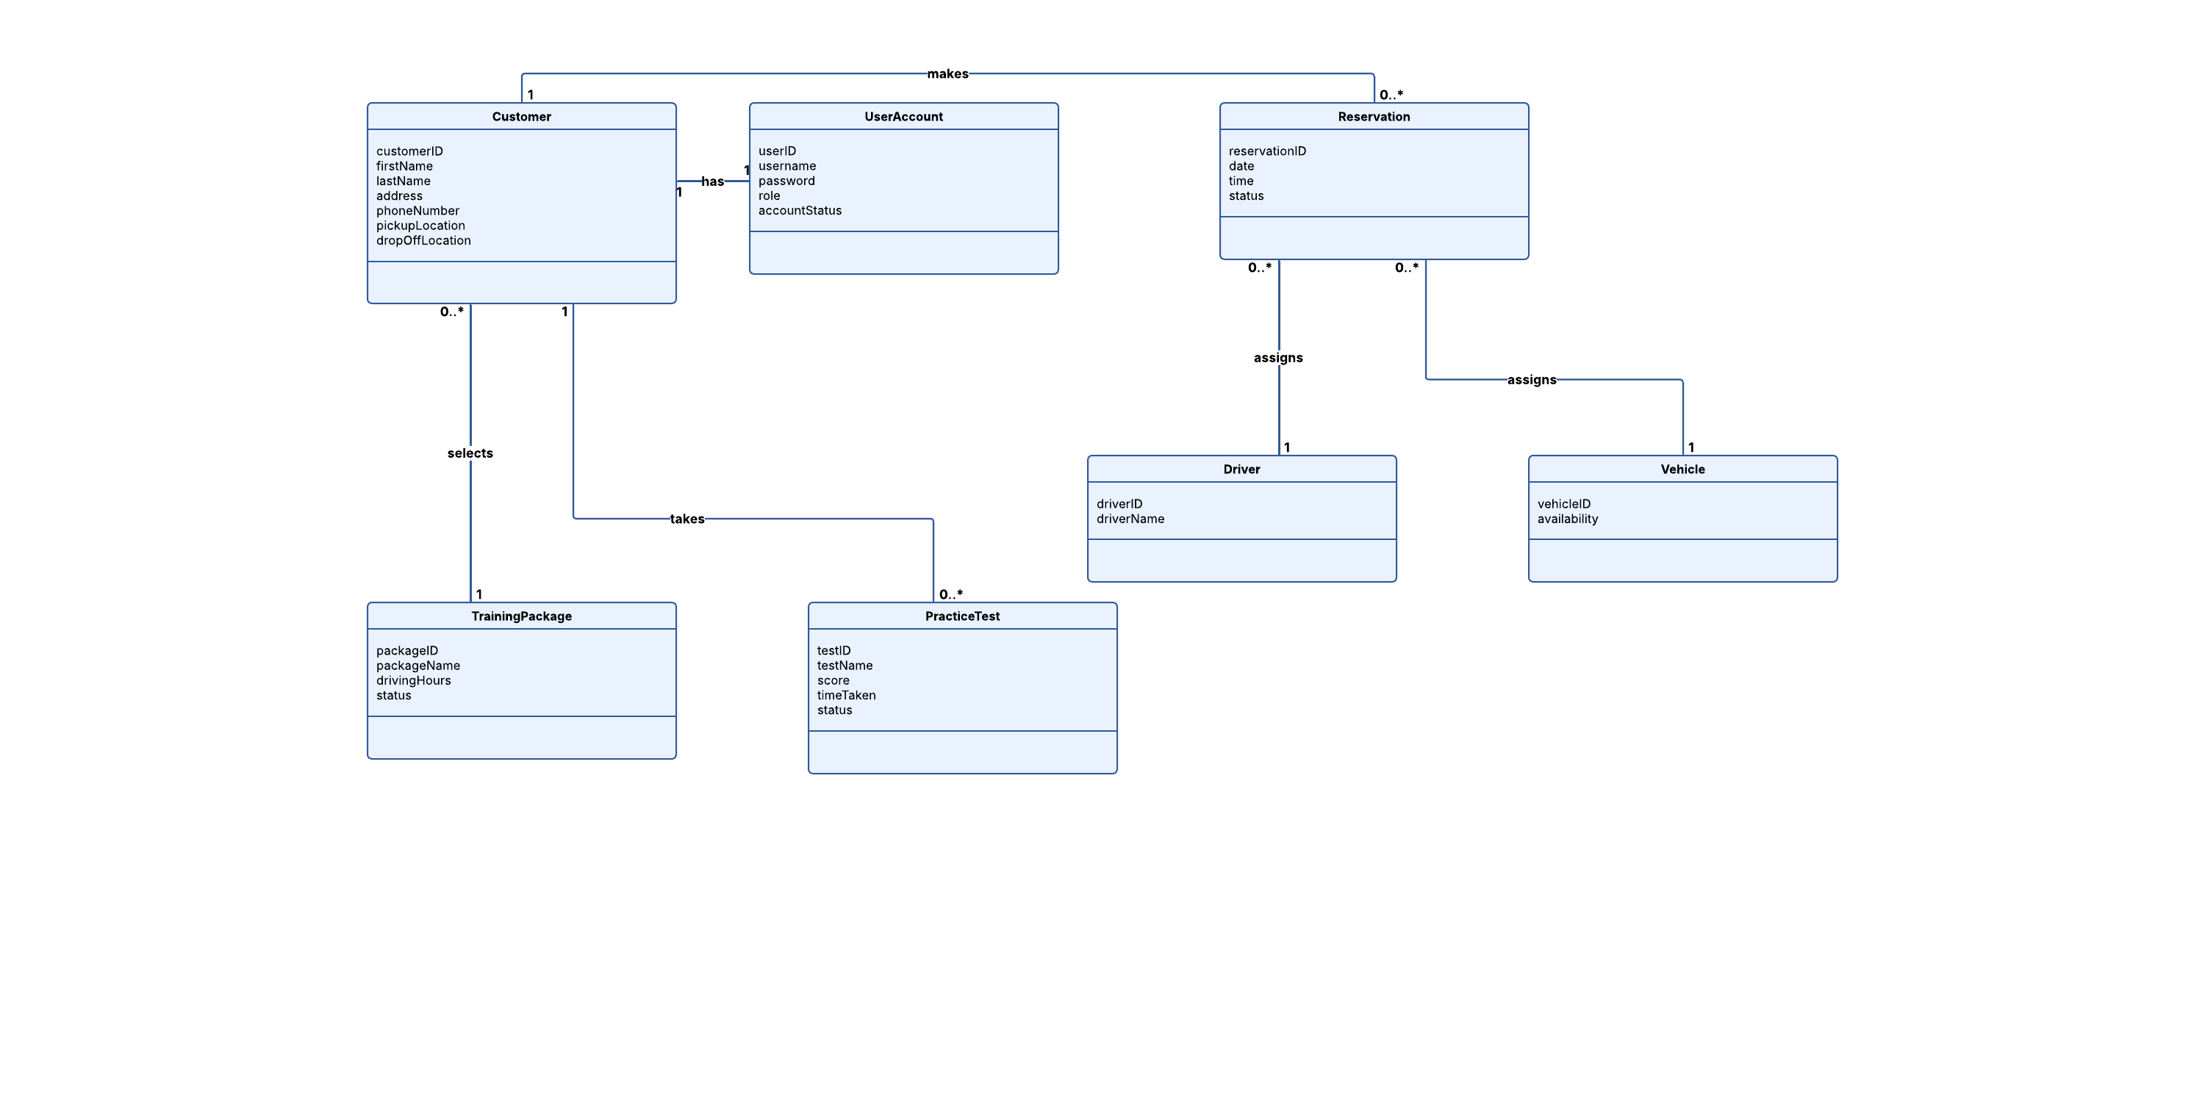

Technical Requirements
The DriverPass system will be a web-based system that can be accessed from computers and mobile devices with an internet connection. Customers and employees will not need specialized hardware, but they will need a computer, tablet, or smartphone with a modern web browser. DriverPass will also need printers for printing reports and other business information when needed.
The system should use cloud-based servers to host the website, application, and database. The cloud environment should provide backups, system availability, and security so DriverPass does not have to maintain its own servers. The database will store customer information, user accounts, reservations, driver and vehicle information, training packages, practice test results, and activity records.
The software will need to support different user roles and permissions. Customers will be able to manage their accounts, schedule or change driving lessons, and access online training. Employees will have access based on their responsibilities, while the IT officer will have greater access for maintaining accounts, resetting passwords, and blocking access when necessary. The system should also keep activity records showing who created, modified, or canceled reservations.
The system will also need a connection to the DMV so DriverPass can receive updated rules, policies, and sample test questions. The system should notify DriverPass when updated information is available. Security should include secure user authentication, password protection, role-based access, encrypted connections, regular cloud backups, and protection of customer information. DriverPass will need reliable internet access because changes to system data should be made while connected to help prevent duplicate or inconsistent information.

