Monique Manual
Monophonic Unique Synthesizer
Intro
Monique is a monophonic, subtractive synthesizer designed to create unique sounds like basses or leads and also with to scope to do it live on stage.
We tried to keep all important parameters every time accessible on a large, free scalable, multitouch compatible user interface. Also we've build in advanced options to adjust slider handling and speeds to your personal needs.
Tutorials you can find video cookbook: www.monique.monoplugs.com/videos. TODO-WEB
Tip
Most of the functions are explained in tool tips inside the application. To show the tool tips move the mouse over a button or slider and stay for one second. Alternatively you can use CTRL+H to force a tool tip or use the option “Help → Force show tool tip” in the context menu (right click on a slider), also if tool tips are disabled.
Naming conventions
Dials, sliders, rotary sliders, linear sliders or whatever, we always call it slider.
Gear Overview
3 oscillators + 1 FM oscillator modulated by an LFO
3 resonant filter (under the hood 3x3) (LowPass, HighPass, Band)
3 LFO's + 4 MFO's from 16/1th up to 1/128th (Sine and near to Square)
7 resonant band filters in a eq bank
20 Envelopes
1 Distortion effect
1 Chorus effect (5 delay lines, modulated by 5 LFO) (Panoramaable)
1 Delay effect (adjustable reflexion size from 1/1th up to 1/1024th) (Panoramaable)
1 Looper effect (adjustable record size ( 4/1th, 2/1th, 1/1th))
1 Reverb
1 Arpeggiator with 16 steps, shuffle

Table of Contents
TODO NOTES 3
- tutorials like in the virus access ti manual (1999 – very clean and easy one) 3
- last point is 6 at the moment 3
1User Interface 4
1.1Slider Concept (Front- and Back slider) 4
1.2Multitouch 4
1.3PopUps 4
2Sound Engine 5
2.1Oscillators 5
2.1.1Tune, Wave and Phase 5
2.1.2Key Sync (K-SNC) 5
2.1.3Sync (SYNC) 6
2.1.4Modulate Tune or Phase by a LFO (L-MOD) 6
2.1.5Frequency Modulation (FM) 6
2.1.6Further reading 6
2.2The FM Oscillator 7
2.3Filters 8
2.3.1Signal Flow, Input control 8
2.3.2Parameter: Filter Type 8
2.3.3Parameters: Cutoff and Resonance (CUTOFF, RESO) 8
2.3.4Parameter: Distortion (DIST) 9
2.3.5Parameter: Panorama (PAN) 9
2.3.6Parameter: Volume and its hidden Compression (VOL) 9
2.3.7The Modulation Mix, automate Parameters (MOD-MIX / X-MOD) 9
2.3.8Define the Modulation Mix 10
2.3.9Automate the Filter Inputs 10
2.4Amp Envelope 11
2.5Equalizer Bank (EQ) 11
2.6Effects (FX) 11
2.6.1 Distortion (DIST) 12
2.6.2Chorus (CHORU) 12
2.6.3Delay (DELAY, F-BACK, RFLEX) 12
2.6.4Looper (FILL, REL, SIZE) 12
2.6.5Reverb (REVERB, ROOM, WET) 12
2.7Master volume and another hidden Compression 12
2.8Envelope (ENV) 12
2.8.1Definition 12
2.9Moniques Envelopes 13
2.9.1Parameter: Retrigger (RETRIG) 13
2.9.2Parameter: Shape (SHAPE) 13
2.10Edit Envelopes 14
2.11LFO 14
2.11.1Parameter: Wave (WAVE) 15
2.11.2Parameter: Speed (SPEED) 15
2.11.3Parameter: Offset (OFFSET) 15
3The Arpeggiator 16
3.1Turn the Arpeggiator On/Off or force it On/Off! (ARP) 16
3.2Steps, Note, Velocity 16
3.3Parameter: Shuffle (SHUFL), Grid Offset (OFFSET)(left) 16
4Playback Parameters 16
4.1Note Glide, Velocity Glide (NOTE (GLIDE), VELO (GLIDE)) 16
4.2Speed, Sync, Fine Offset (OFFSET)(right) Speed Multiplyer 17
4.2.1Plugin Speed and Sync Implementation 17
4.2.2Standalone Speed and Sync Implementation 17
4.3Octave, Project Note, Reset (OCT, P-NOTE, RESET) 17
5Morphing. Think like a DJ, rock the stage live! 18
5.1Morph from exiting programs. Be a DJ. 18
5.2Evolute live. Be a Improviser and Designer. 19
5.3Automate Morphs. Be a Machine. (MFO) 19
5.4Morph Smoothing 20
5.5DragPad and Smoothing (SMOOTH) 20
5.6Option: Animate Morphs 20
5.7Morph Exceptions 20
5.8Parameter Group List 20
6Live jam? Monique as Loop Station (FILL, REL, SIZE) 21
7CTRL Mode 22
8SHIFT Mode 22
9Load and Save 22
9.1Programs 22
9.2Settings 22
10Audio Devices 22
11Context Menu Items 22
12 MIDI mapping 22
13Automation Parameter 22
14Color Themes 22
15 Shortcuts 22
16Workarounds 22

TODO NOTES
- tutorials like in the virus access ti manual (1999 – very clean and easy one)
- last point is 6 at the moment

User Interface

Slider Concept (Front- and Back slider)
Monique comes with an dual slider concept to bundle interactive or similar parameters at the same place. To have the slider control area as large as possible it is not possible to control both parameters at the same time – you have to switch between the front and back slider by clicking the button below a slider (a button directly under a slider it is always and only a front-back slider switch).
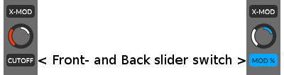

Keyboard shortcut: SHIFT
Also you can take a look at the MIDI mapping (TODO-LINK).

Multitouch

PopUps

Sound Engine
Moniques sound engine basically has 3 oscillators, 3 filters, an equalizer bank, build out of 7 resonant band filters and a few effects. But under the hood is much more you should know.

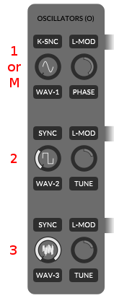
Oscillators
Three oscillators continuously pulsing in Moniques body and cant wait to spread there digital live into your ears.

Tune, Wave and Phase
The first one is known as the master oscillator and is always tuned to the currently playing note (also called: root note). The second and third one can be detuned to the master oscillator or rather to the root note by using the tune slider.
Range: -24 / +24 semitones or 4 octaves in the sum.
Handling: use the mouse wheel to adjust whole semitones

The wave form of each oscillator can be changed by moving the left wave slider. The little graphic on the slider will show you the current wave which can be build/morph out of a sine and square, square and saw or saw and noise.
Waveforms: Sine-Square, Square-Saw, Saw-Noise (white)
Handling: use the mouse wheel to switch to the next clean wave form

The master oscillator comes with a phase shift option instead of the detune option of the third and second one. Phase shift will move the master oscillator cycle on the time axis. The phase option does makes the most sense if you like to let work the master oscillator against oscillator two or/and three. But you can also use it in combination with the K-SNC option (point below).
Max Phase shift: one complete cycle.

Key Sync (K-SNC)
Be Moniques pacemaker and keep her hearts in sync with your fingers.
By default Moniques oscillators will never stop and generate a continuously, clean buzzing sound. Absolutely independent from the keys you hit on the keyboard.
But for example for percussive sounds we do need a reproducible sound on each note on, every time and this a continuously wave can not provide. To generate such reproducible characteristics enable the Key Sync feature (K-SNC button) at the master oscillator to force a new wave cycle on each Note On for each oscillator.
Tip: enabled Key Sync and Phase Shifting can be the missing link for aggressive sounds

Sync (SYNC)
Oscillator two and three can be synced to the master oscillator by turning on the SYNC buttons.
If a oscillator is synced to the master the synced oscillator waits at the end of its own cycle to next cylce of the master oscillator to start its own new cycle.
Oscillator 2 is NOT synced (green).
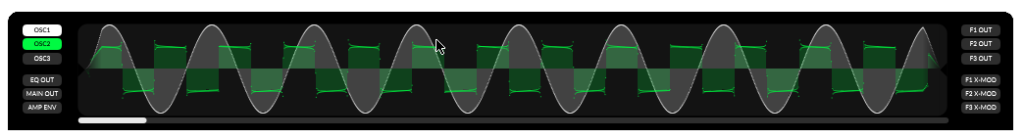
Oscillator 2 IS synced (orange).
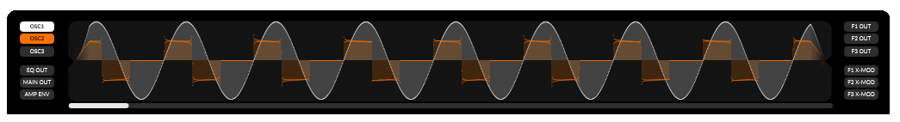

Modulate Tune or Phase by a LFO (L-MOD)
To automate the tune or phase shift parameter you can do this by enable the L-MOD button. The modulating LFO for the phase offset is LFO 1 (same row, filter 1). The tune of the second and third oscillator will be modulated by LFO 2 and 3. (see “How to adjust modulation amounts” TODO-LINK).

Frequency Modulation (FM)
The amount of the frequency modulation of each oscillator can be adjusted by the FM slider (back slider of the wave sliders (see “Backsliders” and “The FM Oscillator” TODO-LINK).

Further reading
FM TODO-LINK, Note Glide TODO-LINK, Oscilloscope

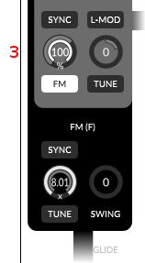
The FM Oscillator
The FM oscillator is a shapeable sine wave oscillator combined with an LFO for its swing option. You can not hear or route the FM oscillator directly to the output, but instead you can add it as subset to each oscillator with the FM slider of each oscillator (the FM Amount slider is the backslider of the oscillators wave slider – is set to 100% at oscillator 3 in the right graphic).
The adjustable tune of the FM oscillator depends on the tune of the master oscillator and can be 2.01 up to 8.01 times faster.
Just take a look at the two oscilloscope screens. The first one shows a clean, unmodulated saw wave. The second one shows the same oscillator with a maximum FM amount (the same settings like in the graphic right).
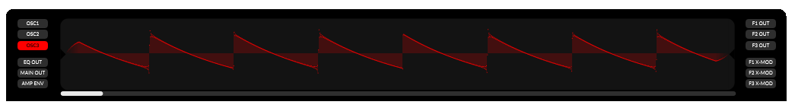
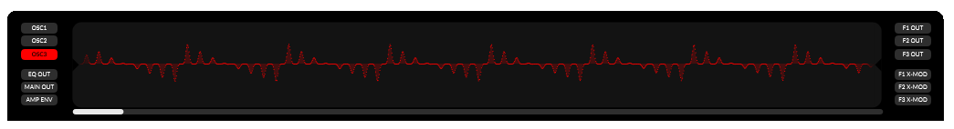
Also it is possible to sync the FM oscillator by turning on the SYNC button. The sync algorithm is the same as for “normal” oscillators. In sync the FM oscillator waits at the end of it's cycle for the next cycle of the master oscillator to start its own new cycle.
By the swing option you can rotate the FM oscillator around its own center.
Recommendation: open the oscilloscope (TODO-LINK) and select an oscillator you like to modulate. Go to the oscillator of your choice and set the FM amount to 50-75%. Now in the FM section you play around with the parameters and you can see what happens in detail.
Further reading: Sync TODO-LINK, oscilloscope TODO-LINK

Filters

Signal Flow, Input control
Each of the three main filters is build out of three single filters to have a own track for each oscillator.
The three tracks will be mixed into a stereo track at each filter output. Before the output mix you can route filtered oscillator signal to the next filter or filter below from UI view. To grab that signal from the next filter you have to move the input slider to the right (on the left you grab the oscillator signal directly).
At the sketch below we use the second oscillator as only input of filter 1 (blue line). Then we process the signal in filter 1 and grab it as only input for filter 2 before the pan effect of filter 1 (red line).
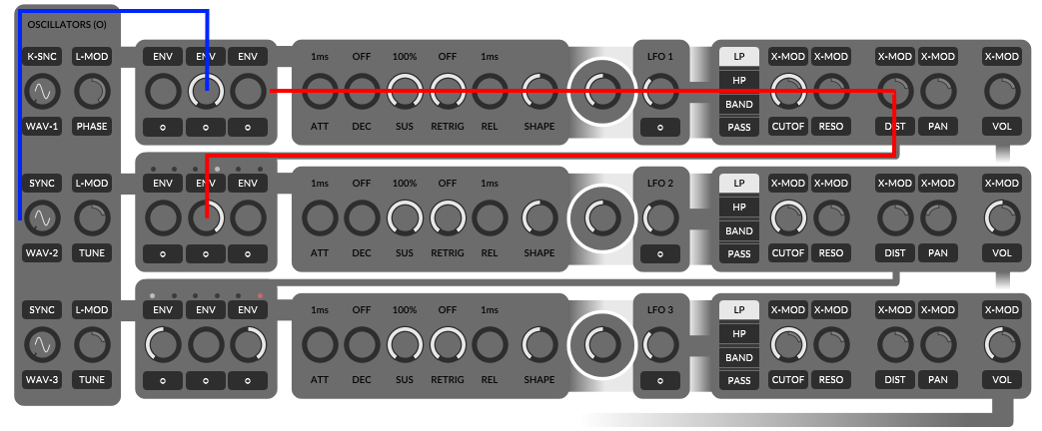
Also you can take a look at filter 3 (bottom one). There we use oscillator 1 as direct input, because the input slider is turned to the left. At input three we have an error or silent track, because we try to grab oscillator 3 processed through filter 2 (slider is on the right position), but filter 2 does only process oscillator 2 and not 3.
Further reading: Automate the Filter Inputs TODO-LINK

Parameter: Filter Type
Monique is a simple girl and the three basic filter types LowPass (LP), HighPass (HP) and BandPass (Band) are enough for her, because she's creative and knows about her routing possibilities.
EXAMPLES: TODO

Parameters: Cutoff and Resonance (CUTOFF, RESO)
The filter cutoff defines the edge frequency there the filter pass or rather remove frequencies from the signal.
Possible range: 35Hz up to 22000Hz
Resonance defines the gain of the edge frequency (cutoff).

Parameter: Distortion (DIST)
The filter distortion effect processes the signal after the filter itself.

Parameter: Panorama (PAN)
With the panorama effect you can control the arrangement of the filter output in a 2D stereo field.

Parameter: Volume and its hidden Compression (VOL)
With the volume you can control the output gain of the filter.
Also you should know that Monique automatically compresses signals with to much power and you can assume that a output volume greater 50% starts to compress the signal more and more by increasing the volume.
To visualize the compression: open the oscilloscope and select F1 OUT. At filter 1 set the input for oscillator 1 to maximum, set oscillators 1 wave form to sine and now play around with the filter 1 output and see what happen.
Another interesting experiment: same settings like before, but set all oscillators to saw and set all three inputs at filter 1 to max. Now play with the output volume and if you like with the distortion effect to.

The Modulation Mix, automate Parameters (MOD-MIX / X-MOD)
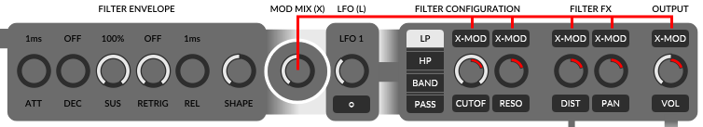
The modulation mix is a curve which will be created out of an envelope curve or/and a LFO wave and can be used to automate: Cutoff, Resonance, Distortion, Panorama and Volume.
To automate one of theses parameter by the modulation mix you have to turn on the modulation button (X-MOD) on top of the parameter slider. To adjust the maximum amount by which the modulation mix change the modulated parameter, switch to the modulation amount slider or back slider and adjust it (see Slider Concept TODO-INK).
As you see the modulation amount (MOD %) is defined in percent will have a relative result depending on the parameter value itself (front slider).
Let us calculate the modulation result quickly at an example: Distortion is set to 0, X-Mod is turned on and the modulation amount is set to 50 percent. This setup will result a distortion of 0 at the smallest amplitude of the modulation mix and a distortion of 50 at the largest amplitude of the mod-mix.
Now we set the distortion to 80 and keep the 50 percent mod-amount. This will result a distortion of 80 at the smallest mod-mix amplitude and a distortion of 90 at the largest possible mod-mix amplitude.

Define the Modulation Mix
After we know how we use the modulation mix for parameter automations we like to create complexer modulation mix curves to get a breeze of live to our sound.
In the middle, between Envelope parameters and LFO Monique provides the MOD MIX slider. Which define the amount of the envelope curve and the amount of the LFO wave in our final modulation mix, which we can use for automations. On the absolute left position of the MOD MIX slider we only use the envelope curve as modulator signal (graphic below), on the right only the LFO and in the middle a fifty fifty mix of both.
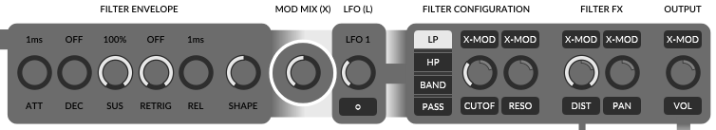
When should I use the LFO and when the envelope? This is up to you, but you should know that Moniques envelopes are always time based (in milliseconds) and LFO's are always synced to your projects speed and match to musically note durations. So if you like to create exact rythmic sounds you should use LFO's. If your sound should be always free and not depend on your projects speed you should use time based curves: the envelope.
Further reading: Envelopes, LFO TODO-LINK

Automate the Filter Inputs
To complete the filter part we have to talk about the ENV buttons on top of the filter input sliders to automate the inputs.
The basic concept to automate the inputs is the same like for all automations: turn on the top button will turn on the automation, but in this case it will change the effect of the input slider itself. If the automation is turned OFF, the input slider defines a fixed input amount of an oscillator (see: Signal Flow, Input control TODO-LINK). If the automation is turned ON, the input slider defines the modulation amount or the maximum power of the amplitude (for example: like the modulation slider for cutoff (please read the point before if you haven't yet)).
The envelope curve you can edit by click the bottom with the little cycle “o”. A pop up will open, please read: Filter, Amp and Envelopes in PopUps TODO-LINK.
Further reading: Envelopes, Filter, Amp and Envelopes in PopUps TODO-LINK

Amp Envelope
The working place of the amp envelope is before the EQ bank, after the output mix of the three main filters. That means, that the amp envelope controls the gain of the mixed filter signals.
Further reading: Envelopes TODO-LINK

Equalizer Bank (EQ)
The seven band filters in the equalizer bank will help you to improve the fine details of the sound you have created before in the main filter section. The complete bank is bypassable with the mix slider on the right. Also you can control the resonance of the all filters by one slider, which you can find as backslider of the mix slider.
Thats not all, all band gains are automatable by an own envelope. This follow the same concept which we already learned here: Automate the Filter Inputs TODO-LINK.
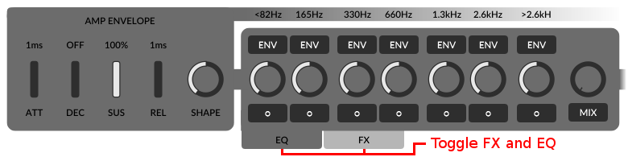
By default you will see the FX section instead of the EQ bank. To toggle between FX and EQ with you can use the two little tab buttons (see red makers on the screen above).
Further reading: Automate the Filter Inputs TODO-LINK, Envelopes TODO-LINK

Effects (FX)
After the EQ bank it's time to send your sound through a panoramaable and bypassable effect chain. First of all we have a distortion, followed by a chorus and a delay bundled with a second buffer for a basic looper effect. At the end of the chain you can round up the signal with a reverb or bypass all effects with the mix slider.
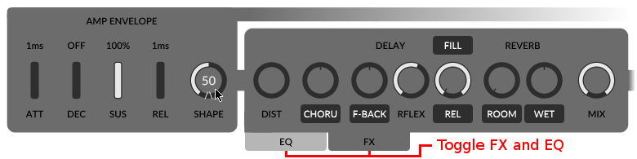

Distortion (DIST)
The distortion effect you can use to gain and destroy your signal.

Chorus (CHORU)
Five delay lines modulated by five oscillators are Moniques chorus effect. The chorus is arrangeable in the panorama by using the backslider of the chorus.

Delay (DELAY, F-BACK, RFLEX)
With an adjustable reflection size comes Moniques delay and like the LFO's the size is synced to the your current project speed. To arrange the delay effect in the panorama you can use the backslider of F-BACK.

Looper (FILL, REL, SIZE)
The Looper has an own chapter: Looper TODO-LINK

Reverb (REVERB, ROOM, WET)
Last but not least the reverb effect. Three parameters to control the effect itself: room, width and wet. The panorama arrangement you can adjust with the backslider of the wet one.

Master volume and another hidden Compression

Envelope (ENV)

Definition
For the beginners the Wikipedia definition for an ADSR envelope:
https://en.wikipedia.org/wiki/Synthesizer#ADSR_envelope
“When an acoustic musical instrument produces sound, the loudness and spectral content of the sound change over time in ways that vary from instrument to instrument. The "attack" and "decay" of a sound have a great effect on the instrument's sonic character. Most often this is an "ADSR" (Attack Decay Sustain Release) envelope, which may be applied to overall amplitude control, filter frequency, etc. The envelope may be a discrete circuit or module, or implemented in software. The contour of an ADSR envelope is specified using four parameters:
- Attack time is the time taken for initial run-up of level from nil to peak, beginning when the key is first pressed.
- Decay time is the time taken for the subsequent run down from the attack level to the designated sustain level.
- Sustain level is the level during the main sequence of the sound's duration, until the key is released.
- Release time is the time taken for the level to decay from the sustain level to zero after the key is released.”

Moniques Envelopes
Moniques envelopes are ADSR envelopes like the definition above and we add two additional parameters: Retrigger and Shape.
- Good to know: Envelopes in Monique are always absolute time based in milliseconds. LFOs instead are synced to note duration and depend on your project speed.

Parameter: Retrigger (RETRIG)
Retrigger define the duration after which the envelope will be restarted. The retrigger timer starts after reaching the sustain level. Take a look at the two oscilloscope screens. The first one shows an standard ADSR envelope and the second one shows the same envelope with retigger.
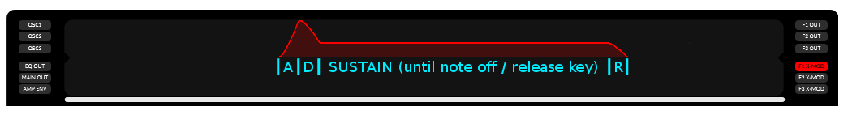
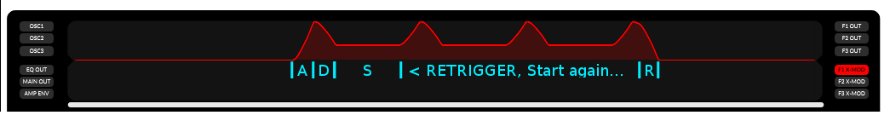

Parameter: Shape (SHAPE)
Moniques Envelope curves are not linear. With the shape parameter you can define the slope of the curve. The nearest to linear slope is at the center of the shape parameter range, about 50. Please take a look at the oscilloscope screens, the first one shows a envelope curve with the shape parameter at zero. At the second one the shape parameter is set to zero and the third screen shows the same curve again with a shape value of 100.
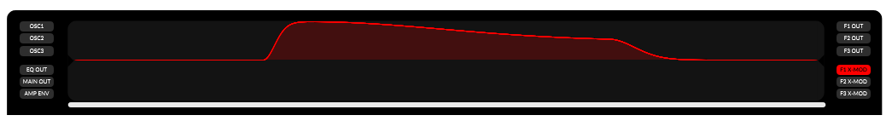
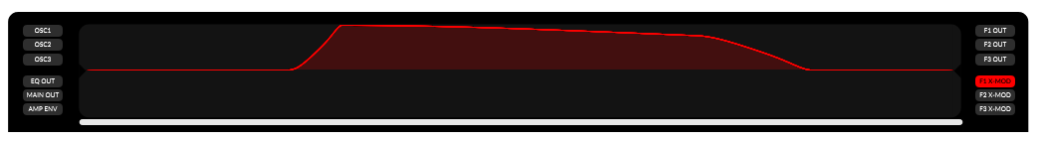
Further reading: Filter, Amp and Envelopes in PopUps TODO-LINK

Edit Envelopes
All of Moniques twenty envelopes working identically, just the retrigger parameter you'll miss at the amp envelope, because this should be done by note on's or/and note off's.
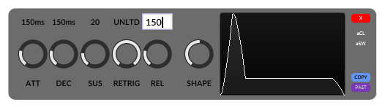

If you edit an envelope in a popup you have a little preview screen on the right (see screen above). If you edit one of the filter- or the amp envelope you can use the oscilloscope to visualize your settings in real time.
To edit envelope parameters via keyboard you can click the label on top of the slider and just enter the value in milliseconds you like.
If you don't like the linear sliders, we have build in the option to only use rotary sliders. Just open the context menu and toggle the entry “GLOBAL SLIDER HANDLING → LINEAR SLIDER HANDLING → Only use linear sliders”.
Further reading: Context Menu Items TODO-LINK, Automate the Filter Inputs TODO-LINK, MIDI mapping TODO-LINK, LFO TODO-LINK

LFO
Moniques low frequency oscillators (LFO) you can use to automate parameters by a sine or near to square wave. Monique has a LFO bundled in each filer and four LFOs driving the morph automations.
- Good to know: LFOs in Monique are always synced to note duration and depend on your project speed. Envelopes instead are absolute time based in milliseconds.
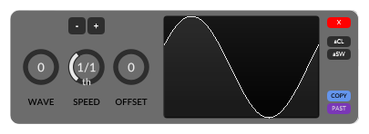

Parameter: Wave (WAVE)
Transform the the sine wave to a square wave (near to square, it will be never a perfect square wave).

Parameter: Speed (SPEED)
Adjust the LFO cycle duration in common note durations.
Range: 16/1th to 1/128th

Parameter: Offset (OFFSET)
With the offset parameter you can move the LFO cycle in the time line with an maximum of one complete cycle (current speed).
Further reading: Define the Modulation Mix TODO-LINK, Morph TODO-LINK, MIDI mapping TODO-LINK

The Arpeggiator
Monique has also build in a one pattern sixteen step sequencer to create arpeggios on the fly.
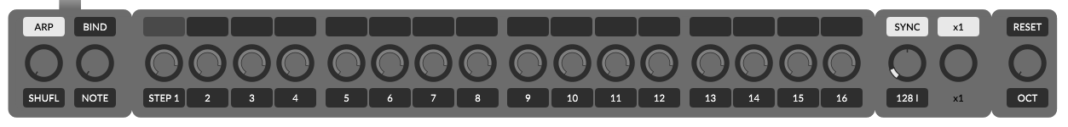

Turn the Arpeggiator On/Off or force it On/Off! (ARP)
The ARP button turns the arpeggiator on or off.
If the mouse is over the ARP button a pop up will rise and you can force the arpeggiator to be always on or off and ignoring the program settings. This might be helpful if you send notes to Monique during you switch through your Monique patches and some of them are stored with arpeggiator on and some with off.

Steps, Note, Velocity
In the middle you have 16 steps, splitted in four 4 step groups. By the top button of each step you can enable that step to trigger a note at this position in the bar. The slider below, the note value offset slider defines the note for this step as offset to the current playing note, the root note in semi tones. As backslider of the note offset slider you'll find the velocity slider which defines the velocity value or volume of this step.

Parameter: Shuffle (SHUFL), Grid Offset (OFFSET)(left)
Increasing the shuffle value will enlarge the duration of each first step and moves every second step by this increasement into the future and shrink the duration to match in the leftover space. Just play around, you will hear and see what you do.
By changing the grid offset, the back slider of shuffle, you can move all the steps in the pattern to the right. This can be useful if you have already a project and a nice pattern, but it does not match from the view of the step positions – then you can try to find a better position in the grid or one bar.

Playback Parameters
The following Parameters are beside the arpeggiator, but they does also work on each note you send from keyboard or rather via MIDI.

Note Glide, Velocity Glide (NOTE (GLIDE), VELO (GLIDE))
Note- and velocity glide are very similar parameters. With both you define the time in milliseconds how long a value change should take.
Velocity glide is the back slider of note glide.

Speed, Sync, Fine Offset (OFFSET)(right) Speed Multiplyer
With the speed slider, right of the arpeggiator you can adjust Moniques internal clock speed and the sync button above let run Monique as synced slave or master with own internal clock.

Plugin Speed and Sync Implementation
If you run the plugin, Moniques internal clock speed has only a influence if you disable sync.
If sync is disabled Monique ignores the host speed and runs absolutely independently at the defined speed. This can be useful if your current DAW speed does not match to the speed in which Moniques current program is designed and you like to get the original feel or if you like to do some experimental out of beat stuff.
If sync is enabled, Monique runs in sync with the host DAW → this is the recommended, default and common way.

Standalone Speed and Sync Implementation
If you drive Monique as MIDI clock slave (see: MIDI sync TODO-LINK) the size of the looper- and delay buffer depends on the internal clock speed, because the midi clock is not exact enough to set/keep the correct buffer size. All other things like LFOs stay in sync to the incoming clock as expected.
If Monique does not receive a clock, the sync function has no effect.

Octave, Project Note, Reset (OCT, P-NOTE, RESET)
With the octave offset you can pitch the root note by -2 up +2 octaves.
Project note is the back slider of octave offset and is more a helper as a real parameter. If you design a sound on E instead of C you can adjust the project note to E and you'll never forget for which note this sound may be especially was created. Also you will now see the E key marked on Moniques keyboard.
By pushing the reset button you'll send a short note on with the value of the project note to trigger the arpeggiator without keyboard.

Morphing. Think like a DJ, rock the stage live!
The morphing features of Monique are one or that features we have the most fun with by ourself. It reminds us to the record case of an DJ and a mixing desktop with 4 turntable pairs. Each of our turntable pairs has a own job. One of them mixes out of two records new oscillator values, one out of two new filter values the next one new arpeggiator values and the fourth one mixes new FX and EQ values.
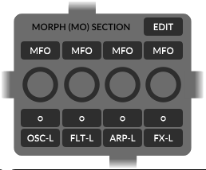

There are two basic ways to put the records on the turntables. One is to edit it manually, may be as a copy or evolution of the current state and the other one is to take a record out of our box of well known records.

Morph from exiting programs. Be a DJ.
We start like a DJ would, we take a well known program from our hard disk and put it on Moniques morphtable.
Let us start to mix new filer values. This is a tutorial, please open Monique and follow me.
First we load the factory default program: “AMBIENT 2”. At the morph mixer we disable all buttons and turn all sliders to the absolute left (0) to prepare our experiment (graphic above) .
Then we open our record case, the morph editor by hit the EDIT button in the morph mixer . From the morph editor we can load any program we have onto any of the 8 morphtables we like – the left or right one of one of the four morphtable pairs, which we like to call morph group now.
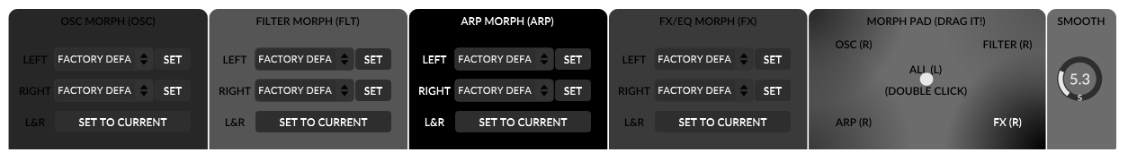
Now we go to the morph editor and in the FILTER MORPH group we load the program “TZZZ” from the RIGHT drop down box to the right table. Back to the morph mixer we turn the filter morph slider (FLT) slowly to the right. The changes in the sound we can hear is a mix out of the states we have on the left table and the new states we load onto the right table. When we reach the absolute right of the filter morph slider we have morphed all slider positions to the right program states (“TZZZ”). To also load button states we can toggle the FLT-L or rather FLT-R button in the morph mixer to switch between left and right table (some exceptions later in the text).
Yes, its the same routine to mix oscillator states, arpeggio or FX/EQ states.

Evolute live. Be a Improviser and Designer.
Lets go on like a real live artist. Let us evolute our records live on the concept we have learned before and update our records live.
Let us create new Filter and FX mixes. This is a tutorial, please open Monique and follow me.
Let us load the program “IMPROVISER”. Then we turn all morph sliders in the morph mixer to the left and disable all buttons. Then we go to the morph editor and press the button “SET TO CURRENT” at the bottom of all four groups. This will update all records to the current program states, if you drag any morph slider now nothing should happen (should not change the sound).
Now let us set all morph sliders to the absolute right – 100 and not 99.9 or something, this is important and makes our live more easy when we edit live (later more).
Ok, let us evolute the current sound a bit. Set the OSC 2 input at filter 2 to -100 – yes, this we can hear. Now you can play around with the filter morph slider and switch between old and new record states. Set the filter morph back to the right. Now set the FX DIST value to 50 and FX reverb WET value to 50. This adds some cool effects to the sound. Play around with the filter- and fx morph sliders – back to the right.
We like to evolute our sound, so lets go back to the morph editor and hit the “SET TO CURRENT” button in the filter group again. Turn the filter morph slider to the left, then turn the OSC 3 input at filter 3 to -100. Play around with the FX- and filter morph slider...
I believe you got it?
If you like you can watch this video, I'll evolute IMPROVISER live. TODO-VIDEO
Also you should go on with the next part. Automations will help you to keep the sound interesting during you evolute another group.

One open thing, why to set the morph slider to absolute right or left if you edit? You have to know that you always update the left or/and right record if you change a slider or button on the user interface. If you change a slider on the user interface, somewhere in the filter section and the filter morph slider in the morph mixer is for example at 25, Monique has to update the left and the right record to get the current value as mix out of two. And exactly this can be a problem, may be Monique has to update the left and right to a very similar value and this is may be not what you want. But if the morph slider is absolutely left or right then Monique has only to set the left or right value instead of calculating two new values to get the current mix.

Automate Morphs. Be a Machine. (MFO)
Each morph group has its own LFO to automate the morph mix. Just enable the MFO button on top of the group you like to automate. The LFO parameters you can edit in the LFO edit pop up which you can open by hit “o” button.
Note, not all parameters are morphed by an automation. For example buttons you have to switch manually. LFO and ENV parameters are not automateable too (except Sustain).
To get an idea you can load the program SNAP STEP, this one it completely automated.
Further Reading: LFO TODO-LINK

Morph Smoothing
If you drag one of the morph sliders the resulting parameter changes are smoothed by the glide motor time.
Further Reading: Glide Motor Time TODO-LINK

DragPad and Smoothing (SMOOTH)
In the morph editor you can find the morph drag pad. The drag pad is just another way to control the morph mix states. It works has the same function like morph slider in the morph mixer. But on the right you can define the morph smooth time, which control the delay on your input.
This is a good tool to make slow changes without spending our focus on the slow change itself – multitasking away, we can use the time to do some other stuff :-)

Option: Animate Morphs
If you don't like the default morph animations you can turn it off in the setup or context menu.
Further Reading: Context Menu TODO-LINK, Setup TODO-LINK.

Morph Exceptions
LFO's are not morphable like other sliders, LFO's can only be morphed by the button toggle like you toggle or rather morph button states.
TODO – there are more

Parameter Group List
An overview of parameters, in which group they are. Is a parameter automateable and in by which kind will it morphed, toggle or float morph.
TODO

Live jam? Monique as Loop Station (FILL, REL, SIZE)
A simple, four bars long loop function Monique has build in. Right of the delay effect you can find the top button FILL, the release slider (REL) and the fill size slider (SIZE).
The loop function is easy to use. To record or fill the loop buffer you have to enable the fill button. This will write the signal after the delay effect into the loop buffer and add mix the output of the loop buffer to the signal after the delay effect.
Also very important to know: the fill function has always a fade in and fade out time if you turn that on or off. This time is the global smooth time which you can adjust in the context menu.
What does the release slider adjust? First you have to know that the record buffer works like a delay and the signal in the buffer will be overdubbed each time. If you set the release slider to 50%, then the signal will be written into the buffer with a loudness of 50. So you will hear it next time with 50% of the original and the time after with only 25% and so on. Only if you set it to 100% you have in theory a clean, endless record.
By the size slider, which is the back slider of the release slider you can adjust in which of the four bars of the loop buffer you like to write the signal. By default the slider is set to 1/1th and rthat means that you write in all the four bars of the buffer. If you set it to 2/1th you will only write in every second buffer and 4/1 will only write in the first buffer. This you can use to make your patter more interesting as a one bar long one.
Note that we do NOT record the reverb effect, but the reverb effect will be process the loop output together with the delay output.
To clear the buffer you have to hold down the fill button more than 3 seconds. The buffer will be also cleared if you hit the program init button. To chancel the automatic buffer clear you can hit the init button again or press the fill button.
Further Reading: Context menu global smooth time TODO-LINK

CTRL Mode

SHIFT Mode

Load and Save

Programs

Settings

Audio Devices

Context Menu Items
To open the context menu right click on any slider on the user interface....

MIDI mapping

Automation Parameter

Color Themes

Shortcuts

Workarounds
- vst load hack

