

FTCC SOCIAL

Data Dictionary



*Lorem ipsum dolor sit amet*

# Images

- - - - X

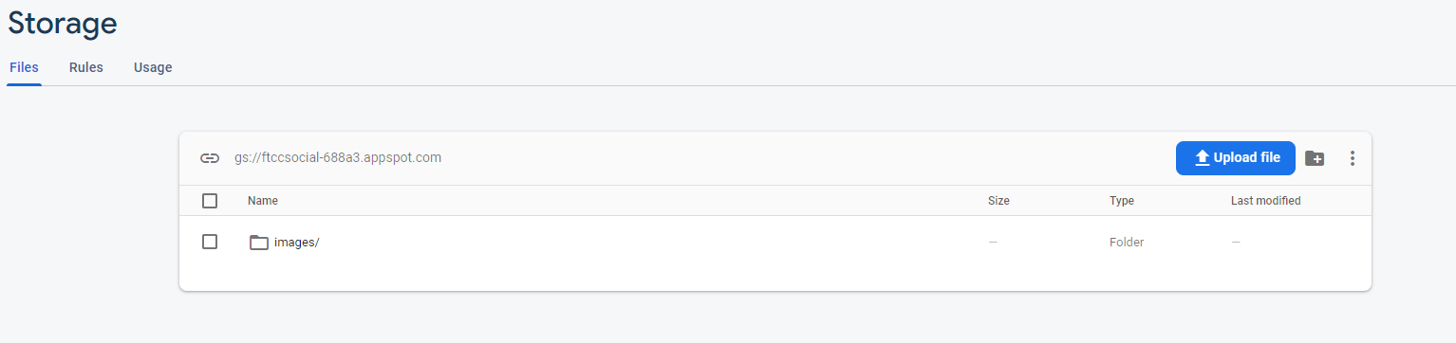

Here we have been focusing our data on what people post and the information that comes with each post. As you can see here we have a folder for images itself. If you dig deeper you see each post.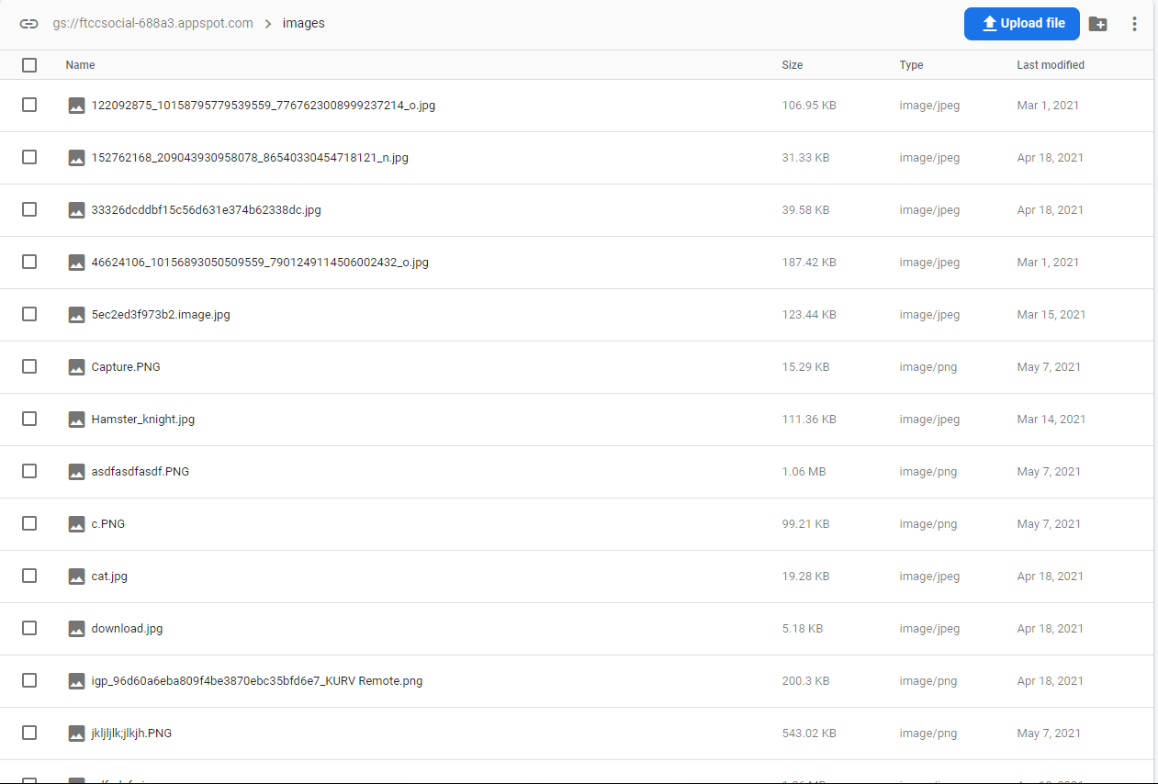With each of these posts, we can see the image and we can see the date, time and name of each post. Not only do we see the information on the post, if we click on the image we can retrieve more information

“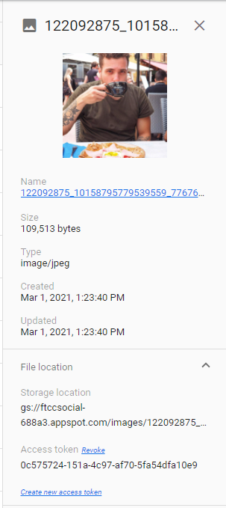

Not all roots are buried down in the ground, some are at the top of a tree.

-James Moen

”

# Going DeeperPlaceholder image

- - - - X

If you see here, you may also be wondering where we keep the information of the students and teachers that join. If you continue to scroll down below we will display images of what it looks like having the user information. Each user is protected by security hashes.



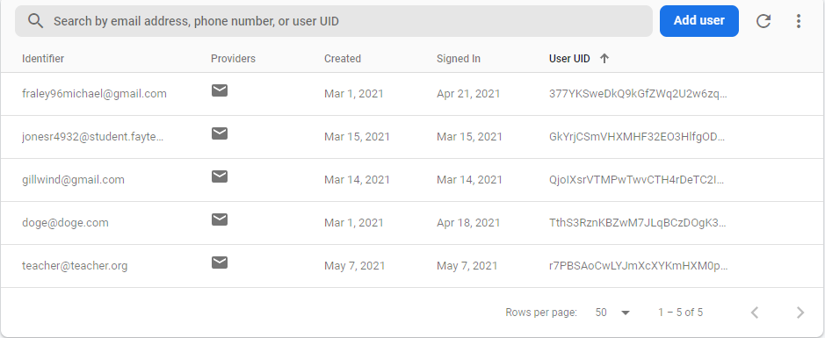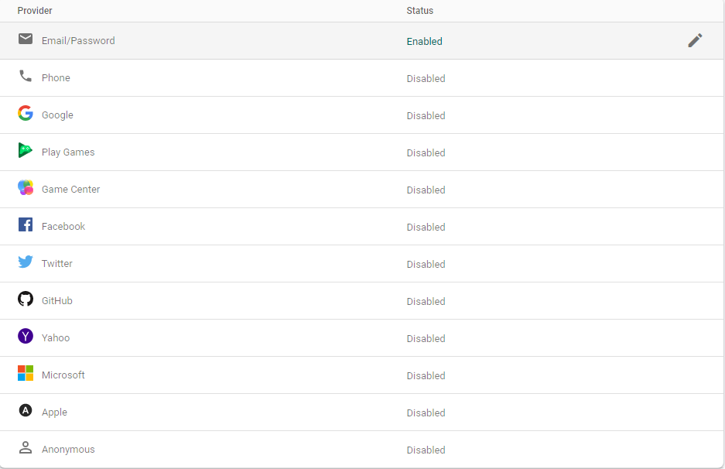

*CHOOSE HOW YOU SIGN IN*