**FTCC Social**

Proposal

May, 07, 2021

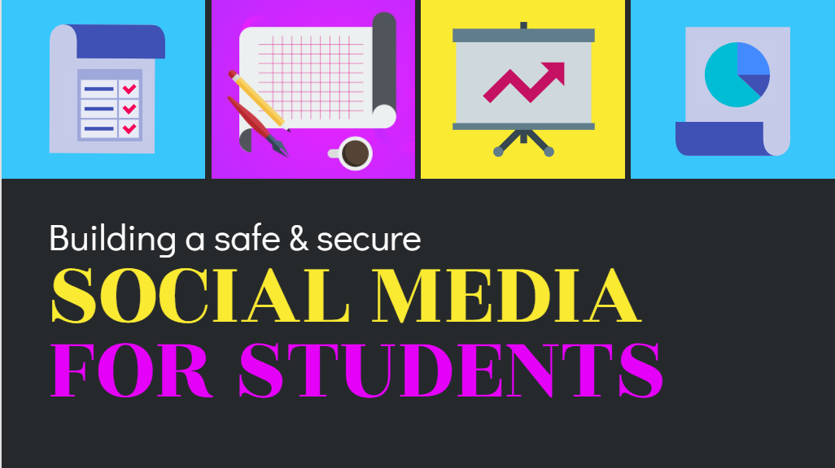

# Building a safe and secure social media

It is time to build a secure social media platform that allows us to push information such as class details, scholarships, and more information on what is going on in school. If we were to develop our own social media platform, the amount of big data we will receive will help us understand where are students are at and we can help push useful information to them

|  |
| --- |
| Watch our launch video |

# Lorem ipsum dolor sit

by **Jude Parker**

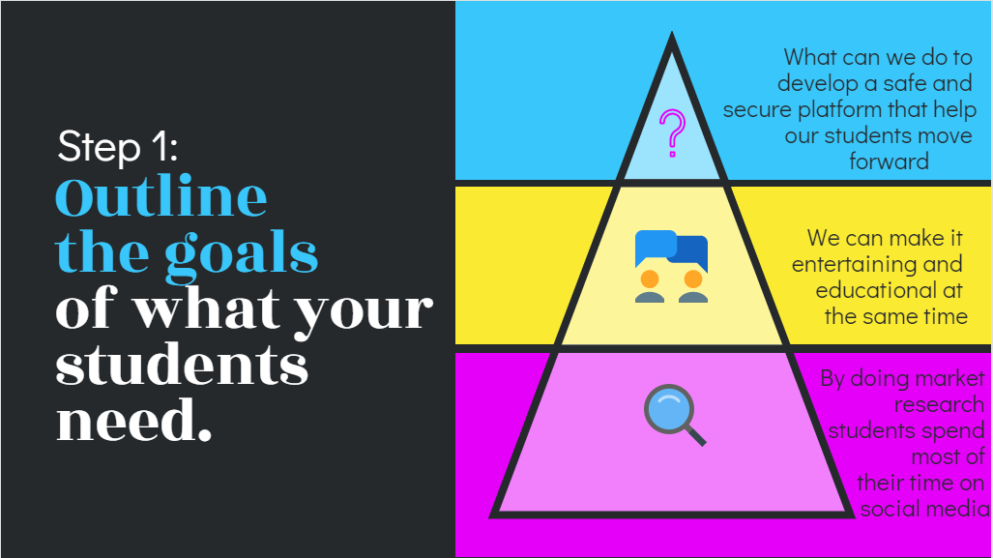

## It is time for us to outline a goal for our students

By outlining our goals for what we want to see and do for our students we really can change the equation that the students are given and really show them a more interactive way to learn and be involved with the ftcc community. Allowing us to push more scholarships and opportunities to our students and faculty.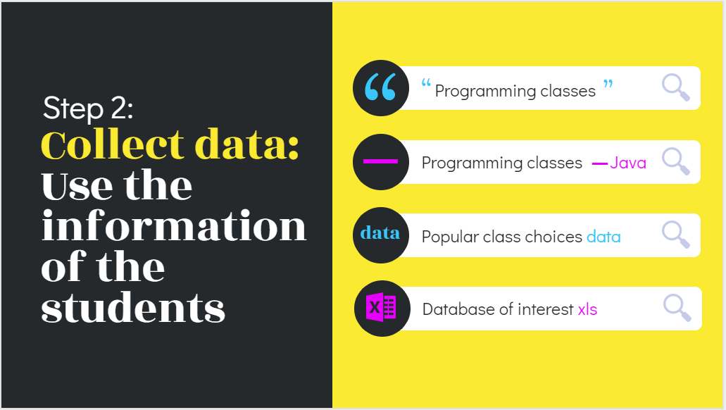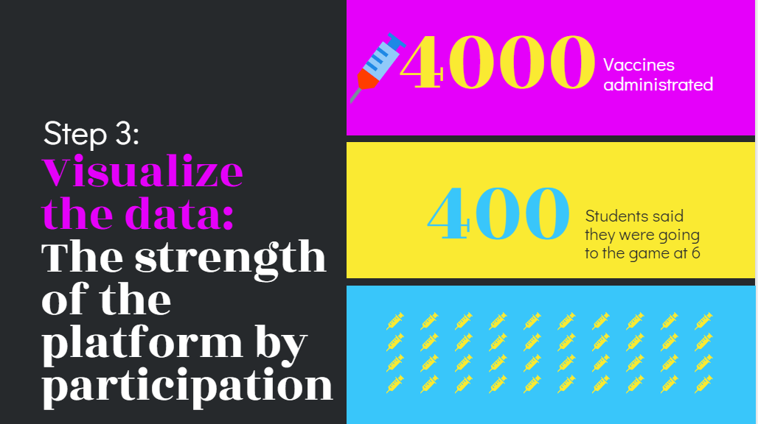

[Read more on our website](https://ftccsocial-688a3.web.app/)

With all this big data we can really make a change to the way students perceive education and form a better way to reach out to teachers

© FTCC SOCIAL

3821 FtccSocial Rd, Fayetteville, NC 28311