**BIO-DATA**

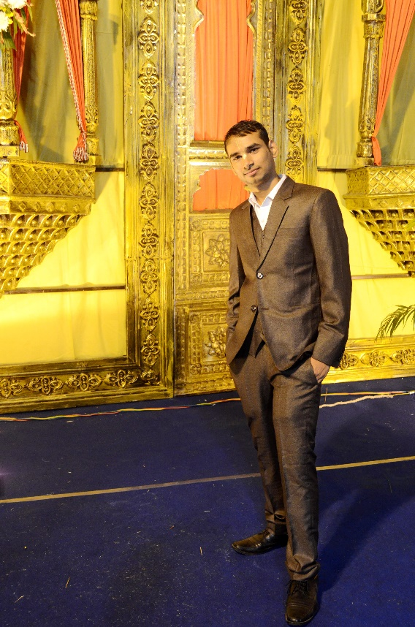**Personal details**

Name: Dr. Surendra Verma (Ph.D)

Date of Birth: 25-01-1993

Time of Birth: 9: 30 PM

Height: 165cm or 5’4’’

Caste: SC, Tantway Kori

Rashi: Aquarius

Manglik: Non-Manglik

Languages: English, Hindi

Hobbies: Cooking, Chanting, Book Reading, Learning new things, Gardening, Listening Kirtans, Travelling

Current Address: Toronto, Canada

**Family details**

Father: Suraj Ram (Income Tax officer, Gwalior)

Mother: Ram Kumari (Home Maker)

Eider Sister: Archana Arya Verma (B.Sc and B.Ed)

Brother-in-law: Dr. Jitendra Arya (Ph.D., Assistant Professor, Mechanical Dept., BU, Jhansi)

Eider Brother: Chandra Shekhar Arya (B.E, selected and about to join Govt. job in New Delhi)

Sister-in-law: Shradha Kori (BSc, BTC, UPTET)

Permanent Address: 1153, Babulal Ka Bagicha, Khusipura, Jhansi (UP)

Native Place: Village Bansar, Post Bijna (Jhansi)

Father’ Gotra: Kargainya

Mother’s Gotra: Garouthiya

**Education**

10th and 12th from CBSE board with 77% and 75%, respectively

(2008 and 2010)

Dual (B.Tech + M.Tech) with 7 CGPA and Ph.D. with 8 CGPA in Aerospace Engineering, IIT Kharagpur, West-Bengal, India

(July 10 – Dec 21)

**Work experience**

Assistant Professor at Punjab Engineering College, Chandigarh (July 22 – 31 Nov 22)

Post-Doctoral research fellow in Mechanical Engineering at Ryerson University, Toronto, Canada

(1 Dec 22 - Present)

**Anything else you would like to mention about yourself:**

I am a soft-spoken and kind-hearted person. I love cooking, listening to kirtans, lectures, book readings, and travelling. My father and mother, and brother and brother’s wife (bhabhi) all are also connected to ISKCON Jhansi and doing regularly chanting. We are agricultural based family. Simple living with spiritual goal is what I follow in my live. In future, I will be taking care of my family members (including future wife parents).

**Looking for**

Non-Drinking, Non-Smoking, Pure Vegetarian Girl having deep faith in Indian culture. She should be religious.

**Contact details for more information:**

+91 7719718193 (Abha, Sister), +91 6266739918 (Suraj Ram, Father), +91 8436929997 (Surendra, Self)