**BIO-DATA**

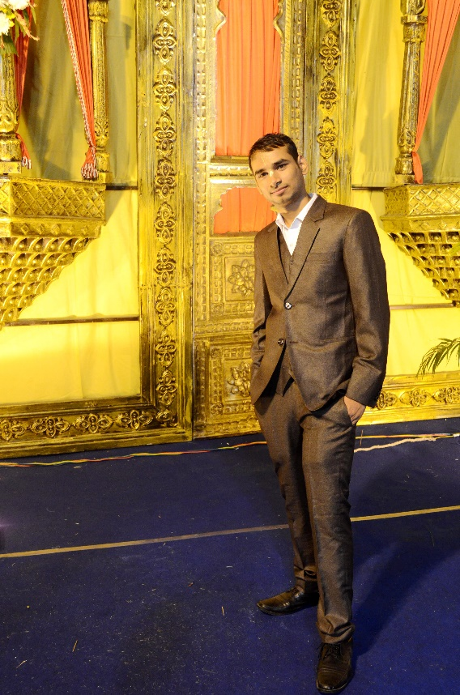**Personal details**

Name: Dr. Surendra Verma (PhD)

Date of Birth: 25-01-1993

Height: 165cm or 5’4’’

Caste: SC, Kori (Mahawar)

Color: Fair

Languages: English, Hindi

Hobbies: Cooking, Book Reading, Learning new things, Gardening, Listening Kirtans, Travelling

Current Address: Toronto, Canada

**Family details**

Father: Suraj Ram (Income Tax officer, Gwalior)

Mother: Ram Kumari (Home Maker)

Eider Sister: Archana Arya Verma (B.Sc and B.Ed, Married)

Eider Brother: Chandra Shekhar Arya (B.E, Married)

Permanent Address: 1153, Babulal Ka Bagicha, Khusipura, Jhansi (UP)

Native Place: Village Bansar, Post Bijna (Jhansi)

Father’ Gotra: Kargainya

Mother’s Gotra: Garouthiya

**Education**

Dual (B.Tech + M.Tech) and Ph.D. in Aerospace Engineering, IIT Kharagpur, West-Bengal, India (July 10 – Dec 21)

**Work experience**

Assistant Professor at Punjab Engineering College, Chandigarh (July 22 – 31 Nov 22)

Post-Doctoral research fellow in Mechanical Engineering, Ryerson University, Toronto, Canada (1 Dec2022 - Present)

**Devotional Details:**

**No. of rounds you chant:** 16

**Connected to ISKCON since:** Nirjala Ekadashi-2014

**Mentor:** HG Sarojmukh Madhav Pr Ji (Jia Sarai, New Delhi)

**Initiating Guru/ Aspiring from:** H H Gopal Krishna Goswami Maharaj

**Services:** Chanting, Prasad cooking, Prasad offering, Reading Prabhupada’s books, Yatra mangament sevas.

**Anything else you would like to mention about yourself:**

I am a soft-spoken, smart, talented, understanding and kind-hearted person. I love cooking, travelling, listening to kirtans, lectures and book readings. My father and mother, and brother and brother’s wife (bhabhi) all are also connected to ISKCON Jhansi and doing regularly chanting.

**Looking for**

Non-Drinking, Non-Smoking, Pure Vegetarian Girl. Girl must be from same caste, i.e., Kori. She should be simple person having spiritual goal who can support me and my family. Having deep faith in Indian culture and family values. A firm believer in the joint family system.

**Contact details for more information:**

+91 7719718193 (Abha), +91 6266739918 (Suraj Ram, Father), +91 8436929997 (Surendra)