AEC
Part A
1)Simulate to measure the light intensity using Tinkercad
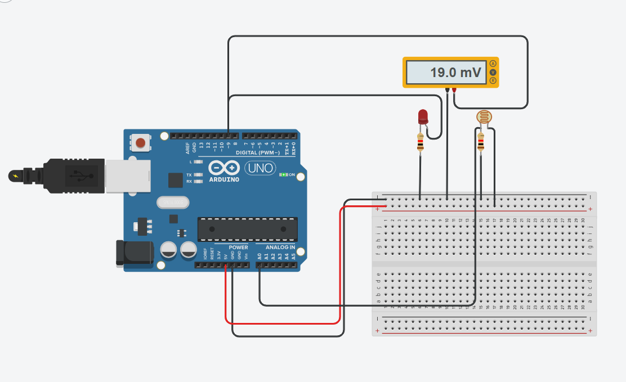
int sensorValue = 0;
void setup()
{
pinMode (A0, INPUT);
Serial.begin(9600);
pinMode(9, OUTPUT);
}
void loop()
{
sensorValue = analogRead(A0);
Serial.println(sensorValue);
analogWrite(9, map(sensorValue,0,1023,0,255));
delay(100);
}
link:
https://www.tinkercad.com/things/gYmeoPsz80l-light-intensity

2) Simulate an ultrasonic distance sensor to detect the distance from the object

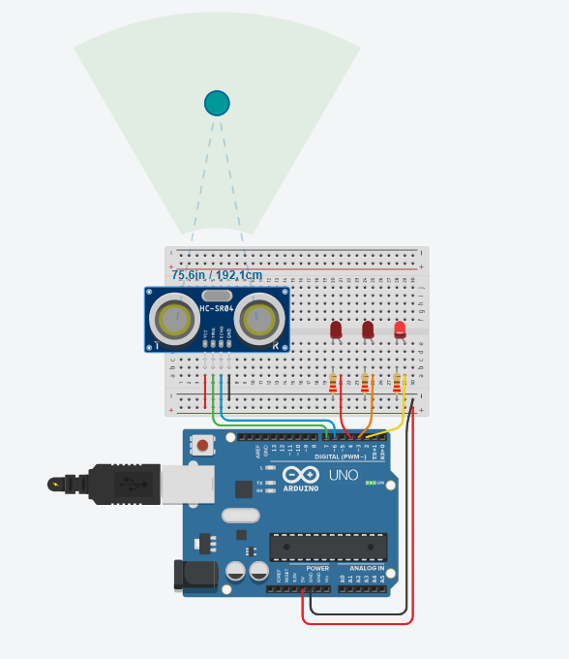

long cm = 0;

long readUltrasonicDistance(int triggerPin, int echoPin)
{
pinMode(triggerPin, OUTPUT); // Clear the trigger
digitalWrite(triggerPin, LOW);
delayMicroseconds(2);
// Sets the trigger pin to HIGH state for 10 microseconds
digitalWrite(triggerPin, HIGH);
delayMicroseconds(10);
digitalWrite(triggerPin, LOW);
pinMode(echoPin, INPUT);
// Reads the echo pin, and returns the sound wave travel time in microseconds *0.01723
return (pulseIn(echoPin, HIGH)*0.01723);

}

void setup()
{
Serial.begin(9600);

pinMode(2, OUTPUT);
pinMode(3, OUTPUT);
pinMode(4, OUTPUT);
}

void loop()
{
cm = readUltrasonicDistance(7, 6);

Serial.print(cm);
Serial.println("cm");

if (cm > 250) {
digitalWrite(2, LOW);
digitalWrite(3, LOW);
digitalWrite(4, LOW);
}
if (cm <= 250 && cm > 175) {
digitalWrite(2, HIGH);
digitalWrite(3, LOW);
digitalWrite(4, LOW);
}
if (cm <= 175 && cm > 100) {
digitalWrite(2, HIGH);
digitalWrite(3, HIGH);
digitalWrite(4, LOW);
}
if (cm <= 100) {
digitalWrite(2, HIGH);
digitalWrite(3, HIGH);
digitalWrite(4, HIGH);
}

delay(100); // Wait for 100 millisecond(s)
}

Link:
https://www.tinkercad.com/things/5Y6hDvN8QgT-ultrasonic-distance-sensor
3) Simulate a DC motor with specified input that runs continuously and vary with the DC motor speed.

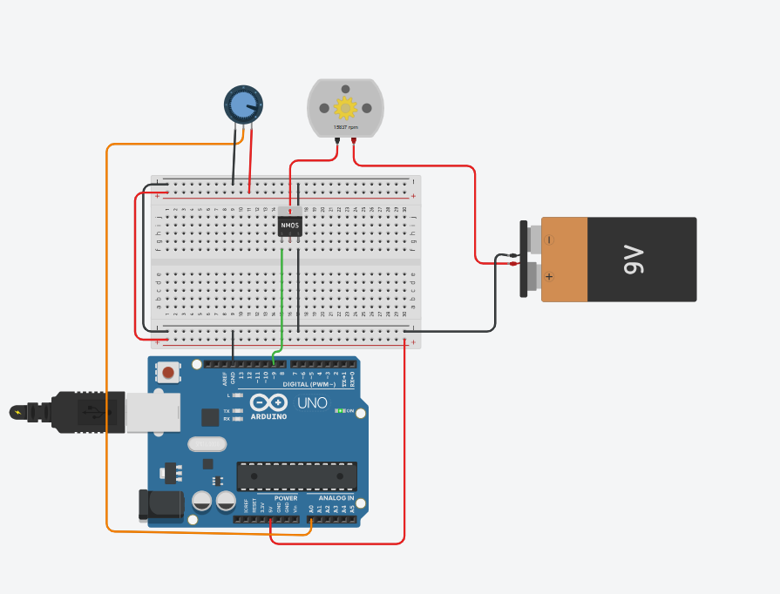

int MPin = 9; //motor pin
int Analog = A0; // Analog Input
int Ainp = 0; // Read analog input, initialized to zero
void setup()
{
Serial.begin(9600);
pinMode(MPin, OUTPUT);
pinMode(Analog, INPUT);
}
void loop()
{
Ainp = analogRead(A0);
int Speed = map(Ainp, 0, 1024, 0, 255);
delay(100);
Serial.println(Speed);
analogWrite(MPin, Speed);
}

Link:
https://www.tinkercad.com/things/a1erhbKdSBQ-dc-motor?sharecode=s5AxJYfrzR3LpDJRrlGtK9va1ZjM4SeVFeEkMIrFG9g
4) Simulate the door sensor for smart homes using IoT sensor

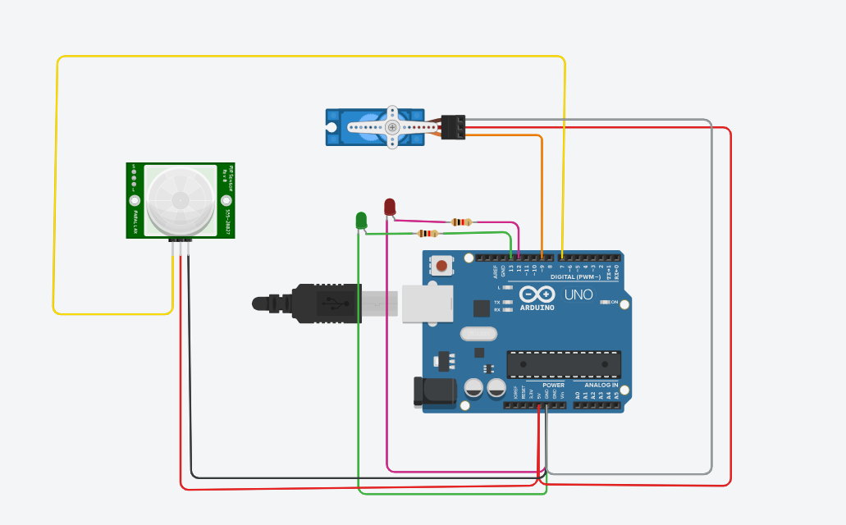

#include <Servo.h>
Servo myservo; // create servo object to control a servo
// twelve servo objects can be created on most boards
int poson = 1 ; // on position(!!YOU WILL HAVE TO SET IT BY TRY AND ERROR ACCORDING TO YOUR SETUP!!)
int posoff = 100 ; //off position(!!YOU WILL HAVE TO SET IT BY TRY AND ERROR ACCORDING TO YOUR SETUP!!)
int pirPin = 7; //the digital pin connected to the PIR sensor's output
int ledPin = 13;
int led2Pin=12;

void setup() {
pinMode(pirPin, INPUT);
pinMode(ledPin, OUTPUT);
pinMode(led2Pin,OUTPUT);
digitalWrite(pirPin, LOW);
myservo.attach(9); // attaches the servo on pin 9 to the servo object
// delay(30000); //enough time for the sensor to calibrate
}

void loop() {
if( digitalRead(pirPin) == HIGH ) {

digitalWrite(ledPin, HIGH);
digitalWrite(led2Pin,LOW);
myservo.write(45); // tell servo to go to position in variable 'poson'
delay(5000);
myservo.write(90); // tell servo to go to position in variable 'posoff'
digitalWrite(ledPin, LOW);
digitalWrite(led2Pin,HIGH);
delay(1000); //delay so it wont start right again imidately
digitalWrite(led2Pin,LOW);

}
}
Link:
https://www.tinkercad.com/things/6Dz5LAuc7Q0-door-sensor?sharecode=_t0zbPxrNGb1hDrz0_wH86Z5SG_SNnKB5xbCbFk6XSA

Part B
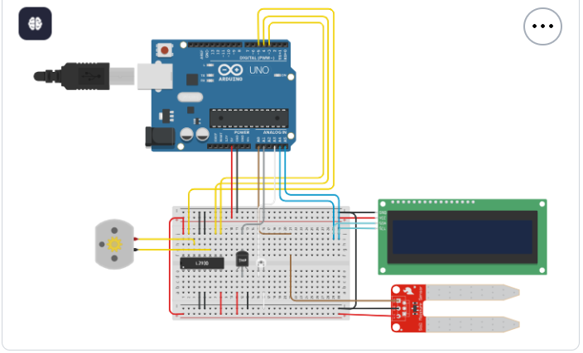
AI in Agriculture - Smart Irrigation System
#include <Wire.h>
#include <LiquidCrystal_I2C.h>

LiquidCrystal_I2C lcd(0x20,16,2);

int enA=5, in1=3, in2=4;
int tempPin=A1, moistPin=A0;

void setup()
{
lcd.init();
lcd.backlight();

pinMode(enA,OUTPUT);
pinMode(in1,OUTPUT);
pinMode(in2,OUTPUT);

Serial.begin(9600);
}

void loop()
{
float temp = (((analogRead(tempPin)*5.0)/1024)-0.5)*100;
float moist = (analogRead(moistPin)*5.0)/1024;

lcd.clear();

lcd.setCursor(0,0);
lcd.print("Temp:");
lcd.print(temp);

lcd.setCursor(0,1);
lcd.print("Moist:");
lcd.print(moist);

if(temp > 30 && moist < 4)
{
digitalWrite(in1,HIGH);
digitalWrite(in2,LOW);
analogWrite(enA,255);

Serial.println("Motor ON");
}
else
{
digitalWrite(in1,LOW);
digitalWrite(in2,LOW);
analogWrite(enA,0);

Serial.println("Motor OFF");
}

delay(1000);
}
link:
https://www.tinkercad.com/things/aZhNG41jLck-copy-of-smart-irrigation-system?sharecode=UMs3WrYnmXLOKgrQQmegWatbF_CuKwvLdyGkIDRi-Qo
2) AI in Smart Cities - Smart Street Lighting with Iot
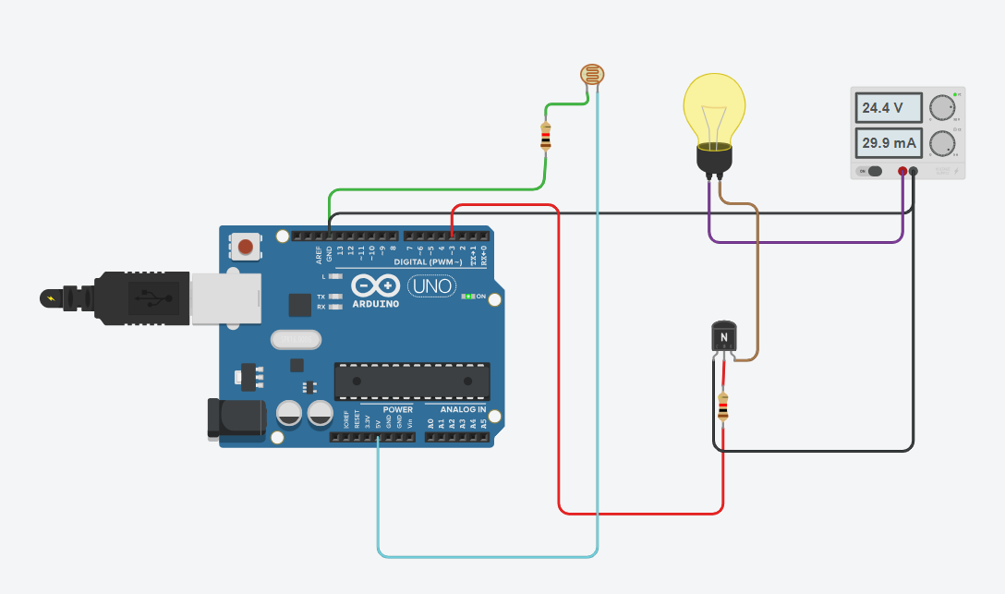
// Pin definitions
const int ldrPin = A5; // LDR connected to analog pin A0
const int bulbPin = 3; // Transistor base controlled by digital pin 9

// Threshold for darkness (adjust based on your setup)
int threshold = 500;

void setup() {
pinMode(bulbPin, OUTPUT);
Serial.begin(9600);
}

void loop() {
int ldrValue = analogRead(ldrPin); // Read LDR value
Serial.println(ldrValue); // Print for debugging

if (ldrValue < threshold) {
digitalWrite(bulbPin, HIGH); // Turn bulb ON
} else {
digitalWrite(bulbPin, LOW); // Turn bulb OFF
}

delay(200); // Small delay for stability
}
Link:
https://www.tinkercad.com/things/hNq5hOrV0Eh-street-light?sharecode=8joKtQweMD3AK4LGr5ukKHkrlDV-RXAh5yLpSUzsFAA
//LAB-6
TOKENIZING AND COUNT WORD FREQUENCY
import nltk
from nltk.tokenize import word_tokenize
from nltk.corpus import stopwords

text = "This is a sample text for word frequency counting"

words = word_tokenize(text.lower())

stop = set(stopwords.words("english"))

words = [w for w in words if w.isalpha() and w not in stop]

freq = {}

for w in words:
freq[w] = freq.get(w,0) + 1

print("Word Frequencies:")

for w,f in freq.items():
print(w,":",f)

//lab-7
nltk word stemming and commatizing words using word net
from nltk.tokenize import word_tokenize
from nltk.corpus import stopwords
from nltk.stem import PorterStemmer, WordNetLemmatizer

text = "The quick brown foxes are jumping over the lazy dogs"

words = word_tokenize(text.lower())

words = [w for w in words if w not in stopwords.words('english')]

ps = PorterStemmer()
stemmed = [ps.stem(w) for w in words]

lm = WordNetLemmatizer()
lemmatized = [lm.lemmatize(w) for w in words]

print("Original:", words)
print("Stemmed:", stemmed)
print("Lemmatized:", lemmatized)
//lab 8 ai in education
//commands- pip install pandas scikit-learn
//dataset name - Updated Resume Dataset
import pandas as pd
from sklearn.feature_extraction.text import TfidfVectorizer
from sklearn.model_selection import train_test_split
from sklearn.neighbors import KNeighborsClassifier
from sklearn.metrics import classification_report,accuracy_score

# Load dataset
data = pd.read_csv("UpdatedResumeDataSet.csv")

# Input and output
x = data["Resume"]
y = data["Category"]

# Convert text into vectors
tfidf = TfidfVectorizer(stop_words='english')
x = tfidf.fit_transform(x)

print("Feature completed...")
print(x.shape)

# Split dataset
x_train,x_test,y_train,y_test = train_test_split(
x,y,test_size=0.2,random_state=0
)

# Train model
model = KNeighborsClassifier()
model.fit(x_train,y_train)

# Prediction
pred = model.predict(x_test)

# Accuracy
print("Accuracy:",accuracy_score(y_test,pred))

# Report
print(classification_report(y_test,pred))
//lab 9 ai in health care
//command : pip install pandas matplotlib seaborn scikit-learn
//kaggle dataset name : diabetes_binary_health_indicator (2021 or 2015)

import pandas as pd
import seaborn as sns
import matplotlib.pyplot as plt

from sklearn.model_selection import train_test_split
from sklearn.ensemble import RandomForestClassifier
from sklearn.metrics import accuracy_score, confusion_matrix

# Load dataset
data = pd.read_csv("diabetes_binary_health_indicators_BRFSS2021.csv")

# Display dataset
print(data.head())
print(data.shape)

# Remove missing values
data = data.dropna()

# Features and labels
x = data.iloc[:,1:]
y = data.iloc[:,0]

# Split dataset
x_train,x_test,y_train,y_test = train_test_split(
x,y,test_size=0.2,random_state=0
)

# Train model
model = RandomForestClassifier(n_estimators=10)

model.fit(x_train,y_train)

# Prediction
pred = model.predict(x_test)

# Accuracy
print("Accuracy:",accuracy_score(y_test,pred))

# Confusion Matrix
cm = confusion_matrix(y_test,pred)

print(cm)

# Graph
sns.heatmap(cm,annot=True,fmt='d')

plt.xlabel("Predicted")
plt.ylabel("Actual")

plt.show()

