AEC
Part A
1)Simulate to measure the light intensity using Tinkercad
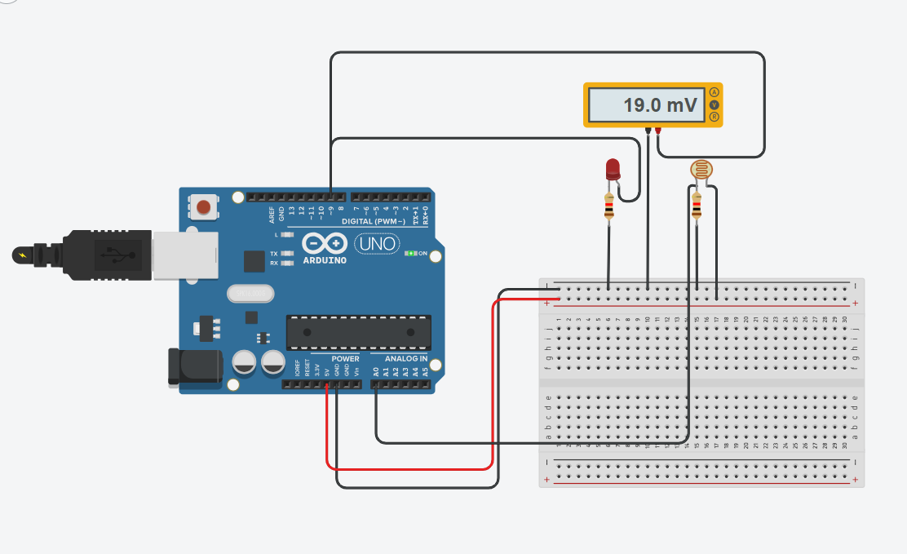
int sensorValue = 0;
void setup()
{
pinMode (A0, INPUT);
Serial.begin(9600);
pinMode(9, OUTPUT);
}
void loop()
{
sensorValue = analogRead(A0);
Serial.println(sensorValue);
analogWrite(9, map(sensorValue,0,1023,0,255));
delay(100);
}
link:
https://www.tinkercad.com/things/gYmeoPsz80l-light-intensity

2) Simulate an ultrasonic distance sensor to detect the distance from the object

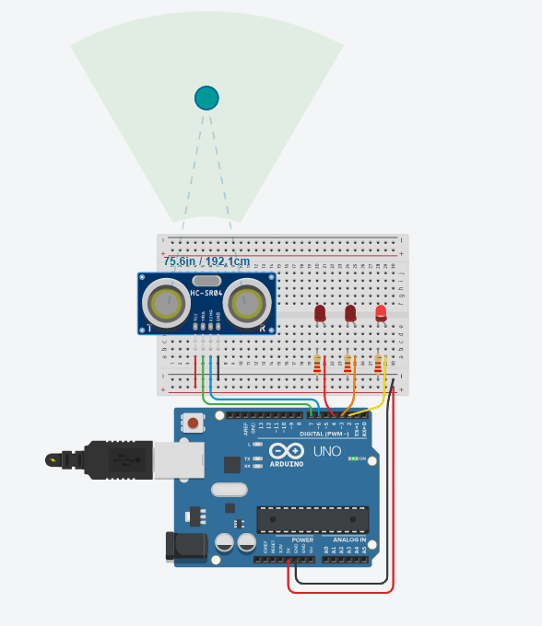

long cm = 0;

long readUltrasonicDistance(int triggerPin, int echoPin)
{
pinMode(triggerPin, OUTPUT); // Clear the trigger
digitalWrite(triggerPin, LOW);
delayMicroseconds(2);
// Sets the trigger pin to HIGH state for 10 microseconds
digitalWrite(triggerPin, HIGH);
delayMicroseconds(10);
digitalWrite(triggerPin, LOW);
pinMode(echoPin, INPUT);
// Reads the echo pin, and returns the sound wave travel time in microseconds *0.01723
return (pulseIn(echoPin, HIGH)*0.01723);

}

void setup()
{
Serial.begin(9600);

pinMode(2, OUTPUT);
pinMode(3, OUTPUT);
pinMode(4, OUTPUT);
}

void loop()
{
cm = readUltrasonicDistance(7, 6);

Serial.print(cm);
Serial.println("cm");

if (cm > 250) {
digitalWrite(2, LOW);
digitalWrite(3, LOW);
digitalWrite(4, LOW);
}
if (cm <= 250 && cm > 175) {
digitalWrite(2, HIGH);
digitalWrite(3, LOW);
digitalWrite(4, LOW);
}
if (cm <= 175 && cm > 100) {
digitalWrite(2, HIGH);
digitalWrite(3, HIGH);
digitalWrite(4, LOW);
}
if (cm <= 100) {
digitalWrite(2, HIGH);
digitalWrite(3, HIGH);
digitalWrite(4, HIGH);
}

delay(100); // Wait for 100 millisecond(s)
}

Link:
https://www.tinkercad.com/things/5Y6hDvN8QgT-ultrasonic-distance-sensor
3) Simulate a DC motor with specified input that runs continuously and vary with the DC motor speed.

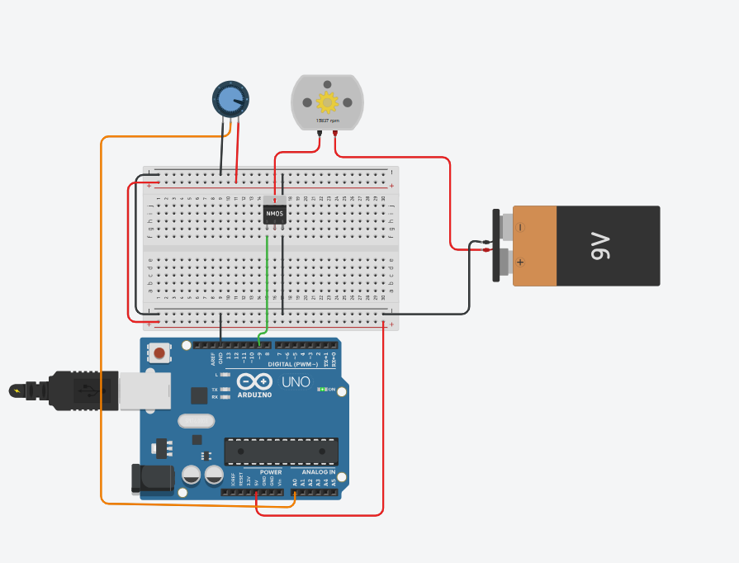

int MPin = 9; //motor pin
int Analog = A0; // Analog Input
int Ainp = 0; // Read analog input, initialized to zero
void setup()
{
Serial.begin(9600);
pinMode(MPin, OUTPUT);
pinMode(Analog, INPUT);
}
void loop()
{
Ainp = analogRead(A0);
int Speed = map(Ainp, 0, 1024, 0, 255);
delay(100);
Serial.println(Speed);
analogWrite(MPin, Speed);
}

Link:
https://www.tinkercad.com/things/a1erhbKdSBQ-brave-vihelmo-amur
4) Simulate the door sensor for smart homes using IoT sensor

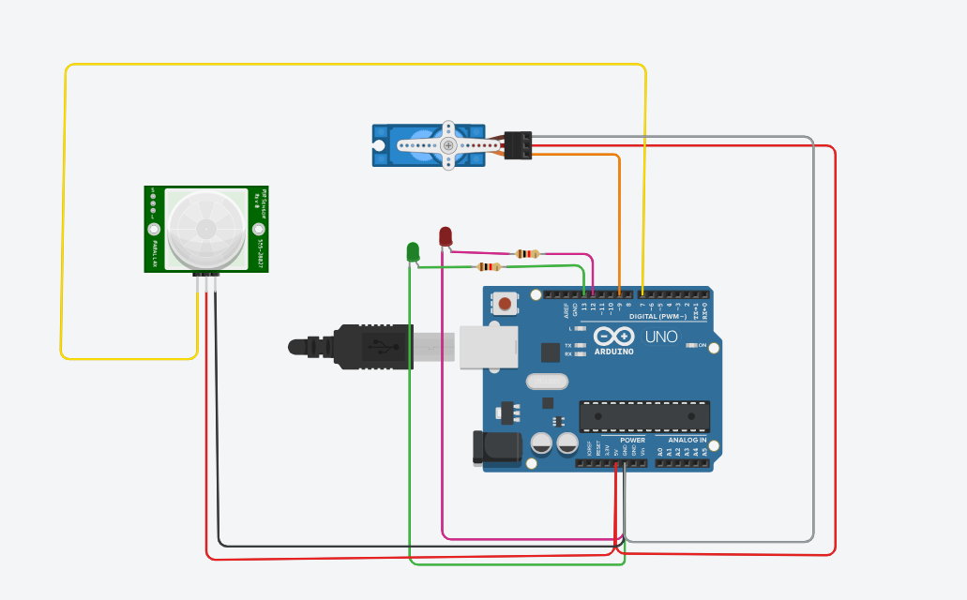

#include <Servo.h>
Servo myservo; // create servo object to control a servo
// twelve servo objects can be created on most boards
int poson = 1 ; // on position(!!YOU WILL HAVE TO SET IT BY TRY AND ERROR ACCORDING TO YOUR SETUP!!)
int posoff = 100 ; //off position(!!YOU WILL HAVE TO SET IT BY TRY AND ERROR ACCORDING TO YOUR SETUP!!)
int pirPin = 7; //the digital pin connected to the PIR sensor's output
int ledPin = 13;
int led2Pin=12;

void setup() {
pinMode(pirPin, INPUT);
pinMode(ledPin, OUTPUT);
pinMode(led2Pin,OUTPUT);
digitalWrite(pirPin, LOW);
myservo.attach(9); // attaches the servo on pin 9 to the servo object
// delay(30000); //enough time for the sensor to calibrate
}

void loop() {
if( digitalRead(pirPin) == HIGH ) {

digitalWrite(ledPin, HIGH);
digitalWrite(led2Pin,LOW);
myservo.write(45); // tell servo to go to position in variable 'poson'
delay(5000);
myservo.write(90); // tell servo to go to position in variable 'posoff'
digitalWrite(ledPin, LOW);
digitalWrite(led2Pin,HIGH);
delay(1000); //delay so it wont start right again imidately
digitalWrite(led2Pin,LOW);

}
}
Link:
https://www.tinkercad.com/things/6Dz5LAuc7Q0-glorious-waasa-trug

Part B
1) AI in Agriculture - Smart Irrigation System
2) AI in Smart Cities - Smart Street Lighting with Iot
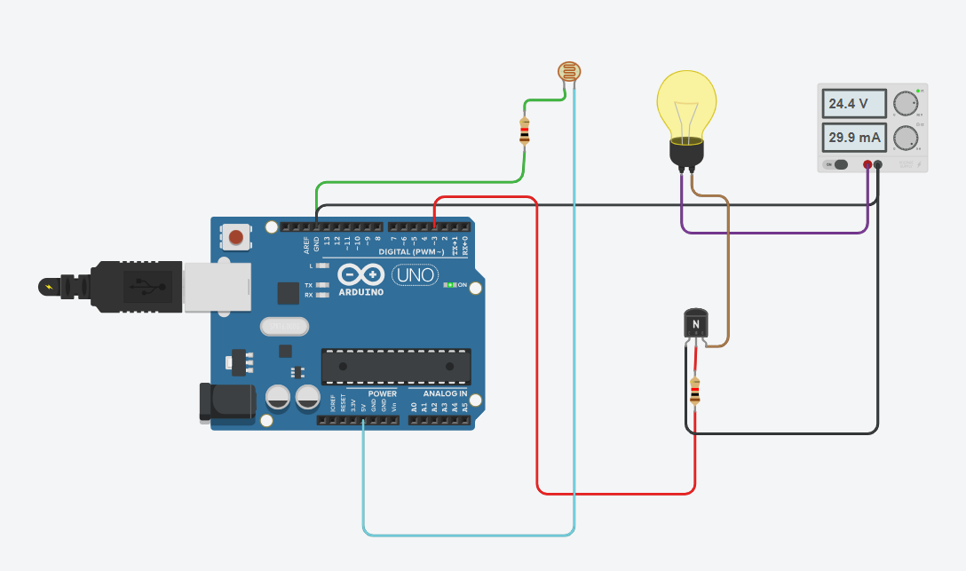
// Pin definitions
const int ldrPin = A5; // LDR connected to analog pin A0
const int bulbPin = 3; // Transistor base controlled by digital pin 9

// Threshold for darkness (adjust based on your setup)
int threshold = 500;

void setup() {
pinMode(bulbPin, OUTPUT);
Serial.begin(9600);
}

void loop() {
int ldrValue = analogRead(ldrPin); // Read LDR value
Serial.println(ldrValue); // Print for debugging

if (ldrValue < threshold) {
digitalWrite(bulbPin, HIGH); // Turn bulb ON
} else {
digitalWrite(bulbPin, LOW); // Turn bulb OFF
}

delay(200); // Small delay for stability
}
Link:
https://www.tinkercad.com/things/hNq5hOrV0Eh-cool-hango-jaban

