1. **Studi Kasus 1:**

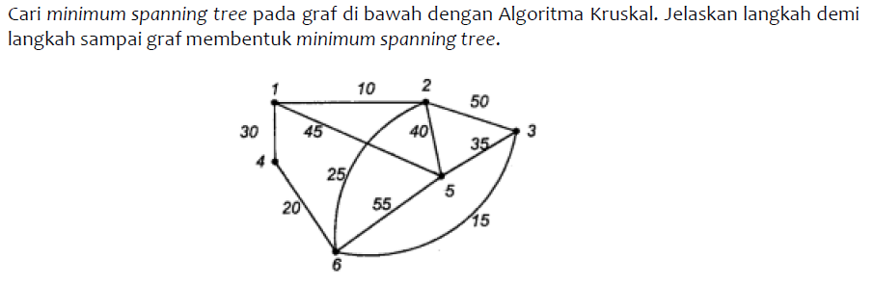

1. **Studi Kasus 2:**

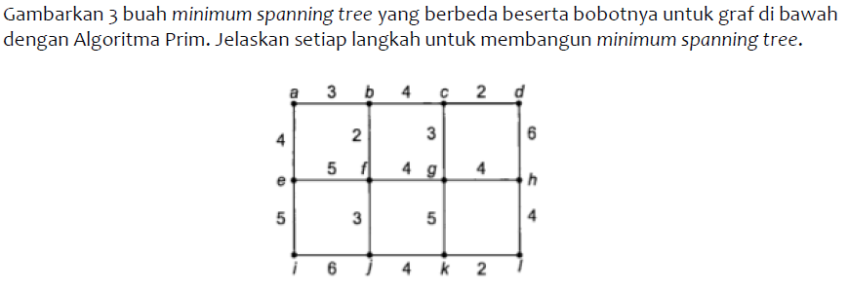

1. **Studi Kasus 3:**



