Design and Development of a Smart Agriculture Monitoring Platform for Sustainable Farming Practices
Suriana Binti Abdullah
Faculty of Information Sciences and Engineering, Management and Science University, Shah Alam, Section 13, 40100 Shah Alam, Selangor, Malaysia
012025021263
Madam Rosidah
Faculty of Information Sciences and Engineering, Management and Science University, Shah Alam, Section 13, 40100 Shah Alam, Selangor, Malaysia
ABSTRACT- Agriculture plays an important role in supporting food availability and sustainable farming practices, but small-scale growers still face problems related to manual checking, delayed irrigation, and limited decision support for fertilizer use. This project presents the design and development of a Smart Agriculture Monitoring Platform for Sustainable Farming Practices. The system uses an ESP32 microcontroller, soil moisture sensor, BME280 sensor, TDS sensor, water flow sensor, relay-controlled pumps, Firebase Realtime Database, and a React/Vite mobile-friendly web application. The platform allows users to view live readings, monitor mustard greens, control irrigation through Auto Mode and Manual Mode, receive notification alerts, and obtain AI-supported fertilizer recommendations. Evaluation was conducted through prototype testing and survey-based user feedback. The findings show that respondents viewed the system positively, especially for soil moisture monitoring, automatic irrigation, AI recommendation, notification alerts, and sustainable farming support. The project demonstrates how IoT, cloud synchronization, mobile application design, and AI decision support can be combined to improve small-scale smart agriculture.
Keywords: smart agriculture, IoT, ESP32, Firebase, irrigation, AI recommendation, sustainable farming, mustard greens
INTRODUCTION
Agriculture is a key sector that supports food production, daily living, and economic development. However, many small-scale farming activities still depend on manual observation and routine watering. This can lead to late irrigation, inconsistent plant care, and inefficient use of water and fertilizer. With the growth of Internet of Things (IoT) technology, farming systems can now collect real-time sensor readings and present them through cloud-connected applications.
The proposed Smart Agriculture Monitoring Platform focuses on mustard greens and small-scale farming practices. The system monitors soil moisture, temperature, humidity, air pressure, TDS raw reading, water flow, and daily water usage. These readings are uploaded through ESP32 and Firebase Realtime Database so that users can view live conditions through a mobile-friendly web application. The project also includes automatic irrigation, manual pump control, notification alerts, trend monitoring, and AI-supported fertilizer recommendation.
PROBLEM STATEMENT
Manual checking can cause irrigation to be delayed because users may not notice changes in soil condition immediately. If soil becomes dry and watering is not performed on time, plant health may be affected. At the same time, fertilizer use is often based on estimation or routine rather than sensor-supported decision making. This can lead to unnecessary fertilizer usage or late fertilizer application.
Another problem is limited user awareness when the dashboard is not being monitored continuously. Important events such as dry soil, pump activity, irrigation completion, or fertilizer recommendation may be missed if the system does not provide alerts. Therefore, this project aims to develop a smart monitoring platform that combines IoT sensor readings, automatic irrigation, AI recommendation, notification alerts, and mobile access to support more sustainable farming practices.
II. LITERATURE REVIEW
Smart Agriculture and IoT
Smart agriculture applies sensors, microcontrollers, internet connectivity, cloud databases, and application interfaces to improve farming decisions. IoT systems allow environmental and plant-related readings to be collected continuously, which helps users understand the condition of crops and respond more effectively.
Automatic Irrigation
Automatic irrigation systems use soil moisture readings to control water delivery. This method reduces dependence on manual watering and supports more consistent plant care. In this project, Auto Mode allows the water pump to operate based on calibrated soil moisture thresholds, while Manual Mode gives users direct control when needed.
AI Fertilizer Recommendation
Artificial Intelligence can support agriculture by helping users interpret sensor data and make better decisions. In this project, the AI fertilizer recommendation feature uses selected readings and system conditions to suggest whether fertilizer may be required. This supports responsible fertilizer use and avoids treating TDS as the only decision factor.
Mobile Web Application and Firebase
Firebase Realtime Database enables live synchronization between the ESP32 and the application dashboard. A React/Vite mobile-friendly web application allows users to access live readings, trend charts, pump controls, and notification settings. This makes the system easier to use on a mobile device and suitable for small-scale smart farming.
III. METHODOLOGY
This project uses Agile methodology because the development requires continuous testing and improvement across hardware, database, and application modules. The system was developed in phases involving planning, design, development, testing, deployment, and review. Each phase allowed the prototype to be improved based on sensor calibration, Firebase synchronization, pump response, notification behaviour, and interface testing.
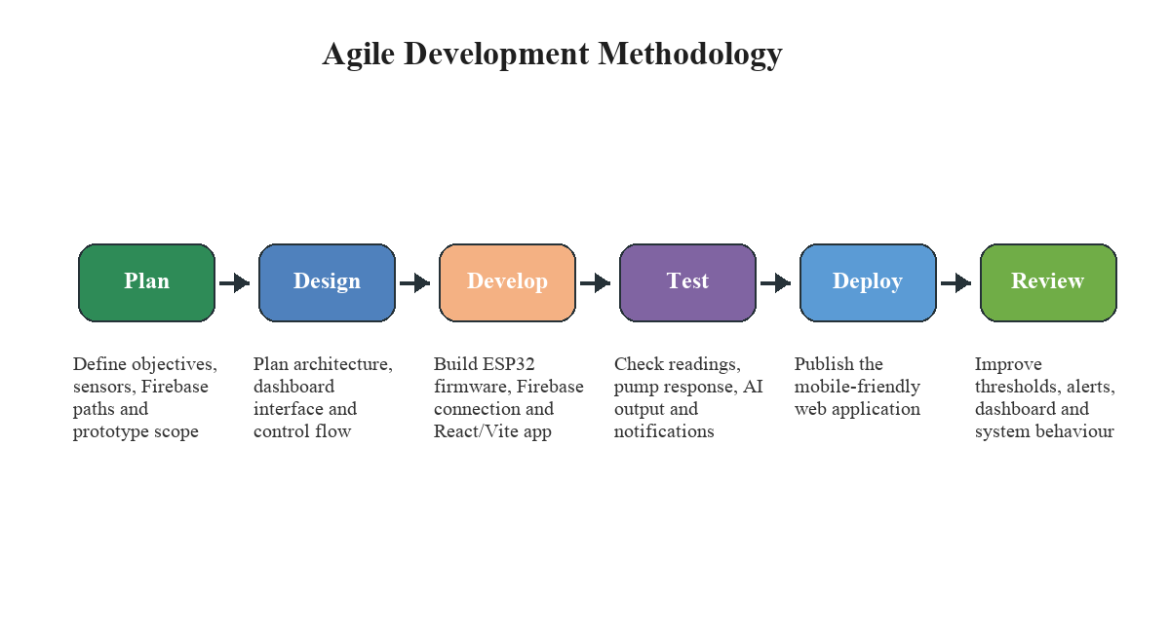
Fig 1 Agile Methodology
During the planning phase, the project objectives, system requirements, sensors, Firebase paths, and prototype limitations were identified. The design phase focused on system architecture, database structure, interface layout, and control flow. The development phase involved writing ESP32 code, creating the React/Vite dashboard, connecting Firebase, implementing pump control, and preparing the AI recommendation logic. The testing phase checked live readings, pump response, Firebase updates, dashboard usability, trend page behaviour, and notification triggers.
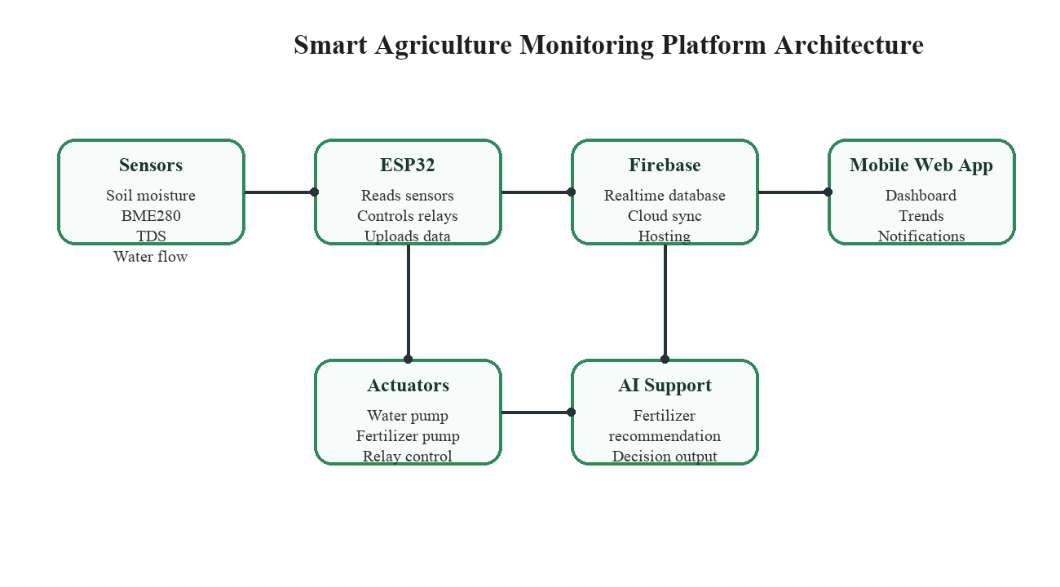
Fig 2 Proposed System Architecture
The evaluation used prototype testing and survey-based feedback. The survey was divided into demographic profile, app experience and usability evaluation, and project value, sustainability, and overall satisfaction. These sections were used to understand whether respondents accepted the system features and whether the platform supports sustainable farming practices.
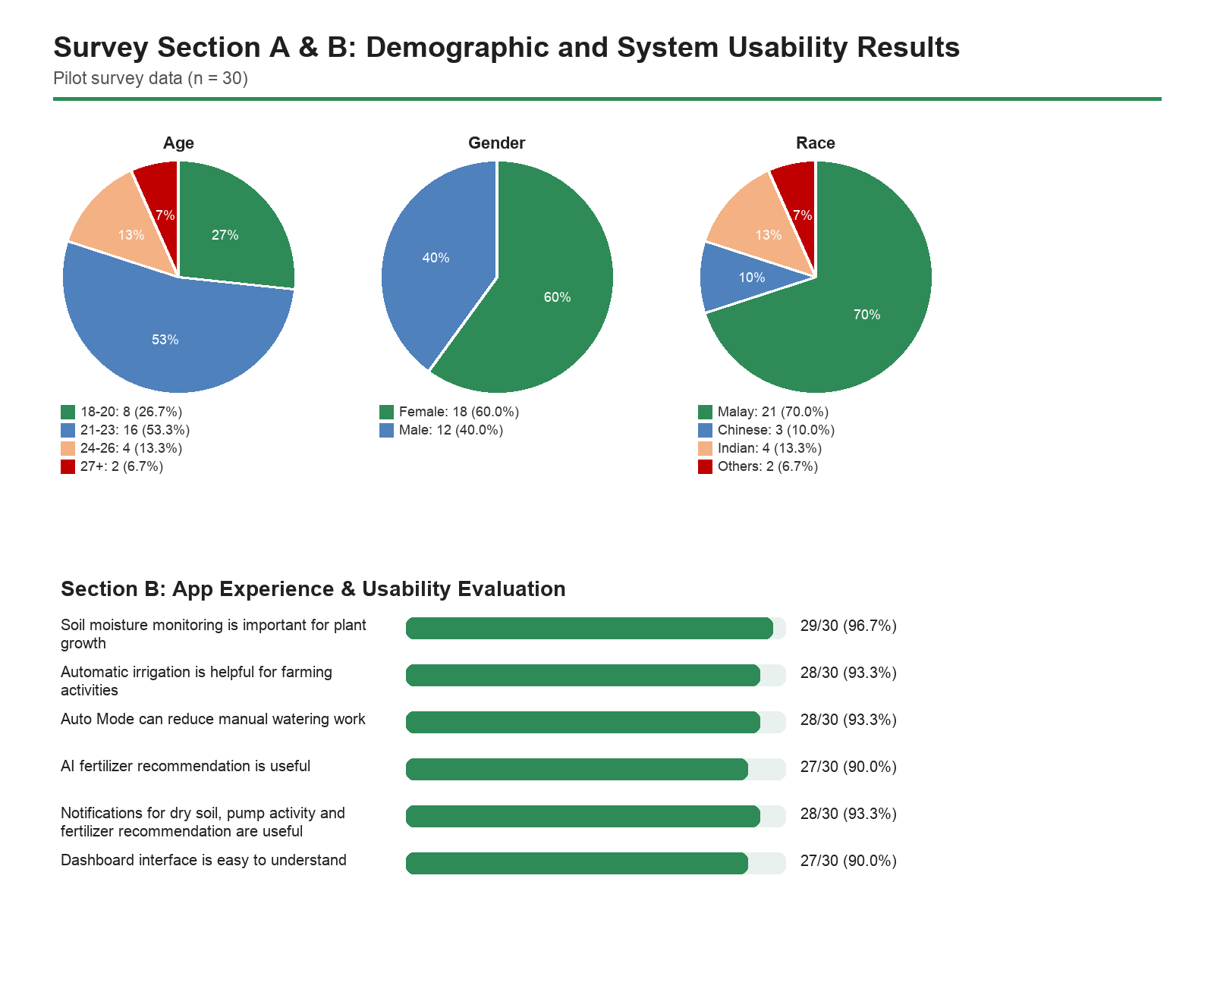
Fig 3 Evaluation Results from Survey Section A & B
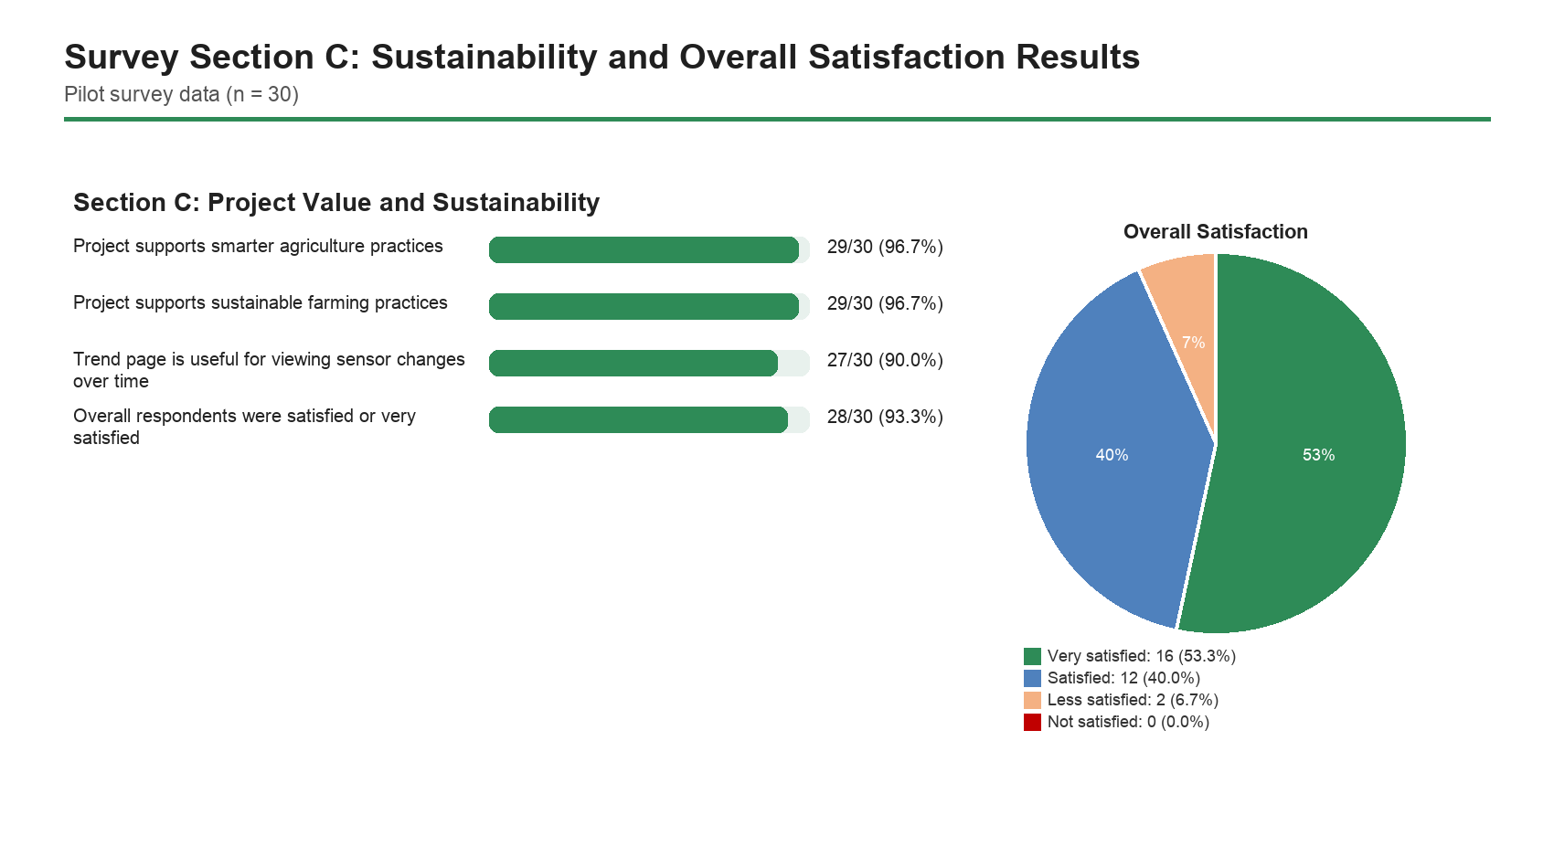
Fig 4 Evaluation Results from Survey Section C
IV. RESULT AND DISCUSSION
The prototype successfully integrates ESP32 sensor readings, Firebase Realtime Database, relay-controlled pumps, and a mobile-friendly application dashboard. The Home page displays live sensor readings, soil condition, pump status, AI fertilizer recommendation, and system controls. The Trend page shows sensor changes over time, while the Settings page supports notification permissions and notification history.
The survey results show positive user acceptance toward the proposed platform. Most respondents agreed that soil moisture monitoring is important for plant growth and that automatic irrigation can help reduce manual watering work. Respondents also viewed AI fertilizer recommendation and notification alerts as useful because these features provide decision support and improve user awareness. For sustainability, most respondents agreed that the project supports smarter and more sustainable farming practices.
V. CONCLUSION AND FUTURE ENHANCEMENTS
The Smart Agriculture Monitoring Platform was developed to support sustainable farming practices through IoT monitoring, automatic irrigation, AI fertilizer recommendation, notification alerts, and mobile access. The system helps users monitor mustard greens more effectively by presenting live readings and allowing pump control through Auto Mode and Manual Mode. Firebase synchronization enables the application to update in real time, while the AI recommendation feature supports better fertilizer-related decisions.
Although the project achieved its main objectives, several improvements can be made in the future. The system can be expanded with more crop types, more advanced AI models, larger survey validation, long-term field testing, improved sensor calibration, and enhanced analytics for water and fertilizer usage. Future versions may also include multilingual support, user accounts, cloud reports, and wider deployment for small-scale farmers.
ACKNOWLEDGEMENT
This project was completed with guidance, support, and encouragement from the project supervisor, Madam Rosidah. Appreciation is also extended to the Faculty of Information Sciences and Engineering, Management and Science University, lecturers, classmates, family members, and respondents who contributed support and feedback throughout the completion of this project.
REFERENCES
Adafruit. (n.d.). BME280 temperature, humidity and pressure sensor. https://learn.adafruit.com/adafruit-bme280-humidity-barometric-pressure-temperature-sensor-breakout
Arduino. (n.d.). Arduino IDE. https://www.arduino.cc/en/software
Espressif Systems. (2024). ESP32 series datasheet. https://www.espressif.com/sites/default/files/documentation/esp32_datasheet_en.pdf
Firebase. (n.d.). Firebase Realtime Database documentation. Google. https://firebase.google.com/docs/database
Food and Agriculture Organization of the United Nations. (2017). The future of food and agriculture: Trends and challenges. https://www.fao.org/3/i6583e/i6583e.pdf
React. (n.d.). React documentation. https://react.dev/
United Nations. (n.d.). Goal 2: Zero hunger. https://sdgs.un.org/goals/goal2
Vite. (n.d.). Vite guide. https://vite.dev/guide/
Wolfert, S., Ge, L., Verdouw, C., & Bogaardt, M. J. (2017). Big data in smart farming: A review. Agricultural Systems, 153, 69-80.
Zhang, N., Wang, M., & Wang, N. (2002). Precision agriculture: A worldwide overview. Computers and Electronics in Agriculture, 36(2-3), 113-132.

