EXP.NO: 1
Web Page Creation using HTML

AIM:
To create a web page that embeds a map with hotspots, frames, and links. The web page should be designed using HTML, incorporating embedded, external, and inline CSS for styling. This exercise aims to enhance understanding of integrating multimedia elements like maps, creating interactive hotspots, and organizing content using frames while applying different CSS techniques for styling.

ALGORITHM:
1)Create the HTML Structure:
- Set up the basic HTML document using <!DOCTYPE html>, <html>, <head>, and <body> tags.
- In the <head> section, link the external CSS file using the <link> tag, define the title, and include necessary metadata.
- In the <body>, create the required elements:
Frames:
Use the <frameset> tag to create a frame layout. (Since <frameset> is obsolete in modern HTML, <iframe> is recommended.)
Map:
Use the <img> tag to display the map image.
Hotspots:
Create clickable regions on the image using the <map> and <area> tags.
Links:
Add hyperlinks using the <a> tag to navigate to different sections of the page or to external websites.
2) Create CSS Styles:
- External
Define styles such as colors, fonts, spacing, and layout in a separate CSS file to maintain a consistent design across the webpage.
- Inline
Apply styles directly within HTML elements using the style attribute (for example, inside <div> or <p> tags) when specific styling is required.
- Embedded
Use the <style> tag inside the <head> section to define styles for particular elements such as maps, frames, and text.
3) Map with Hotspots:
- Use the <map> tag to create an image map.
- Define clickable areas using the <area> tag and specify the coordinates with the coords="x,y,x2,y2" attribute to mark the hotspot regions on the image.
4) Frames:
- Use the <iframe> tag to embed external content such as maps or webpages.
- Important attributes include:
  - src – URL of the page to display
  - width – Width of the frame
  - height – Height of the frame
5) Add Links:
- Inside the <body>, use the <a> tag to create navigation links that direct users to other sections of the webpage or external sites.
6) Test the Page:
- Test the webpage to ensure that frames, hotspots, and links function correctly.
- Verify that the hotspots on the map are clickable and that the linked content loads properly.
- Confirm that all styles are applied correctly using inline, embedded, and external CSS.
CODE:
Index.html:
<!DOCTYPE html>
<html>
<head>
<title>Online Restaurant Booking</title>
</head>

<frameset rows="100,60,*">
<frame src="header.html" name="headerFrame" noresize>
<frame src="menu.html" name="menuFrame" noresize scrolling="no">
<frame src="home.html" name="contentFrame">
</frameset>

</html>

Menu.html :

<!DOCTYPE html>
<html>
<head>
<style>
body{
margin:0;
font-family:Arial;
background:transparent;
}

.menu{
display:flex;
justify-content:center;
background:rgba(0,0,0,0.8);
}

.menu a{
color:white;
padding:15px 30px;
text-decoration:none;
font-weight:bold;
letter-spacing:1px;
}

.menu a:hover{
background:rgba(255,255,255,0.2);
}
</style>
</head>
<body>

<div class="menu">
<a href="home.html" target="contentFrame">HOME</a>
<a href="foodmenu.html" target="contentFrame">MENU</a>
<a href="booking.html" target="contentFrame">BOOK TABLE</a>
<a href="contact.html" target="contentFrame">LOCATION</a>
</div>

</body>
</html>

Header.html :
<!DOCTYPE html>
<html>
<head>
<style>
body{
margin:0;
background-color:black;
color:white;
text-align:center;
font-family:Arial, sans-serif;
}
.logo{
display:flex;
justify-content:center;
align-items:center;
padding:15px;
}
.logo img{
width:50px;
margin-right:15px;
}
h1{
letter-spacing:3px;
}
</style>
</head>
<body>

<div class="logo">
<img src="logo.jpg" alt="Dragon Logo">
<h1>DRAGON STONE</h1>
</div>

</body>
</html>

Home.html :
<!DOCTYPE html>
<html>
<head>
<style>
body{
margin:0;
font-family:Arial, sans-serif;
background-image:url("image.jpg");
background-size:cover;
background-position:center;
color:white;
}

.overlay{
background:rgba(0,0,0,0.7);
padding:50px;
min-height:100vh;
}

h2{
font-size:40px;
margin-bottom:10px;
}

p{
font-size:18px;
line-height:1.6;
max-width:800px;
}
</style>
</head>
<body>

<div class="overlay">

<h2>Welcome to Dragon Stone</h2>

<p>
Welcome to Dragon Stone, where every dish is crafted with passion and every visit feels like home. We bring together fresh ingredients, rich flavors, and a warm ambiance to create an unforgettable dining experience. Whether you're here for a quick bite or a special celebration, we are delighted to serve you.
</p>

<br><br>

<h2>About Us</h2>

<p>
Welcome to Dragon Stone, where flavor meets passion and every meal tells a story.

Founded with a love for great food and warm hospitality, our restaurant is more than just a place to dine — it’s a place to connect, celebrate, and create unforgettable memories. We blend fresh ingredients, bold flavors, and modern culinary techniques to craft dishes that satisfy both the heart and the palate.

Our chefs carefully select quality ingredients to ensure every plate served reflects excellence, creativity, and authenticity. Whether you’re joining us for a casual lunch, a family dinner, or a special celebration, we strive to make every visit exceptional.

At Dragon Stone, we believe great food brings people together. From our welcoming ambiance to our attentive service, everything we do is designed to give you an experience worth savoring.

We look forward to serving you.Book your table online and enjoy a seamless dining experience.
</p>

</div>

</body>
</html>

Foodmenu.html :
<!DOCTYPE html>
<html>
<head>
<title>Dragon Stone - Specials</title>
<style>
body{
margin:0;
font-family:Arial, sans-serif;
background-color:#111;
color:white;
text-align:center;
}

h2{
padding:20px;
}

.gallery{
display:flex;
flex-wrap:wrap;
justify-content:center;
gap:30px;
padding:20px;
}

.item{
width:300px;
}

.item img{
width:100%;
height:250px;
object-fit:cover;
border-radius:10px;
}

.item h3{
margin-top:10px;
}
</style>
</head>
<body>

<h2> Dragon Stone - Our Food</h2>

<div class="gallery">

<div class="item">
<img src="briyani.jpg">
<h3>Chicken Biryani</h3>
</div>

<div class="item">
<img src="dosa.jpg">
<h3>Dosa</h3>
</div>

<div class="item">
<img src="fried rice.jpg">
<h3>Fried Rice</h3>
</div>

<div class="item">
<img src="grill.jpg">
<h3>Grilled Chicken</h3>
</div>

<div class="item">
<img src="idli.jpg">
<h3>Idli</h3>
</div>

<div class="item">
<img src="kebab.jpg">
<h3>Tandoori Kebab</h3>
</div>

<div class="item">
<img src="meals.jpg">
<h3>South Indian Meals</h3>
</div>

<div class="item">
<img src="paratha.jpg">
<h3>Paratha</h3>
</div>

<div class="item">
<img src="tandoori.jpg">
<h3>Tandoori Chicken</h3>
</div>

</div>

</body>
</html>

Contact :
<!DOCTYPE html>
<html>
<head>
<title>Dragon Stone - Contact</title>

<style>
body{
margin:0;
font-family:Arial, sans-serif;
background-image:url("image.jpg");
background-size:cover;
background-position:center;
color:white;
}

.overlay{
background:rgba(0,0,0,0.85);
min-height:100vh;
padding:40px;
}

.container{
display:flex;
justify-content:center;
align-items:center;
gap:40px;
}

.contact-info{
max-width:300px;
line-height:1.8;
}

iframe{
border-radius:10px;
}

h2{
text-align:center;
margin-bottom:30px;
}
</style>
</head>

<body>

<div class="overlay">

<h2>📍 Dragon Stone - Contact Us</h2>

<div class="container">

<!-- Google Map -->
<iframe src="https://www.google.com/maps/embed?pb=!1m18!1m12!1m3!1d15544.583375638294!2d80.19728679531214!3d13.089941945780323!2m3!1f0!2f0!3f0!3m2!1i1024!2i768!4f13.1!3m3!1m2!1s0x3a5264078822719b%3A0xbda01077b89581e2!2sAnna%20Nagar%2C%20Chennai%2C%20Tamil%20Nadu!5e0!3m2!1sen!2sin!4v1771429378999!5m2!1sen!2sin" width="600" height="450" style="border:0;" allowfullscreen="" loading="lazy" referrerpolicy="no-referrer-when-downgrade"></iframe>

<!-- Contact Details -->
<div class="contact-info">
<h3>Contact Details</h3>

📞 <strong>Contact No:</strong><br>
+91 98765 43210 <br><br>

📧 <strong>Email:</strong><br>
dragonstone@gmail.com <br><br>

📍 <strong>Address:</strong><br>
Dragon Stone Restaurant,<br>
Anna Nagar,<br> Chennai,<br>
Tamil Nadu, India.
</div>

</div>

</div>

</body>
</html>

OUTPUT:
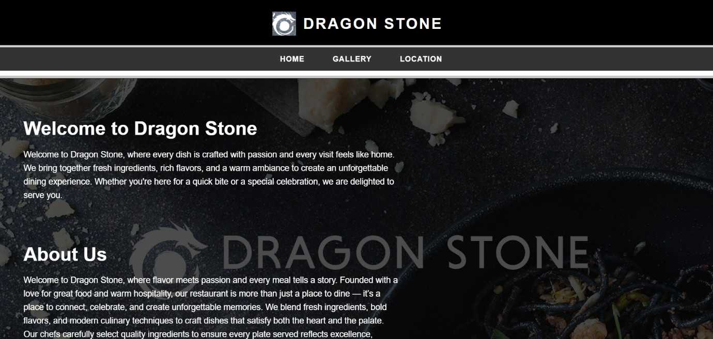
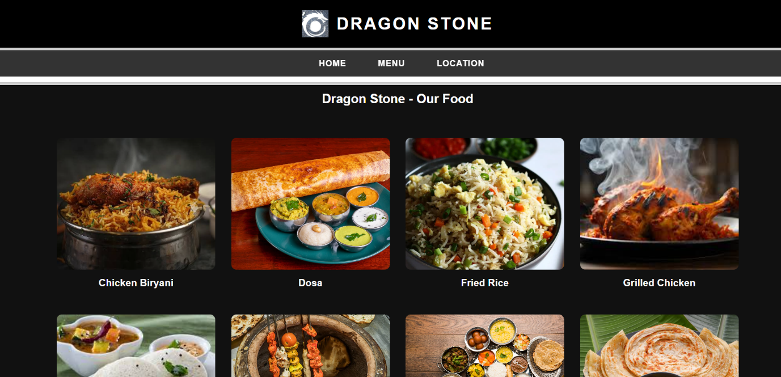

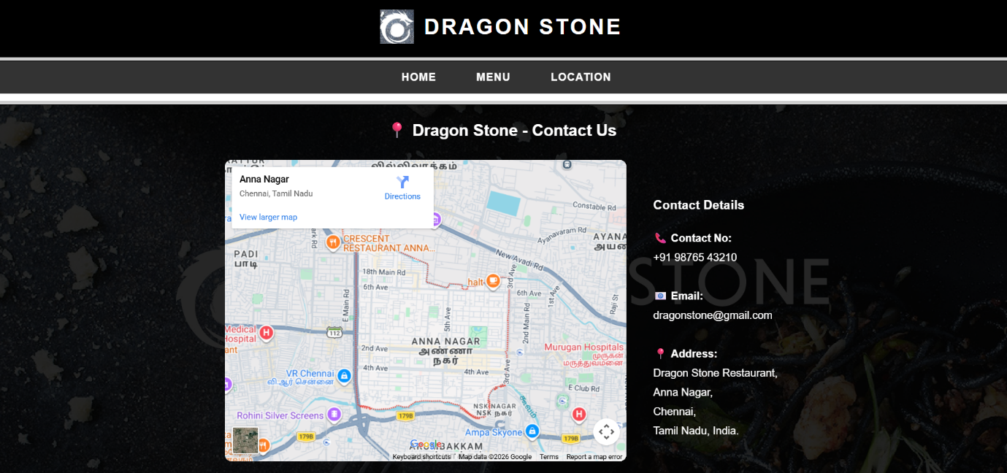

Result:
Html Page is created with embedded Bangalore map along with hot spot, frames ,map & Links.

