DR. RVR NRI INSTITUTE OF TECHNOLOGY
WEB DEVELOPMENT
ACTIVITY-BASED LEARNING (ABL) ASSIGNMENT
Consolidated Report of Three Website Case Studies

Student Name | SURI MEGHANA
Roll Number | 26001186
Branch / Department | CSE-AI/ML
Section | CSM-5
Course | Web Development

Academic Year: 2026

1. Introduction
This report documents three HTML and CSS website projects prepared as part of the Web Development Activity-Based Learning (ABL) assignment. The projects demonstrate the use of semantic page sections, navigation links, content cards, tables, forms, CSS layouts, colors, hover effects, and responsive styling.
The three case studies documented here are Healthy Bites (food and nutrition), Borcelle Café (restaurant website), and Dr. RVR NRIIT FEST 2026 (college fest website). These are based on the code shared for the projects. Add your own screenshots after running each webpage in a browser.

2. Objectives
- Apply HTML to structure webpages and organize content into meaningful sections.
- Use CSS to style headers, navigation, cards, tables, buttons, and footers.
- Create navigation links that move users to sections within a page.
- Use layout techniques such as Flexbox, CSS Grid, spacing, and responsive media queries where included.
- Practice organizing project files and documenting work for a GitHub repository.

3. Software and Technologies
- HTML5 — webpage structure and content.
- CSS3 — visual styling, layouts, hover effects, and responsive behavior.
- Web browser — to run and test each HTML page.
- Code editor — to create and edit the HTML and CSS files.
- Git and GitHub — for version control and project submission, if used.

4. Case Study 1: Healthy Bites — Food & Nutrition Website

4.1 Overview
Healthy Bites is an informational website about healthy eating. It organizes food categories, simple recipe ideas, a sample daily meal plan, and healthy-eating tips in a readable page layout.

4.2 Main Features
- Navigation links for Home, Recipes, Meal Plans, Nutrition, and Tips.
- Hero section with the message “Eat Healthy, Live Better!” and an Explore Recipes link.
- Food category cards for vegetables, fresh fruits, protein foods, and whole grains.
- Recipe cards for Fresh Vegetable Salad, Oatmeal Breakfast, and Vegetable Rice Bowl.
- Daily meal plan covering breakfast, snacks, lunch, and dinner.
- Healthy-eating tips about water, fruits and vegetables, whole grains, salt, sugar, portions, and activity.
- Green color palette, card styling, hover effects, and a responsive layout for smaller screens.

4.3 Technologies and Files
Technologies: HTML5 and CSS3.
Expected files: the HTML page, act14.css, and this report/documentation as needed.

4.4 Result and Limitations
The page presents nutrition information in separate sections. The recipe calorie values are estimates, and the sample meal plan is general information rather than personalized medical or dietary advice. The site does not include a database or interactive backend.
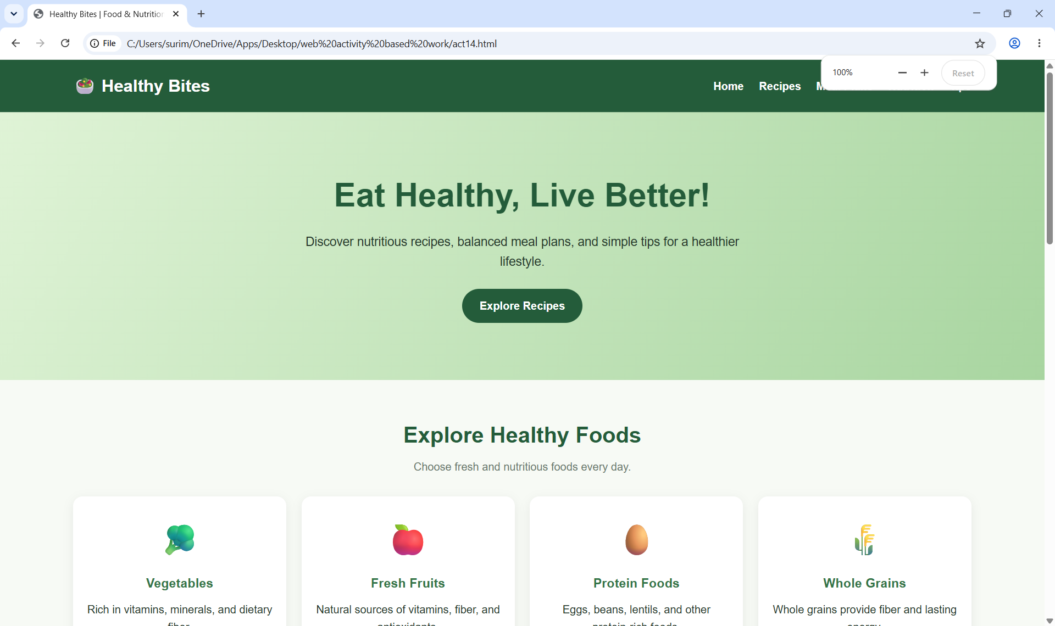
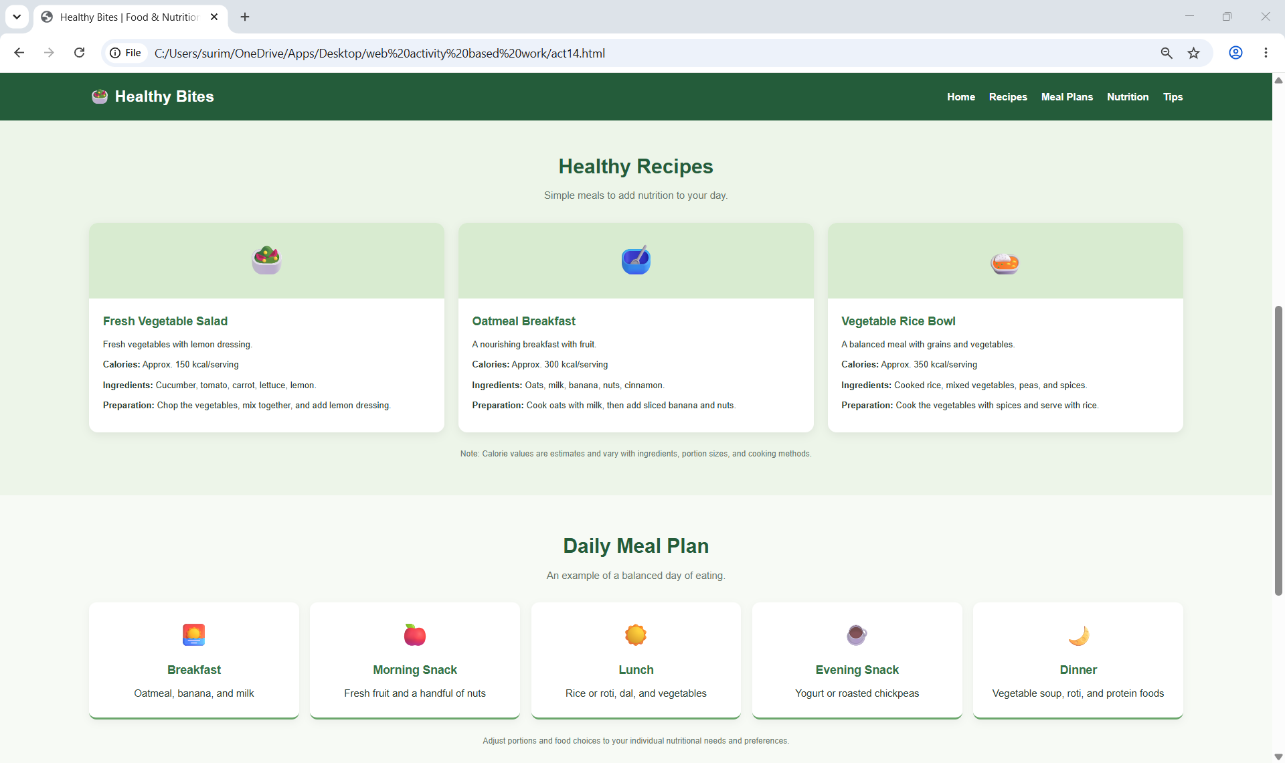
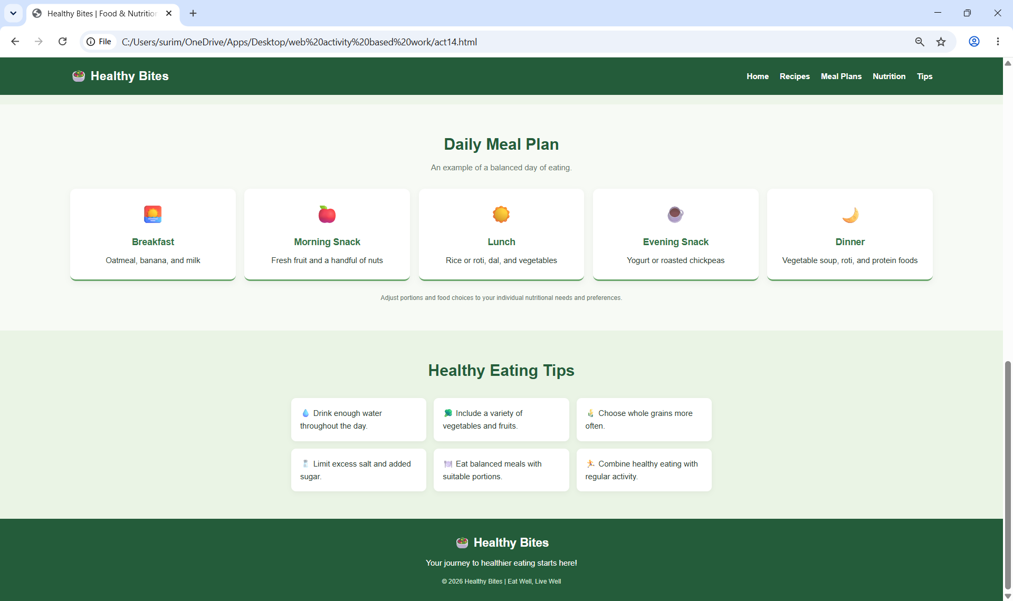

5. Case Study 2: Borcelle Café — Restaurant Website

5.1 Overview
Borcelle Café is a restaurant-themed webpage that introduces the restaurant, describes selected dishes, presents cuisine information, and highlights newer fusion-food ideas.

5.2 Main Features
- Header containing the Borcelle Café name and welcome message.
- Navigation links for Home, Dishes, Cuisines, and Contact.
- About section introducing the restaurant.
- Dish descriptions for Spaghetti and Fusion Dosa.
- Cuisine descriptions for Italian, Indian, Chinese, Mexican, and Japanese food.
- Latest-dish list featuring Korean-Style Spicy Paneer, Tandoori Momos, Butter Chicken Pizza, and Paneer Tikka Tacos.
- Warm cream, brown, and orange styling, section cards, and hover effects.
- Footer containing contact details as currently entered in the code.

5.3 Technologies and Files
Technologies: HTML5 and CSS3.
Expected files: the HTML page, act18.css, and this report/documentation as needed.

5.4 Result and Limitations
The webpage groups restaurant information into distinct sections. The contact information should be checked and replaced with real details before publishing. The current page is a static frontend; online ordering and table reservations are not implemented. Some nested HTML elements and the cuisine styling class should be checked for valid structure and consistent display.
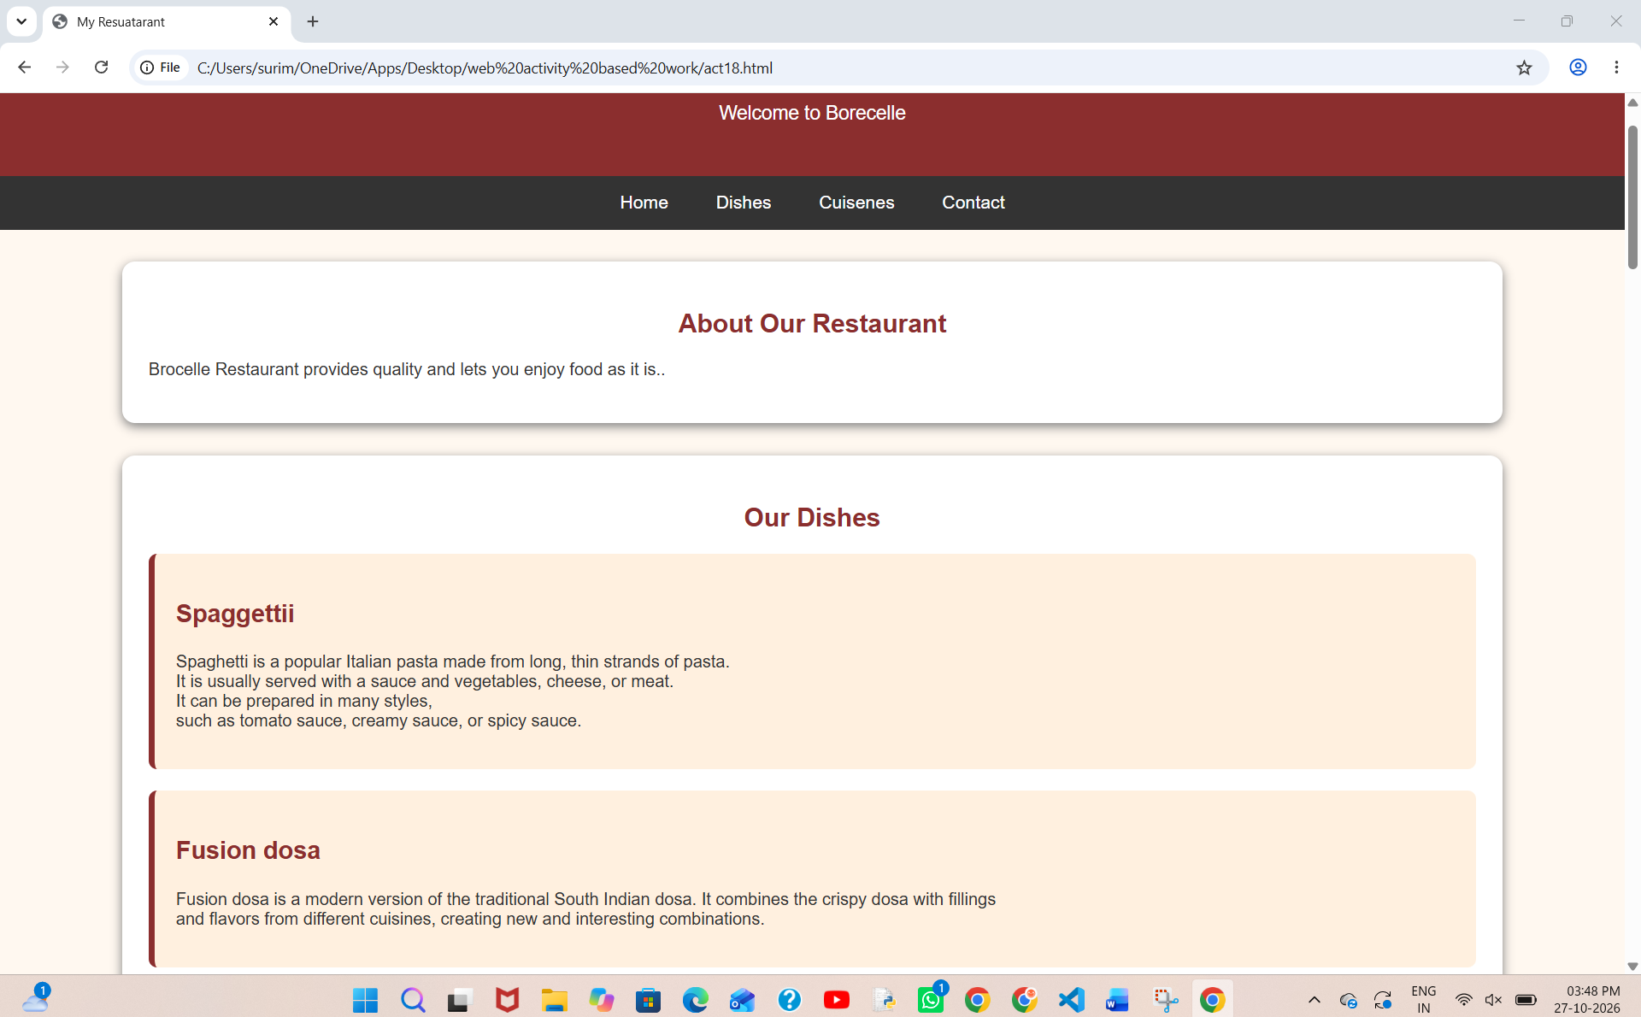
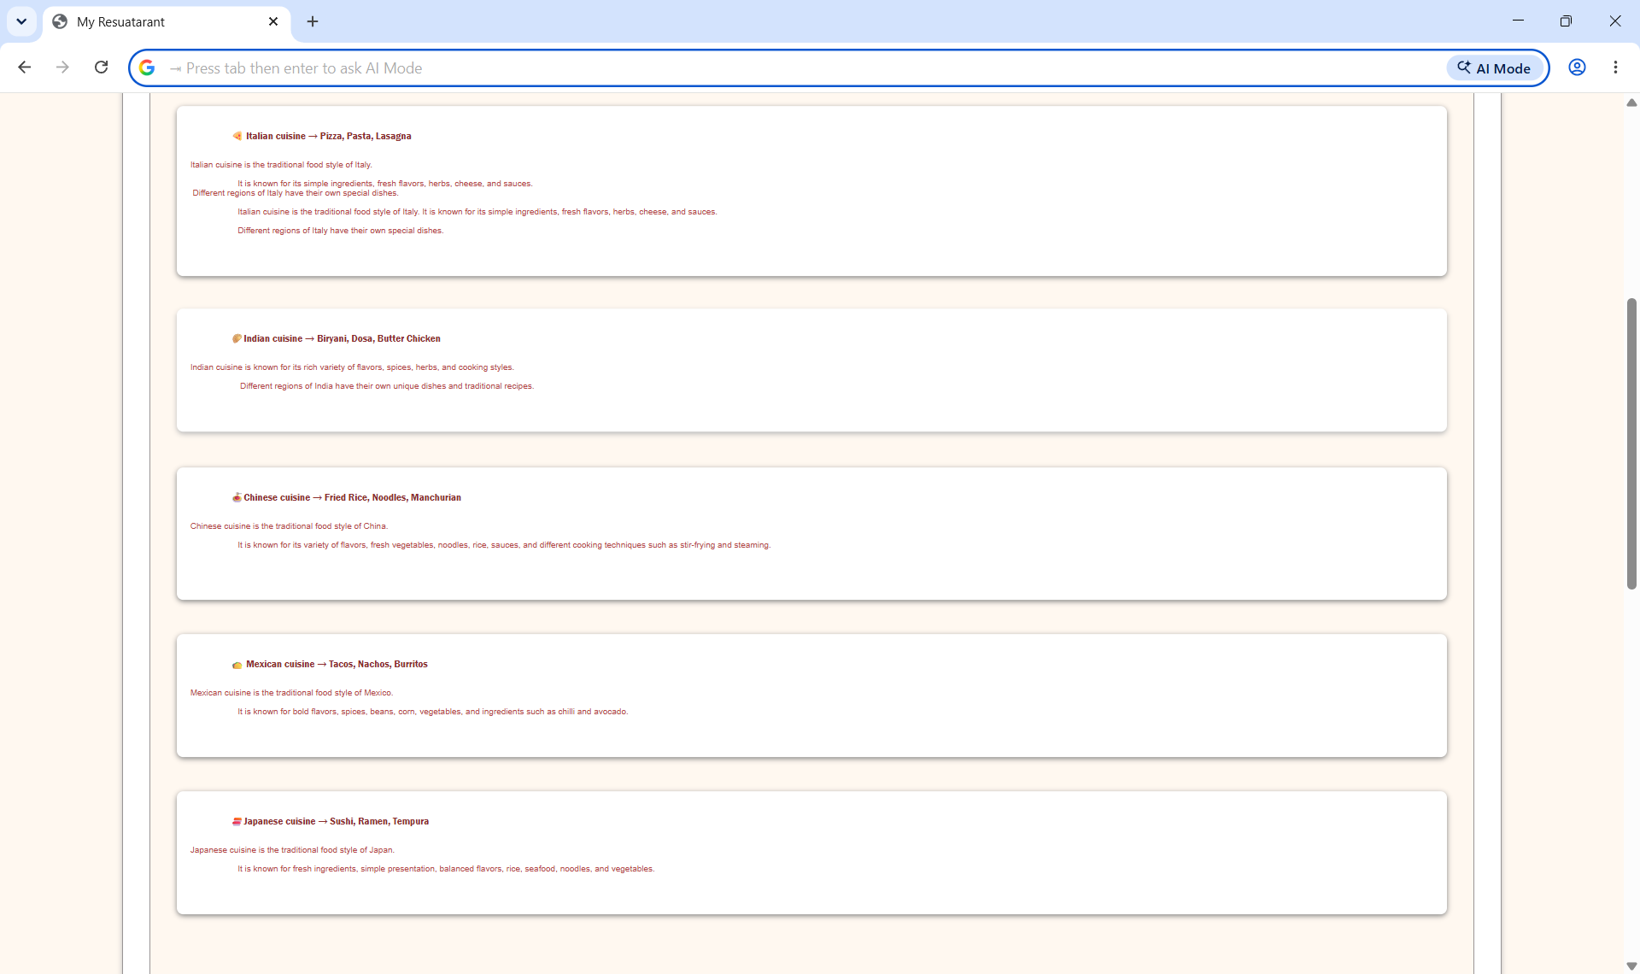
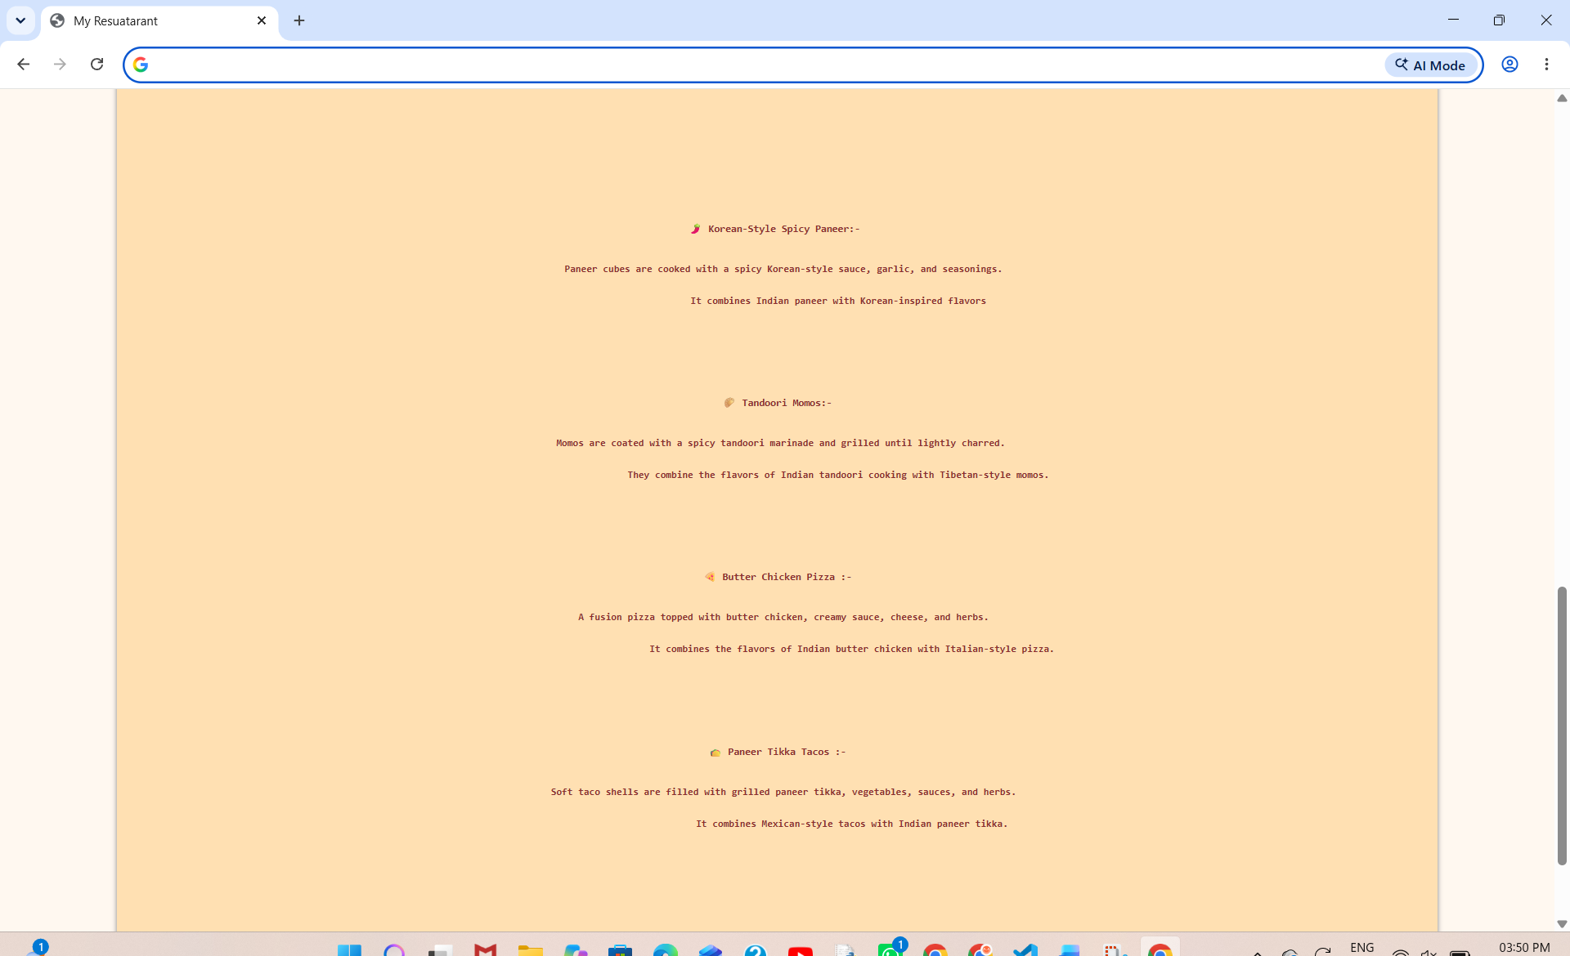

6. Case Study 3: Dr. RVR NRIIT FEST 2026 Website

6.1 Overview
This website promotes a college-fest concept for Dr. RVR NRIIT FEST 2026. It presents the event theme, schedule, guests, activities, food stalls, DJ night, highlights, and a section for contact details and registering interest.

6.2 Main Features
- Navigation links for Home, About, Schedule, Guests, Activity, DJ, and Contact.
- Hero section with the tagline “Celebrate • Connect • Create” and an Explore Fest button.
- About cards for Celebrate, Connect, and Create.
- Event schedule table showing time, event, and location.
- Guest cards with images and descriptions.
- Games and activities: Gaming Zone, Competitions, Creative Zone, and Fun Games.
- Food and stalls section for the Food Court, Creative Stalls, and Fun Stalls.
- DJ Night section and fest highlights.
- Venue/contact details and a registration-interest form.
- Dark background styling with golden accents, hover transitions, and a mobile media query.

6.3 Technologies and Files
Technologies: HTML5 and CSS3.
Expected files: the HTML page, act26.css, homebg.jpg, dj.jpeg, modi.jpeg, satish.jpeg, rahman.jpeg, and this report/documentation. Keep image files in the paths referenced by the code.

6.4 Result and Limitations
The webpage brings event information together in one page. The schedule, date, guest information, email, and phone number should be verified before public use. The phone number is currently a placeholder. The registration form is frontend-only and does not save or send submissions. The HTML/CSS class names and markup should be checked: for example, the schedule wrapper uses table="container" while the CSS expects .table-container, and the HTML uses class="guest" while the CSS selector is .guests.
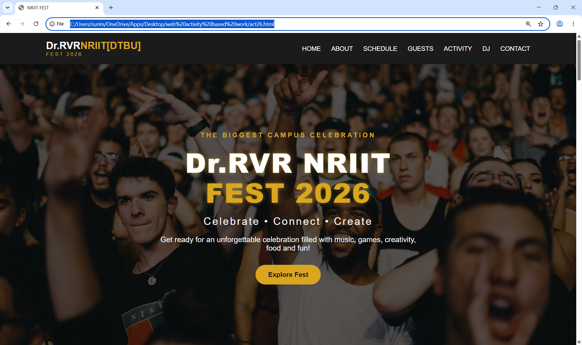.

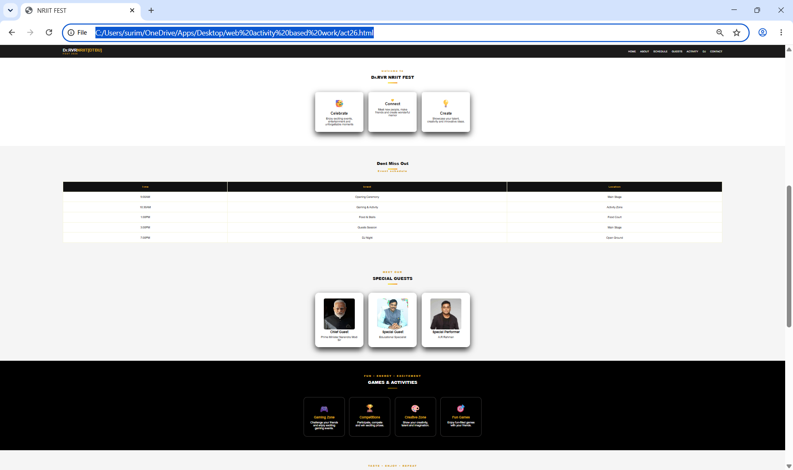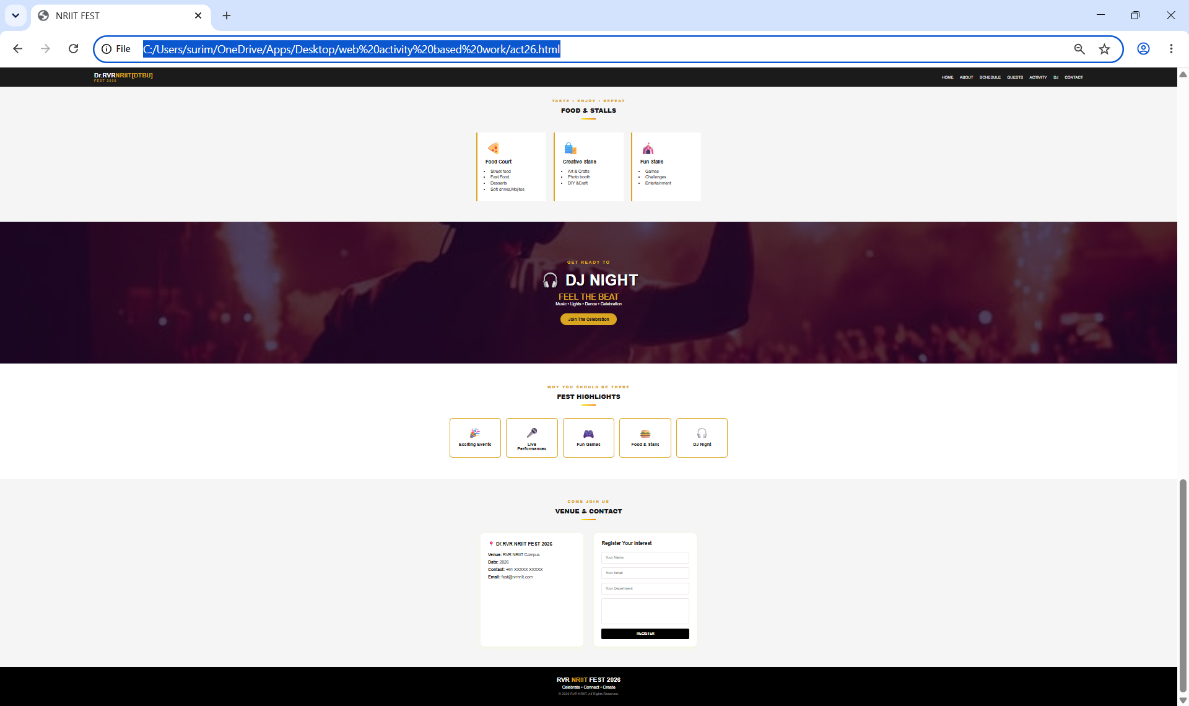.

7. Testing and Verification
After opening each page in a browser, check the following and mark the items you have tested:
- ☐ The HTML file opens without a blank page.
- ☐ The linked CSS file is found and the page is styled.
- ☐ Navigation links scroll to the correct sections.
- ☐ Images load correctly and file names match the HTML/CSS paths.
- ☐ Cards, tables, and content remain readable at different screen widths.
- ☐ Buttons and forms behave as expected; frontend-only forms are not treated as saved registrations.
- ☐ Spelling, headings, contact details, and event information are reviewed.

8. Learning Outcomes
- Practiced building multi-section webpages using HTML.
- Applied CSS colors, typography, spacing, borders, shadows, and hover transitions.
- Used links, lists, cards, tables, images, and form controls.
- Learned the importance of matching HTML class names with CSS selectors and keeping asset paths correct.
- Recognized the difference between a static frontend form and a fully functional form connected to a backend.

9. Conclusion
The three projects demonstrate different applications of HTML and CSS: a nutrition information website, a restaurant website, and a college fest promotional website. They provide practice in page structure, visual design, navigation, reusable styling, and responsive layouts. Before final submission, run each webpage, correct any markup or styling issues, add actual browser screenshots in the marked spaces, and confirm that the project files are organized in the required GitHub repository.

10. Submission Checklist Based on the Circular
- ☐ Three selected case studies are included in the repository.
- ☐ Each website's HTML, CSS, and required image assets are uploaded.
- ☐ A README.md file is maintained with student name, roll number, branch, section, and the titles of the three selected case studies.
- ☐ A consolidated report is exported to PDF with actual screenshots of the webpages.
- ☐ The GitHub repository URL is ready to submit to the Web Development faculty member / Lab Mentor.
- ☐ The student is prepared to explain and demonstrate each website.

