# Cluster creation from a two node machine

* We are having a two machines, these has to be connected , declaring one as master node and the other as worker node

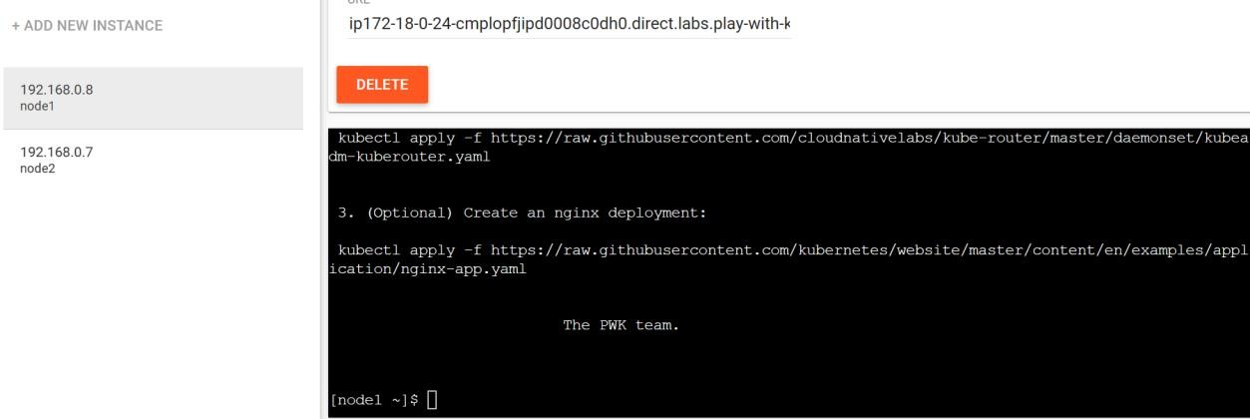

# Step 1 – Installing packages in master node

* Since the node machine already comes with softwares like kubeadm and kubectl , no need to install those
* In the cli enter the following command

kubeadm init --apiserver-advertise-address $(hostname -i) -- pod-network-cidr 10.5.0.0/16

* Kubeadm init – will setup a Kubernetes control plane in machine
* --apiserver-advertise-address $(hostname -i) – This will get advertise the api layer of Kubernetes to the host machine
* Pod-network – This is range of pod network

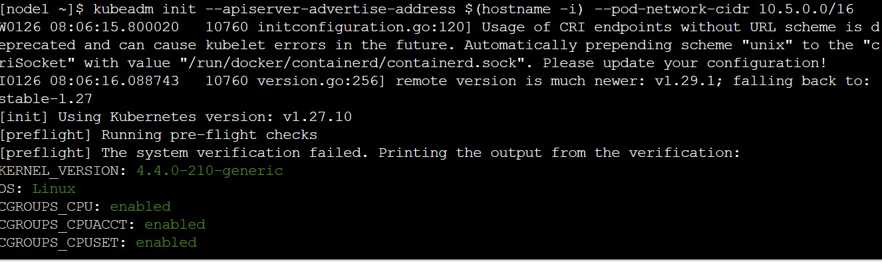

* After this there will be a config file created in the location /etc/kubernetes/admin.conf
* At the end of command execution , there will be number of commands that has to be executed

mkdir -p $HOME/.kube

sudo cp -i /etc/kubernetes/admin.conf $HOME/.kube/config

sudo chown $(id -u):$(id -g) $HOME/.kube/config

export KUBECONFIG=/etc/kubernetes/admin.conf

kubeadm join 192.168.0.8:6443 --token c3u6xu.evrwojz3mvcw8ulv --discovery-token-ca-cert- hash sha256:22acffd2bc6c76faa4a8d0c3ba6e22ca2556b127f86641fb552e575d0c05f582

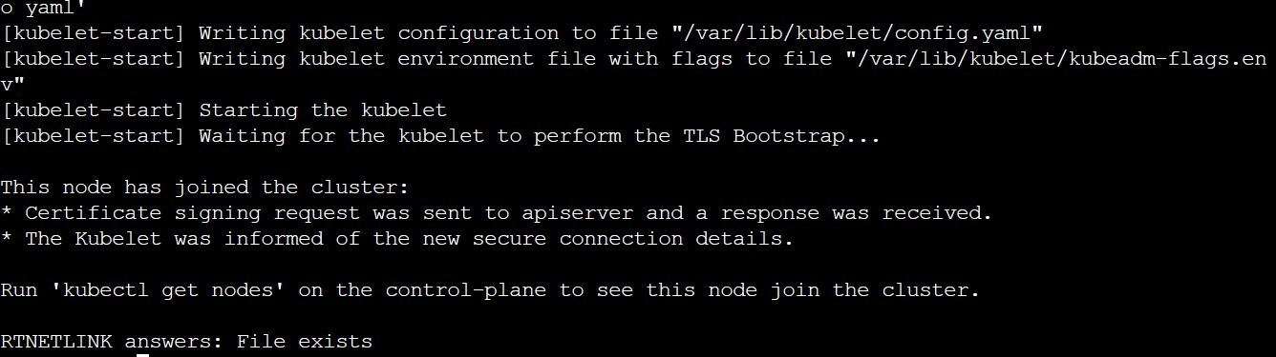

* Kubeadm join – used to join the nodes
* 192.168.0.8:6443 – Ip address of the control plane

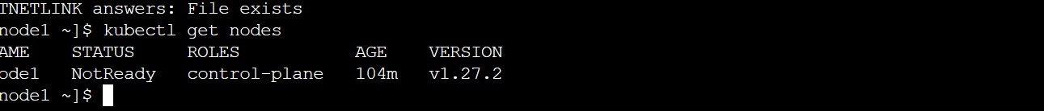

* Node is the not ready state, This is because we have not initialized networking for the cluster. Run the following command to initialize the networking

kubectl apply -f [https://raw.githubusercontent.com/cloudnativelabs/kube-](https://raw.githubusercontent.com/cloudnativelabs/kube-router/master/daemonset/kubeadm-kuberouter.yaml) [router/master/daemonset/kubeadm-kuberouter.yaml](https://raw.githubusercontent.com/cloudnativelabs/kube-router/master/daemonset/kubeadm-kuberouter.yaml)



**Step 2 – Linking the worker node**

* Enter the same join command used in master node in worker node, the node will be added to the master node

