**K8 pods**

* Pod are not as same as containers, it is like a box that can run multiple containers, we can access the pod with pod IP, and containers run in the localhost of the pod



* By default, the **PID namespace** is not shared however kubernetes provide options to enable process sharing between containers inside the pod using shareProcessNamespace Option
* The mount namespace is not shared between containers. Each container has its own private filesystem and directories. However, the pod mount volumes are shared between containers.

**Creating a pod using nginix image**

apiVersion: v1

kind: Pod

metadata:

name: web-server-pod

labels:

app: web-server

environment: production

annotations:

description: This pod runs the web server

spec:

containers:

- name: web-server

image: nginx:1.14.2

ports:

- containerPort: 80

* Command is kubectl create -f <filename.yaml>

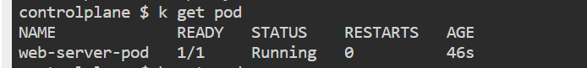

* Port forward th exposed port to any localhost port

Command - kubectl port-forward pod/web-server-pod 8080:80

* In localhost:8080 the application will be accessible