**Setting up metric server**

* After the node setup , the metric server will not be enabled by default, command for checking that is



* We can ensure that by checking for a metric pod kube-system namespace

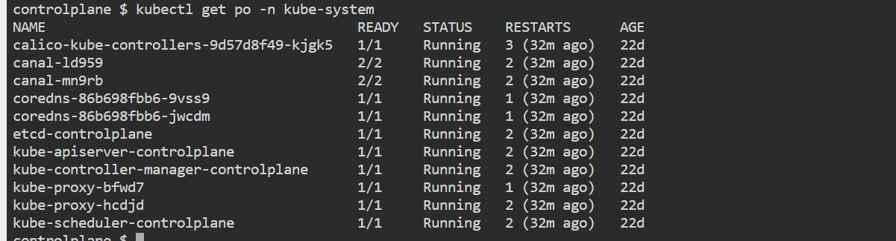

* Run the following command for setting up the metric server

**Command** - kubectl apply -f <https://github.com/kubernetes-sigs/metrics-server/releases/latest/download/components.yaml>