**Image creation**

* First step in image creation to convert your source code into a jar file

Command – mvn clean package

* This command will scan the java code and build a jar file in the target folder

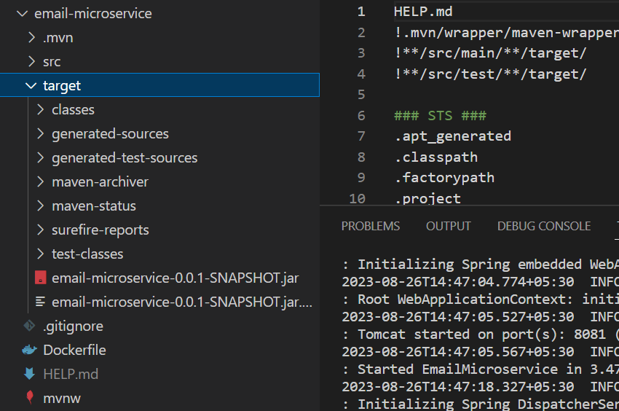

**Creation of Dockerfile**

# Use a base image with Java runtime

FROM openjdk:11-jre-slim

# Set the working directory inside the container

WORKDIR /app

# Copy the compiled JAR file from the target directory of your project into the container

COPY target/email-microservice-*.jar /app/email-microservice.jar

# Expose the port that the Spring Boot application is running on

EXPOSE 8081

# Command to run the application when the container starts

CMD ["java", "-jar", "/app/email-microservice.jar"]

* FROM openjdk is base image , on top of which our application is build
* WORKDIR – The working directory within the image
* COPY – Copying the jar file into the image
* EXPOSE – Through this port only the incoming and outgoing requests are sent
* CMD – This command is ran when is container is created with the image
* Tag the local image with your repo and push it , this allows it to be accessible from anywhere